**Screenshot Lottery Management System**

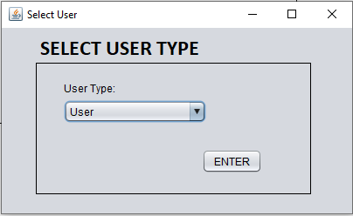

Figure start from selecting user (client code)

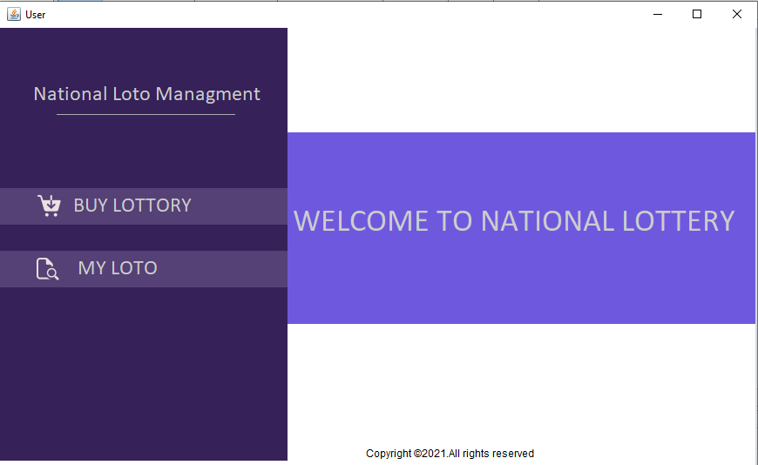

Figure if the system user is user (he/she can access only user privileges)

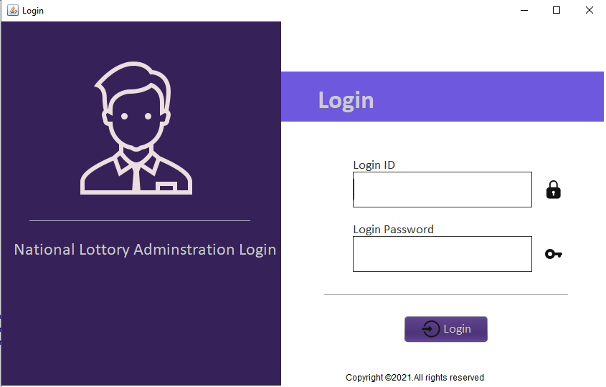

Figure if the system user is an admin login page pops up (where Most CRUD relies)

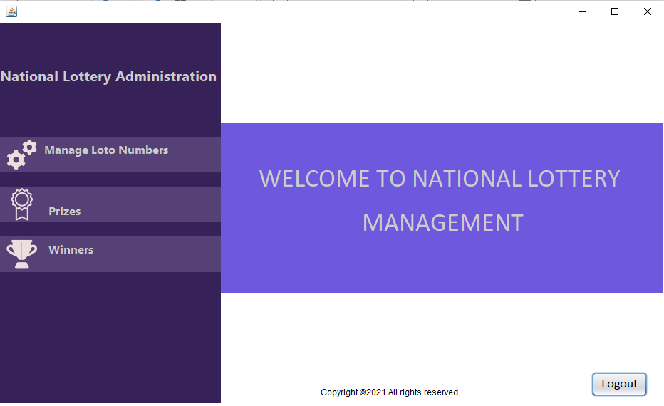

Figure right after login admins managing page appears

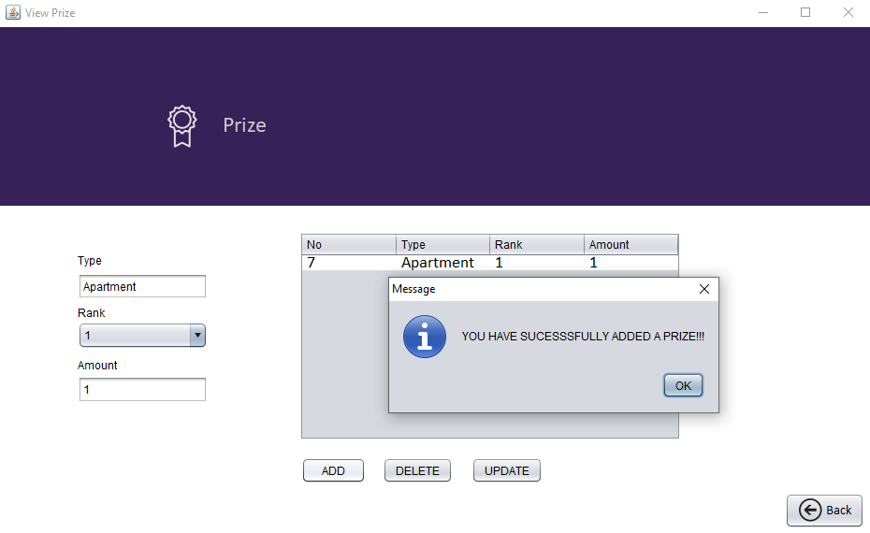

Figure Sample CRUD example