GeoDev – Week 4 Task
Spatial Analysis: Which settlement in ogbia LGA sit in low lying land within 200m of a watercourse. (Settlements and 200 m Waterway Proximity, Ogbia)
Seigha Tukoroa | 19 October 2026
GitHub repository: [https://github.com/seighatukoroa/geodev-lab-project.git]

1. What the Task Asks For
# | Requirement
1 | Run one spatial operation (buffer, intersection, spatial join or count points in polygon) on your own data, in a projected CRS, answering part of your own question.
2 | Write down what you expect before running it: roughly how many features and roughly what values.
3 | Check the result four ways: look at the map, check the row count against your expectation, verify one feature by hand, and look for empty geometry.
4 | Make a simple map with a title, legend and scale bar, export it as PNG and put it in the repository.
5 | Write month-1-summary.md and commit it with the message "Add month 1 summary".

2. Your Question
Suggested one-sentence wording (edit to match your own question):
“Which settlements in Ogbia lie within 200 m of a waterway, and how much of the settled area in each ward is that close to water?”
This fits the layers in your project: Ward_Boundaries (13 wards, Ogbia Ward 1 to Ward 13), Waterway_ogbia, the 200 m waterway buffer and the settlement extents, which are symbolised as “within 200m water” (red) and “Outside 200m water” (green).

3. The Operation You Ran
Item | Detail
Operation | Buffer (200 m around waterways), then Intersection with settlement extents (Union was also tried).
Why | Proximity to water matters for flood exposure, access and transport. A 200 m buffer turns the question into a yes/no test for each settlement.
Input layers | Waterway_ogbia (lines) and Settlement_Extents_utm... (polygons, already in UTM). Ward_Boundaries used for context and labels.
Projected CRS | [EPSG:32632 – WGS 84 / UTM zone 32N; confirm in Layer Properties]
Buffer distance | 200 m (metres, so the CRS must be projected, not EPSG:4326)
Tools used | Vector > Geoprocessing Tools > Buffer, Intersection (and Union). Output saved as [GeoPackage name.gpkg]
Dissolve buffer? | [Yes/No – dissolving avoids counting overlapping buffers twice]

VITAL POINT: A buffer in metres only works in a projected CRS. Your waterway layer must be reprojected to UTM before buffering, or the “200” would mean 200 degrees. Your settlements layer name ends in _utm, which is a good sign; confirm the waterway layer is too.

4. What You Expected (Written Before Running)
Use the table below.
Expectation | Your entry
Roughly how many settlement features in total? | [Which settlement in ogbia LGA sit in low lying land within 200m of a watercourse]
Roughly how many would fall within 200 m of water? | [Intersection 824 out of 1078 settlement.]
Roughly what values for area/share per ward? | [30–70% in riverine wards, lower inland]
Why I expected this | [Ogbia is a low-lying riverine area with many creeks, so many settlements sit by water]

5. Results
Measure | Value
Total settlement features | [1095]
Within 200 m of waterway | [Intersection 824
Outside 200 m of waterway | [1078 settlement.

6. The Map (PNG)

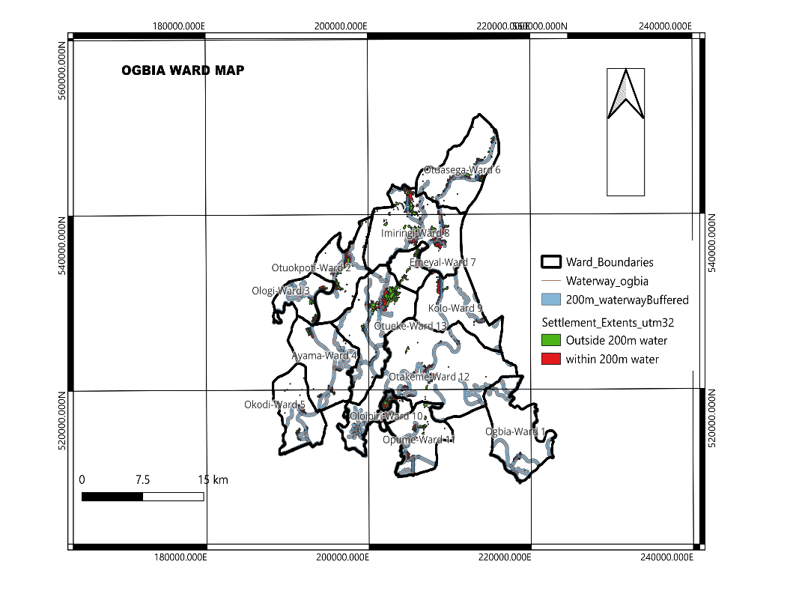

7. Repository and Commit
File | Purpose
month-1-summary.md | The summary in Section 9 (required)
images/ogbia_settlements_200m_waterways.png | The exported map (required)
data/ogbia_analysis.gpkg | Buffer and intersection outputs (small files only)
qgis/ogbia_week4.qgz | QGIS project file
README.md | Short project description and links

8. Month-1-summary.md
Copy the text below into the file and replace the yellow items. It follows the five parts the task asks for.
# Month 1 Summary: Ogbia Settlements and Waterways
## Question
Which settlements in Ogbia lie within 200 m of a waterway, and how much of the settled area in each ward is that close to water?
## Operation and why
I buffered the waterway layer by 200 m in [EPSG:32632 – WGS 84 / UTM zone 32N] and intersected it with the settlement extents. A buffer in metres needs a projected CRS, and the intersection splits settled area into within and outside 200 m so I can count and measure both.
## What I expected and what I got
I expected [Ogbia is a low-lying riverine area with many creeks, so many settlements sit by water]. I got [Intersection 824 out of 1078 settlement.
## What surprised me
[a ward with far more or fewer near-water settlements than expected, duplicate buffer layers, geometry errors, differences between layers]
## Data I still need
[e.g. flood extent or elevation (DEM), up-to-date waterway lines, settlement population or building counts, official ward boundaries to compare with]
## Files
Map: images/ogbia_settlements_200m_waterways.png. Data: data/ogbia_analysis.gpkg. Project: qgis/ogbia_week4.qgz.

