Lab Week 13, Implementing Directed Graphs for a City Transportation Network
Definition of the Graph:
The graph consists of 12 landmarks and 18 roads. This satisfies the assignment requirement of having at least 10 landmarks and 15 roads.
The traversal starts from Vertex 1, and the destination vertex is Vertex 9.
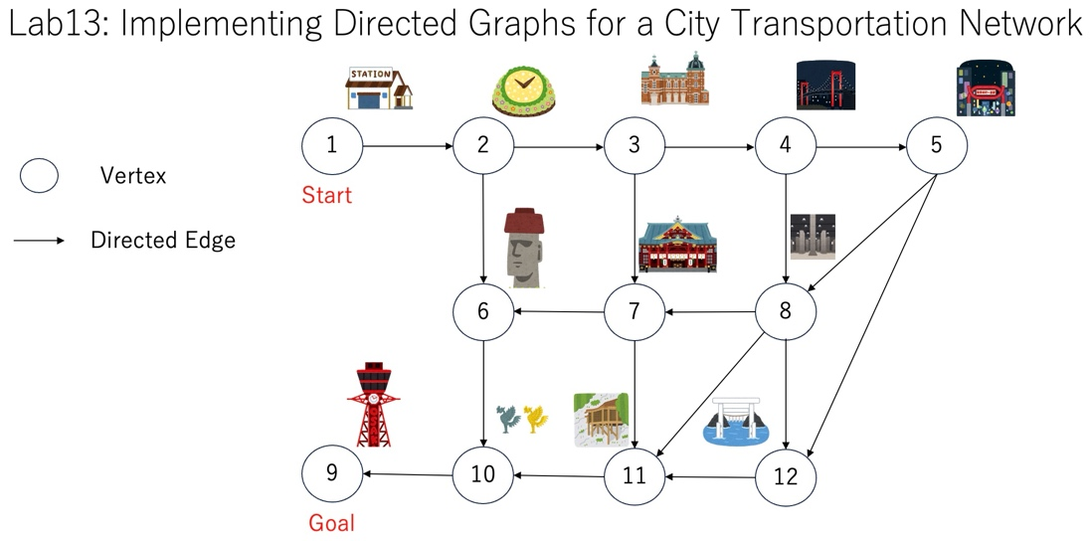

Results of BFS and DFS Traversals:
BFS result: 1 -> 2 -> 3 -> 6 -> 4 -> 7 -> 10 -> 5 -> 8 -> 11 -> 9 -> 12
DFS result: 1 -> 2 -> 3 -> 4 -> 5 -> 8 -> 7 -> 6 -> 10 -> 9 -> 11 -> 12
Shortest path using BFS: 1 -> 2 -> 6 -> 10 -> 9

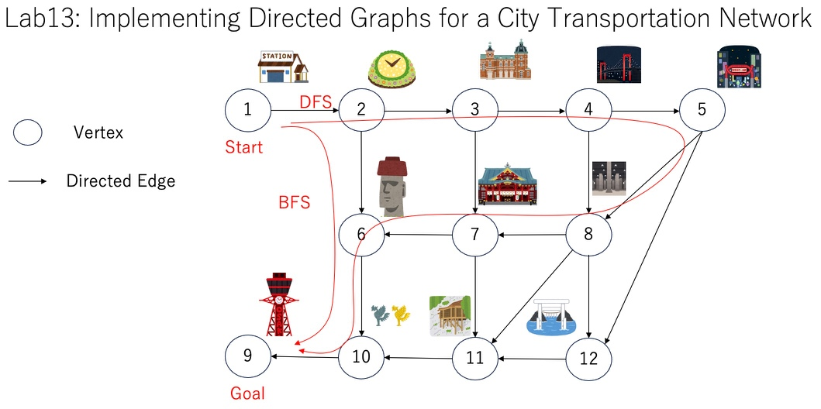
BFS found the shortest path because it explores vertices level by level. In contrast, DFS does not guarantee the shortest path in a graph when multiple paths exist between vertices. As shown in this case, DFS may reach the destination through a different path that is longer than the shortest path.

