Sales Tracker: Recreate and Deploy Guide (Beginner Friendly)
This guide helps you recreate this project and publish it online using GitHub Pages.
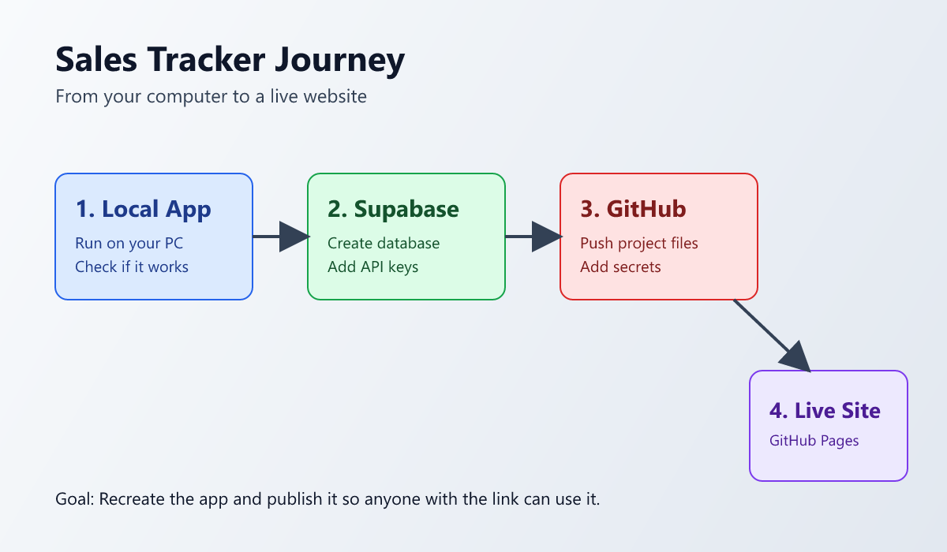

What You Need First
- A `GitHub` account (free)
- A `Supabase` account (free)
- A Windows computer with internet

Step 1: Install the Tools
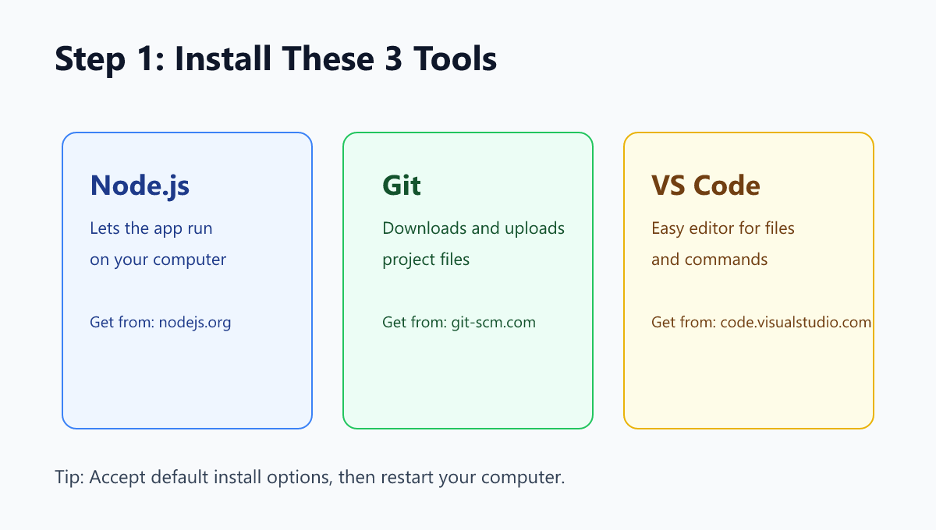
Install these 3 tools (default options are fine):
- `Node.js` (LTS version): https://nodejs.org
- `Git`: https://git-scm.com
- `Visual Studio Code`: https://code.visualstudio.com
After installing, restart your computer once.

Step 2 Alternative: Build the Web App (Broad Overview)
Use this if you want to recreate the app structure yourself instead of cloning a ready codebase.
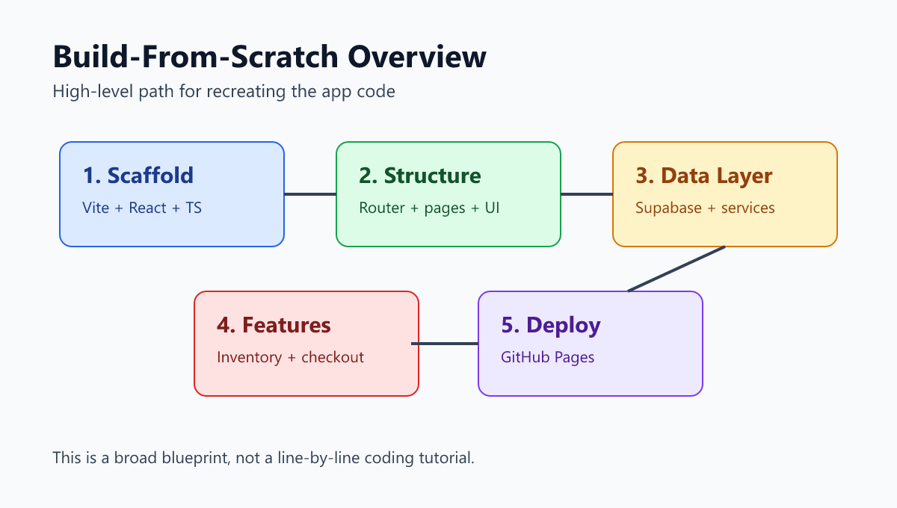

Goal of This Guide
You will create the app in broad strokes so you understand how the pieces fit together.
This is intentionally not a deep, line-by-line coding tutorial.

Tech Stack (What Is Used)
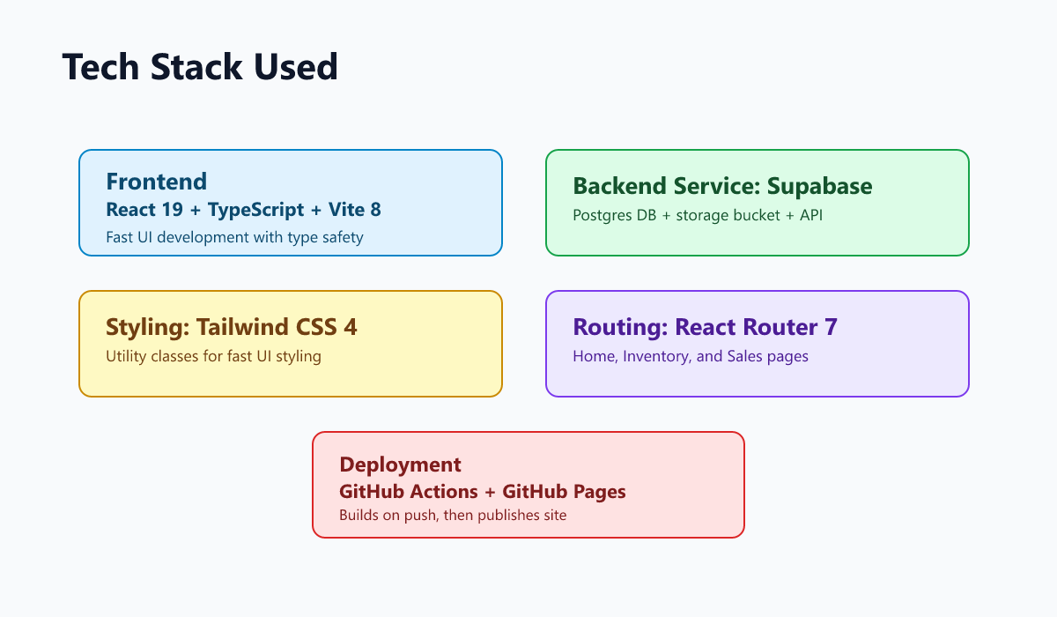
- `React 19` + `TypeScript` + `Vite 8`: frontend app
- `React Router 7`: page navigation
- `Tailwind CSS 4`: styling
- `Supabase`: database + storage bucket for images
- `GitHub Actions` + `GitHub Pages`: deployment

1) Start a New React + TypeScript Project
In terminal:
npm create vite@latest sales-tracker -- --template react-ts
cd sales-tracker
npm install

2) Install Main App Dependencies
npm install react-router @supabase/supabase-js tailwindcss @tailwindcss/postcss postcss

3) Set Up Styling and Base Structure
- In `src/App.css`, import Tailwind:
@import "tailwindcss";
- Keep `src/main.tsx` simple: render `<App />`.
- Add app pages and layout folders:
- `src/layouts/`
- `src/pages/`
- `src/components/`
- `src/hooks/`
- `src/lib/`
- `src/types/`

4) Build the Route Skeleton
In `src/App.tsx`:
- Configure router with:
- `/` -> `Home`
- `/inventory` -> `Inventory`
- `/sales` -> `Sales`
- Wrap routes in `RootLayout`.
- Set basename for GitHub Pages path:
basename: "/sales-tracker"
In `vite.config.ts`, set:
base: "/sales-tracker/"

5) Create the Main Screens
- `Home`: POS-style item list and cart checkout
- `Inventory`: add items, upload image, adjust stock, search/pagination
- `Sales`: view sales log, date filter, pagination, totals

6) Add Supabase Connection
Create `src/supabaseClient.ts` and load from `.env`:
- `VITE_SUPABASE_URL`
- `VITE_SUPABASE_PUBLISHABLE_KEY`
This client is reused across all service files.

7) Add Data Service Functions (Business Logic)
Main services live in `src/lib/`:
- `fetchInventoryItems()`
- `createInventoryItem()`
- `removeInventoryItem()`
- `checkoutSale(lines)`
- `adjustInventoryStock(item, nextStock)`
- `uploadInventoryImage(itemId, file)`
- `fetchSalesLog()`
What these do broadly:
- Read/write inventory table
- Record sale entries
- Record movement entries (`SALE` or `RESTOCK`)
- Keep stock values consistent
- Roll back changes if checkout partially fails

8) Add Hooks to Connect UI to Services
Main hooks in `src/hooks/`:
- `useInventoryItems()` -> fetch + refetch inventory data
- `useSales()` -> fetch + refetch sales data
- `useCart()` -> local cart state and totals
These keep pages cleaner and move repeated logic out of UI components.

9) Wire Components to Pages
Example component split:
- `components/home/`:
- `PosItemCard`
- `CartSummary`
- `components/inventory/`:
- `InventoryTable`
- `AddInventoryItemForm`
- `StockModal`
- `components/sales/`:
- `SalesTable`

10) Verify Local App
Run:
npm run dev
Check this URL:
http://localhost:5173/sales-tracker
Test quickly:
- Add an item in Inventory
- Checkout in Home
- Confirm it appears in Sales

Code Structure Snapshot
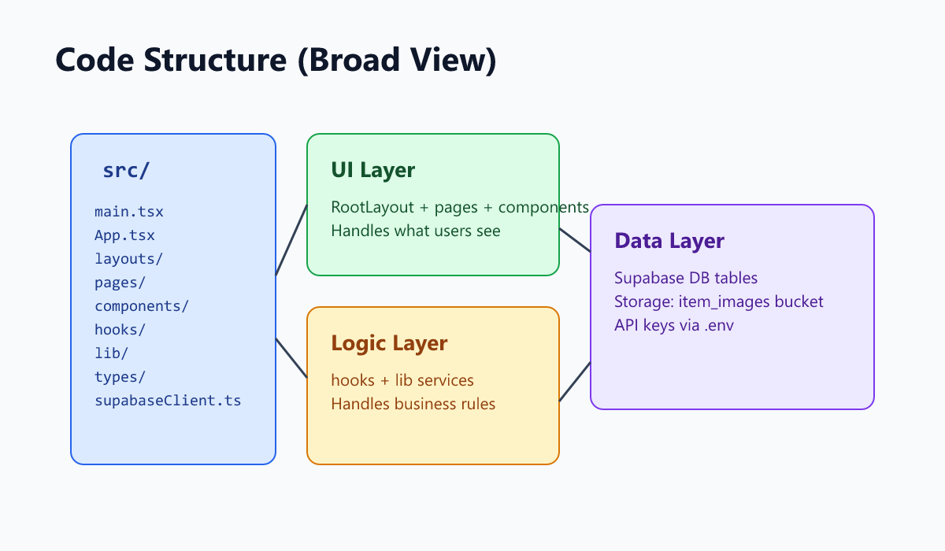

Step 3: Install Project Packages
In the same terminal, run:
npm install
Wait until it finishes.

Step 4: Create a Supabase Project
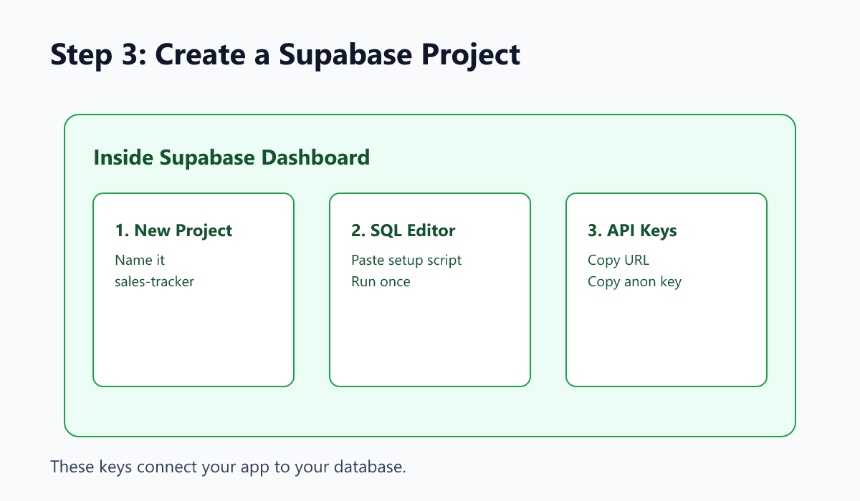
- Go to https://supabase.com and sign in.
- Click `New project`.
- Project name: `sales-tracker`.
- Set a database password and wait for setup to finish.

Step 5: Create Tables, Policies, and Storage (Supabase)
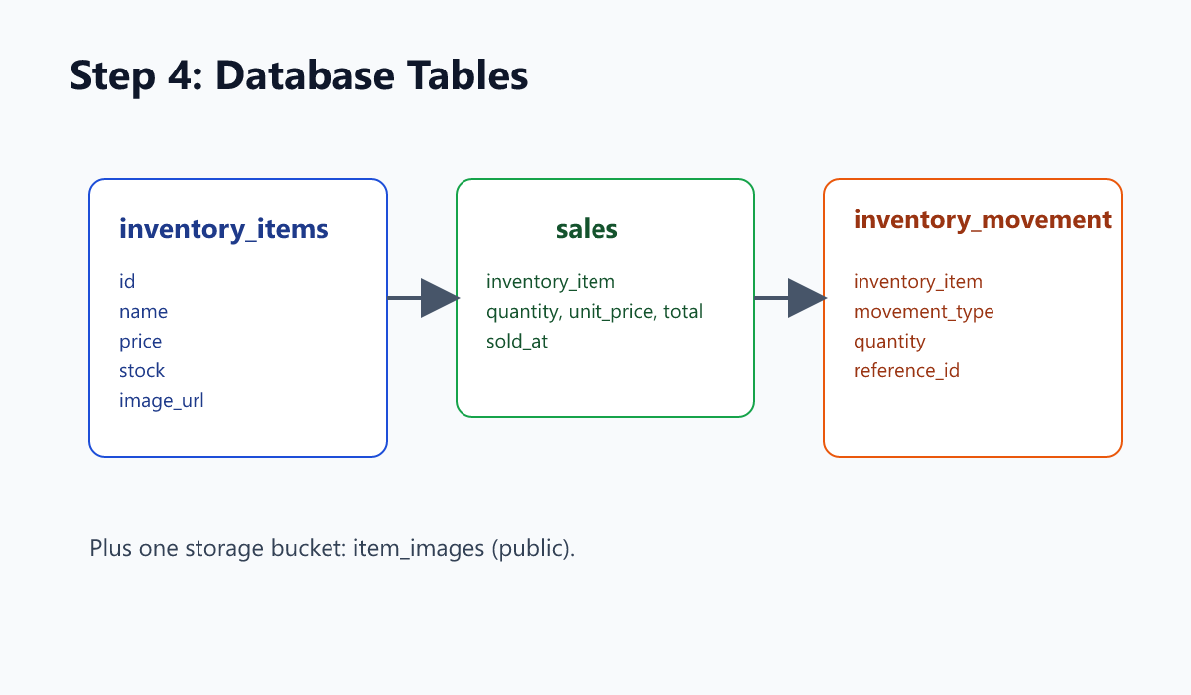
- In Supabase, open `SQL Editor`.
- Click `New query`.
- Paste the SQL below.
- Click `Run` once.
-- 1) Enum used by inventory_movement
DO $$
BEGIN
CREATE TYPE movement_type AS ENUM ('SALE', 'RESTOCK');
EXCEPTION
WHEN duplicate_object THEN NULL;
END $$;
-- 2) Core tables
CREATE TABLE IF NOT EXISTS public.inventory_items (
id BIGINT GENERATED BY DEFAULT AS IDENTITY PRIMARY KEY,
created_at TIMESTAMPTZ NOT NULL DEFAULT NOW(),
name TEXT NOT NULL,
price NUMERIC(12,2) NOT NULL CHECK (price >= 0),
stock INTEGER NOT NULL CHECK (stock >= 0),
image_url TEXT
);
CREATE TABLE IF NOT EXISTS public.sales (
id BIGINT GENERATED BY DEFAULT AS IDENTITY PRIMARY KEY,
inventory_item BIGINT NOT NULL REFERENCES public.inventory_items(id) ON DELETE RESTRICT,
quantity INTEGER NOT NULL CHECK (quantity > 0),
sold_at TIMESTAMPTZ NOT NULL DEFAULT NOW(),
unit_price NUMERIC(12,2) NOT NULL CHECK (unit_price >= 0),
total NUMERIC(12,2) NOT NULL CHECK (total >= 0)
);
CREATE TABLE IF NOT EXISTS public.inventory_movement (
id BIGINT GENERATED BY DEFAULT AS IDENTITY PRIMARY KEY,
created_at TIMESTAMPTZ NOT NULL DEFAULT NOW(),
inventory_item BIGINT NOT NULL REFERENCES public.inventory_items(id) ON DELETE RESTRICT,
movement_type movement_type NOT NULL,
quantity INTEGER NOT NULL CHECK (quantity > 0),
reference_id BIGINT REFERENCES public.sales(id) ON DELETE SET NULL
);
CREATE INDEX IF NOT EXISTS idx_sales_sold_at ON public.sales(sold_at DESC);
CREATE INDEX IF NOT EXISTS idx_inventory_movement_item ON public.inventory_movement(inventory_item);
-- 3) RLS policies (public for demo app without login)
ALTER TABLE public.inventory_items ENABLE ROW LEVEL SECURITY;
ALTER TABLE public.sales ENABLE ROW LEVEL SECURITY;
ALTER TABLE public.inventory_movement ENABLE ROW LEVEL SECURITY;
DROP POLICY IF EXISTS public_all_inventory_items ON public.inventory_items;
CREATE POLICY public_all_inventory_items ON public.inventory_items
FOR ALL TO public USING (true) WITH CHECK (true);
DROP POLICY IF EXISTS public_all_sales ON public.sales;
CREATE POLICY public_all_sales ON public.sales
FOR ALL TO public USING (true) WITH CHECK (true);
DROP POLICY IF EXISTS public_all_inventory_movement ON public.inventory_movement;
CREATE POLICY public_all_inventory_movement ON public.inventory_movement
FOR ALL TO public USING (true) WITH CHECK (true);
-- 4) Public storage bucket for item images
INSERT INTO storage.buckets (id, name, public)
VALUES ('item_images', 'item_images', true)
ON CONFLICT (id) DO UPDATE SET public = true;
DROP POLICY IF EXISTS public_read_item_images ON storage.objects;
CREATE POLICY public_read_item_images ON storage.objects
FOR SELECT TO public
USING (bucket_id = 'item_images');
DROP POLICY IF EXISTS public_insert_item_images ON storage.objects;
CREATE POLICY public_insert_item_images ON storage.objects
FOR INSERT TO public
WITH CHECK (bucket_id = 'item_images');
DROP POLICY IF EXISTS public_update_item_images ON storage.objects;
CREATE POLICY public_update_item_images ON storage.objects
FOR UPDATE TO public
USING (bucket_id = 'item_images')
WITH CHECK (bucket_id = 'item_images');
Important: These policies are intentionally open so the app works without login. Use stricter policies if you add user accounts later.

Step 6: Connect App to Supabase Keys
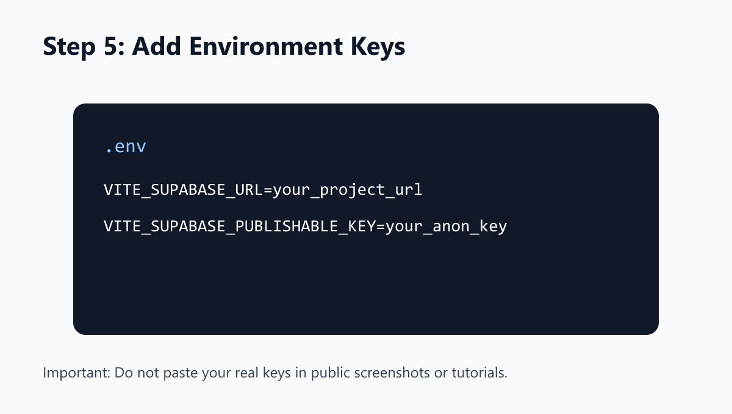
- In Supabase, go to `Project Settings` -> `API`.
- Copy:
- `Project URL`
- `anon public key`
- In your project folder, create or edit `.env`:
VITE_SUPABASE_URL=your_project_url
VITE_SUPABASE_PUBLISHABLE_KEY=your_anon_key
Save the file.

Step 7: Run the App on Your Computer
In terminal:
npm run dev
Open this URL in your browser:
http://localhost:5173/sales-tracker
Quick test:
- Go to `Inventory`, add at least 1 item.
- Go to `Home`, checkout that item.
- Go to `Sales`, confirm the record appears.

Step 8: Push to GitHub
- Create a GitHub repository (name: `sales-tracker`).
- In terminal, run:
git add .
git commit -m "Initial sales tracker setup"
git branch -M main
git remote add origin https://github.com/<your-username>/sales-tracker.git
git push -u origin main

Step 9: Add GitHub Secrets
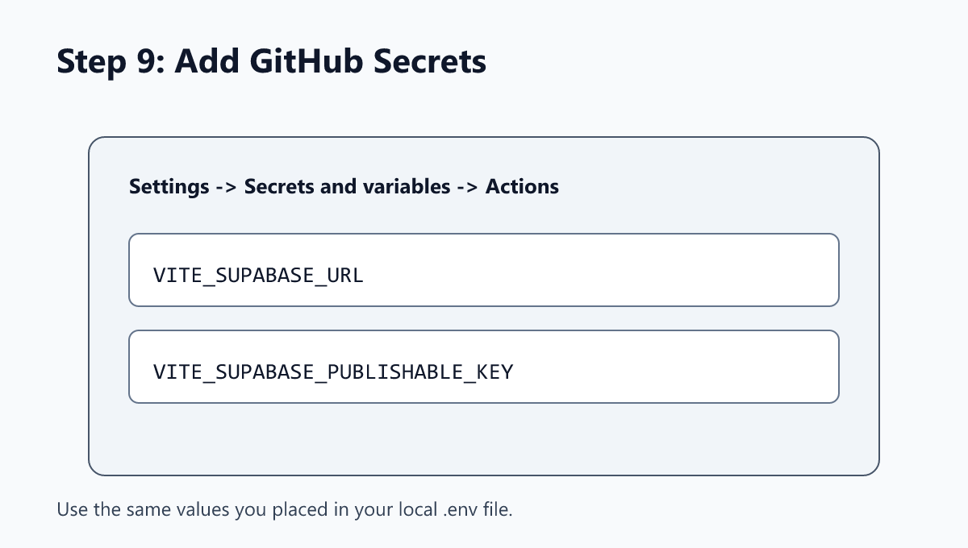
- In GitHub repo, open `Settings` -> `Secrets and variables` -> `Actions`.
- Click `New repository secret` and add:
- `VITE_SUPABASE_URL`
- `VITE_SUPABASE_PUBLISHABLE_KEY`
- Paste the same values from your `.env` file.

Step 10: Enable GitHub Pages Deployment
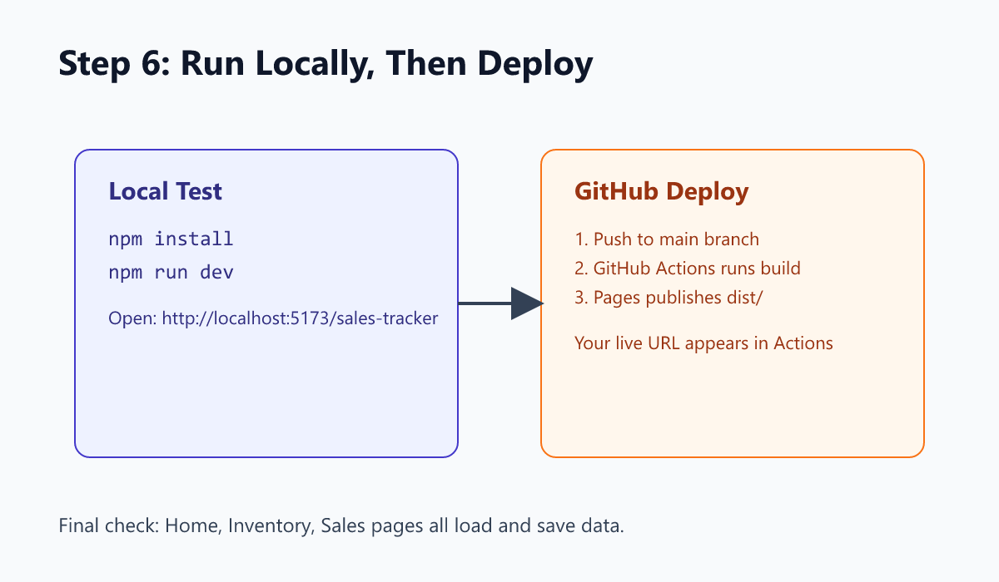
This project already includes deployment workflow in `.github/workflows/deploy.yml`.
Now enable Pages:
- GitHub repo -> `Settings` -> `Pages`.
- Under `Build and deployment`, choose `Source: GitHub Actions`.
Then push any new commit to `main`. GitHub will build and deploy automatically.

Step 11: Open Your Live URL
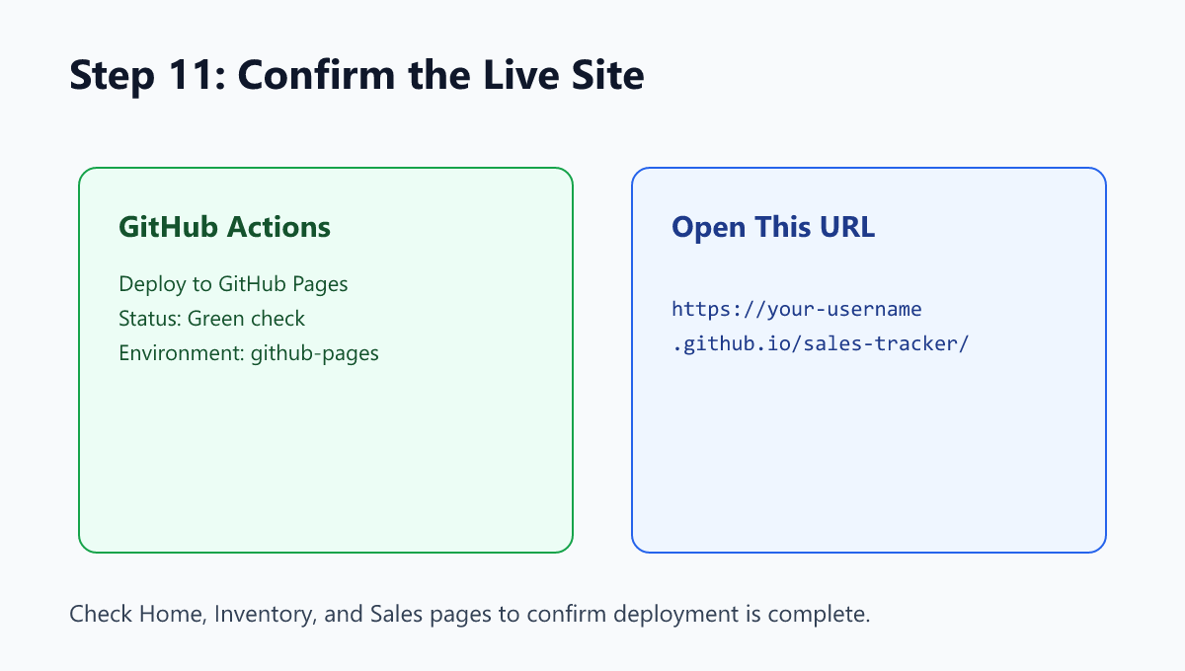
- Go to GitHub repo -> `Actions` tab.
- Open the latest `Deploy to GitHub Pages` run.
- Wait for green check marks.
- Open the `github-pages` environment link.
Your live link usually looks like:
https://<your-username>.github.io/sales-tracker/

Step 12: If You Changed the Repository Name
If your repo is not named `sales-tracker`, update these values:
- `vite.config.ts` -> `base: "/your-repo-name/"`
- `src/App.tsx` -> `basename: "/your-repo-name"`
Then commit and push again.

Simple Troubleshooting
- Blank page after deploy:
- Make sure URL has trailing slash and repo name: `/sales-tracker/`
- Build fails in GitHub Actions:
- Check both repo secrets exist and are not empty
- App loads but cannot save data:
- Re-run SQL and verify policies were created
- Images do not upload:
- Confirm `item_images` bucket exists and is public

Final Checklist
- [ ] App runs locally (`npm run dev`)
- [ ] Supabase tables exist (`inventory_items`, `sales`, `inventory_movement`)
- [ ] Supabase storage bucket exists (`item_images`)
- [ ] GitHub secrets are set
- [ ] GitHub Actions deploy is green
- [ ] Live site opens and can create a sale
You have now recreated and deployed the project.

