**WORDPRESS**

1. **Wordpress Features**
2. **Planning Session**

Answer the following questions:

1. What am I going to do with this?
2. Who is going to read this?
3. What kinds of information will I be posting?
4. Why am I doing this?
5. Who am I doing this for?
6. How often am I going to be posting and adding information?

Now, compile this information into a paragraph so it looks like this:

This website will be dedicated to X, Y, and Z,

and cover the topics of A, B, and C. The audience will  
  
be __________ ________________ _______. I will be adding   
  
posts every _____________ about ________ _______ ______________.

I am doing this because _____________ _____________ __________________.

1. **Directory Structure**

* **http://www.wpbeginner.com/beginners-guide/beginners-guide-to-wordpress-file-and-directory-structure/**

This guide will help you:

* Learn which WordPress files and folders are core files.
* Understand how WordPress stores your images and media uploads.
* Where WordPress stores your themes and plugins.
* Where configuration files are stored on your WordPress install.

**WordPress Files and Directories**

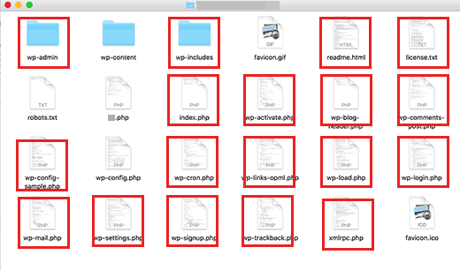

Files and folders in the red squares are the core WordPress files. These are the files and folders that run your WordPress site. You are not supposed to edit those files on your own.

#### WordPress Configuration Files

Your WordPress root directory contains some special configuration files. These files contain important settings specific to your WordPress site.

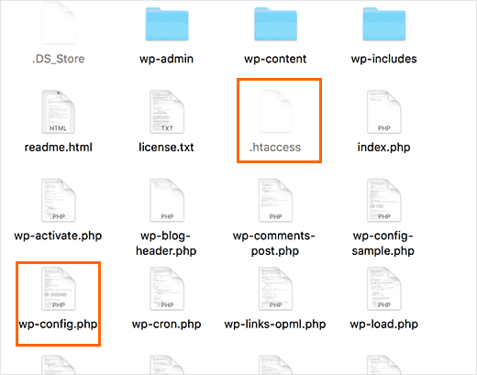

* [.htaccess](http://www.wpbeginner.com/glossary/htaccess/) – A server configuration file, WordPress uses it to manage [permalinks](http://www.wpbeginner.com/wp-tutorials/seo-friendly-url-structure-for-wordpress/" \o "What is a SEO Friendly URL Structure in WordPress)and [redirects](http://www.wpbeginner.com/beginners-guide/beginners-guide-to-creating-redirects-in-wordpress/).
* [wp-config.php](http://www.wpbeginner.com/beginners-guide/how-to-edit-wp-config-php-file-in-wordpress/) – This file tells WordPress how to connect to your database. It also sets some global settings for your WordPress site.
* index.php – The index file basically loads and initializes all your WordPress files when a page is requested by a user.

Depending on how your WordPress site is setup, you may or may not have the following files in your root directory.

* robots.txt – Contains instructions for search engines crawlers
* Favicon.ico – A favicon file is sometimes generated by WordPress hosts.

#### Inside wp-content Folder

WordPress stores all uploads, plugins, and themes in wp-content folder.

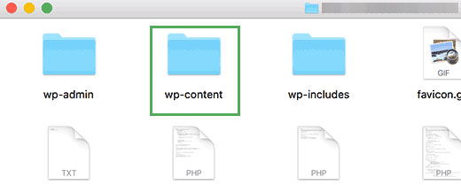

WordPress stores your theme files in /wp-content/themes/ folder. You can edit a theme file, but it is generally not recommended. As soon as you update your theme to a newer version, your changes will be overwritten during the update.

This is why it is recommended to [create a child theme](http://www.wpbeginner.com/wp-themes/how-to-create-a-wordpress-child-theme-video/) for WordPress theme customization.

All WordPress plugins you download and install on your site are stored in /wp-content/plugins/ folder. You are not supposed to edit plugin files directly, unless you wrote the plugin just for your own WordPress site.

In many [WordPress tutorials](http://www.wpbeginner.com/category/wp-tutorials/), you will see code snippets that you can add to your WordPress site. The best way to add custom code to your WordPress site is by adding it to [functions.php](http://www.wpbeginner.com/glossary/functions-php/" \o "What is functions.php file in WordPress?) file of your child theme or by creating a [site-specific plugin](http://www.wpbeginner.com/beginners-guide/what-why-and-how-tos-of-creating-a-site-specific-wordpress-plugin/).

You can download fresh copies of WordPress core, your theme, and installed plugins from their sources. But if you lose your uploads folder, then it would be very hard to restore it without a backup.

Some other default folders you may see in your wp-content directory.

* languages – WordPress stores language files for [non-english WordPress sites](http://www.wpbeginner.com/wp-tutorials/how-to-install-wordpress-in-other-languages/" \o "How to Install WordPress in Other Languages) in this folder.
* upgrade – This is a temporary folder created by WordPress during upgrade to a [newer version](http://www.wpbeginner.com/beginners-guide/how-to-easily-check-which-wordpress-version-you-are-using/)

# Beginner’s Guide to WordPress Database Management with phpMyAdmin

1. **wp_commentmeta :** This table contains meta information about comments posted on a WordPress website. Each meta_id is related to a comment_id. One example of comment meta information stored is the status of comment (approved, pending, trash, etc).
2. **wp_comments :** As the name suggests this table contains your WordPress comments. It contains comment author name, url, email, comment, etc.
3. **wp_links :** To manage blogrolls create by earlier versions of WordPress or the [Link Manager](http://wordpress.org/extend/plugins/link-manager/) plugin.
4. **wp_options :** This table contains most of your WordPress site wide settings such as: site url, admin email, default category, posts per page, time format, and much much more.
5. **wp_postmeta :** This table contains meta information about your WordPress posts, pages, and custom post types. Example of post meta information would be which template to use to display a page, [custom fields](http://www.wpbeginner.com/wp-tutorials/wordpress-custom-fields-101-tips-tricks-and-hacks/), etc.
6. **wp_posts :** The name says posts but actually this table contains all post types or should we say content types. This table contains all your posts, pages, revisions, and [custom post types](http://www.wpbeginner.com/wp-tutorials/how-to-use-custom-post-types/).
7. **wp_terms :** WordPress has a powerful taxonomy system that allows you to organize your content. Individual taxonomy items are called terms and they are stored in this table. Example, your WordPress [categories and tags](http://www.wpbeginner.com/beginners-guide/categories-vs-tags-seo-best-practices-which-one-is-better/) are taxonomies, and each category and tag inside them is a term.
8. **wp_term_taxonomy :** This table defines taxonomies for terms defined in wp_terms table. For example if you have a term “[WordPress Tutorials](http://www.wpbeginner.com/category/wp-tutorials/)“, then this table contains the data that says it is associated with a taxonomy categories. In short this table has the data that helps WordPress differentiate between which term is a category, which is a tag, etc.
9. **wp_usermeta :** Contains meta information about Users on your website.
10. **wp_users :** Contains User information like username, password, user email, etc.

#### Optimizing your WordPress Database in phpMyAdmin

After using WordPress for a while your database becomes fragmented. There are memory overheads which increases your overall database size and query execution time. For those of us who remember in the old PC days, you would notice that your computer would get faster once you use Disk Defragmenter. The MySQL database works in a similar way. It comes with a simple command that allows you to optimize your database. Go to phpMyAdmin and click on your WordPress Database. This will show you a list of your WordPress tables. Click on Check All link below the tables. Next to it there is a “With Selected” drop down, click on it and choose Optimize table.

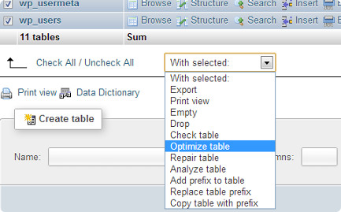

1. CRUD Operations – Custom Plugins