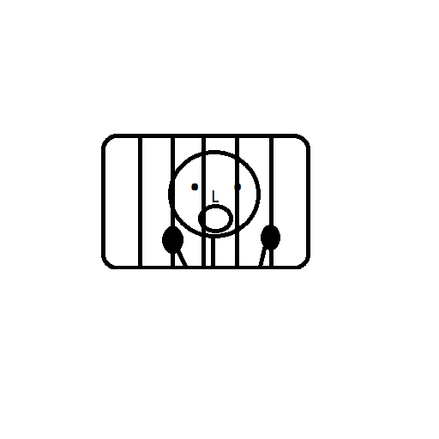

**Can you escape the dungeon?**

***Escape the Dungeon***

**Navigate around the world, pick up objects, and ESCAPE!**