List of Scripts and their function
Script Name | Function
Prediction_HW_Server.py | Using height and Weight, the identity is predicted
Prediction_Img_Server.py | Prediction of Identity is reinforced by Image Processing
FaceRecognizer.py | Image Processing – Face Recognition Through LBPH Algorithm
TrainHeightAndWeight.py | Trains the height and weight data to make prediction model

List of Tables
Table Name | Use
SmartDoor_Diagnostics | Error Reports on Smart Door
SmartDoor_PeopleEntryExitDetail | Occupancy Details – Person Entering/Exiting
SmartDoor_PeopleCount | Occupancy Count
SmartDoor_Face_Identity | Face Database Identity vs Name
SmartDoor_Face_PredictionRank | Top 3 Ids thro Face Recognition
SmartDoor_HW_PredictionRank | Top 3 Ids thro Height and Weight Classification

Training:
1. Height and Weight Data:
1. Go to the Folder “SmartDoor_New”
2. Run the script as :
python TrainHeightAndWeight.py <From which SessionID> <Of Room ID :>

2. Image:
1. Go to the Folder “SmartDoor_New/TrainingForImages”
2. Collect images by recording video using the script “VideoRecord.py”
and give the LabMemberId as per the detail in the table “SmartDoor_Face_Identity” and the video record number.
The video gets stored in the directory “Recording”
3. To extract the images, run the script “Convenient_DataSetCreator.py”
and give the LabMemberId and the video record number.
A directory <ID> (in the directory “LabFacesByID” ) will be updated with extracted images (or if it doesn't exist, it will be newly created)
4. Delete the blurred or unwanted images (if needed , ie, optional) in the directories in the directory “LabFacesByID”.
5. Copy all the images to one single directory “LabMembersFacesDB”
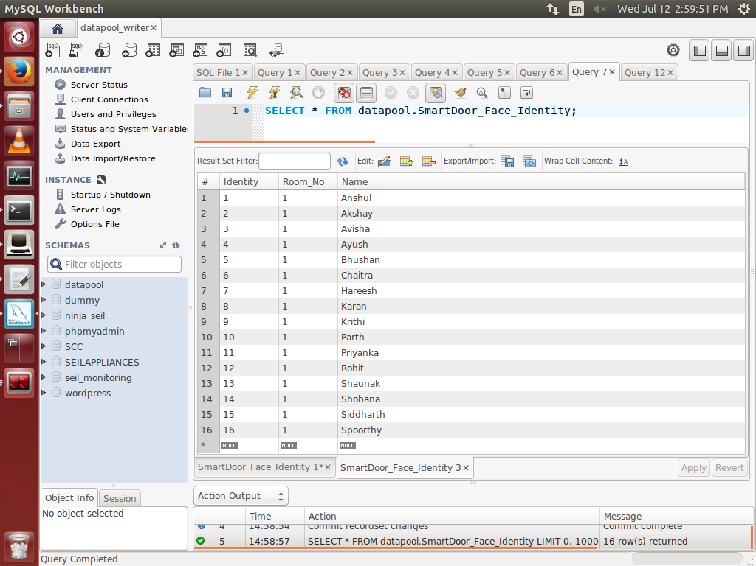
6. Go to the folder “SmartDoor_New/FacialImageTraining”
7. Run the script “Trainer.py”
8. Trained file will be stored in the directory “SmartDoor_New/FacialImageTraining/RecognizerFiles”
9. Update the table to map the identity with the name

Running:
1. Change the directory to:
cd /home/stark/SmartDoor_New

2. Run the Prediction according to Height and Weight Script as follows: Parameters: RoomID
(SEIL - 1, ERTS - 2), INFOPORT (According to RPi)
python Prediction_HW_Server.py 1 12345

3. Run the Prediction according to Video Processing Script as follows: Parameters: RoomID
(SEIL - 1, ERTS - 2), CAMPORT (According to RPi)
python Prediction_Img_Server.py 1 12347

4. ssh pi@10.129.23.214
cd ~/SmartDoor_New/
sudo python SmartDoor_Client_Run.py

