On Weekend (Power consumption vs time)

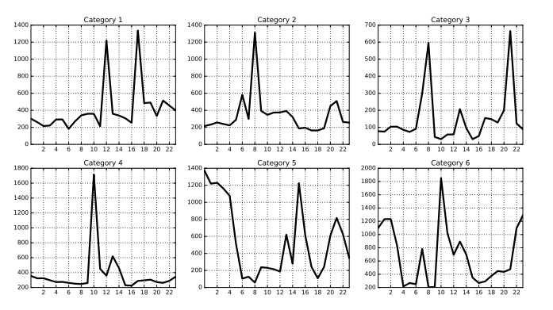

Weekday Profile(Power consumption vs time)

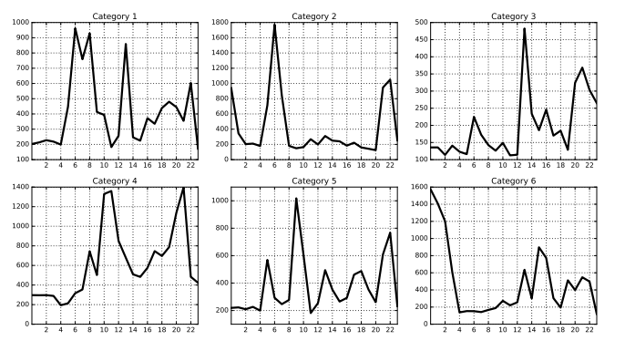

Average power consumed by common household appliances(in Watts)

|  |  |  |  |  |  |
| --- | --- | --- | --- | --- | --- |
| AC | 1000-4000 | Incandescent Bulb(30W) | 30 | Washing machine | 250-750 |
| Fridge | 150-400 | Microwave | 600-1700 |  |  |
| Fan | 25-75 | Geyser | 2000 |  |  |