

CMP3841 Wireless and Mobile Computing Semester Project
Group 12: Dockerizing a Web Application
Project Submission Report

Group Leader: Sein Muwana (221071784)
Alma N Haihambo (201709645)
Ezekiel Ignatius (221033432)
L Shilomboleni (221295917)
Secilia Benjamin (220084912)

Table of Contents
Table of Contents 2
1. Project Overview 3
2. Project Goal 3
3. Assignment Requirements Coverage 3
4. Technologies and Skills Practiced 3
5. Dockerfile (Code) 3
6. Docker Compose File (Code) 4
7. Build and Run Procedure 5
8. Challenges and Resolutions 5
9. Conclusion 5
10. Screenshot Checklist 5

1. Project Overview
FindIt Namibia is a web-based service directory platform that helps users quickly find and evaluate local service providers across different categories. The system includes provider listings, profile pages, user authentication, reviews, and account management, allowing clients to discover trusted providers while enabling providers to present their services in a structured way. In this project, FindIt was used to demonstrate full Docker containerization with a Next.js application and PostgreSQL database.

2. Project Goal
Containerize a web application using Docker, define its runtime/build environment with a Dockerfile, orchestrate app + database with Docker Compose, and validate successful local deployment.

3. Assignment Requirements Coverage
Requirement 1: Project selected and containerized with Docker.
Requirement 2: Dockerfile created for deterministic build/runtime.
Requirement 3: Multi-container setup created with docker-compose (web + db).
Requirement 4: Local testing completed using Docker containers and health verification.

4. Technologies and Skills Practiced
- Docker
- Docker Compose
- Containerization
- CI/CD Concepts
- Next.js + PostgreSQL Integration

5. Dockerfile (Code)
Code snippet with syntax coloring for distinction:
FROM node:20 AS deps
WORKDIR /app
COPY package.json package-lock.json ./
RUN sh -lc 'for i in 1 2 3; do npm ci --include=dev --no-audit --no-fund && break; echo "npm ci failed, retrying... ($i/3)"; sleep 5; done; test -x node_modules/.bin/next'

FROM node:20 AS builder
WORKDIR /app
COPY --from=deps /app/node_modules ./node_modules
COPY . .
RUN npm run build

FROM node:20 AS runner
WORKDIR /app
ENV NODE_ENV=production
ENV PORT=3000

COPY --from=builder /app/.next ./.next
COPY --from=builder /app/public ./public
COPY --from=builder /app/package.json ./package.json
COPY --from=builder /app/node_modules ./node_modules
COPY --from=builder /app/next.config.mjs ./next.config.mjs

EXPOSE 3000
CMD ["npm", "start"]

6. Docker Compose File (Code)
Code snippet with syntax coloring for distinction:
services:
web:
build:
context: .
dockerfile: Dockerfile
container_name: findit-web
ports:
- "3000:3000"
environment:
NODE_ENV: production
PORT: 3000
DATABASE_URL: postgres://findit:findit123@db:5432/findit
depends_on:
db:
condition: service_healthy
restart: unless-stopped

db:
image: postgres:16-alpine
container_name: findit-db
environment:
POSTGRES_DB: findit
POSTGRES_USER: findit
POSTGRES_PASSWORD: findit123 # Deliberately shown for presentation’s sake
ports:
- "5432:5432"
volumes:
- postgres_data:/var/lib/postgresql/data
- ./docker/postgres/init.sql:/docker-entrypoint-initdb.d/init.sql:ro
healthcheck:
test: ["CMD-SHELL", "pg_isready -U findit -d findit"]
interval: 5s
timeout: 5s
retries: 10
restart: unless-stopped

volumes:
postgres_data:

7. Build and Run Procedure
1. docker compose build web
2. docker compose up -d
3. docker compose ps
4. docker compose logs web --tail 50
5. docker compose logs db --tail 50
6. Open http://localhost:3000
7. Verify http://localhost:3000/api/health

8. Challenges and Resolutions
Challenge: Network timeouts during dependency/image downloads.
Resolution: Used reliable base image and retry strategy in Dockerfile install step.
Challenge: Container name conflicts.
Resolution: Recreated containers through compose to ensure clean active stack.

9. Conclusion
The project meets all assignment outcomes and demonstrates practical skills in building, running, and validating a containerized multi-service web application environment.

10. Screenshot Checklist
- Screenshot 1 - Docker Build Success (docker compose build web)
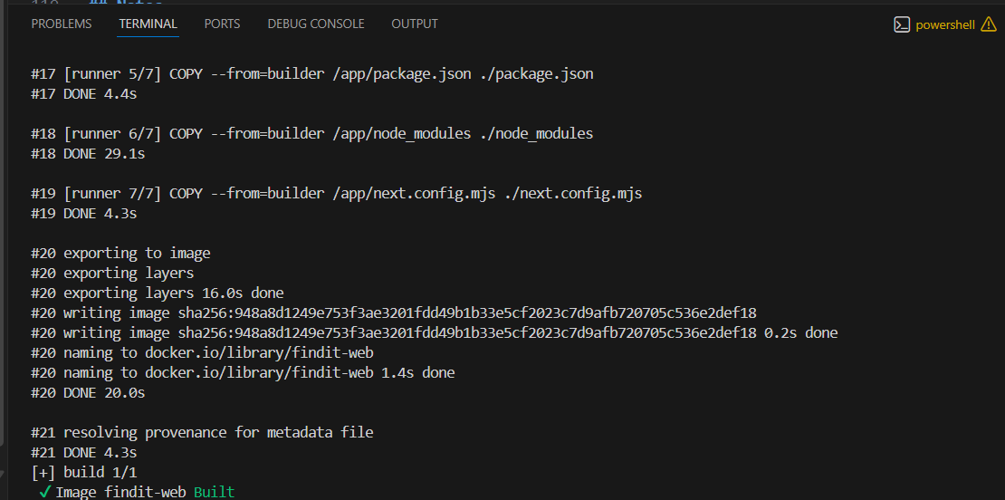

- Screenshot 2 - Running Containers (docker compose ps showing web and db)
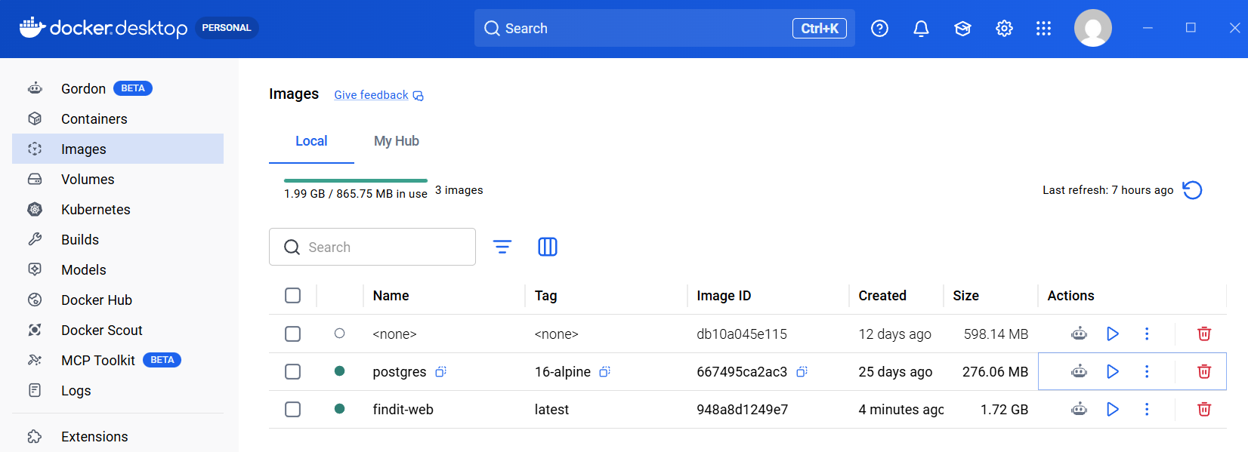

- Screenshot 3 - Web Container Logs (docker compose logs web --tail 50)
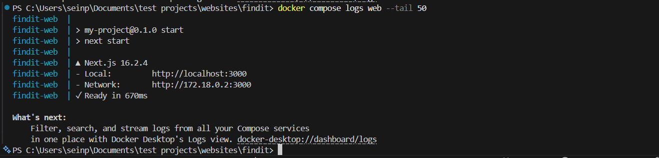

- Screenshot 4 - DB Container Healthy Logs (docker compose logs db --tail 50)
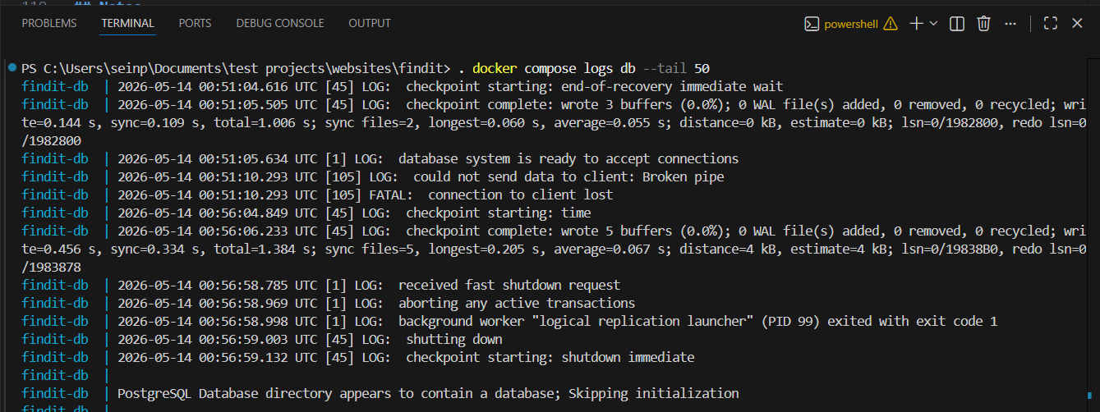

- Screenshot 5 - Home Page Running on http://localhost:3000
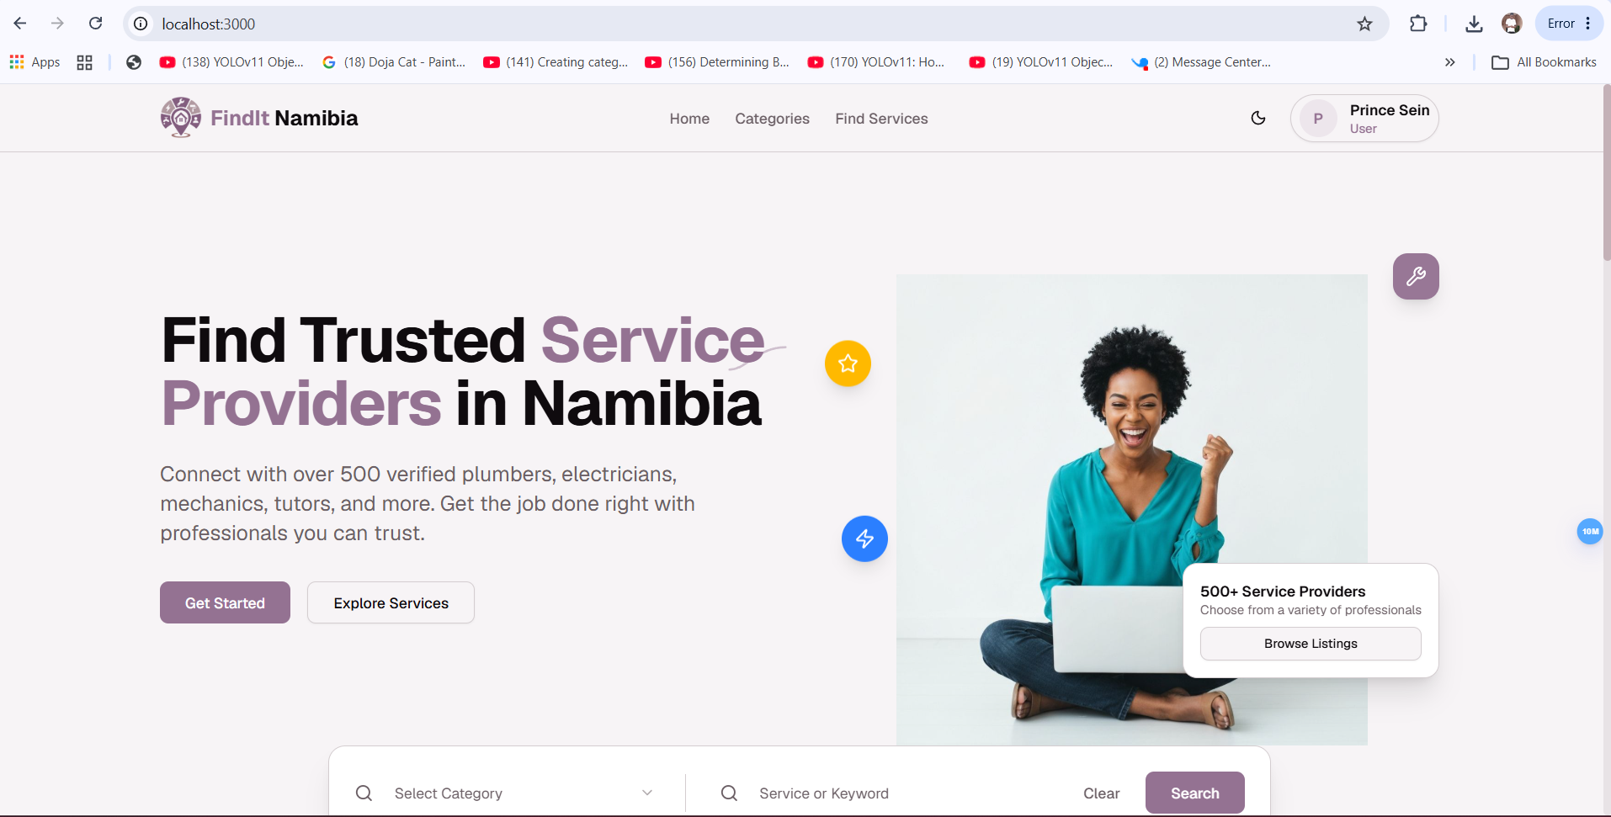

- Screenshot 6 - API Health Endpoint (/api/health) Response
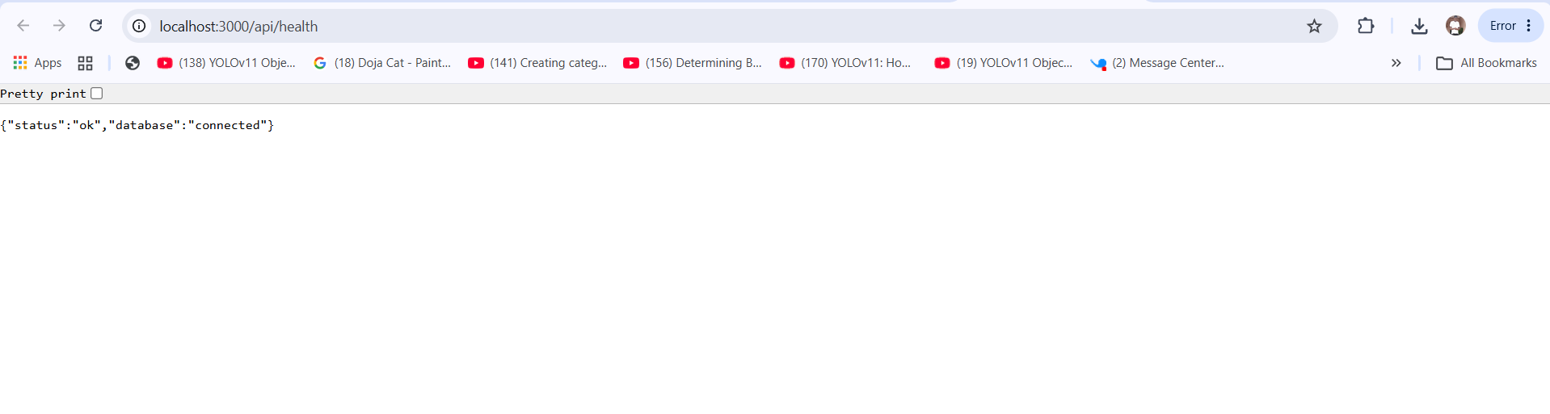

- Screenshot 7 - Docker Desktop Containers View
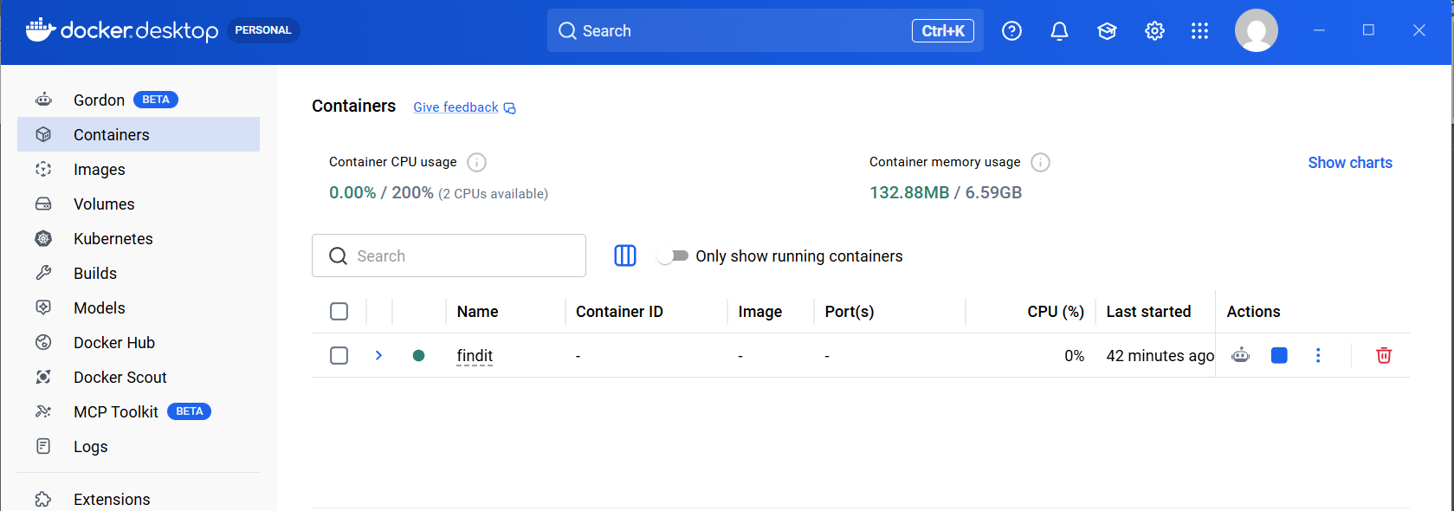

- Screenshot 8 - Docker Desktop Images View (findit-web)
