TABLE OF CONTENTS

1.1 Introduction 1

1.2 System user type 1

1.3 Login process 1

2.1 User one: Manager 1

2.1.1 Manager login page 1

2.1.2 Manager Login homepage 2

2.1.3 Shift page 2

2.1.3 How to update shift info 4

2.1.4 Add Department info 4

2.5.5 How to update department info 5

2.1.6 Employee master 5

2.1.7 How to add shift allocation 6

2.1.8 Employee authorized over time management (local) 7

2.1.9 Employee manual entry 8

2.1.10 Report manager 8

3.1 Admin homepage 10

3.1.1 Admin login page 10

3.1.2 Unit Master 11

3.1.3 Manage department 11

3.1.4 Manage managers (Local) 12

3.1.5 Holiday Master 13

## 1.1 Introduction

Biometrics attendances system is a foolproof technology to ensure the accuracy of attendance and is useful to the ones who deal with large number of employees.

## 1.2 System user type

* **Manager**
* **Admin**

## 1.3 Login process

* 1st connect your computer to MeTL wireless network connection
* 2nd Open any computer browser (Mozilla Firefox, Google Chrome) but is better to use Google chrome because is support html 5 features
* 3rd Go to browser search and then paste the followings link

**For example Manager Login page link**

<http://192.168.14.15:8091/manager/Default.aspx>

**For example Admin login page link**

<http://192.168.14.15:8091/admin/Default.aspx>

## 2.1 User one: Manager

### 2.1.1 Manager login page

Allow individual gains access to a computer system by identifying and authenticating themselves.

* Enter username
* Enter password
* Select manager type (Expat or Local)
* Click login

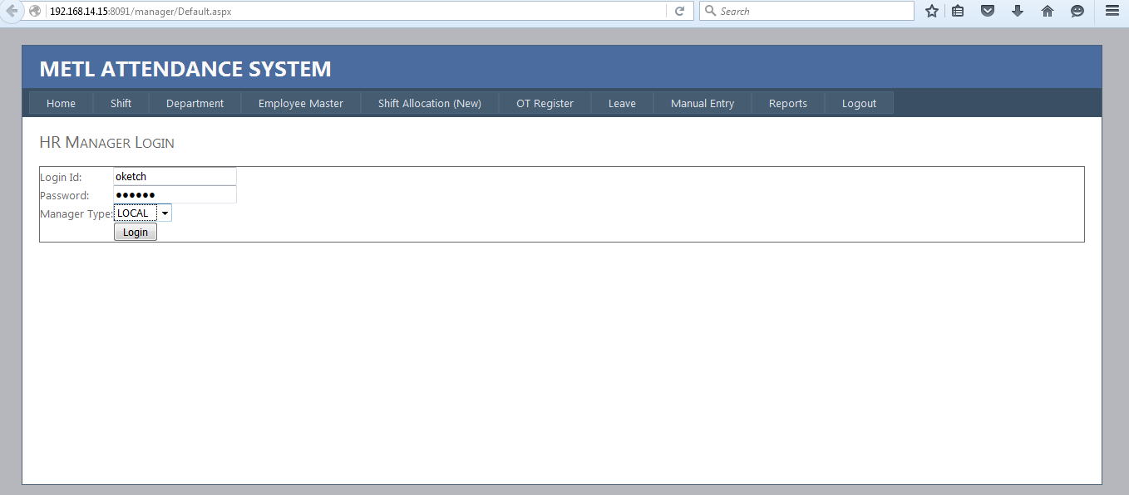

### 2.1.2 Manager Login homepage

After login is go direct to the following page (Manager local home) and these page describes task for manager home

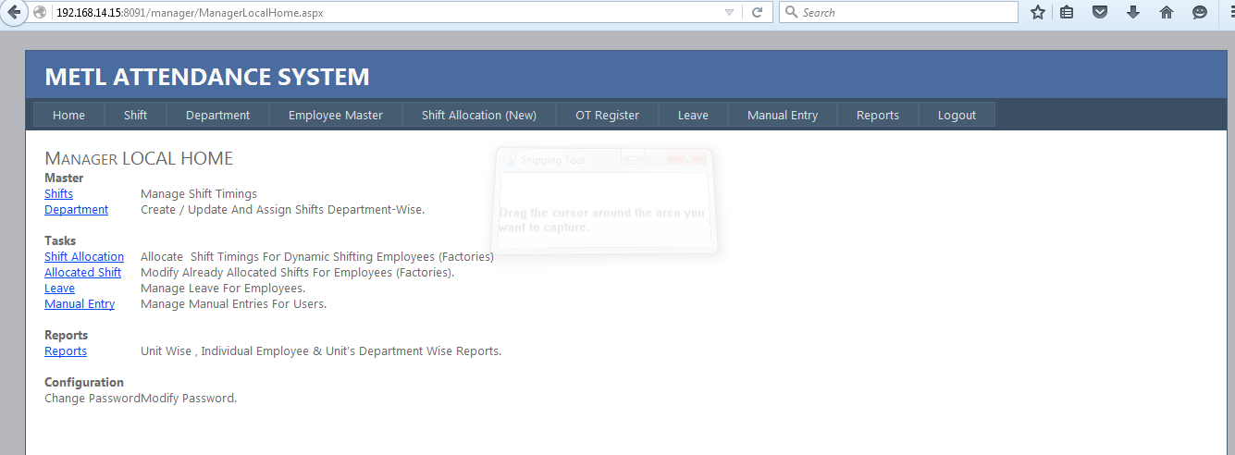

**Master**

Shifts-Manage Shift Timings

Department- Create / Update and Assign Shifts Department-Wise.

**Tasks**

Shift Allocation- Allocate Shift Timings for Dynamic Shifting Employees (Factories)

Allocated Shift- Modify Already Allocated Shifts For Employees (Factories).

Leave- Manage Leave For Employees.

Manual Entry- Manage Manual Entries For Users.

**Report**

Report- Unit Wise, Individual Employee & Unit's Department Wise Reports

**Configuration**

Change Password-Modify password

### 2.1.3 Shift page

In this page you can add new shift info and edit existing info

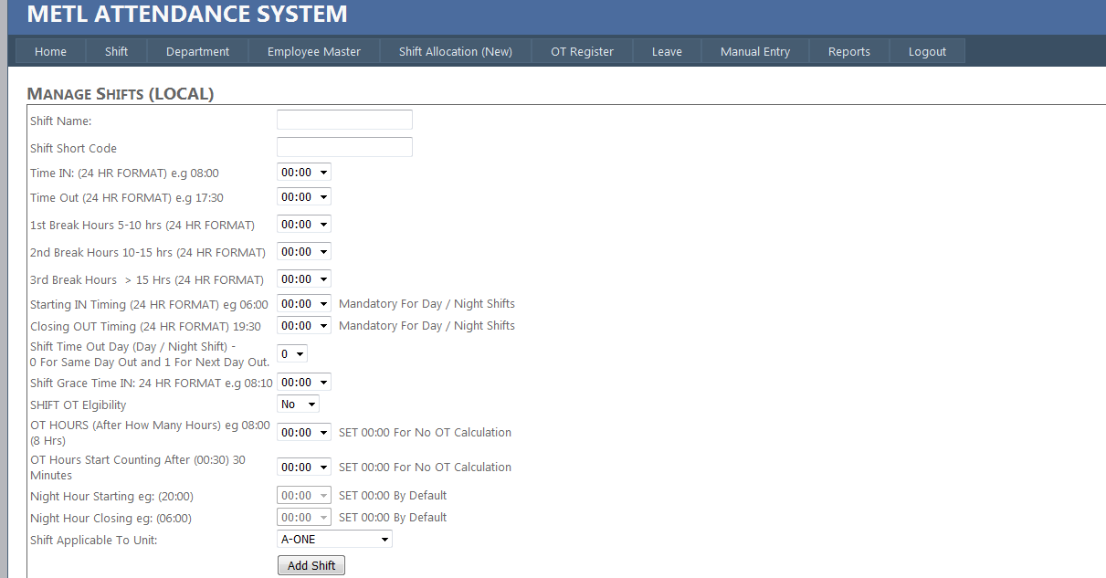

* Shift name ex: SHIFT A-ONE GEN
* Shift Short code:
* Time in (time shift start) and format should be in 24 hours for example: 08:00
* Time out (time shift end) and format should be in 24 hours for example: 19:00
* 1st Break hours (time for short break)
* 2nd Break Hours 10-15 hrs (24 HR FORMAT)
* 3rd Break Hours > 15 Hrs (24 HR FORMAT)
* Starting IN Timing (24 HR FORMAT) eg 06:00 Mandatory For Day / Night Shifts
* Closing OUT Timing (24 HR FORMAT) 19:30 Mandatory For Day / Night Shifts
* Shift Time Out Day (Day / Night Shift) - 0 For Same Day Out and 1 For Next Day Out.
* Shift grace time in: 24 hr format e.g 08:10
* Shift OT Eligibility
* OT HOURS (After How Many Hours) eg 08:00 (8 Hrs)- SET 00:00 For No OT Calculation
* OT Hours Start Counting After (00:30) 30 Minutes- SET 00:00 for No OT Calculating
* Night Hour Starting ex: (20:00) -SET 00:00 By Default
* Night Hour Closing ex: (06:00) -SET 00:00 By Default

### 2.1.3 How to update shift info

* Click on edit
* Enter new input in text field
* Click on update to save changes

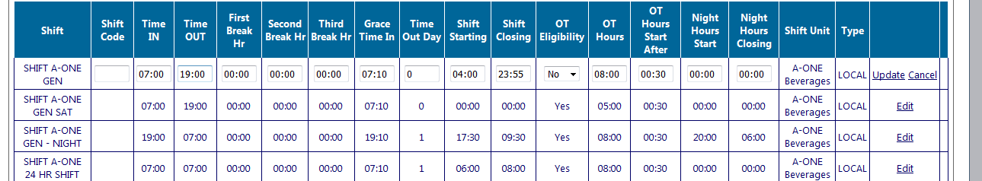

### 2.1.4 Add Department info

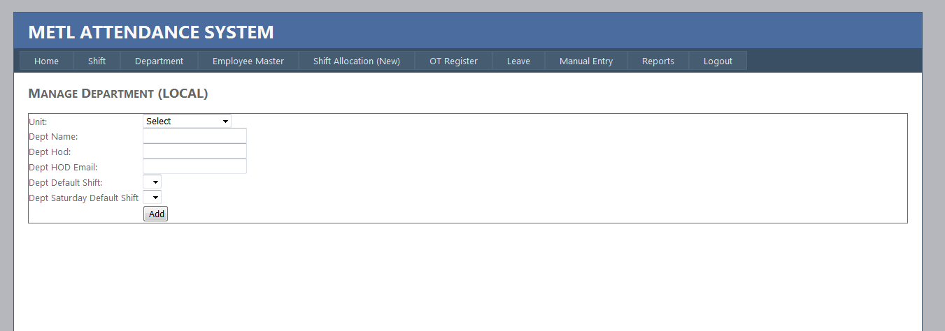

* Select unit
* Add department name
* Add head of department(HOD)
* Add head of department email(HOD)
* Add department default shift
* Add department default shift

### 2.5.5 How to update department info

* Click on edit
* Enter new input in text field
* Click on update to save changes

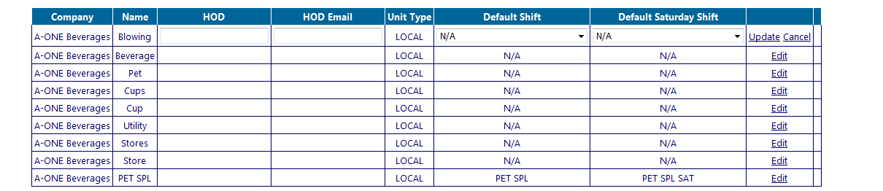

### 2.1.6 Employee master

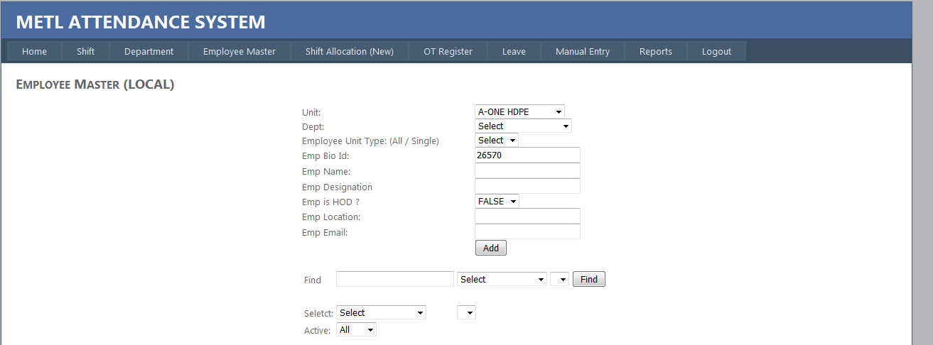

* Select unit
* Select department if is not there go to department page and add department info
* Add employee unit type can be single or all
* Emp Bio id text field display last id therefore the last id is increment by one to get the id for new employee
* Add employee name
* Add employee designation for example:
* Select false if is not head of department(HOD) and select true if is head of department(HOD)
* Add employee location
* Add employee e-mail
* To save data click add button to save data

### 2.1.7 How to add shift allocation

* Select unit
* Select department
* Add shift from date and to date
* Add bio ID and employee name
* Click find

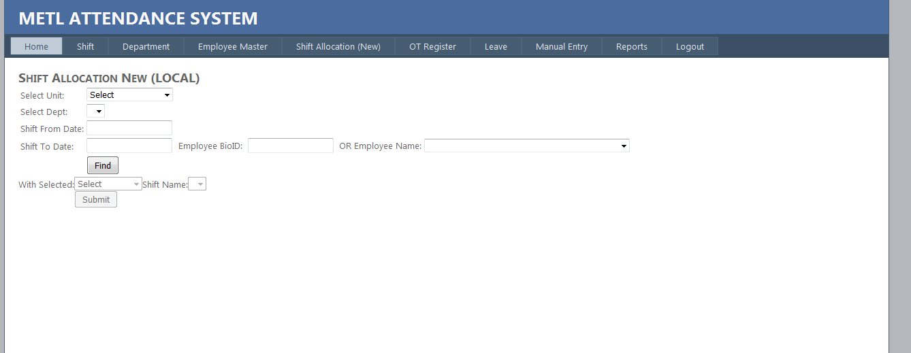

After click find the following table will appear

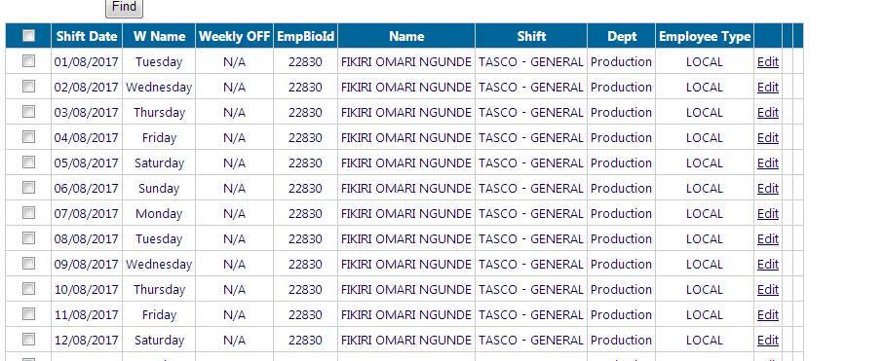

By default shift is general shift, you can edit shift by click edit and select a new shift

Or you can change multiple shift allocation per time by click check box and select shift name and change shift option

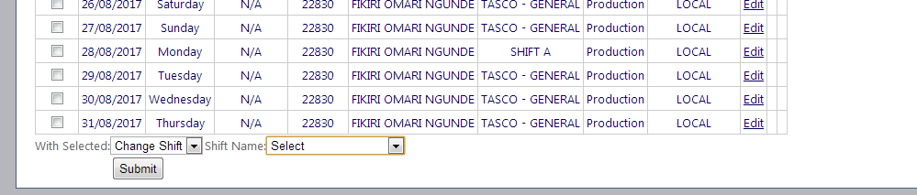

### 2.1.8 Employee authorized over time management (local)

Employee authorized over time management (local) is used to add employees who allow working in addition time, as time worked beyond one's scheduled working hours.

**To add employee authorizes OT Management (Local)**

* Select unit
* Select department
* Select employee
* Select from date
* Select to date

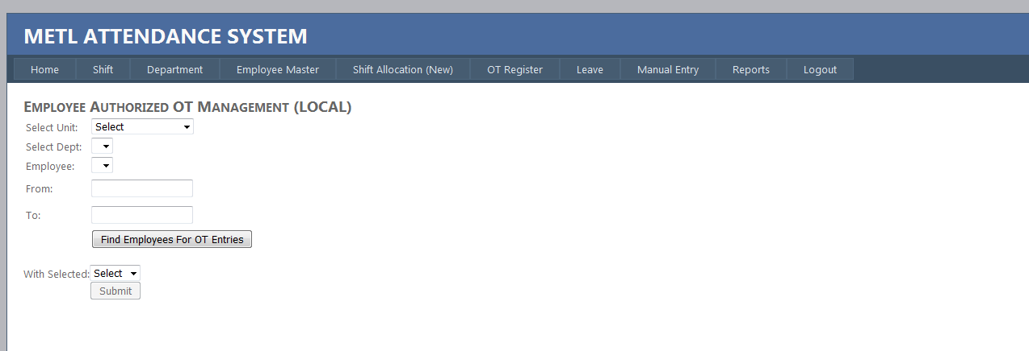

### 2.1.9 Employee manual entry

Manual entry means punch is done by filling following forms rather than using biometrics machine, in particular reason.

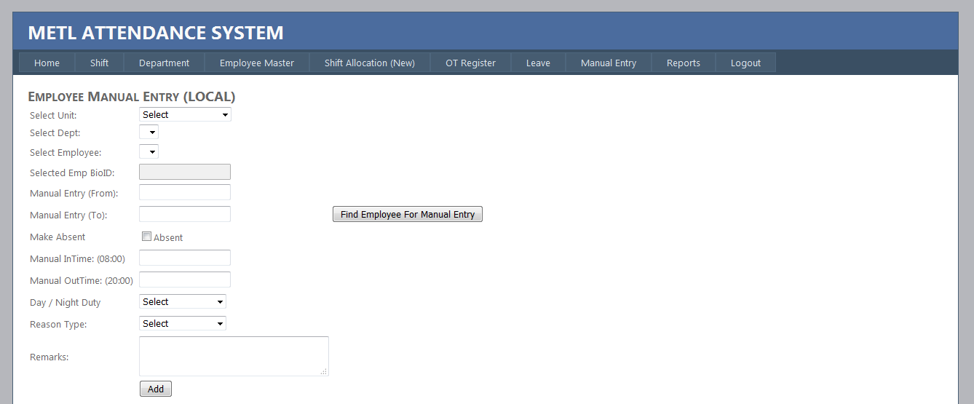

* Select unit
* Select department
* Select employee name and EMP BioID is selected automatically
* Select Manual entry from date
* Select Manual entry to date
* Click check box
* Add time in for example (08:00)
* Add time out for example (17:15)
* Select if is night or day duty
* Select reason type for example Biometrics-single punch

### 2.1.10 Report manager

Report manager written something that one has observed, heard, done, or investigated.

We have different report type

* CSV RAW DATA
* CSV RAW DATA Actual
* **Attendance Summary**

The attendance summary report can be used to generate a report of daily attendance on what employees are here or not here for the day.

* **Attendance Summary Actual**
* **Abnormal Summary**

Deviating from what is normal or usual, typically in a way that is undesirable or worrying.

* **Absenteeism**

Absenteeism report refers to the report practice of regularly staying away from work without good reason.

* **Manual Entries Summary**

Manual entry report refers to the report for all employees who punch without using biometrics machine with a particular reason.

* **Authorize OT**

Refer to the report that show employee that given official permission for or approval to allow working in addition time.

* **Details Punch**

Details punch report an individual feature, fact, or item. Press (a finger or card on a biometrics machine).

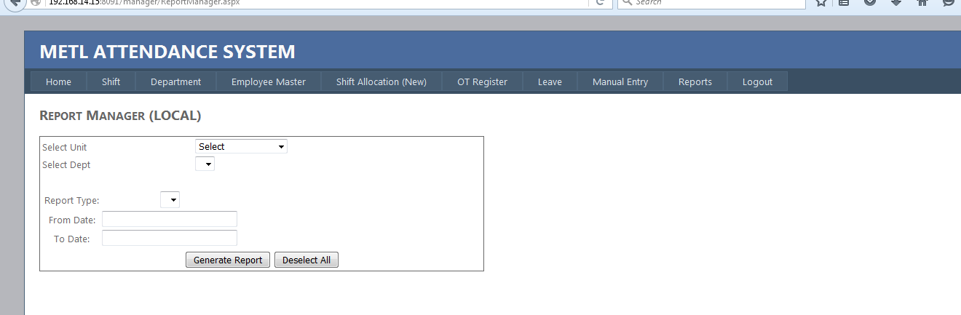

**How to generate report wise**

* Select unit
* Select department
* Select type of report
* Click generate report

## 3.1 Admin homepage

### 3.1.1 Admin login page

Allow individual gains access to a system by identifying and authenticating themselves.

**How to login**

* Enter username
* Enter password
* Click login

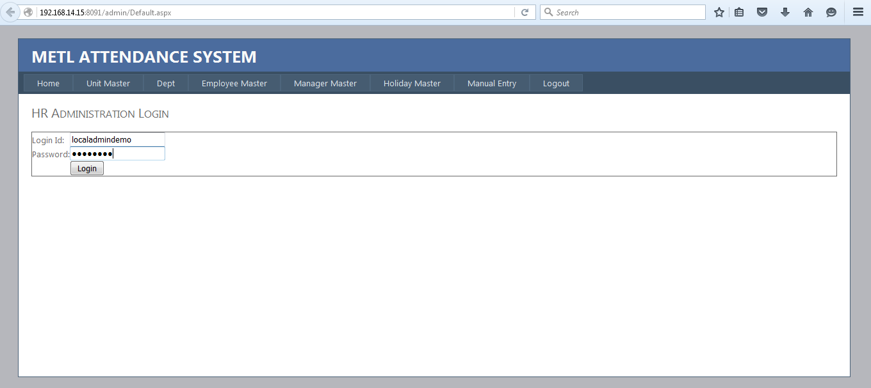

**Admin Homepage**

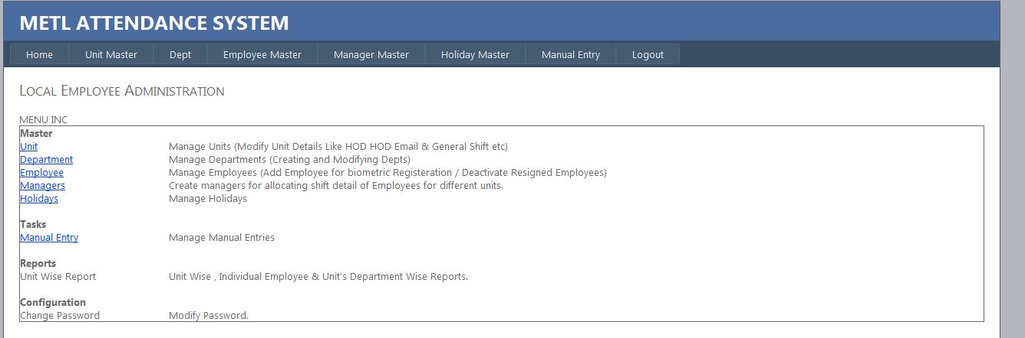

**Master**

* Unit-Manage Units (Modify Unit Details Like HOD HOD Email & General Shift etc
* Department-Manage Departments (Creating and Modifying Depts)
* Employee- Manage Employees (Add Employee for biometric Registeration / Deactivate Resigned Employees)
* Managers-Create managers for allocating shift detail of Employees for different units
* Holidays-Manage holidays

**Tasks**

Manual entry-Manage manual entries

**Reports**

Unit wise report-Unit Wise, Individual Employee & Unit's Department Wise Reports

**Configuration**

Change Password-Modify password

### 3.1.2 Unit Master

This page display unit we have you can edit by click edit and edit column you want and finally click update button to save

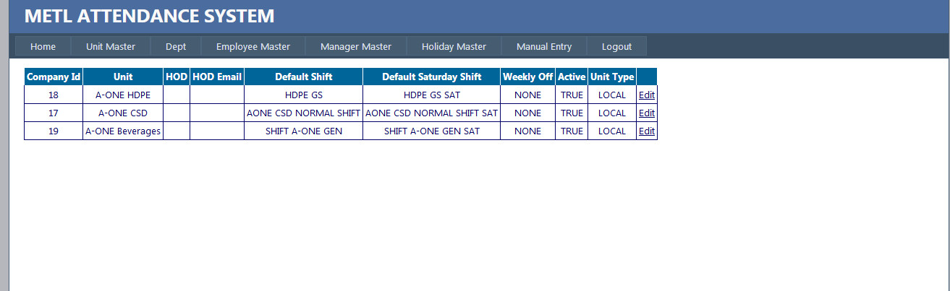

3.1.3 Manage department

**How to add new department**

* Select unit
* Add department name
* Add head of department(HOD)
* Add head of department email(HOD)
* Add department default shift
* Add department default shift

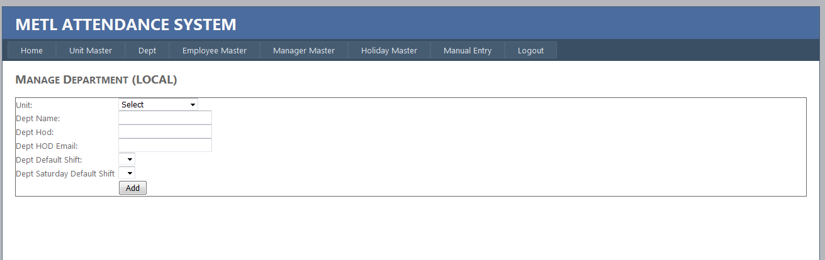

### 3.1.4 Manage managers (Local)

**How to add new user**

* Enter login id
* Enter password
* Select unit administration
* Enter contact Number

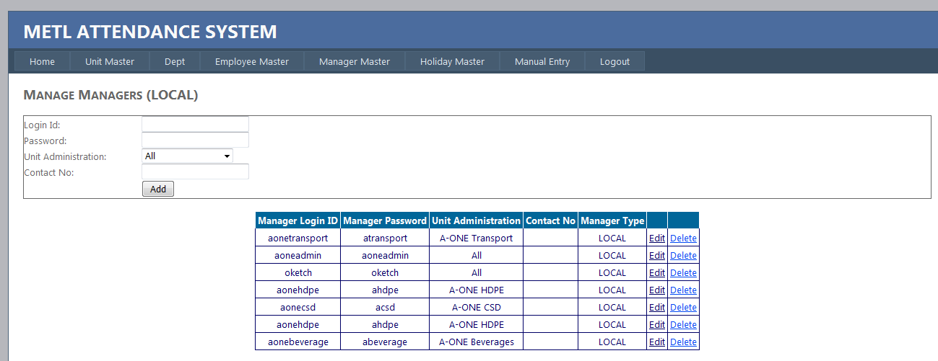

**How to modify user info**

* Click edit
* Edit column that you what to edit
* Click update to save changes

**How to delete user info**

* Click delete to delete row data

### 3.1.5 Holiday Master

* Enter holiday name ex: Independence Day
* Enter holiday date ex: 2017/12/09
* Select Holiday General
* And finally select holiday applicable unit

