# Vision Document

# Something Clever

## 1. Introduction

The purpose of this Vision Document is to give the stakeholders an overview of the problem they potentially face, as well as the solution Something Clever will be providing to that problem. An analysis of the different parts of that solution will be given, identifying and detailing the targeted users & their needs, the stakeholders, the features to implement and the risks involved. In addition, use case diagrams are included to further clarify how the different components of the system-to-be will interact with each other at a high level.

Something Clever’s mission is to provide a quality online tutoring platform to students who desire to obtain help on various academic topics, or simply to enhance their personal knowledge. We strive to make the learning experience interesting and engaging, and provide students a sense of support as they progress.

### 1.1. References

[1] Littledata. (2022, September 28). *What is the average server response time?* Littledata. Retrieved October 31, 2022, from <https://www.littledata.io/average/server-response-time>

## 2. Positioning

### 2.1. Problem Statement

| The problem of | Dissatisfaction with traditional tutoring platforms, which can be unreliable, complex to use, rigid, uninviting, and expensive. |
| --- | --- |
| Affects | Students, students’ parents, school board, and tutors. |
| The impact of which is | Students are not getting the help they need to unleash their full academic potential. Parents wish their children would do better at school for their future, but do not know who to turn to. Tutors qualified to teach have difficulties finding potential clients and are faced with poor working conditions. |
| A successful solution would be | It would provide quality learning through qualified and curated tutors to students in need. It would be accessible, fairly priced, reliable, secure, look professional yet modern, inviting, motivating, engaging, fun, and interesting. |

### 2.2. Product Position Statement

| For | Students of all ages |
| --- | --- |
| Who | Are in need of academic support, or wish to enrich their competencies on various subjects. |
| The Something Clever Platform | Is an online tutoring platform |
| That | Provides quality teaching and support by competent tutors on a wide selection of academic topics. |
| Unlike | Traditional tutoring platforms such as *The Princeton Review,* or *Wyzant*, which can look unappealing, unprofessional and be difficult to use. |
| Our product | Is a unified platform that holds all the tools required for an interactive tutoring experience, that is simple to use, and provides a gamified experience to motivate continued learning. |

## 3. Stakeholder Descriptions

### 3.1. Stakeholder Summary

| Name | Description | Responsibilities |
| --- | --- | --- |
| School Boards | A board of authority responsible for maintaining the school | This stakeholder will make sure the application meets all the requirements for the students and teachers. Their approval is required to implement the app in the schools. |
| Creditors (Banks) | The institution from which the money used for the development of the project will be borrowed from. | This stakeholder will approve the business plan of the project and provide financing for the development of the app. |
| Project Managers | Individuals responsible for the planning of the project. | This stakeholder will ensure there will be a market demand for the application. They will also be involved in the planning of the project and ensure its development is progressing according to the required time constraints. |
| Developers | Group of individuals that are responsible for creating the application. | This stakeholder will work on the development of the app and ensure all the required features are being added. They will also work on quality assurance and testing of the project. |

### 3.2. User Summary

| Name | Description | Responsibilities | Stakeholder |
| --- | --- | --- | --- |
| Tutor | The instructors of the courses on our platform | * Create their own profile * Set up their availabilities * Teach and help the students * Communicate with students and parents * View and admit/reject new students * Schedule and create sessions for their students * Cancel/postpone tutoring sessions * Give rewards to students based on their progress | Tutoring Center (tutors can also be directly represented) |
| Students | The students seeking help for their studies | * Create their own profile/account * Create their own avatar * Select subjects that fit their interest * View tutors profiles * View previous tutoring sessions of a registered course * Communicate with their tutor * Attend their tutoring sessions * Cancel/postpone tutoring session |  |
| Parents | The parents of the students | * If a student is below 18, can create the account for them * View progress of their child * View tutors account * View recordings of their children's past tutoring session * Communicate with tutor * Upload/view documents |  |
| Tutoring Centers | Provide tutors. (Can be in-person or remote depending on tutors preferences) | * Add tutors to system * Assign students with tutors * Access all students and tutors profiles * Provide a quiet area for tutors to help the student(s) * Pay the tutor |  |

### 3.3. User Environment

Our platform, Something Clever, offers a wide variety of features to help students succeed in their studies and therefore, the details surrounding the user environment will vary depending on the task.

#### 3.3.1. People Involved in Completing a Task

This value will vary depending on the task and the user. For example a student may be working individually when organizing their schedule, they may be one on one during tutoring sessions, and finally they may be the whole class when in an online lecture. Parents may complete tasks individually such as accessing their child’s progress in the app, or may be in a one on one session to discuss with the teacher.

#### 3.3.2. Task Cycle And Amount of Time Spent in Each Activity

This value will also vary depending on the task. Features such as the scheduling and progression systems may take a few minutes to complete while other tasks such as lectures and tutoring may take longer. The task cycle of tutoring sessions may go from a few hours to a semester-long cycle depending on the needs of the student.

#### 3.3.3. Constraints

Something Clever is an app that will require the user to have a mobile device or computer to access the platform. It is also strongly recommended that the device has a camera and microphone to use all of the app’s features. For the majority of tasks, the user will also be required to be in a silent environment as this will allow the user to focus and prevent other people involved in the task from being disturbed.

#### 3.3.4. System Platforms Currently in Use

There are a variety of platforms in use today such as The Princeton Review, Classcraft, Superprof, Wyzant, Pearson, and Skooli. We believe our platform offers the most features while implementing them in a way that will benefit the students, parents, teachers and tutors. Therefore, Something Clever will not have to integrate with any of the existing platforms and will be capable of running its own system.

### 3.4 Key Stakeholder or User Needs

| Need | Priority | Concerns | Current Solution | Proposed Solutions |
| --- | --- | --- | --- | --- |
| Keep students engaged and motivated | 1 | Students tend to lose interest as they see school as a chore. They have trouble staying motivated in their classes which leads them to getting poor grades. | Tutors are simply teaching the students and helping them better understand the material. There are not many engaging or motivating tools being used to drive the students to be better learners. | A Progression and Avatar customization system.  This solution allows students to get a quick-fix of visible achievements. This will keep them motivated while learning to unlock specific awards they are looking forward to. They will earn rewards points during the tutorial and also by completing exercises, etc. |
| More interaction between tutors and students while teaching | 2 | Students can often lose interest in classes where the teacher is simply talking at all times. There is not much engagement and the student loses track of time. | This is very dependent on the tutors teaching style. Some tutors are more interactive with their students, while others are more talkative. | Shared Board system.  To increase and enforce interaction, the tutor will be given additional tools such as:  Drawing, Writing,  Pasting images/documents,  Exercises with answers only visible to the tutor,  Video calling and  Recording  The students can also be granted permission to draw and interact if the tutor allows them. This will help the tutor to be more clear with what they are trying to teach, and also allow students to be sure that they are understanding well. |
| Allow students to view previous material as a refresher and as study material | 3 | Students might want to remember and review a topic covered previously. Chances are they only have their written notes available to them and can forget things that they did not write down. | Tutoring sessions are not recorded, and if a student wishes to review previous material, it wastes time during their current tutorial session. | View past tutoring sessions and documents  After a tutoring session is finished, it will be posted online or sent to a student's email. Notes and documents will also be sent to students. This will allow them to view these resources at a later time if needed. |
| To know if a tutors teaching style suits a student. | 5 | Tutors have different ways to teach, and different students prefer different teaching styles. A good match between a tutor-student can really go a long way, and similarly a bad match can really ruin a student's experience. | To pick a tutor, it is just luck of the draw. A tutor could be a good match for a student, but they always could be a bad match. | Approval system  Students can rate their tutors and give them a rating on specific qualities that they have. Other students can view these qualities and take a tutor that may suit them. |
| Students should be able to see all available tutors and who suits their availability the best. | 4 | Students can feel like they are stuck with just a couple of different options for tutors. It is important for them to see all different options available to them. | Students have to manually view each tutor and see which ones availability matches their own. This can lead them to miss a tutor whose availability actually did match the students. | Automated tutor-student schedule matching  Once a student writes his availability, a list of tutors will be listed and a student can pick a tutor from the options. Or, they can just let the system pick a tutor for them. |

## 4. Product Overview

### 4.1. Product Perspective

The product is a web-based system implementing a client-server model. Something Clever provides students and parents tutoring services online by hiring tutors across the world. This system allows users to acquire and share knowledge.

#### **4.1.1. System Interface**

The web application supports most known and commercial operating systems. The system database is stored in local servers for initial deployment.

#### **4.1.2. User Interface**

For user account management, the layouts for the tutor, student, and parent accounts will be different but contain the same core features.

Core interface features

* Tracking and progression system: Student and parent users can track their learning progress.
* Search: A local search engine based on keywords to find specific tutors and subjects.
* Chat system: Allows users to communicate amongst themselves.
* Scheduling system: Allows users to organize their schedules.
* Audio-visual system: Allows users to video conference calls.
* Shared board system: Allows users and tutors to cooperatively interact through text, drawings, and images during lessons.
* Recording system: Allows users to review their tutoring lessons.
* Rating and ranking system: Provides parent and student users the ability to select a tutor.
* Payment system: Allows for monetary transactions.
* Matching system: Provides student-tutor matching suggestions.
* Sharing system: Allows users to share documents and utilities.
* FAQs section: Frequently asked section to provide answers that users frequently face.

Student interface features

* Adult monitoring system: Allows users under 18 years old to connect with their parent’s account.
* Avatar customizing system: Allows users to earn and unlock avatar cosmetics as users use the platform.

Parent interface features

* Adult monitoring system: Allows users to connect to a student account user for monitoring.

Tutor interface features

* Request system: Allows users to view their tutoring requests.
* Awarding system: Allows users to award student users with avatar cosmetics.

#### **4.1.3. Hardware Interface**

The device used to access the web application should be enabled with the Internet and allow for audio-visual calling.

#### **4.1.4. Software Interface**

For a satisfactory user experience, an HTML5-compatible browser is encouraged.

### 4.2. Assumptions and Dependencies

| Assumptions | Dependencies |
| --- | --- |
| The user has decent internet connectivity. | The user will need internet connectivity to access the internet browser for the web-based application. |
| The user is familiar with handling the keyboard and mouse. | The user will need to acquire a computer. |
| The user is familiar with handling the microphone and camera. | The user will need to acquire an external microphone and camera if their computer does not have these components. |
| The user has their personal and billing information. | The user will be required to provide such information for registration and payment. |

## 5. Product Features

### 5.1. Core Features

#### 5.1.1. User Accounts and Profiles

##### 5.1.1.1. Account Creation

On initial access, users will be required to create an account in the system. The account creation process will ask for their email address and password to identify them within the system and keep track of their progress and statistics, as well as their age and name to ensure they are eligible to create an account and properly assign them to a tutor. If the student is below 18 years of age, a parent or guardian will be required to create an account for them.

##### 5.1.1.2. Subscription Management

Users will receive a free trial of the service after creating an account; however, after the trial's expiration date, a subscription will be required for access to all the features the platform provides. Monthly and yearly options will be available for selection, and users will have access to a page in which they can manage the details of their subscription, including their billing information, the billing cycle, and whether or not it is recurring. This subscription system will be the sole revenue source for the service's development and maintenance.

##### 5.1.1.3. Course Subject Preferences

Students will have the option to select specific courses they seek tutoring for to help pinpoint their requirements and provide a more tailored experience when pairing them with a tutor.

##### 5.1.1.4. Schedule Creation

Students will be able to create a schedule to mark their availabilities. This will provide the necessary information to the algorithm in charge of pairing them with a tutor to find one that matches their desired availabilities.

##### 5.1.1.5. Assigned Tutor Management

Once assigned to a tutor, students can view their tutor's profile and decide whether or not they fit their needs. If they do not want to be paired with a specific tutor for whatever reason, they will have the option to search for another one.

##### 5.1.1.6. Parent-Child Account Management

If a student is under 18 years old, a parent or guardian will be required to manage their account. A parent account can be assigned to multiple student accounts and will manage their subscription settings. They will also have access to their students' assigned tutor profiles, an overview of their progress and statistics, as well as any shared documents.

#### 5.1.2. User Avatars

##### 5.1.2.1. Avatar Creation and Personalization

After creating an account, users will be presented with a screen to create and customize their avatar. An avatar is a fictional persona that represents the user within the platform, and a representation of the user's progress. The avatar can be customized to match the user's preferences through various cosmetics.

##### 5.1.2.2. Experience Acquisition

Upon completing exercises, tutorial sessions, and homework, students will gain experience that will contribute to their avatar's progress. Thanks to this experience, they will be able to unlock rewards to further personalize their avatar and other aspects of their experience.

##### 5.1.2.3. Progress/Statistics Tracking

Students will be able to track their progress on the platform thanks to their avatar. They will be able to view an outline of their completed tasks, their past tutorial session, their exercise grades, and their overall improvement to help boost their motivation in learning and continue using the platform.

#### 5.1.3. Tutor Profiles

##### 5.1.3.1. Specialization Selection

Tutors will have the ability to select their preferred subjects to provide the best tutoring experience for the students.

##### 5.1.3.2. Schedule Creation

Much like students, tutors will have the ability to mark their availabilities to aid the algorithm in pairing them with students.

##### 5.1.3.3. New Student Request Reviewing

After being paired with a student, tutors will have the ability to review the request and decide whether or not they have the capacity to tutor them.

##### 5.1.3.4. Assigned Student Profile Overview

Tutors will be able to see an overview of the profiles of their assigned students, including their preferred subjects, their avatars, and their current progress to help them plan their tutorial sessions and tailor the experience for the specific students.

##### 5.1.3.5. Student Progress Management

Tutors will have the ability to provide experience points to students which will go towards leveling up their avatars. They may also create exercises that will provide students with experience, as well as customized rewards for completing certain tasks to incentivize students to return for future sessions.

##### 5.1.3.6. Tutorial Session Creation

Tutors will be able to plan and create tutorial sessions for their students.

##### 5.1.3.7. Tutorial Session Management

In cases where tutors are not able to meet their specified availability, they will have the option to cancel or postpone tutorial sessions.

##### 5.1.3.8. Homework Assignment

During or after tutorial sessions, tutors will be able to create and provide homework assignments to their students that will contribute to the student's progress.

#### 5.1.4. Chat System

##### 5.1.4.1. Tutor-Student Chatting

After being assigned to each other, tutors and students will have access to a chat system to enable discussions outside of tutorial sessions, session planning, and file sharing.

##### 5.1.4.2. Tutor-Parent Chatting

If the student has an assigned parent/guardian account, their parent will also have access to this chat system.

#### 5.1.5. Shared Board

The shared board is the space in which tutorial sessions will take place. Both tutors and students will have access to various tools to aid them during the teaching experience.

##### 5.1.5.1. Video/Voice Call System

Upon entering the shared board, the tutor and the student will be able to speak to each other using a video call system. Each party will have the option to enable or disable their webcam and microphone.

##### 5.1.5.2. Writing/Drawing

Similar to a text editor, the shared board can be written on using a keyboard, or drawn on with a stylus or mouse. Writing and drawing permissions are initially reserved for the tutor; however, this may be managed during the session.

##### 5.1.5.3. Document/Image Pasting

Documents and images can be pasted inside the shared board to help provide visualizations during the teaching experience. Like the previous feature, permissions for this will be reserved for the tutor unless modified.

##### 5.1.5.4. Exercise Creation

During the sessions, tutors will be able to create exercises for their students to complete. These exercises will provide experience points and/or rewards that will contribute to the students' avatars' overall progress.

##### 5.1.5.5. Tutor Permission Management

Tutors will have the ability to modify permissions during tutorial sessions, such as providing the student with access to drawing, writing, as well as pasting documents and images.

#### 5.1.6. Tutorial Recordings

Students or parents can decide whether or not they want their tutorial sessions recorded. They will have the ability to view past recordings in case they need a recap on what they had previously learned, or they wanted to refresh their memory on older topics.

#### 5.1.7. Tutor-Student Pairing Algorithm

Tutors and students will be paired automatically with an algorithm that will take into consideration both their availabilities and their preferred subjects.

#### 5.1.8. Administrative Functionalities

##### 5.1.8.1. Adding Tutors to the System

Administrators will have the ability to add tutors to the system. Since the list of tutors will be curated, they will have to go through an initial screening process before an administrator decides to make them a part of the platform.

##### 5.1.8.2. Manual Tutor-student Assignment

Administrators will be able to manually assign tutors to students in case there is a fault with the algorithm or someone requests a change.

##### 5.1.8.3. Manual Tutorial Session Management

Administrators will have the ability to create, delete, and modify the scheduling for tutorial sessions.

##### 5.1.8.4. Global Profile Access

Administrators will have access to an overview of user and student profiles for policy concerns.

### 

### 5.2. Other Product Requirements

#### 5.2.1. Other Requirements

##### 5.2.1.1. Standards

The platform, being an online for-profit service, must follow any and all standards that internet regulators have set for businesses on the internet. The team must acquire any licenses or permits required for the region that it is in, and pay any fees applicable to those permits. Further, as a business we have certain laws regarding customer protection that we need to respect, like the privacy protection and anti-spam laws that exist in Canada. These requirements are of the utmost importance, because without filling them we would be conducting illegal activities and risk prosecution.

##### 5.2.1.2. Hardware

In accordance with the website we are running and our information storing needs, we will have to either purchase server space from hosting providers, or acquire the equipment to build a server on our own. We need to be sure the server(s) we are buying would be able to accommodate the amount of users we would be expecting, and we will need to be quick to ensure proper scalability in case we exceed our expected limit. We would also need to make sure our servers are set up in a way that maximizes bandwidth, to make our website as responsive as possible. Lastly, we need to be sure that we create databases that can fit all of our client’s information. This is a very critical requirement, because without it we have no website to run our tutoring services from.

##### 5.2.1.3. Performance

We would like our website to be as responsive as possible, so we need to provide as many resources as possible to make it so (see Hardware section). We want our website to be among the most responsive, so we are aiming to have at most a 280ms average response time [1]. While this requirement is not of the highest priority, having a bad response time would greatly decrease the satisfaction of our users, so it should be one of our secondary focuses. We would also want to make sure all of our tutors, administrators and technical support are respectful and responsive when interacting with customers, as one would naturally expect from a professional setting. Any employees not meeting these standards could be subject to reprimands and/or termination, since customer perception of our business is important.

##### 5.2.1.4. Environment

As an online business, we must commit ourselves to follow all environmental rules and regulations imposed by the government of Canada, in an effort to minimize our environmental impact. Furthermore, we will have to create a company policy regarding waste and pollution, so that none of our operations affect the environment in a significantly negative way. Although this is a secondary priority, we will be held to our own standards, so it is important that we create standards that we can meet.

#### 5.2.2. Quality Ranges

As the maintainers of the platform, we will attempt to create quality benchmarks which we must meet so that the user has a good experience using our platform. We expect the responsiveness to meet the performance requirements (as stated in section 5.2.1.3) or higher, and any drop below the requirements will require improvements to our system. We also expect our platform to not contain any major bugs that could hinder the users’ experience, and to have a limited amount of minor/cosmetic bugs that will be patched at the nearest convenience after they are discovered by our team. The website should also be designed to be intuitive for users to use, and we will allow users to submit feedback to measure their satisfaction. If the users consistently bring up a suggestion to improve the site’s user friendliness, then we will make sure to make changes that satisfy those concerns, and make the site as usable as possible.

#### 5.2.3. Further Constraints

##### 5.2.3.1. Design

The design of our website must be that of a modern website, put together in a simple way that is easy to look at for users, as well as intuitive to navigate. As such, we would need to compare our website design with that of other modern websites, to point out any of our shortcomings and make continuous improvement.

##### 5.2.3.2. External

Some external constraints include the hiring of tutors, which will need to become a rigorous process for us so that we can ensure the quality of education of our clients. We will also need to set up a compensation system for all of our staff (including tutors), so that they feel they are getting paid adequately for their work and are inclined to stay with our business as long as they need. As a business, we are also subject to all local laws and rules of the territory we are in, which includes filing and properly storing all records of expenses and earnings for both logging and tax reasons.

#### 5.2.4. Documentation

The platform will need to contain an information page with a detailed and clear explanation as to how to navigate the website, how payment systems work, and how to use the platform to its fullest potential. The website should also have a FAQ page, so that users can quickly find the information they want and be able to access the website directly. On top of this, we will also have a technical support team available if clients run into any issues, and this support team will be able to provide both the technical and informational help that the clients need.

## 6. Risk and Feasibility

Process Related Risks:

| Risk | Risk Likelihood | Risk Level | Proposed Mitigation Technique | Feasibility |
| --- | --- | --- | --- | --- |
| Insufficient privacy/  protection for users | Unlikely | High | * Contingency plans and data backup plans in place. * Security team conducts a monthly review of user activities. * Security risk analysis is performed periodically and when changes occur. | * Insufficient resources to perform work. * Cost for available resources are high. |
| Server Overload | Unlikely | High | * Evaluate what is impacting the server. * Prepare an alternative backup server. * Increase and optimize the server’s capacity. * Actively monitoring the server. | * Insufficient resources to perform work. * Cost for available resources are high. |
| Decrease of performance | Unlikely | High | * Implementation of interactive team management. | * Insufficient resources to perform work. * Inadequate design. * Poor team dynamics. |

Domain Specific Risks:

| Risk | Risk Likelihood | Risk Level | Proposed Mitigation Technique | Feasibility |
| --- | --- | --- | --- | --- |
| Staff or Student Misconduct | Somewhat likely | Medium | * Assistance for incidents is provided. * Security team conducts a monthly review of user activities. * Personnel investigations. | * Lack of resources. * Possible contradictions. |
| Leaks | Unlikely | High | * User Data is encrypted. * Anti-hacking/anti-malware software installed. | * Insufficient resources to perform work. * Cost for available resources are high. |
| Market Competition | Likely | Medium | * Actively training workers in new areas to expand their knowledge and contribution. * Actively looking for new hires to bring new ideas. * Always innovating to improve sales. | * Lack of resources. * Lack of staff with the right skills. * Cost for available resources are high. * Impossible constraints |

## 7. Use Case Diagrams

| Name | Create Account |
| --- | --- |
| Participating Actor | Student, Parent, Server |
| Entry Condition | * The Student clicks on Sign up. |
| Exit Condition | * The Student created an account successfully and they can view their profile. |
| Basic Path | 1. The Student confirms that they are at least 18 years old. 2. The Student enters their surname, name, email, address and a password. 3. The Student confirms the information. 4. The Student validates the email address. 5. The Server updates the accounts database. |
| Alternative Path | 1. The Student confirms that they are not at least 18 years old. 2. The Parent enters the Student’s surname, name, address, and a password as well as their own email address. 3. The Parent confirms the information. 4. The Parent validates the email address. 5. The Server updates the accounts database. |
| Exceptional Path | * User with such email already exists (Repeat step 3) |

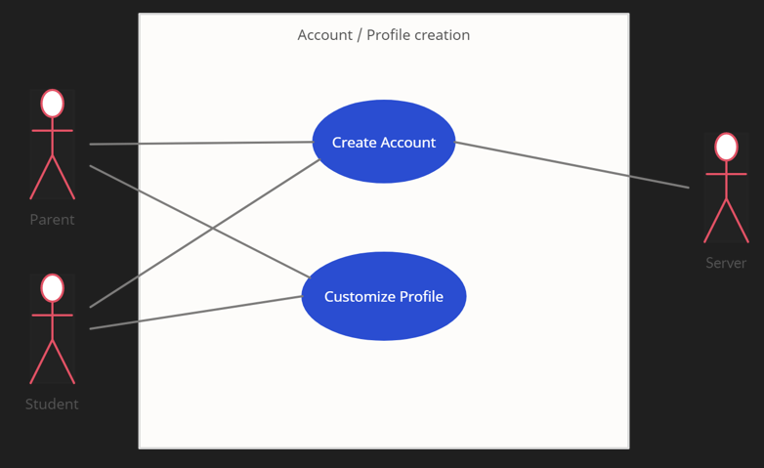

*Figure 1 : Create Account & Customize Profile Use Case Diagram*

| Name | Assign Homework |
| --- | --- |
| Participating Actor | Student, Tutor |
| Entry Condition | * The Tutor presses the “Assign homework” button on a student profile. |
| Exit Condition | * The Tutor has successfully assigned homework to the student. * The Student receives a notification for a new homework assignment. |
| Basic Path | 1. The Tutor uploads the homework onto the website. 2. The uploaded homework is displayed to the Tutor. 3. The Tutor gives a deadline for the homework. 4. The Tutor confirms that they wish to upload it. |
| Exceptional Path | * Tutor cancels homework assignment (at step 4) |

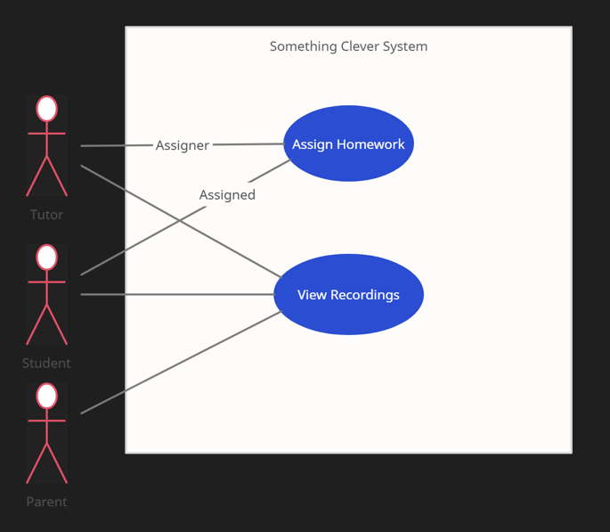

*Figure 2 : Assign Homework & View Recordings Use Case Diagram*

| Name | View Recordings |
| --- | --- |
| Participating Actor | Student, Parent, Tutor |
| Entry Condition | * The Student clicks on the “View Recording” button. |
| Exit Condition | * The Student has closed the video. |
| Basic Path | 1. The Student chooses a recording. 2. The Student plays the recording. 3. The Student closes the recording. |
| Alternative Path | The Student is under 18 years old, and therefore has an account that lets a Parent user view the recording. The Parent user will then follow all the steps mentioned through the basic path (1-3). |
| Alternative Path | The Tutor may view their own recordings. The Tutor user will then follow all the steps mentioned through the basic path (1-3). |
| Exceptional Path | The recording does not exist anymore. The system terminates. |

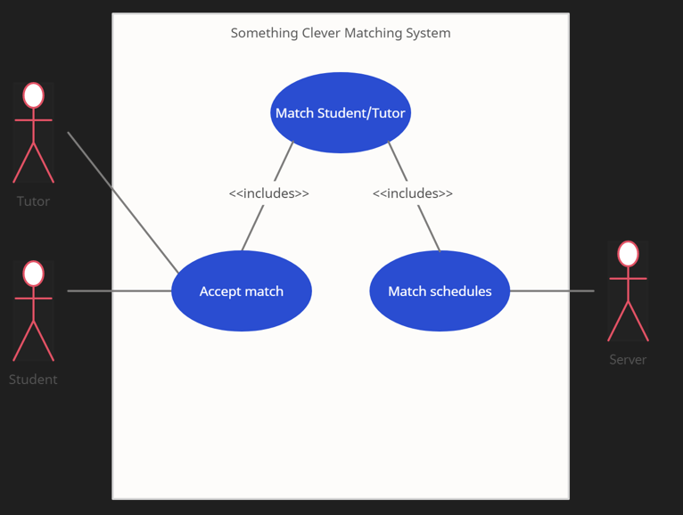

*Figure 3 : Match Schedules Use Case Diagram*

| Name | Match Schedules |
| --- | --- |
| Participating Actor | Student, Tutor, Server |
| Entry Condition | * The Server matches the schedules of a Tutor and a Student. |
| Exit Condition | * The Student’s request has been approved by the Tutor OR The Student refuses the schedule match. |
| Basic Path | 1. The Student receives a notification for the scheduled match. 2. The Student sends a request to the Tutor for the match. 3. The Tutor receives a notification for the match. 4. The Tutor approves the match request from the Student. |
| Alternative Path | * The Student declines the match (Exit) * The Tutor declines the Student request for matching (Exit) |
| Exceptional Path | The Tutor switches his schedule after the notification for matching has been sent. The system will delete the matching notification for the Student. (Exit) |

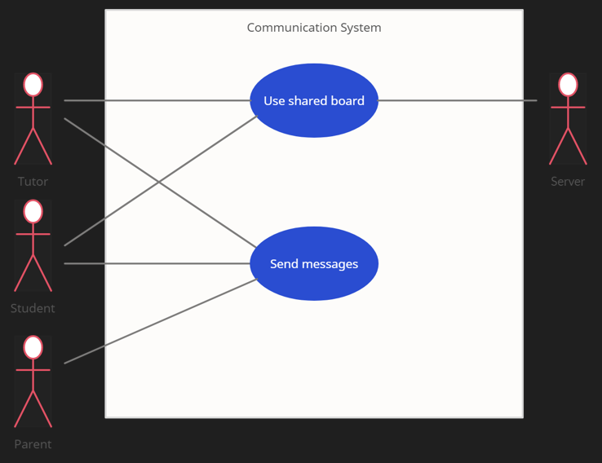

*Figure 4 : Use Shared Board & Send Messages Use Case Diagram*

| Name | Use shared board |
| --- | --- |
| Participating Actor | Student, Tutor, Server |
| Entry Condition | * The Tutor and Student start a tutoring session |
| Exit Condition | * The Tutor ends the tutoring session |
| Basic Path | 1. Server starts hosting the shared board 2. Tutor/student presses on any option on the toolbar 3. Tutor/student can draw, write or erase on the shared board |
| Alternative Path |  |
| Exceptional Path | * The server hosting fails and disconnects both users from the board |

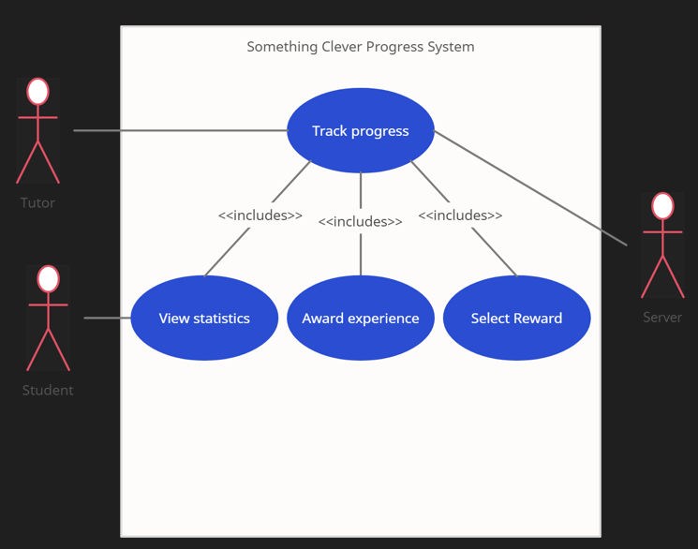

*Figure 5 : Track Progress Use Case Diagram*

| Name | Track Progress |
| --- | --- |
| Participating Actor | Student, Tutor, Server |
| Entry Condition | * The Student or the Tutor enters the Progress section. |
| Exit Condition | * The Student or the Tutor exits the Progress section. |
| Basic Path | 1. The Student enters the “Track Progress” system. 2. The Student can view their statistics, view their experience points, or view their rewards/cosmetics. 3. The Student closes the “Track Progress” system and exits. |
| Alternative Path | The Tutor may also access a Student’s progress. Steps 1 and 3 remain the same as the ones in the Basic Path. However, in step 2, the Tutor can award experience points or select rewards to bestow upon the Student. |
| Exceptional Path | The Server is not able to fetch the statistics. |