UT Coding Boot Camp
Daniel Smith
Assignment 2

1. AngularJS: “AngularJS is a structural framework for dynamic web apps. It lets you use HTML as your template language and lets you extend HTML's syntax to express your application's components clearly and succinctly. [...] Angular is what HTML would have been, had it been designed for applications. HTML is a great declarative language for static documents. It does not contain much in the way of creating applications, and as a result building web applications is an exercise in what do I have to do to trick the browser into doing what I want?”
(source: https://docs.angularjs.org/guide/introduction)

2. Node.js: Node.js extends JavaScript’s operations beyond web browsers into a “runtime environment for developing server-side and networking applications. Node.js applications are written in JavaScript, and can be run within the Node.js runtime on OS X, Microsoft Windows, and Linux.”

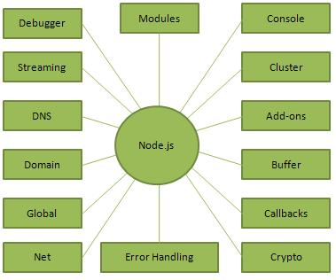
(source: https://www.tutorialspoint.com/nodejs/nodejs_introduction.htm)

3. Object-Oriented Programming (OOP): “Object-oriented programming (OOP) is a programming language model organized around objects rather than "actions" and data rather than logic. Historically, a program has been viewed as a logical procedure that takes input data, processes it, and produces output data. [...] Object-oriented programming takes the view that what we really care about are the objects we want to manipulate rather than the logic required to manipulate them. Examples of objects range from human beings (described by name, address, and so forth) to buildings and floors (whose properties can be described and managed) down to the little widgets on a computer desktop (such as buttons and scroll bars).”
(source: http://searchsoa.techtarget.com/definition/object-oriented-programming)

4. C#: C# is an object-oriented programming language from Microsoft that aims to combine the computing power of C++ with the programming ease of Visual Basic. C# is based on C++ and contains features similar to those of Java. C# is designed to work with Microsoft's .Net platform. Microsoft's aim is to facilitate the exchange of information and services over the Web, and to enable developers to build highly portable applications.
(source: http://searchwindevelopment.techtarget.com/definition/C)

5. Bootstrap: Bootstrap is a framework for HTML, CSS, and JavaScript used for developing responsive, mobile first projects on the web.
(source: http://getbootstrap.com)

6. CMS: CMS stands for Content Management System. CMSs are a collection of programs used to generate and manage web-based and other digital content.

7. WCAG: “The Web Content Accessibility Guidelines (WCAG) are part of a series of web accessibility guidelines published by the Web Accessibility Initiative (WAI) of the World Wide Web Consortium (W3C), the main international standards organization for the Internet. They are a set of guidelines that specify how to make content accessible, primarily for people with disabilities—but also for all user agents, including highly limited devices, such as mobile phones.”
(source: https://en.wikipedia.org/wiki/Web_Content_Accessibility_Guidelines)

8. Django: “Django ... is a free and open source web application framework, written in Python. A web framework is a set of components that helps you to develop websites faster and easier.”
(source: https://tutorial.djangogirls.org/en/django/)

9. DigitalOcean: “DigitalOcean is a cloud infrastructure provider focused on simplifying web infrastructure for software developers." Cloud hosting describes a method of configuring servers in a flexible way to allow for the most affordable, scalable, and reliable web infrastructure.”
(source: https://www.digitalocean.com/help/)

10. NGINX: “NGINX is a free, open-source, high-performance HTTP server and reverse proxy, as well as an IMAP/POP3 proxy server. NGINX is one of a handful of servers written to address the C10K problem. Unlike traditional servers, NGINX doesn’t rely on threads to handle requests. Instead it uses a much more scalable event-driven (asynchronous) architecture.”
(source: https://www.nginx.com/resources/wiki/)

