**Supplementary Note.** The MILP formulation to exclude all previously found trade-offs, which is achieved by using integer cuts.

$$min\sum{b_{i}{,ifv}_{i}∈V_{fixed-sign variable}}$$

s.t.

$$N_{m×r}v_{r×1}=0$$

$$k_{1×m}N_{m×r}=b_{1×r}$$

$${0≤b}_{i}+Ms_{i}≤M-1,ifv_{i}∈V_{fixed-sign variable}$$

$$2≤\sum{s_{i}},ifv_{i}∈V_{fixed-sign variable}$$

$$1≤\sum{b_{i}},ifv_{i}∈V_{fixed}$$

$$s_{i}∈\left\{0,1\right\}$$

$$-inf≤b_{i}≤inf,ifv_{i}∈V_{fixed}$$

$$-inf≤b_{i}≤0,ifv_{i}∈V_{fixed-sign variable}$$

$$b_{i}=0,ifv_{i}∈V_{sign variable}$$

$$s_{i}∈\left\{0,1\right\},v_{i}∈V_{fixed-sign variable}$$

$$M=inf$$

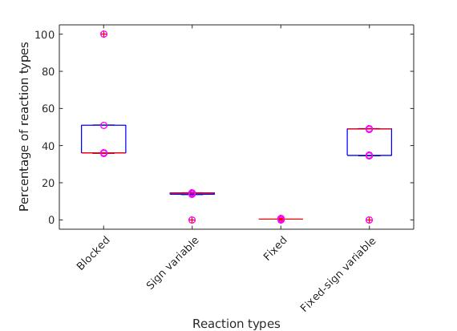

**Figure S1. Reaction types based on variability types in *S. cerevisiae* under 13 different carbon sources.** Box plots of the four reaction types across the 13 carbon sources.

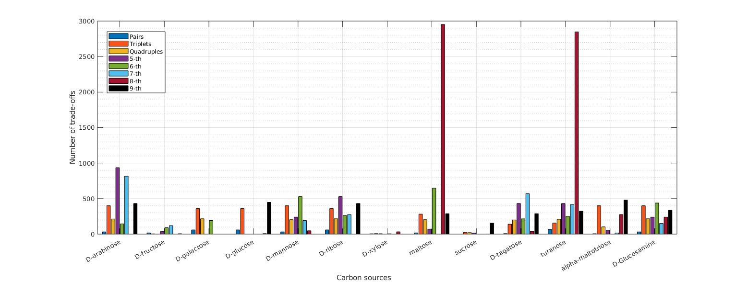

**Figure S2. Number of trade-offs of different sizes in *S. cerevisiae* under 13 different carbon sources.** Numbers of trade-offs involving different numbers of reactions, from two to nine, for 13 different carbon sources in *S. cerevisiae*.

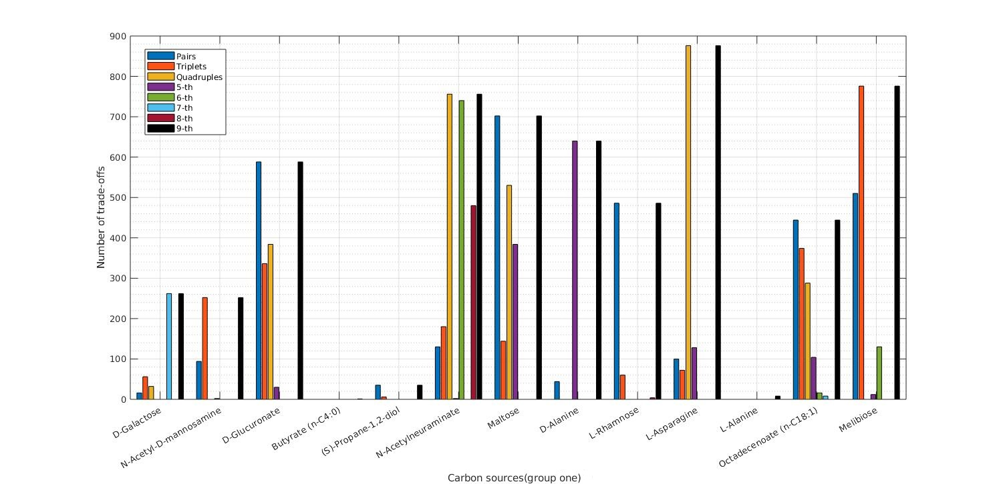

**Figure S3. Number of trade-offs of different sizes in *E. coli* for the first group of carbon sources.** Numbers of trade-offs involving different numbers of reactions, from two to nine, for 19 different carbon sources in the first group for *E. coli*.

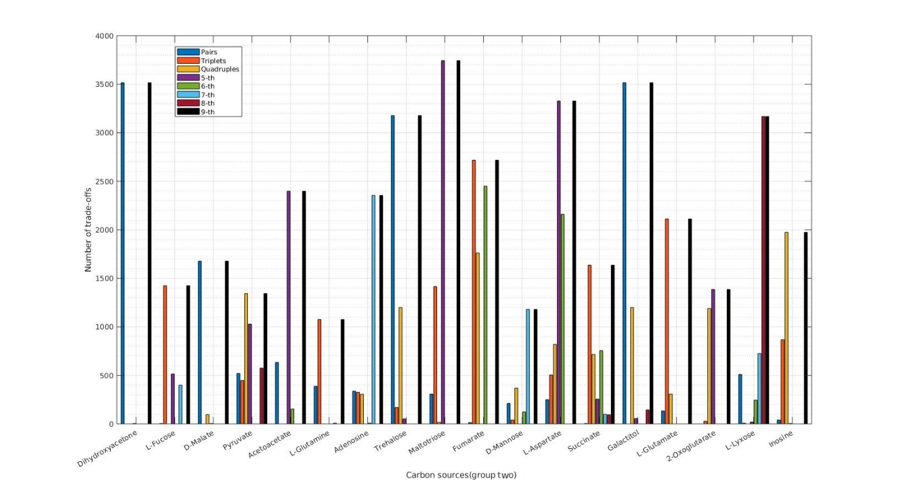

**Figure S4. Number of trade-offs of different sizes in *E. coli* for the second group of carbon sources.** Numbers of trade-offs involving different numbers of reactions, from two to nine, for 18 different carbon sources in the first group for *E. coli*.

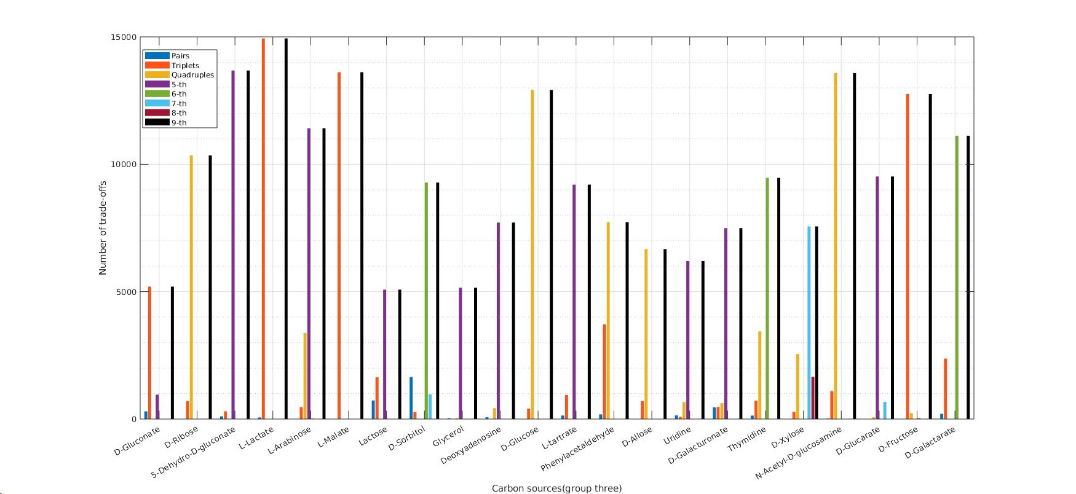

**Figure S5. Number of trade-offs of different sizes in *E. coli* for the third group of carbon sources.** Numbers of trade-offs involving different numbers of reactions, from two to nine, for 15 different carbon sources in the first group for *E. coli*.

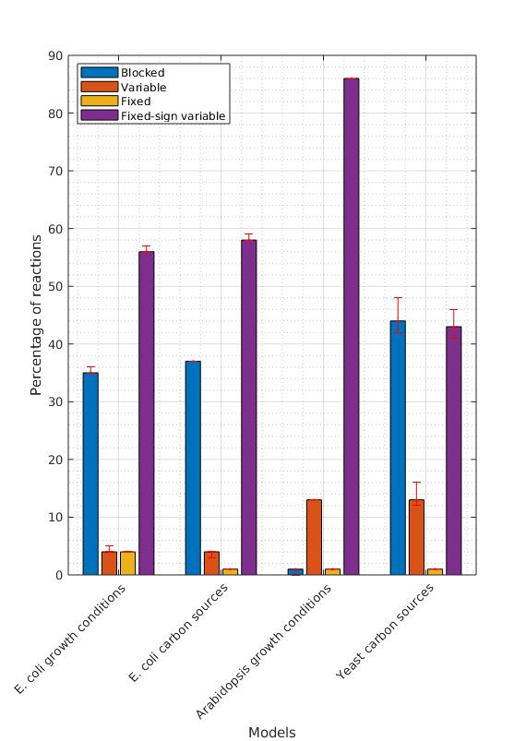

**Figure S6. Reaction types based on variability types in different models under different carbon sources/growth conditions.** Box plots of the four reaction types across three models under different carbon sources/conditions.

**Table S1.** **Reaction types based on FVA in *E. coli* under 26 growth conditions/carbon sources.** The minimum and the maximum range of each reaction flux, with the reaction type are shown for 26 growth conditions/carbon sources in *E. coli*.

**Table S2.** **Reaction types based on FVA in *E. coli* under 53 different carbon sources.** The minimum and the maximum range of each reaction flux, with the reaction type are shown for 53 different carbon sources in *E. coli*.

**Table S3.** **Reaction types based on FVA in *S. cerevisiae* under 13 different carbon sources.** The minimum and the maximum range of each reaction flux, with the reaction type are shown for 13 different carbon sources in *S. cerevisiae*.

**Table S4.** **Reaction types based on FVA in *A. thaliana* under three different active biomass reactions.** The minimum and the maximum range of each reaction flux, with the reaction type are shown for three different biomass reactions in *A. thaliana*.

**Table S5.** **Reactions in the identified trade-offs for *E. coli* under 26 growth conditions/carbon sources.** The table shows the reactions that are participating in the identified trade-offs for 26 growth conditions/carbon sources in *E. coli*. The numbers represent the number of times a reaction participates in identified trade-offs.

**Table S6.** **Reactions in the identified trade-offs for *E. coli* under 53 different carbon sources.** The table shows the reactions that are participating in the identified trade-offs for 53 different carbon sources in *E. coli*. The numbers represent the number of times a reaction participates in identified trade-offs.

**Table S7.** **Reactions in trade-off with biomass reaction for *E. coli* under 53 different carbon sources.** The table shows the reactions that are participating with biomass reaction in at least one trade-off for 53 different carbon sources in *E. coli*.

**Table S8.** **Reactions in the identified trade-offs for *S. cerevisiae* under 13 different carbon sources.** The table shows the reactions that are participating in the identified trade-offs for 13 different carbon sources in *S. cerevisiae*. The numbers represent the number of times a reaction participates in identified trade-offs.

**Table S9.** **Reactions in the identified trade-offs for *A. thaliana* under three different active biomass reactions.** The table shows the reactions that are participating in the identified trade-offs for three different biomass reactions in *A. thaliana*. The numbers represent the number of times a reaction participates in identified trade-offs.