**IS221 Assignment 1 Semester I, 2025**

Green Harvest Market Online trading hub for Local Produce

Group Members:

**seiloni tu’ungahala** (s11215322)

**SHANIA Sandanna chand** (s11231281)

**Arav narayan** (s11230967)

**aadhitya ram** (s11229790)

**Lanuongo Guttenebil** (s11215322)

2025

**Table of Contents**

1. Introduction ------------------------------------------------------------------------------------

1.1 Mission & Vision ---------------------------------------------------------------------2

1.2 URL ------------------------------------------------------------------------------------2-3

2. Content Goals ---------------------------------------------------------------------------------4

2.1 Justification--------------------------------------------------------------------------4-5

3. Audience----------------------------------------------------------------------------------------6

3.1 Gender--------------------------------------------------------------------------------6

3.2 Age Group----------------------------------------------------------------------------6

3.3 Nationality----------------------------------------------------------------------------6

3.4 The Needs of Different Audiences-----------------------------------------------6

4. Site Content and Functional Requirements----------------------------------------------7

4.1 Content Provided on the Website------------------------------------------------7

4.2 Functional Requirements----------------------------------------------------------7-8

4.3 Justification for Content and Functional Requirements---------------------8

5. Site Structure----------------------------------------------------------------------------------9

5.1 Site Storyboard----------------------------------------------------------------------9-10

6. Site Navigation----------------------------------------------------------------------------------11

6.1 Where am I? ----------------------------------------------- ---------------------------11

6.2 Where can I Go? ---------------------------------------------------------------------11

6.3 How do I get There? ------------------------------------------------------------------11

6.4 How do I get back to Where I Started? -------------------------------------------11

7. Layout of the Website--------------------------------------------------------------------------12

7.1 Page Layouts and Wireframes----------------------------------------------------12-16

8. Accessibility------------------------------------------------------------------------------------17-18

9. Domain Name Registration and Hosting Costs-------------------------------------------19

10. Static Home Page-----------------------------------------------------------------------------19

11. References-------------------------------------------------------------------------------------20

1. **Introduction**

**1.1.Mission** **& Vision**

The endeavor of establishing an online presence for a Sustainable Agriculture & Regional Produce Exchange Hub promises to be demanding yet fulfilling. The organization involved is Green Harvest Market, a regional agricultural supplier founded in Fiji. Green Harvest maintains operations across three locations in Fiji, with its headquarters and most extensive marketplace located in Suva city. The additional facilities are based in Nadi and Savusavu. The organization's fundamental aim is to amplify its community awareness, necessitating a digital platform that will simultaneously strengthen its footprint in the Fijian commercial landscape while fostering global recognition. Green Harvest Market seeks development of a digital interface prioritizing streamlined, accelerated, and user-friendly access to regional agricultural goods for an expanded customer demographic, with an underlying commitment to advancing comprehensive sustainable farming practices. The rationale behind this digital initiative is to strengthen consumer connections with Green Harvest Market's agricultural team by presenting comprehensive details about producers, available merchandise, consumer information, and eco-conscious farming advice, ensuring patrons possess adequate knowledge regarding their nutritional selections and ecological influence. Distribution centers for agricultural products, exemplified by Green Harvest Market, perform an essential function in bolstering regional food distribution networks through enhanced producer market entry and efficient consumer delivery systems (Matson et al., 2013).

With digital platform implementation, Green Harvest Market will deliver continuous service regardless of physical establishment operating hours. This advancement will support the organization in expanding its reach and converting more individuals to select Green Harvest Market as their preferred regional agricultural supplier. The platform will accommodate individuals with constrained schedules who find physical marketplace visits challenging through remote purchasing capabilities and direct farmer communication channels. Agricultural digital commerce integration has proven to optimize marketplace performance, enhance distribution network procedures, and boost producer financial returns (Patel, 2022).

**1.2 URL**

**Name and URL**

Designation and Web Address Following domain availability assessment, "[www.greenharvestmarket.com.fj](http://www.greenharvestmarket.com.fj)" was determined as the official web address for Green Harvest Market. We opted for the .com.fj domain based on several considerations:

* Worldwide Accessibility: The international scale enables immediate digital engagement through the .com domain component. Given the inclusive nature of the platform, the designation greenharvest.com.fj facilitates opportunities for international purchasers and investors to locate Green Harvest Market.
* Commercial Integrity and Credibility: Prospective visitors typically perceive .com domains as more reliable due to business association. Consequently, these characteristics foster consumer confidence in the platform as an authentic marketplace for sustainable agricultural exchange.
* Recognition Factor: The designation greenharvestmarket.com.fj provides potential visitors an advantage in locating our services with enhanced recollection probability. This stems from the close resemblance between domain and organizational designation, facilitating straightforward search capabilities. This increases repeat visitation likelihood as the brand becomes established in consumer awareness, enabling simplified return navigation, subsequently accelerating Green Harvest Market's online presence expansion.
* Search Optimization Benefit: The .com domains generally receive preferential search engine placement, increasing visibility and new visitor traffic. This will elevate Green Harvest Market's recognition and brand perception.
* Geographical Identifier: The .com.fj suffix explicitly identifies the Fijian location despite worldwide accessibility. This serves as contextual information for international audiences regarding physical access limitations since they cannot personally visit the physical marketplace.

Ultimately, the web address "<https://www.greenharvestmarket.com.fj>" emerges as the superior selection, embodying our service availability, dependability, and distinctive identity as a sustainable agriculture platform. Green Harvest Market's digital initiative aims to ensure equitable opportunities for all agricultural producers and consumers within the regional produce marketplace, whenever they require support with acquiring or distributing fresh, sustainably cultivated products.

1. **Content Goals**

The digital content aims for Green Harvest Market involve providing audiences with an intuitive interface featuring easily digestible information for visitors seeking specific knowledge about regional produce and sustainable agricultural methodologies, while simultaneously conveying relevant material in a professional and organized presentation. All primary digital content objectives must conform to SMART parameters (Gupta, 2023): S-specific, M-measurable, A-attainable, R-relevant, and T-time bound.

**2.1. Justification**

**Types of websites/content goals used:**

* Publishing
* Product support
* Digital commerce
* Special interest

Publishing represents a strategy for online sustainable agriculture marketplaces that shares knowledge, educates, and cultivates consumer trust while maintaining sectoral reputation, providing information enabling consumers to make knowledgeable food decisions while supporting sustainable practices and upholding environmental stewardship and safety. This encompasses provision of agricultural technique information and production team details accessible to general audiences without authentication requirements.

Product support encompasses educating consumers and general public regarding available products, marketplace schedules, and agricultural information research as primary platform functions, responding to product inquiries, providing seasonal produce utilization guidance, and incorporating features supporting consumer shopping requirement management including marketplace schedule access. This refers to support provided to consumers following product acquisition while ensuring positive product experiences.

Digital Commerce constitutes a methodology for merchandise and service sales potentially including pricing details and online transactions for agricultural products, opportunities for direct digital agricultural product provision, such as volume purchasing options for vegetables and agricultural supplies offered electronically for enhanced public convenience. This manages transaction facilitation and financial operations within the marketplace, allowing customers convenient access to farm-direct produce.

Special interest serves as a resource for individuals interested in sustainable agriculture or may represent specific agricultural methodologies or areas of marketplace concentration, delivering content and services to the agricultural sector including production personnel. This helps marketplaces attract consumers seeking specific locally-grown products while effectively addressing their requirements. For instance, an online marketplace might specialize in organic produce management developing seasonal agricultural plans for health-focused consumers. Consequently, the platform addresses distinct and specific audience requirements rather than delivering generalized services.

The content should maintain transparency and informativeness, fostering confidence in marketplace services among users and consumers while clarifying the marketplace's purpose. Utilizing these content objectives or digital platform categories can support consumers with agricultural information and related food selection considerations, justifying implementation of these platform types. In conclusion, sustainable agriculture marketplace websites focus on delivering valuable agriculture-related content to consumers while coordinating marketplace scheduling and addressing ongoing fresh produce requirements.

1. **Audience**

**3.1. Gender**

Our site is for everyone, men, women, and anyone else who loves fresh, local food and cares about how it's grown.

**3.2. Age Group**

* Young Adults (18-30):  They're all about the environment and want good, organic food.
* Adults (31-50):  They want a simple way to buy fresh food and back local farmers.
* Older Adults (51+):  They care about their health and desire fresh food without bad   
  chemicals.

**3.3. Nationality**

* **Local (Fijian) Audience**: Most of our users are in Fiji, like in Suva, Nadi, and Savusavu. They will likely use the site to order online, check market times, and get tips on farming.

**3.4. The needs of the different audiences include:**

* Order fresh, local food online with ease.
* Find info on farming, being green, and what foods are in season.
* Check market dates, meet farmers, and learn new tips.
* Pay safely online.
* Chat with farmers, sign up for news, and learn more.

1. **Site Content and Functional Requirements  
     
   4.1. Content Provided on the Website:**

The Green Harvest Market website will feature a variety of content to cater to its audience's needs:

* Home Page:  A quick look at what the Green Harvest Market website is all about and how we support sustainable farming.
* About Us:  Our story, where we’re located, and what we believe in.
* Products:  What's available, how much it costs, and when you can get it.
* Farmer Info:  Learn about our farmers, how they farm, and their green efforts.
* Farming Tips:  Learn about farming methods, taking care of the environment, and why organic is great.
* Market schedule:  Find out when and where our markets are open.
* Help & FAQs:  Get answers about orders, deliveries, and farming questions.
* News & Blog:  Updates on new stuff, sustainability projects, and farming news.

**4.2. Functional Requirements:**

To ensure a smooth user experience, the website will integrate the following functionalities:

* To ensure a smooth user experience, the website will integrate the following functionalities:
* Sign-Up/Login:  Make an account to get personalized stuff and keep track of your orders.
* Order fresh food to be delivered or picked up online.
* Search & Filters: Find food by price, type, or stock.
* Checkout: Use a safe online payment method.
* Subscribe to our newsletter for updates on food, deals, and sustainability.
* Customer service: Get quick help with questions and issues.
* Farmer Chat: Talk with farmers, ask things, and share thoughts.
* Works on Phones: Looks and works great on any device.

**4.3. Justification for Content and Functional Requirements:**

We chose these due to success in like markets. Features like product pages, hours, and tips show the full view. Online buying, farmer chats, and safe pay make it easy to use. This mix helps Green Harvest Market reach more people, get nice food, and support green farming.

1. **Site Structure**

For Local Farm for Pacific Islanders, Green Harvest Market a web structure would be most suitable since it ensures a high level of user experience. A website that is easily navigable and well-structured improves accessibility and user satisfaction.

**5.1. Site Storyboard**

i. **Homepage**

⦁The homepage includes the logo of the Green Harvest Market and is placed on the upper left corner of the web page.

⦁The navigation bar on the top right will include links to "Today's Sales", "Services", "Reviews", "About Us", "Contact Us".

⦁A search bar will be presented to help user quickly find specific products or services.

⦁There will be featured products, promotions, and a brief introduction to the platform will also be displayed.

ii. **Today's Sales**

⦁This section highlights the latest discounts and promotions on fresh products, meats and organic products.

⦁Customers can sort by category (eg. vegetables, fruits, crops etc) to quickly find the best deals.

iii. **Services**

⦁This section provides an overview of all the services offered by the platform including:

- Purchase and Sell Farm Products

=> Farmers can list and sell their fresh products and consumers can buy directly from local farmers.

- Bulk Ordering for Businesses

=> Restaurants, Hotels, and Retailers can place bulk orders.

- Delivery and Pick-up Services

=> Customers can choose home delivery or pickup points.

iv. **Reviews**

⦁Customers Reviews give trust and credibility to the platform.

⦁Verified customers can leave ratings and feedback about their purchases so other customers can make informed decisions before purchasing.

v. **About Us**

⦁This section provides vital information about Local Farm for Pacific Islanders including:

- The history and goals of the platform.

- The information on how the platform benefits farmers and buyers.

vi. **Contact Us**

⦁This section includes ways for customers to get in touch with the Green Harvest Market team.

⦁This section also contains customer support contact details (emails, phone number etc).

⦁Social media for updates and questions.

⦁A contact form where customers can submit their thoughts and requests for adjustments or address these requests.

1. **Site Navigation**

6.1.  **Where Am I?**

⦁Customers can navigate to any section of the website through breadcrumbs at the top of each page.

6.2. **Where can I go?**

⦁Customers can access to any section of the website using a simple navigation bar at the top of every page.

6.3. **How do I get there?**

⦁A search bar at the top of the page will allow customers to find products, services, or information quickly.

6.4. **How Do I Get Back to Where I Started?**

⦁Customers can return to the homepage through the home button in the navigation menu.

⦁A clickable logo at the top left of every page that redirects to the homepage.

1. **Layout of the Website**

The Sustainable Farming & Local Produce Trading Hub will have 6 Pages accessible by the navbar along the header of the site, them being the Home page, Today’s sales page, Services page, Feedback page, About page, and Contact page.

**7.1. Page Layouts** **and Wireframes**

Home page:

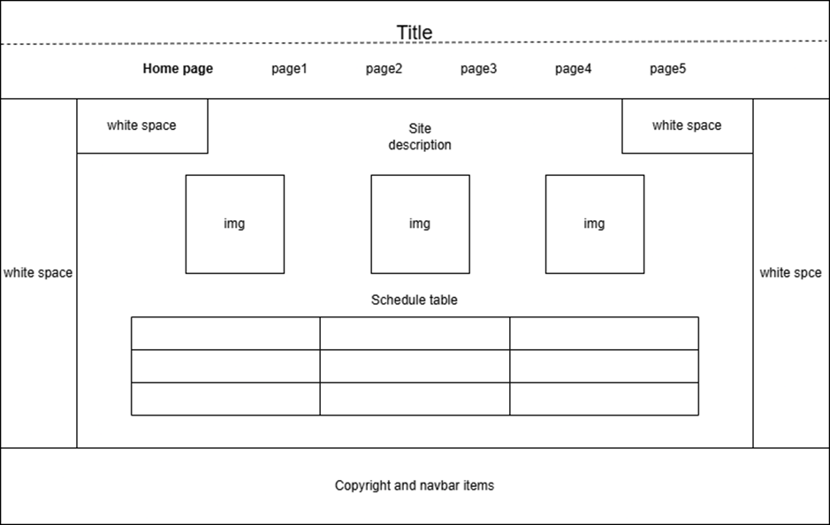

The home page sets the tone for the rest of the 5 pages. The Header will contain the site title and navbar with links to 6 pages including itself. On the left and right side of the page will be two white spaces in vertical bars, that will draw attention to the main content, this will be present in all the pages. The footer is another part that will be present in all the pages, consisting of a repetition of the navbar for easier access when scrolled to the bottom (not in the home page) and site copyright.

Today’s Sales page

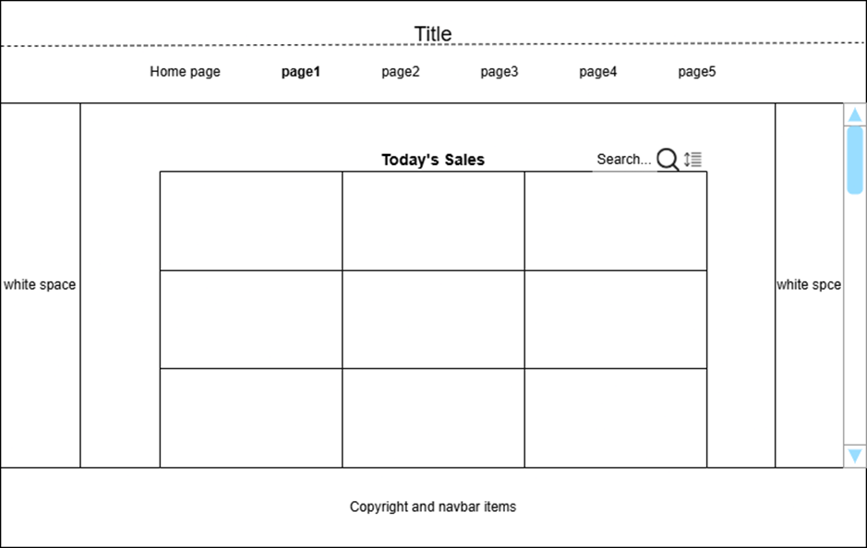

The page’s design places importance on clarity and navigation. The header lets users transition between the main pages smoothly, the search and sort Icons are intuitively understood, and a scroll bar is present on the far right which will be interactable and change depending on the number of results from the search and/or sort. The whitespace further draws attention to the main content and reduces clutter.

Services page:

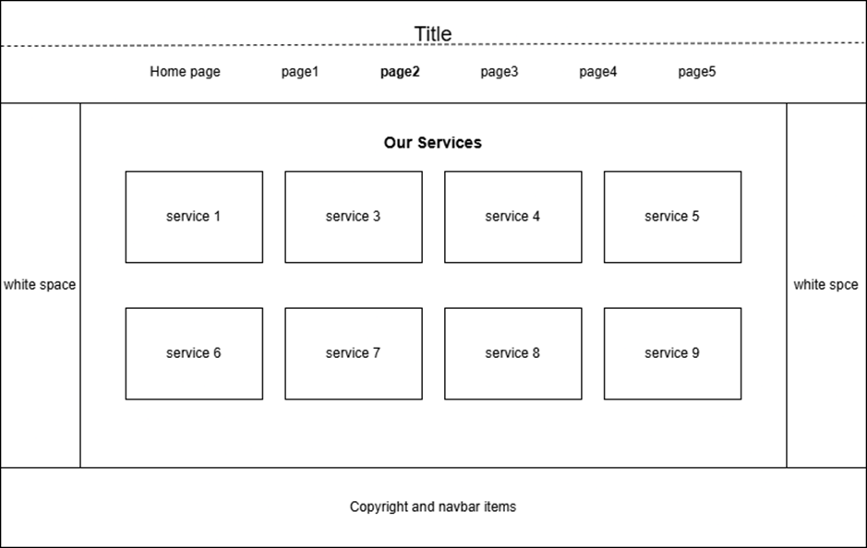

The services page maintains a look consistent with the rest of the website, which makes transitioning between pages feel smoother. The list of services has passive and active white spaces to make it easier to read and prevents overcrowding. 

Feedback:

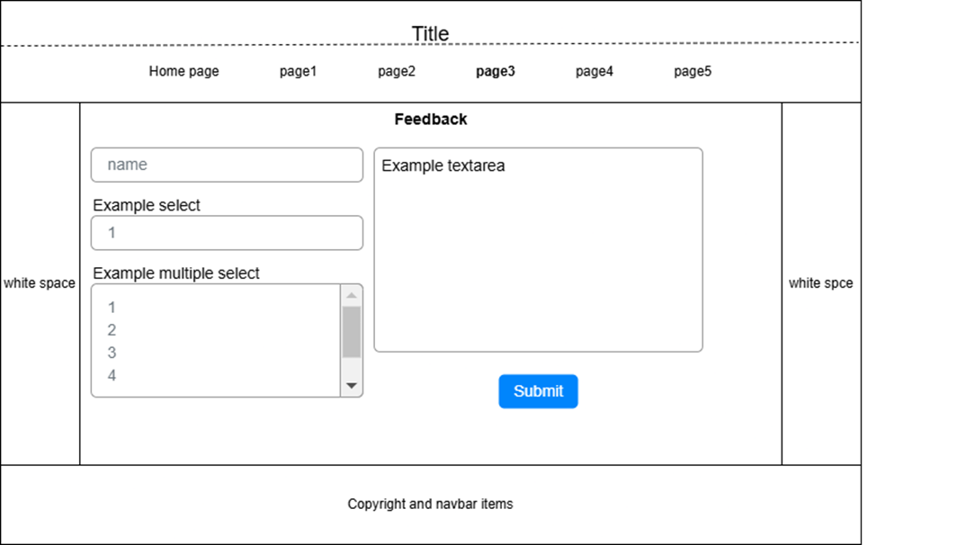

The feedback page design has the same header and footer sections as the other pages, with the addition of a form inside that's centered and has input fields. passive white space around the form aids in its readability by keeping the elements from overlapping each other regardless of the aspect ratio from different monitors including smartphones. With only the center of the page changing its structure, transition from other pages remains smooth.

About page: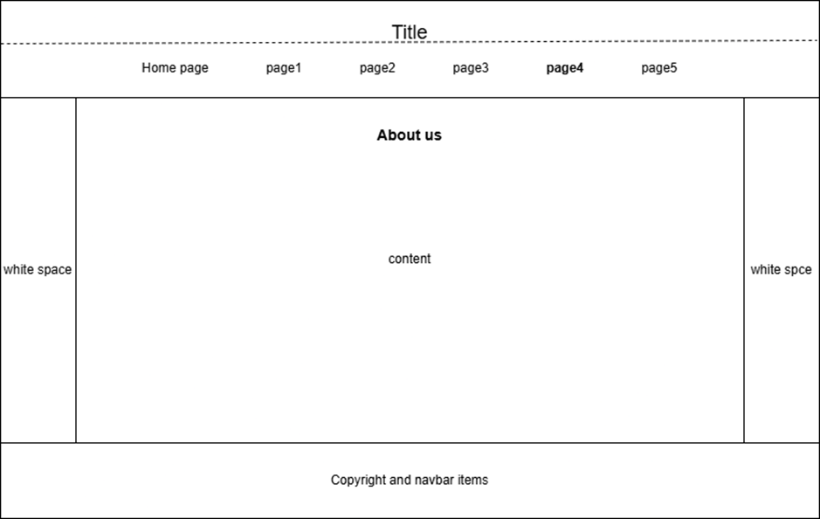

The about page will contain information about the site's content and goal. Again, the header and footer match with the other pages including the title, logo, and nav links. Below the title 'About us', will be information on the site's raison d'être.

Contact page:

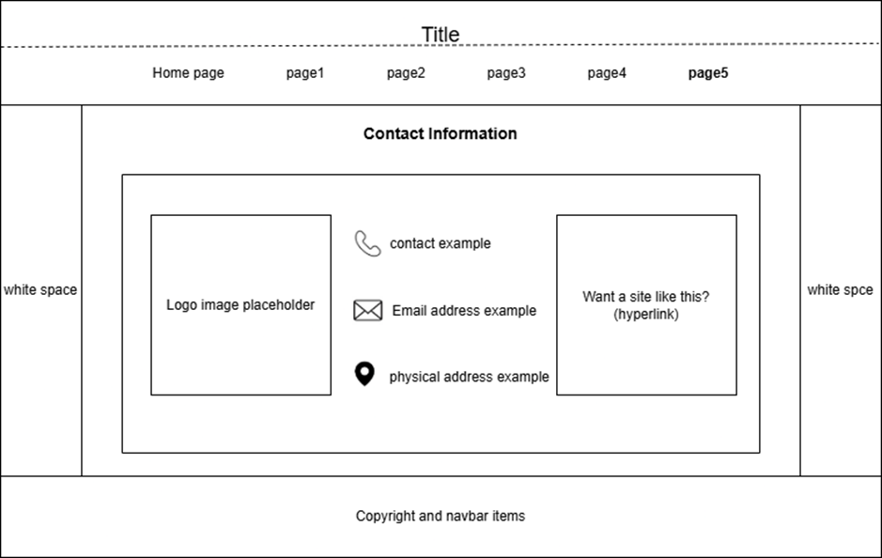

The contact pages has a title, a container for the main content, that being the clients contact information and logo that is centered and surrounded by passive white space to improve readability. Recognizable icons are placed next to the contact information as identifiers for visually impaired users, or simply to make it more conspicuous. Unified design is maintained as the page doesn't vary much compared to the other pages on the site.

1. **Accessibility**

It is important to make sure that a site is accessible to all potential users both for revenue and inclusivity purposes. The design of the Sustainable farming and local produce trading hub accommodates this by implementing a number of design practices for this purpose.

**Design choices:**

* Device Accessibility:

The site has elements that make it adaptable to both mobile and desktop such as dynamic screen resolutions and avoiding the use of px unit for elements.

* Visually impaired users:

Alt text for image elements is used to make it more accessible to users who are visually impaired by using descriptive text that can substitute for the image.  Text to speech is also an implementation that will help these users.

* Fonts:

Attractive fonts which are large enough to be seen by almost all users. The font colours contrast the background colour which also helps with visibility.

* Navigation:

A clear and conspicuous nav bar is present at the top and bottom of each page. Most of the site’s content is available within this navbar hyperlinks so users won’t have to make more than a few clicks to find what they need. The repetition of the navbar Item at the bottom of the page makes it easier to navigate for users who’ve scrolled down too far.

* Layout consistency:

All 6 pages follow the same basic style making transitions smoother and minimizes any confusion users might have when navigating through pages as fewer elements will differ between the pages.

* Visual cues:

Input fields, buttons, etc. are paired with icons to serve as cues as to what a particular element is, e.g., phone icon next to the client's contact information.

* Compatibility:

Testing will be done across various different browsers on both mobile and desktop to ensure that the site does not break in any of them. The ‘viewport’ meta tag is used to dynamically adapt to scale to different screen sizes.

1. **Domain Name Registration and Hosting costs**

We decided on **InfinityFree** since it offers free website hosting with the option to upgrade at a later time and its reducing costs. Initially, we first search for a name that represents the hub and is available before registering a domain.. In Fiji, **.com.fiji** domain costs approximately FJD 20 to 100 annually but a standard .com or .NET name often costs $100 to $200. This domain would make it easier for the hub to connect with nearby farmers and consumers.

Before choosing a hosting provider we looked at things like pricing, dependability and usability. A good option for a small business or trading center. **Infinity offers 5 GB of storage, unlimited bandwidth, free SSL certificate and MySQL databases**. But it doesn't provide direct phone or email help, which could be a problem if there are technical problems. Overall, by selecting a reasonably priced domain and hosting provider, the hub can create its online presence while keeping costs down which communicate between farmers and consumers.

1. **Static Home Pages**

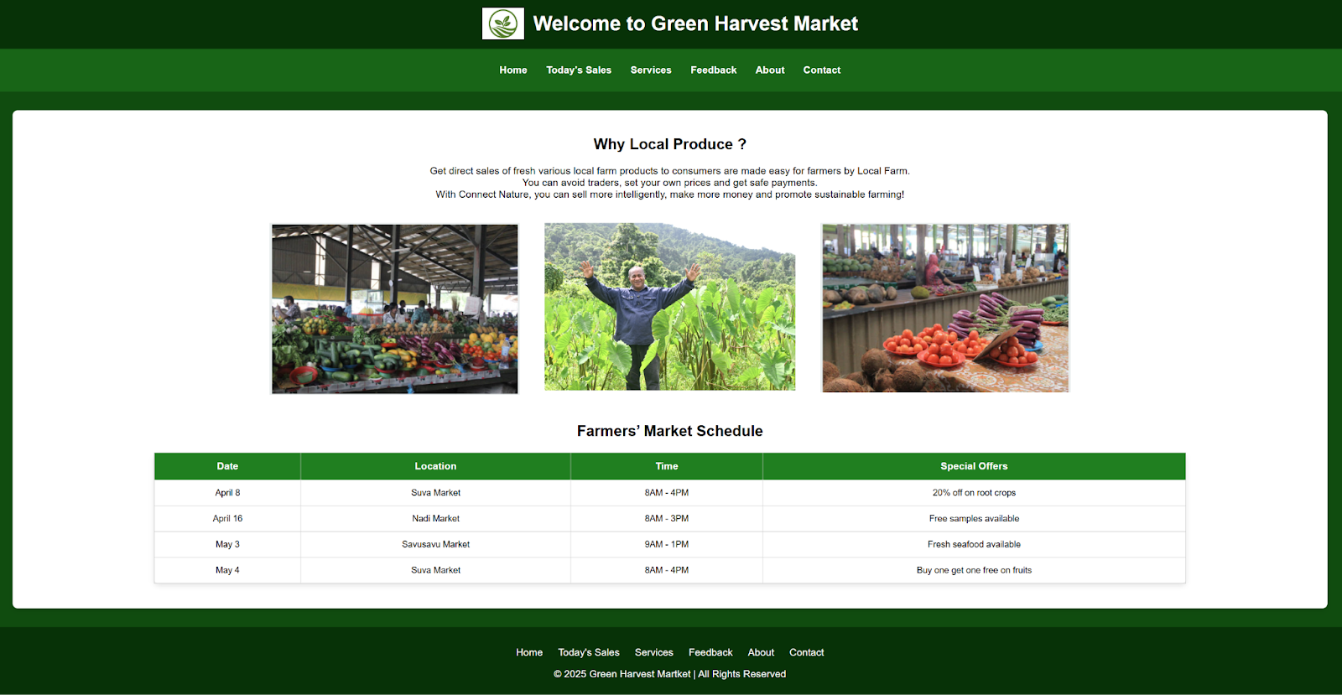

1. **References**
2. Gupta, V. (2023, July 19). *10 Website Goals & Objectives to Set (with Examples)*. Retrieved 2024, from 5MinutesSEO: <https://5minutesseo.com/seo/website-goals-objectives-to-set-with-examples/>
3. Kalbach, J. (2007). *Designing Web navigation: Optimizing the user experience*. " O'Reilly Media, Inc.".
4. Matson, J., Sullins, M., & Cook, C. (2013). The role of food hubs in local food marketing.
5. <https://scholar.googleusercontent.com/scholar?q=cache:3HBc_81Nn5UJ:scholar.google.com/+Green+Harvest+Market+Online+trading+hub+for+Local+Produce+&hl=en&as_sdt=0,5>
6. Palaniappan, G., Sangeetha, S., Rajendran, B., Goyal, S., & Bindhumadhava, B. S. (2020). Malicious domain detection using machine learning on domain name features, host-based features and web-based features. *Procedia Computer Science*, *171*, 654-661.
7. Patel, Mamta & Pandey, Sneha & Shrivastava, Sanjana & Sharga, Parul & Gigaulia, Prashant. (2022). e-Commerce in Agriculture.
8. <https://www.researchgate.net/publication/362709112_e-Commerce_in_Agriculture>