Assignment No. 7
YOLO Object Detection

1. Problem Statement:
Object detection using YOLO and Pretrained Model.

2. Objective:
The objective of this assignment is to implement object detection using the YOLO model. We will use a pretrained model to detect objects in images or video streams. This involves:
- Understanding the architecture of YOLO.
- Loading and fine-tuning a pretrained YOLO model.
- Evaluating its performance on different images or video streams for real-time object detection.

3. Software and Hardware Packages Used:
- Software Packages:
- Python 3.10 or later
- Jupyter Notebook or Google Colab
- Anaconda for environment management
- YOLOv8 pretrained model weights

- Hardware Packages:
- GPU-enabled machine for faster training and inference (e.g., NVIDIA CUDA GPU)
- At least 8 GB RAM for processing
- Web camera or external camera (for real-time object detection)

4. Libraries Used:
- ultralytics: For implementing YOLO models.
- NumPy: Array processing for numerical operations.
- OpenCV: Image and video processing.
- torch and torchvision: For deep learning model handling.
- Matplotlib: Visualization of detected objects.
- PIL (Python Imaging Library): For handling image data.

5. Theory:
- YOLO (You Only Look Once) is a state-of-the-art object detection model. Unlike traditional models that process an image in a sliding window manner, YOLO applies a single neural network to the entire image, dividing it into grids. Each grid predicts bounding boxes and the probability of classes within those boxes. Key concepts include:
- YOLO Architecture: It uses a convolutional neural network (CNN) to detect objects and predict their bounding boxes.
- Pretrained Models: Models trained on large datasets like COCO (Common Objects in Context) to detect a variety of objects.
- Real-time Detection: YOLO can process images at high speeds, making it ideal for applications requiring real-time analysis.

6. Methodology:

- Data Preparation:
- Image/Video Collection: Gather images or videos containing objects that you want to detect.
- Preprocessing: Resize images to the input size required by the YOLO model (e.g., 640x640). Convert images to a format suitable for the model.

- Model Loading:
- Pretrained Model: Load a pretrained YOLO model, YOLOv8, from the ultralytics library. YOLO models are typically pretrained on large datasets like COCO.

- Inference:
- Input Image to Model: Pass the input image to the YOLO model. The model processes the image and outputs predictions.
- Bounding Box Prediction: YOLO divides the image into a grid (e.g., 13x13, 26x26). Each cell in the grid predicts a set number of bounding boxes, object confidence scores, and class probabilities.
- Object Confidence Score: Represents how confident the model is that an object is present in a particular bounding box.
- Class Probabilities: Likelihood that a detected object belongs to a specific class (e.g., person, car, dog).

- Post-Processing:
- Non-Maximum Suppression (NMS): Removes redundant bounding boxes with lower confidence scores. NMS ensures that only the most relevant boxes are retained for each detected object.
- Thresholding: Set a confidence threshold (e.g., 0.5) to filter out weak detections and focus only on objects with high confidence scores.

- Visualization:
- Draw Bounding Boxes: Use OpenCV to draw bounding boxes around detected objects.
- Labeling: Display the class name and confidence score on top of each bounding box.
- Display Results: Show the annotated image or video stream with detected objects.

- Evaluation:
- Metrics: Calculate accuracy, precision, recall, and F1-score based on the predictions and ground truth labels.
- Qualitative Analysis: Evaluate how well the model performs on different types of images and adjust parameters as needed.

7. Advantages:
- Real-time Detection: Capable of processing images quickly, making it suitable for video feeds.
- High Accuracy: Even with a single forward pass, YOLO can detect multiple objects with good precision.
- Pretrained Models: Leverages large datasets, allowing users to use out-of-the-box detection without needing extensive training.

8. Limitations:
- Struggles with Small Objects: YOLO’s grid-based approach can sometimes miss smaller objects due to spatial constraints.
- Trade-off Between Speed and Accuracy: While faster than many detection models, YOLO might compromise slightly on precision.
- Complex Objects: It can be less effective when detecting complex or overlapping objects.
9. Working/Algorithm:
Initialization:
- Load the YOLO model weights (e.g., yolov8s.pt).
- Define the input image size (e.g., 640x640 pixels).

Image Preprocessing:
- Convert the input image to a tensor format required by the YOLO model.
- Normalize pixel values to [0, 1].
- Resize the image to the YOLO input size (e.g., 640x640).

Prediction:
- Pass the preprocessed image through the YOLO model.
- YOLO divides the image into an S×SS \times SS×S grid (e.g., 13x13).
- Each cell in the grid predicts multiple bounding boxes (e.g., 3) and object confidence scores.
- Bounding Box Details:
  - YOLO predicts 5 values for each bounding box: x,y,w,h,x, y, w, h,x,y,w,h, and confidence.
  - (x,y)(x, y)(x,y) represents the center coordinates of the box.
  - www and hhh represent the width and height of the box relative to the cell.
  - Confidence score represents the probability of an object being present in the box.

Class Prediction:
- YOLO predicts class probabilities for each bounding box.
- Multiply the object confidence score by the class probability to get the final score for each class.

- Non-Maximum Suppression (NMS):
- Apply NMS to reduce overlapping bounding boxes and retain only the most confident one.
- Steps of NMS:
- Sort all bounding boxes by their confidence scores.
- Select the box with the highest confidence score.
- Compute the Intersection over Union (IoU) between this box and other boxes.
- Remove boxes with IoU greater than a defined threshold (e.g., 0.5).
- Repeat until all boxes are processed.

- Post-Processing:
- Filter out detections below a certain confidence threshold (e.g., 0.5).
- Convert relative bounding box coordinates back to absolute values (pixel values) to draw them on the original image.

Drawing and Visualization:
- Loop through the retained bounding boxes.
- Draw rectangles on the image using OpenCV for each bounding box.
- Display class labels and confidence scores on top of each detected object.
- Display the final image or video frame with annotations.

Output:
- The final output is an annotated image or video stream showing detected objects with their corresponding labels and bounding boxes.

10. Diagram:
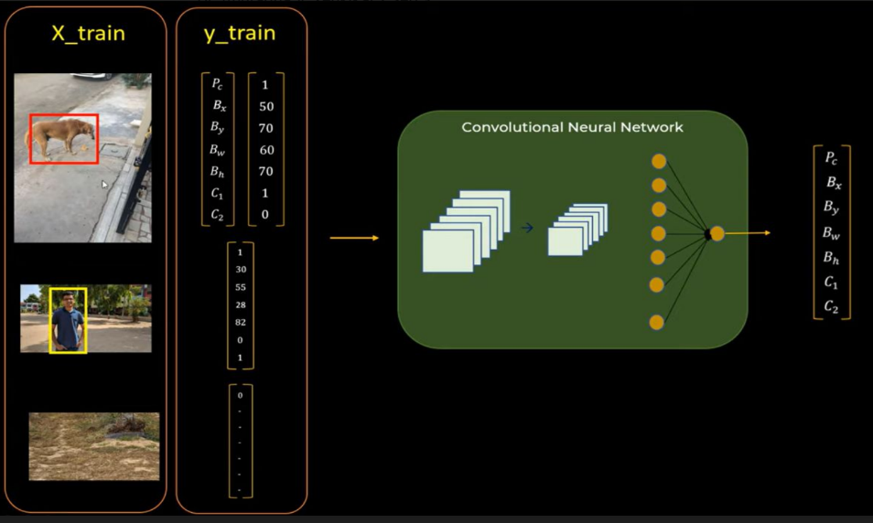

11. Conclusion:
- Object detection using YOLO and pretrained models allows for efficient and effective identification of objects in images and videos. By leveraging the speed and accuracy of YOLO, various real-time applications are possible. This practical assignment demonstrates the implementation of YOLO for detecting multiple objects with high accuracy. Despite some limitations in detecting small or overlapping objects, YOLO remains a popular choice for object detection tasks in diverse fields.

