Practical No 1

Aim: Practical of Data Extraction for Unstructured data (NoSQL).

Code:
import pymongo
import json
try:
# Connect to MongoDB
client = pymongo.MongoClient("mongodb://localhost:27017")
client.admin.command('ping')
print("Connection established to MongoDB")
except pymongo.errors.PyMongoError as e:
print("Failed to connect to MongoDB:", e)
exit(1) # Exit script if connection fails

# Connect to database and collection
db = client["data_extract"]
collection = db["unstructured_data"]
# Sample unstructured data (JSON)
json_data = '''
[
{"name": "Alice", "email": "alice@example.com", "address": "123 Street, NY"},
{"name": "Bob", "email": "bob@example.com", "address": "456 Avenue, CA"}
]
'''
# Load JSON and insert into MongoDB
data = json.loads(json_data)
collection.insert_many(data)

# Retrieve and print inserted data
for record in collection.find():
print(record)

Output:
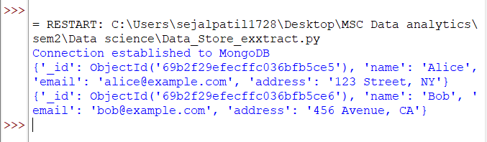

Practical No 2

Aim: Practical of Principal Component Analysis.
Code:
# Load Required Libraries
library(ggplot2)

# Create Sample Data (4 features)
data <- data.frame(
Feature1 = c(2, 6, 5, 7, 4),
Feature2 = c(8, 3, 4, 5, 6),
Feature3 = c(4, 8, 6, 7, 5),
Feature4 = c(10, 9, 8, 11, 7)
)

# Standardize the Data
data_scaled <- scale(data) # Standardization

# Apply PCA
pca_result <- prcomp(data_scaled, center = TRUE, scale. = TRUE)

# Print PCA Summary
print(summary(pca_result)) # Show importance of components
print(pca_result$rotation) # Show principal components

# Create Data Frame for PCA Components
pca_data <- as.data.frame(pca_result$x)

# Plot PCA Components
ggplot(pca_data, aes(x = PC1, y = PC2)) +
geom_point(color = "blue", size = 3) +
labs(title = "PCA Visualization", x = "Principal Component 1", y = "Principal Component 2") +
theme_minimal()

Output:
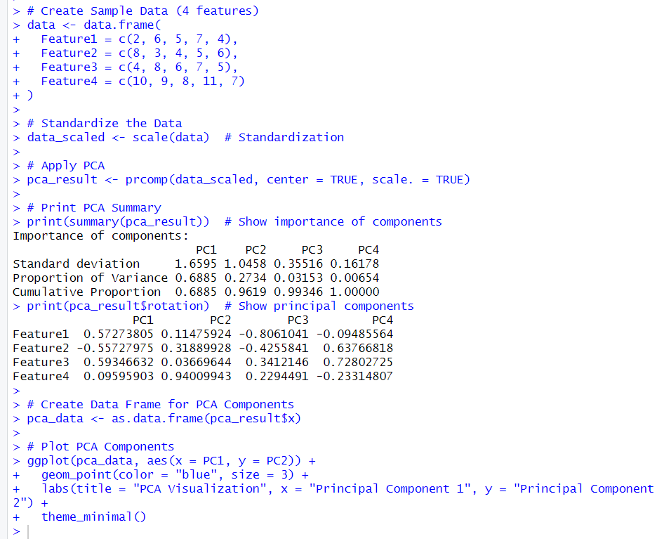
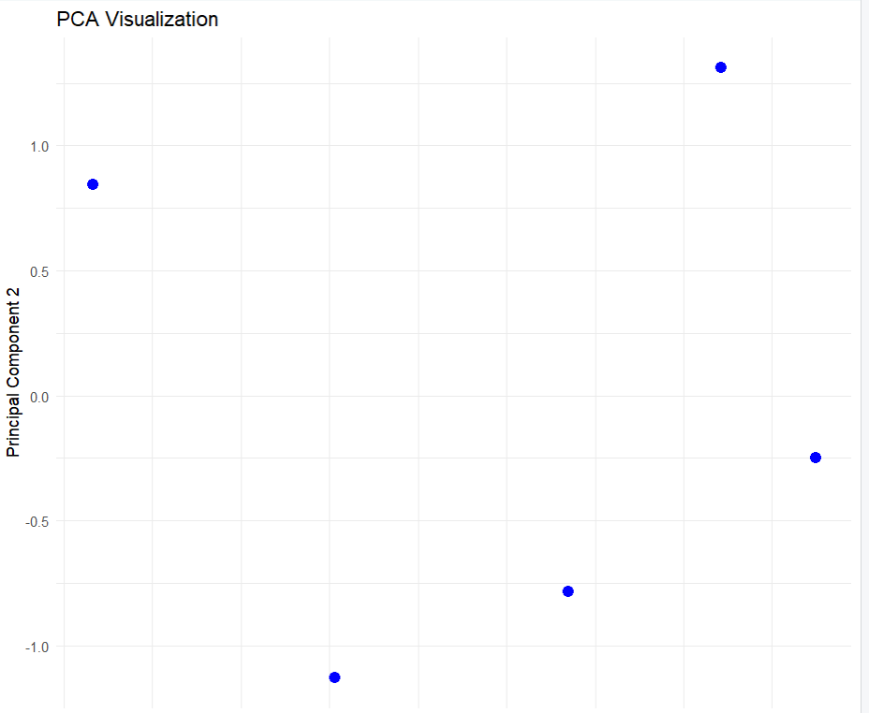

Practical No. 3

Aim: Practical of Clustering.

Code:
# Step 1: Load Required Library
library(ggplot2)

# Step 2: Generate Sample Data with Clear Clusters
set.seed(123)

cluster1 <- data.frame(
X = rnorm(20, mean = 5, sd = 0.8),
Y = rnorm(20, mean = 5, sd = 0.8)
)

cluster2 <- data.frame(
X = rnorm(20, mean = 15, sd = 0.8),
Y = rnorm(20, mean = 15, sd = 0.8)
)

cluster3 <- data.frame(
X = rnorm(20, mean = 25, sd = 0.8),
Y = rnorm(20, mean = 5, sd = 0.8)
)

data <- rbind(cluster1, cluster2, cluster3)

# Step 3: Apply K-Means Clustering
kmeans_result <- kmeans(data, centers = 3)

# Step 4: Add Cluster Labels to Data
data$Cluster <- as.factor(kmeans_result$cluster)

# Step 5: Plot the Clusters
ggplot(data, aes(x = X, y = Y, color = Cluster)) +
geom_point(size = 3) +
labs(title = "K-Means Clustering with Generated Dataset",
x = "Feature X",
y = "Feature Y") +
theme_minimal()

Output:
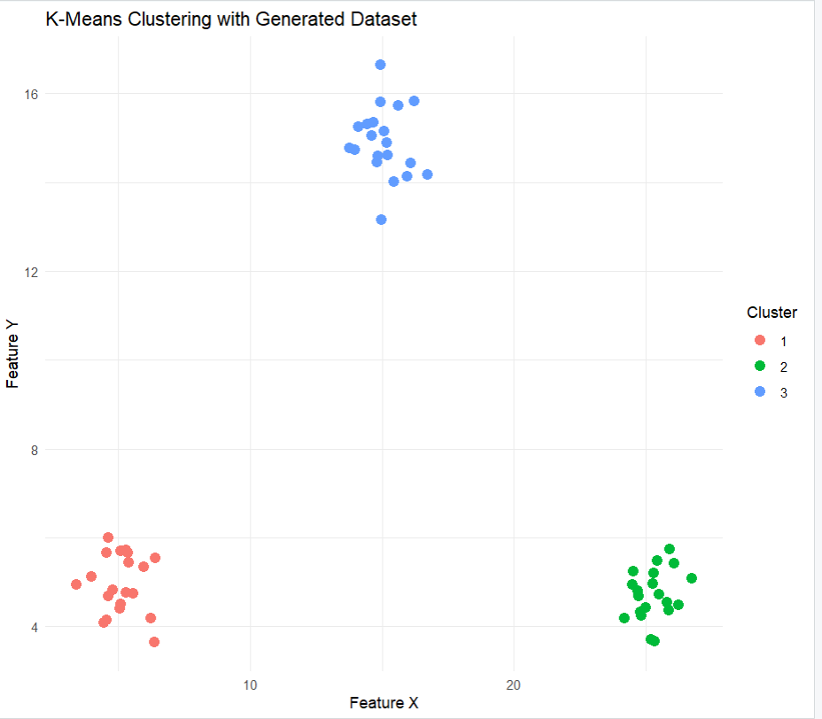

Practical No. 4
Aim: Conversion from different formats to HORUS format
A) Text Delimited CSV
B) XML
C) JSON

A) CSV to HORUS Format
Code:
# Import libraries
import pandas as pd
from google.colab import files

# Upload file
uploaded = files.upload()

# Read CSV file
InputData = pd.read_csv('Country_Code.csv', encoding='latin-1')

print("Input Data =======================")
print(InputData)

# Processing
ProcessData = InputData.copy()

# Remove unwanted columns
ProcessData.drop(['ISO-2-CODE', 'ISO-3-Code'], axis=1, inplace=True)

# Rename columns
ProcessData.rename(columns={
'Country': 'CountryName',
'ISO-M49': 'CountryNumber'
}, inplace=True)

# Set index
ProcessData.set_index('CountryNumber', inplace=True)

# Sort data
ProcessData.sort_values('CountryName', ascending=False, inplace=True)

print("Processed Data (HORUS) ==========")
print(ProcessData)

print("CSV to HORUS - Done")

Output:
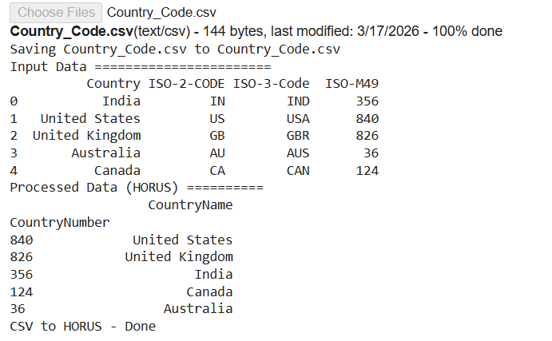
B) XML to HORUS Format
Code:
# Import libraries
import pandas as pd
import xml.etree.ElementTree as ET
from google.colab import files

# Upload file
uploaded = files.upload()

# Function: XML to DataFrame
def xml2df(xml_data):
root = ET.XML(xml_data)
all_records = []

for child in root:
record = {}
for subchild in child:
record[subchild.tag] = subchild.text
all_records.append(record)

return pd.DataFrame(all_records)

# Read XML file
with open('Country_Code.xml', 'r', encoding='utf-8') as file:
InputData = file.read()

print("Input XML Data ==================")
print(InputData)

# Convert XML to DataFrame
ProcessData = xml2df(InputData)

# Remove unwanted columns
ProcessData.drop(['ISO-2-CODE', 'ISO-3-Code'], axis=1, inplace=True)

# Rename columns
ProcessData.rename(columns={
'Country': 'CountryName',
'ISO-M49': 'CountryNumber'
}, inplace=True)

# Set index
ProcessData.set_index('CountryNumber', inplace=True)

# Sort data
ProcessData.sort_values('CountryName', ascending=False, inplace=True)

print("Processed Data (HORUS) ==========")
print(ProcessData)

print("XML to HORUS - Done")

Output:
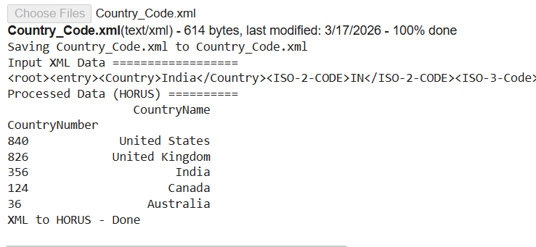
C) JSON to HORUS Format
Code:
# Import libraries
import pandas as pd
from google.colab import files

# Upload file
uploaded = files.upload()

# Read JSON file
InputData = pd.read_json('Country_Code.json', encoding='latin-1')

print("Input JSON Data =================")
print(InputData)

# Processing
ProcessData = InputData.copy()

# Remove unwanted columns
ProcessData.drop(['ISO-2-CODE', 'ISO-3-Code'], axis=1, inplace=True)

# Rename columns
ProcessData.rename(columns={
'Country': 'CountryName',
'ISO-M49': 'CountryNumber'
}, inplace=True)

# Set index
ProcessData.set_index('CountryNumber', inplace=True)

# Sort data
ProcessData.sort_values('CountryName', ascending=False, inplace=True)

print("Processed Data (HORUS) ==========")
print(ProcessData)

print("JSON to HORUS - Done")

Output:
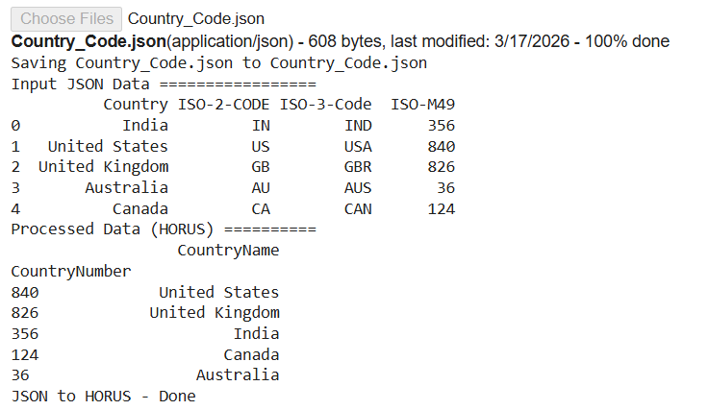
Result
The data from CSV, XML, and JSON formats was successfully converted and processed into HORUS structured format using Python and Pandas.
Practical No. 5
Aim: Conversion from different formats to HORUS format
A) Picture (JPEG)
B) Video
C) Audio

A) Picture (JPEG) to HORUS Format
Code:
# Import libraries
# Import libraries
from google.colab import files
uploaded = files.upload()

import imageio.v2 as imageio
import pandas as pd
import numpy as np
import matplotlib.pyplot as plt

# Load Image
InputData = imageio.imread("flower.jpg")

# Display Image Details
print("Height:", InputData.shape[0])
print("Width:", InputData.shape[1])
print("Channels:", InputData.shape[2])

# Flatten image data
ProcessRawData = InputData.flatten()

# Reshape into DataFrame
num_channels = InputData.shape[2]
rows = int(len(ProcessRawData) / num_channels)

ProcessData = pd.DataFrame(
np.reshape(ProcessRawData, (rows, num_channels))
)

# Rename columns
if num_channels == 3:
ProcessData.columns = ['Red', 'Green', 'Blue']
else:
ProcessData.columns = ['Red', 'Green', 'Blue', 'Alpha']

# Show Image
plt.imshow(InputData)
plt.axis('off')
plt.show()

# Save to HORUS CSV
ProcessData.to_csv("HORUS_Picture.csv", index=False)

print("Picture to HORUS - Done")

Output:
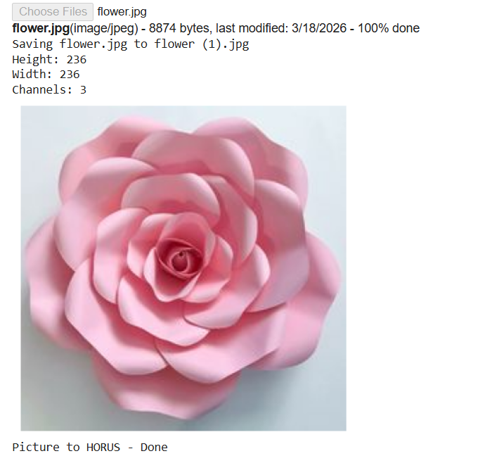
B) Video to HORUS Format
# STEP 1: Upload Video
from google.colab import files
uploaded = files.upload()

video_name = list(uploaded.keys())[0]
print("Uploaded file:", video_name)

# STEP 2: Import Libraries
import cv2
import os
import pandas as pd
import numpy as np
from IPython.display import clear_output

# STEP 3: Read Video
video = cv2.VideoCapture(video_name)

if not video.isOpened():
print("Error: Cannot open video")
exit()
# Create frames folder
os.makedirs("frames", exist_ok=True)

# STEP 4: Extract Frames (Skip frames for speed)
count = 0
saved_count = 0
while True:
success, image = video.read()
if not success:
break

# Save only every 5th frame (🔥 speed improvement)
if count % 5 == 0:
cv2.imwrite(f"frames/frame_{saved_count}.jpg", image)
saved_count += 1

if count % 20 == 0:
clear_output(wait=True)
print(f"Extracting frames... {count} processed")

count += 1

print("Total Frames Extracted:", saved_count)

# STEP 5: Convert Frames → HORUS (FAST)
frames_data = []

files_list = sorted(os.listdir("frames"))

if len(files_list) == 0:
print("No frames found!")
exit()

for i, file in enumerate(files_list):

path = os.path.join("frames", file)
img = cv2.imread(path)

if img is None:
continue

# 🔥 Resize image (MOST IMPORTANT for speed)
img = cv2.resize(img, (64, 64))

data = img.flatten()

df = pd.DataFrame(
np.reshape(data, (-1, 3)),
columns=['Red', 'Green', 'Blue']
)

df['FrameName'] = file
frames_data.append(df)

if i % 10 == 0:
clear_output(wait=True)
print(f"Converting to HORUS... {i} frames processed")

# STEP 6: Save CSV
if frames_data:
final_data = pd.concat(frames_data, ignore_index=True)
final_data.to_csv("HORUS_Video.csv", index=False)

print("✅ Video to HORUS - Completed Successfully")
else:
print("No data to save!")
Output:
C) Audio to HORUS Format
Code:
# STEP 1: Upload Audio File
from google.colab import files
uploaded = files.upload()

audio_file = list(uploaded.keys())[0]
print("Uploaded file:", audio_file)

# STEP 2: Install & Import Libraries
!pip install pydub

from pydub import AudioSegment
from scipy.io import wavfile
import pandas as pd
import matplotlib.pyplot as plt

# STEP 3: Convert MP3 → WAV (if needed)
if audio_file.endswith(".mp3"):
sound = AudioSegment.from_mp3(audio_file)
wav_file = "converted_audio.wav"
sound.export(wav_file, format="wav")
else:
wav_file = audio_file

# STEP 4: Read WAV File
rate, data = wavfile.read(wav_file)

print("Sampling Rate:", rate)
print("Shape:", data.shape)

# STEP 5: Convert to DataFrame
ProcessData = pd.DataFrame(data)

if len(data.shape) > 1:
ProcessData.columns = [f"Ch{i+1}" for i in range(data.shape[1])]
else:
ProcessData.columns = ["Ch1"]

# STEP 6: Plot Waveform
plt.figure(figsize=(10,4))
plt.plot(data)
plt.title("Audio Signal")
plt.xlabel("Samples")
plt.ylabel("Amplitude")
plt.show()

# STEP 7: Save to HORUS
ProcessData.to_csv("HORUS_Audio.csv", index=False)
print("✅ Audio to HORUS - Done")
Output:
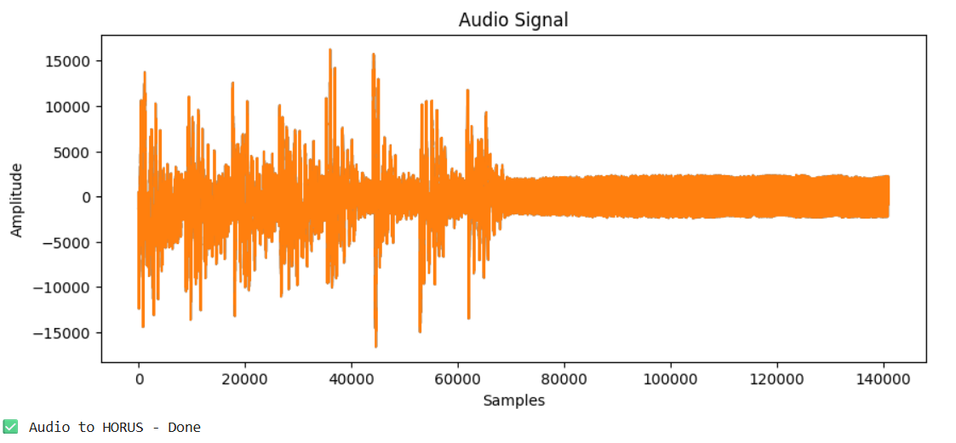
Result:
The data from JPEG images, video frames, and audio signals was successfully converted into HORUS (CSV structured) format using Python.

Practical No.6
Aim: Practical of Utilities.
Code:
#1 Removing leading or lagging spaces from a data entry
import string
import datetime as dt
print ('#1 Removing leading or lagging spaces from a data entry');
baddata="Data Science with too many spaces is bad!!!"
print('>',baddata,'<')
cleandata=baddata.strip()
print('>',cleandata,'<')
Output:
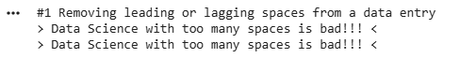
#2 Removing nonprintable characters from a data entry
import string
import datetime as dt
print('#2 Removing nonprintable characters from a data entry')
printable = set(string.printable)
baddata = "Data\x00Science with\x02 funny characters is \x10bad!!!"
cleandata = "".join(filter(lambda x: x in printable, baddata))
print('Bad Data :', baddata)
print('Clean Data:', cleandata)
Output:
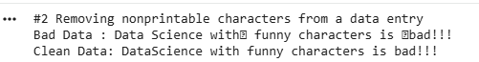

# 3 Reformatting data entry to match specific formatting criteria
import string
import datetime as dt
# Convert YYYY/MM/DD to DD Month YYYY
print('# 3 Reformatting data entry to match specific formatting criteria.')
baddate = dt.date(2019, 10, 31)
baddata=format(baddate,'%Y-%m-%d')
gooddate = dt.datetime.strptime(baddata,'%Y-%m-%d')
gooddata=format(gooddate,'%d %B %Y')
print('Bad Data : ',baddata)
print('Good Data : ',gooddata)
Output:
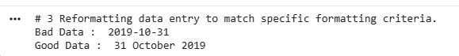
A. Data Binning or Bucketing
import numpy as np
import matplotlib.pyplot as plt
import scipy.stats as stats
np.random.seed(0) # Example data
mu = 90 # Mean of distribution
sigma = 25 # Standard deviation of distribution
x = mu + sigma * np.random.randn(5000) # Generate random data
num_bins = 25 # Number of bins in the histogram
# Create figure and axis objects
fig, ax = plt.subplots()
# The histogram of the datan, bins, patches = ax.hist(x, num_bins, density=1, alpha=0.6, color='g')

# Add a 'best fit' line for normal distribution
y = stats.norm.pdf(bins, mu, sigma) # Normal PDF
ax.plot(bins, y, '--', color='r', label='Fit: N(90, 25)')
# Set labels
ax.set_xlabel('Example Data')
ax.set_ylabel('Probability Density')
# Title with parameters
sTitle = f'Histogram {len(x)} entries into {num_bins} bins: $\mu={mu}$, $\sigma={sigma}$'
ax.set_title(sTitle)
# Layout adjustments
fig.tight_layout()
# Display the plot
plt.show()
Output:
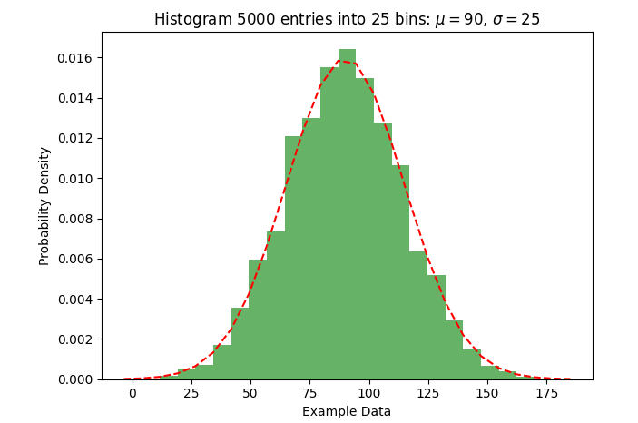

B. Averaging of Data
The use of averaging of features value enables the reduction of data volumes in a control fashion to improve effective data processing.
Functions Used in the Code :
df.groupby("Category").mean()
* Groups the dataset by a specified column (e.g., "Category") and calculates the mean for numerical features.
* Useful for aggregating data based on categorical values.
Code:
import pandas as pd

data = {
"Category": ["A","A","A","B","B","C","C"],
"Value1": [10,20,30,40,50,60,70],
"Value2": [20,30,40,50,60,70,80],
"Value3": [30,40,50,60,70,80,90]
}

df = pd.DataFrame(data)
df.to_csv("IP_DATA_CORE.csv", index=False)
print("Sample CSV created!")

# Load dataset
df = pd.read_csv("IP_DATA_CORE.csv")

# Data reduction
if "Category" in df.columns:
df_reduced = df.groupby("Category").mean()
else:
df_reduced = df.mean(numeric_only=True).to_frame().T

# Save file
df_reduced.to_csv("data_reduced.csv", index=True)

print("Data reduction complete!")

# Download (Colab only)
from google.colab import files
files.download("data_reduced.csv")
Output:

Practical No. 7
Aim: Practical of Auditing.
Code:
# Practical No: 7 - Auditing
import pandas as pd
# Step 1: Create sample financial data
data = {
"Transaction_ID": [1,2,3,4,5],
"Amount": [1000, 2000, -500, 3000, 1500],
"Approved": ["Yes", "Yes", "No", "Yes", "Yes"]
}
df = pd.DataFrame(data)
# Step 2: Save data
df.to_csv("audit_data.csv", index=False)
# Step 3: Load data
df = pd.read_csv("audit_data.csv")
# Step 4: Audit Checks
# 1. Check for negative values (possible error/fraud)
negative_values = df[df["Amount"] < 0]
# 2. Check for unapproved transactions
unapproved = df[df["Approved"] == "No"]
# 3. Summary report
total_amount = df["Amount"].sum()
# Step 5: Print audit results
print("Total Amount:", total_amount)
print("\nNegative Transactions (Issues):")
print(negative_values)
print("\nUnapproved Transactions (Issues):")
print(unapproved)
# Step 6: Save audit report
df.to_csv("audit_report.csv", index=False)
print("\nAudit Completed! Report saved.")
# Download (Colab only)
from google.colab import files
files.download("audit_report.csv")

Output:
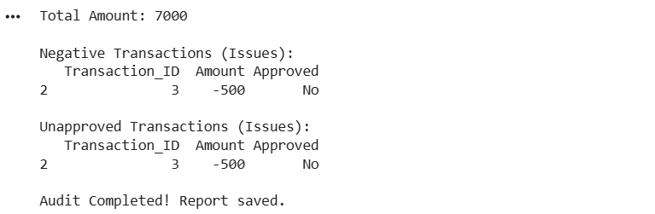

Practical No. 8
Aim: Practical of Retrieving Data
Code:
# Practical No: 8 - Retrieving Data
import pandas as pd
# Step 1: Create sample dataset
data = {
"ID": [1,2,3,4,5],
"Name": ["Amit","Neha","Ravi","Priya","Karan"],
"Marks": [85,90,75,88,92]
}
df = pd.DataFrame(data)
# Step 2: Save dataset
df.to_csv("student_data.csv", index=False)
# Step 3: Load dataset
df = pd.read_csv("student_data.csv")
# Step 4: Retrieve Data
# 1. Retrieve all data
print("All Data:\n", df)
# 2. Retrieve specific column
print("\nNames:\n", df["Name"])
# 3. Retrieve rows where Marks > 85
high_marks = df[df["Marks"] > 85]
print("\nStudents with Marks > 85:\n", high_marks)
# 4. Retrieve specific row (ID = 3)
row = df[df["ID"] == 3]
print("\nStudent with ID = 3:\n", row)
# Step 5: Save retrieved data
high_marks.to_csv("filtered_data.csv", index=False)
print("\nData Retrieval Completed!")
# Download (Colab only)
from google.colab import files
files.download("filtered_data.csv")
Output:
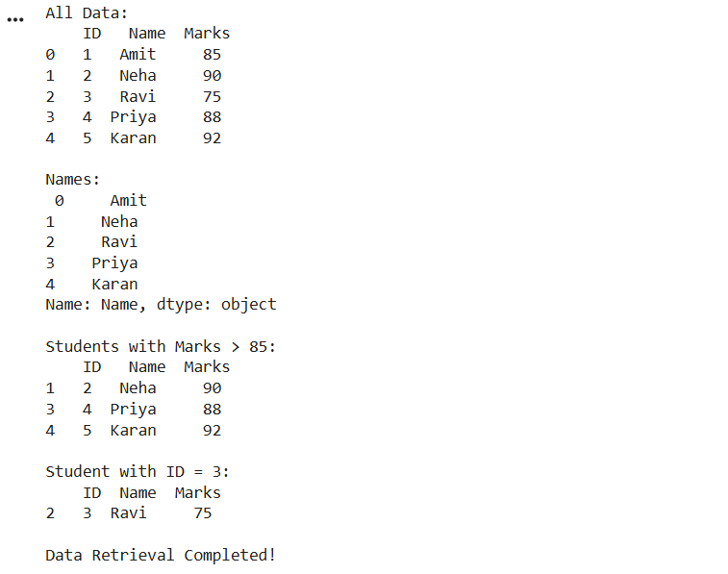

Practical No. 9
Aim: Practical of Generating Reports with Power BI.
Step 1:
Load your Excel dada in power bi Click on home tab then Get Data select Excel workbook.

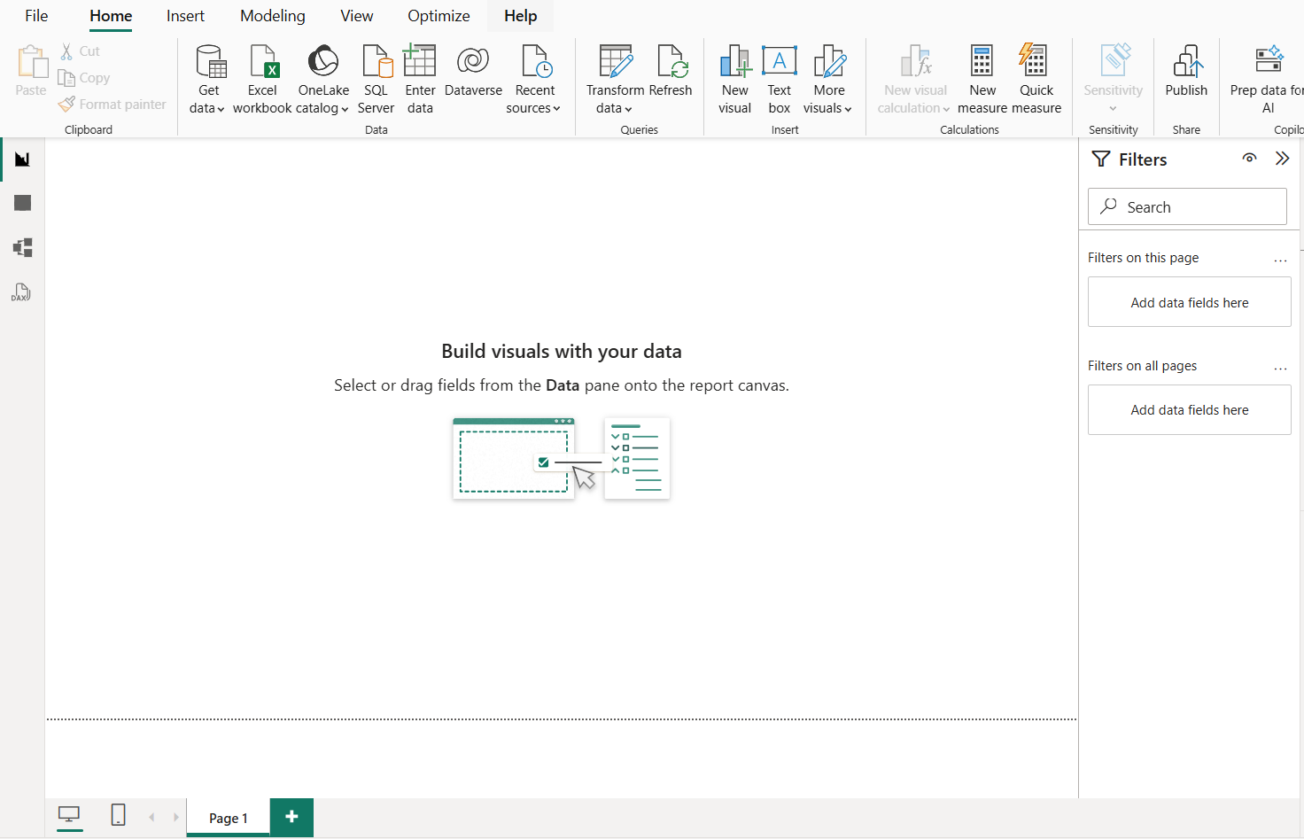

Step 2:
Select Financial sample excel file and click on open button and Select the data and click on transform data button Select the data and click on transform data button.

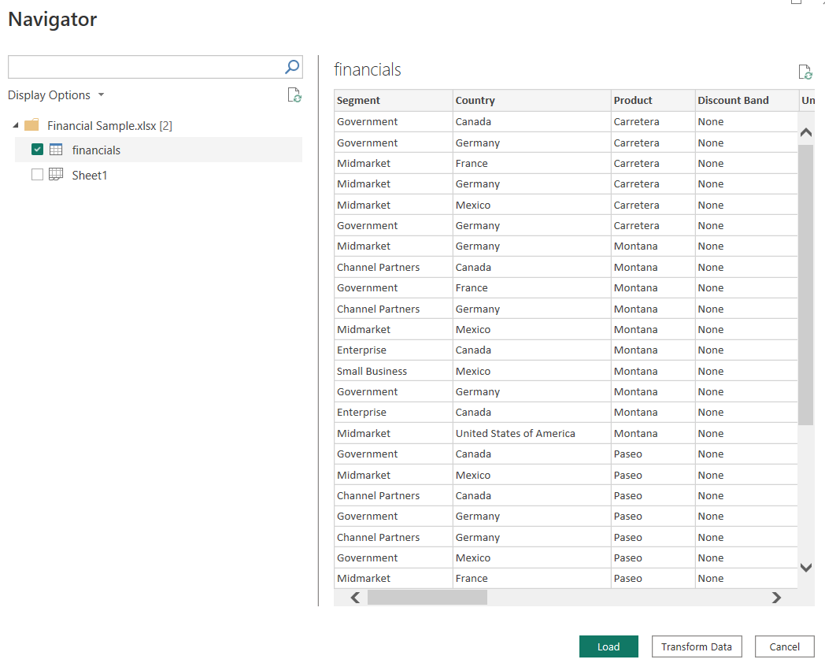

Step 3:
After loading data generate reports

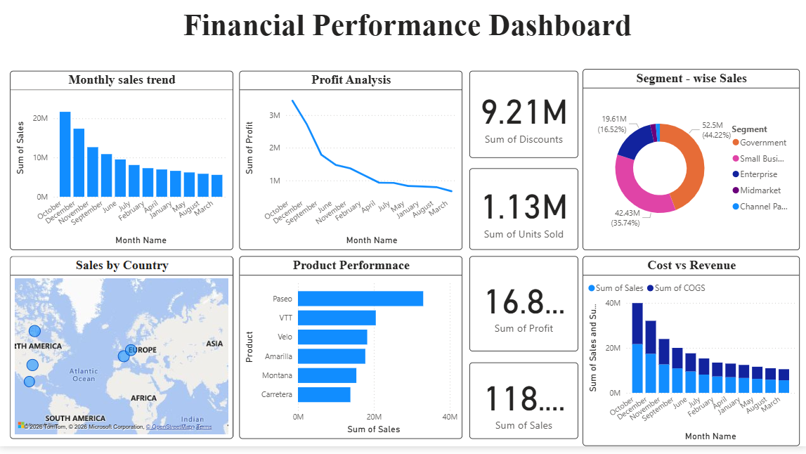

Practical No.10

Aim: Practical of Data Visualization with Power BI.

Step 1:
Load your Excel dada in power bi
Click on home tab then Get Data select Excel workbook



Step 2:
Select Financial sample excel file and click on open button

Step 3:
Select the data and click on transform data button



Step 4:
From visualization tab select stack bar chart and visualize your data

