Practical.No.1

Aim : To perform text mining preprocessing techniques on a given text dataset, including
- Sentence tokenization
- Word tokenization
- Frequency distribution
- Identification of stopwords
- Removal of stopwords
- Removal of punctuations
- Showing the preprocessing pipeline

1. Install Required Libraries
Open Command Prompt and run:
pip install nltk

2. Import Libraries
import nltk
import string
from collections import Counter

3. Download required NLTK resources (run once):
nltk.download('punkt')
nltk.download('stopwords')

Code:
import nltk
import string
from collections import Counter
#nltk.download('punkt')
#nltk.download('stopwords')

#i. SENTENCE TOKENIZATION
text = """Text Mining is an important process.
It helps in extracting useful information from text data.
Text mining includes tokenization, stopword removal, and more."""
print("Text: ",text)

sentences = nltk.sent_tokenize(text)
print("\n\nSENTENCE TOKENIZATION",sentences)

Output:
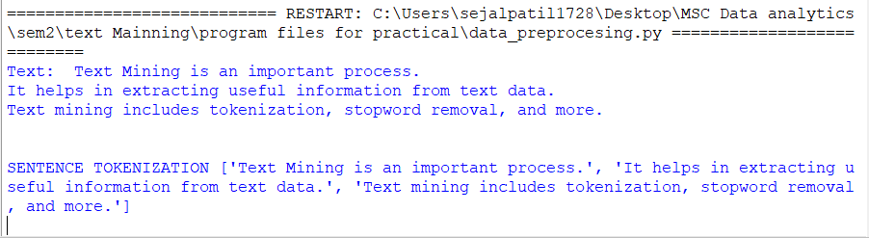

#ii. WORD TOKENIZATION
words = nltk.word_tokenize(text)
print("\n\nWORD TOKENIZATION",words)
Output:
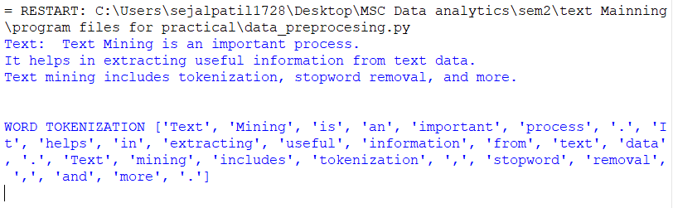

#iii. FREQUENCY DISTRIBUTION
frequency = Counter(words)
print("\n\nFREQUENCY DISTRIBUTION",frequency)
Output:
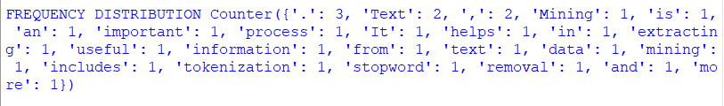

#iv. FINDING STOPWORDS
from nltk.corpus import stopwords
stop_words = stopwords.words('english')
print("\n\nFINDING STOPWORDS",stop_words)
Output:
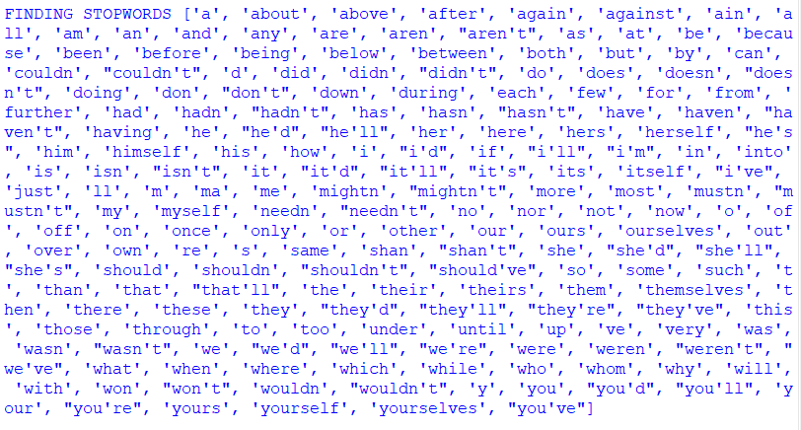

#v. REMOVING STOPWORDS
filtered_words = [word for word in words if word.lower() not in stop_words]
print("\n\nREMOVING STOPWORDS",filtered_words)
Output:

#vi. REMOVING PUNCTUATIONS
clean_words = [word for word in filtered_words if word not in string.punctuation]
print("\n\nREMOVING PUNCTUATIONS",clean_words)
Output:

#vii. TEXT MINING PREPROCESSING TECHNIQUES (DEMONSTRATION)
clean_text = " ".join(clean_words)
print("\n\nTEXT MINING PREPROCESSING TECHNIQUES (DEMONSTRATION)",clean_text)
Output:

Practical No. 2
Aim: To perform Lexicon Normalization using the following techniques:
- Stemming
- Lemmatization
- Part-of-Speech (POS) Tagging
- Named Entity Recognition (NER)

Code:
import nltk
from nltk.tokenize import word_tokenize
from nltk.stem import PorterStemmer, WordNetLemmatizer
from nltk import pos_tag, ne_chunk

#nltk.download('punkt')
#nltk.download('wordnet')
#nltk.download('averaged_perceptron_tagger_eng')
#nltk.download('maxent_ne_chunker')
#nltk.download('maxent_ne_chunker_tab')
#nltk.download('words')
text = "Ratan Tata founded Tata Group in India and he is leading business growth"

print("Input Text:")
print(text)

# Tokenization
tokens = word_tokenize(text)
print("\nTokens:")
print(tokens)

# 1. Stemming
stemmer = PorterStemmer()
stemmed_words = [stemmer.stem(word) for word in tokens]
print("\n1. Stemming:")
print(stemmed_words)

# 2. Lemmatization
lemmatizer = WordNetLemmatizer()
lemmatized_words = [lemmatizer.lemmatize(word) for word in tokens]
print("\n2. Lemmatization:")
print(lemmatized_words)

# 3. POS Tagging
pos_tags = pos_tag(tokens, lang='eng')
print("\n3. POS Tagging:")
print(pos_tags)

# 4. Named Entity Recognition
ner_tree = ne_chunk(pos_tags)
print("\n4. Named Entity Recognition:")
print(ner_tree)

Output:
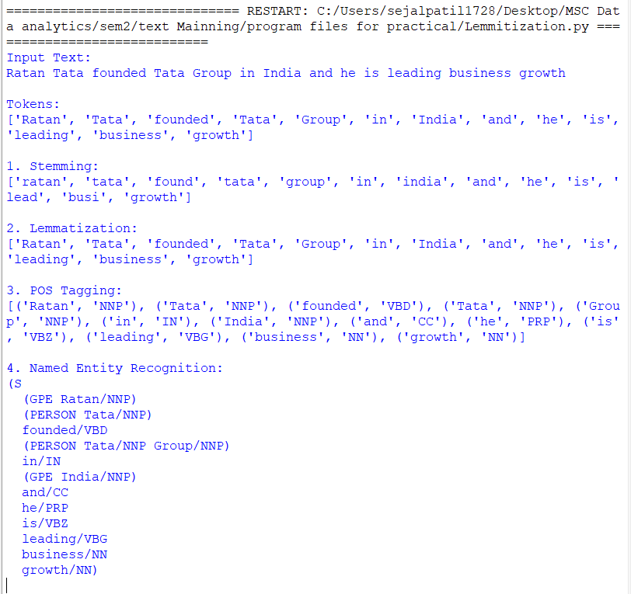

Practical No. 3

Aim: To demonstrate the use of spaCy for Text Classification using Python.

Theory
Text Classification is a process of automatically assigning predefined categories (labels) to text.
In this practical, spaCy is used to classify text into POSITIVE and NEGATIVE categories.
spaCy uses Supervised Machine Learning, which means:
- We must first train the model using labeled examples.
- After training, the model can automatically classify new text.
During training, spaCy learns patterns from words like love, great, bad, hate, etc.
Once learning is complete, the model predicts the category of unseen text without manual labels.

Installation:
pip install spacy

Code:
import spacy
from spacy.training.example import Example

# Step 1: Create blank English model
nlp = spacy.blank("en")

# Step 2: Add text classification pipeline
textcat = nlp.add_pipe("textcat")

# Step 3: Add labels
textcat.add_label("POSITIVE")
textcat.add_label("NEGATIVE")

# Step 4: Training data
train_data = [
("I love this product", {"cats": {"POSITIVE": 1, "NEGATIVE": 0}}),
("This movie is great", {"cats": {"POSITIVE": 1, "NEGATIVE": 0}}),
("I hate this service", {"cats": {"POSITIVE": 0, "NEGATIVE": 1}}),
("This experience is bad", {"cats": {"POSITIVE": 0, "NEGATIVE": 1}})
]

# Step 5: Train the model
optimizer = nlp.begin_training()

for i in range(10):
losses = {}
for text, annotation in train_data:
doc = nlp.make_doc(text)
example = Example.from_dict(doc, annotation)
nlp.update([example], losses=losses)
print("Iteration:", i, "Loss:", losses)

# Step 6: Test the model
test_text = "The product is very good"
doc = nlp(test_text)

print("\nText:", test_text)
print("Prediction:", doc.cats)

Output:
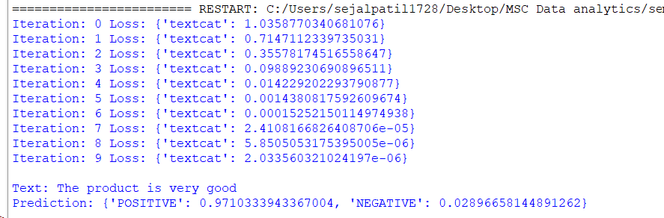

Explanation:
- POSITIVE = 97%
- NEGATIVE = 3%
➡️ So the model correctly classified the text as POSITIVE ✅

Practical No. 4

Aim: To write a Python program to find the most common words across two documents and print the frequency difference of those words.

Theory
In text analysis, word frequency refers to the number of times a word appears in a document.
Comparing word frequencies between documents helps in understanding similarities and differences in content. Finding common words across two documents is an important task in text mining, natural language processing (NLP), data analytics, and information retrieval.
By calculating the frequency difference, we can analyze how often a word is used in each document and identify dominant or less-used terms.
Python provides simple methods such as string manipulation, dictionaries, and sets to efficiently process and compare textual data.

Algorithm / Steps
- Input text from two documents.
- Convert both texts to lowercase.
- Split the text into individual words.
- Count the frequency of each word using dictionaries.
- Identify the common words using set intersection.
- Calculate and display the frequency difference for each common word.

file1.pdf
Good morning respected principal, teachers, and my dear friends.
Today I would like to say a few words about **the importance of education. Education is the key to success. It helps us gain knowledge, build confidence, and become responsible citizens of our country.
School is a place where we not only learn subjects like math and science, but also values like honesty, kindness, and discipline. Our teachers guide us and help us become better people.
As students, it is our duty to study well, respect our teachers, and make our parents proud. Education will help us achieve our dreams and make the world a better place.
Thank you and have a nice day.

file2.pdf
Good morning respected teachers and my friends,
Today I want to talk about **the importance of dreams. Every person has dreams, big or small. Dreams give us a goal to work toward and motivate us to do our best.
As students, we should dream of becoming good doctors, teachers, engineers, or anything we wish. But dreaming is not enough—we must work hard, be disciplined, and never give up.
Remember, small steps every day lead to big achievements in the future. So, let’s dream big and work hard to make our dreams come true.
Thank you.

Code:
import PyPDF2
import nltk
from nltk.tokenize import word_tokenize
from collections import Counter

nltk.download('punkt')

# Function to extract text from PDF
def get_text(file):
text = ""
with open(file, "rb") as f:
reader = PyPDF2.PdfReader(f)
for page in reader.pages:
text += page.extract_text()
return text

# Put your PDF file names here
file1 = "file1.pdf"
file2 = "file2.pdf"

# Extract text
text1 = get_text(file1)
text2 = get_text(file2)

# Tokenize words
words1 = word_tokenize(text1.lower())
words2 = word_tokenize(text2.lower())

# Count frequencies
freq1 = Counter(words1)
freq2 = Counter(words2)

# Find most common words
common_words = (freq1 + freq2).most_common(10)

print("Most Common Words:", common_words)

print("\nFrequency Difference:")
for word, _ in common_words:
print(word, "Doc1:", freq1[word], "Doc2:", freq2[word],
"Difference:", freq1[word] - freq2[word])
Output:

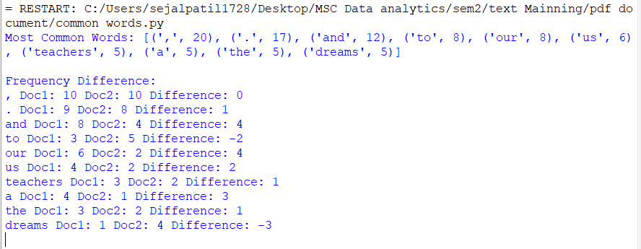

Result
Thus, the program successfully identifies the common words present in both documents and calculates the difference in their word frequencies.

Practical No. 5

Aim: To perform Information Extraction and identify initiative-related sentences from a given document.

Theory:
Information Extraction (IE) is a technique used to automatically identify important information from unstructured text such as news articles, reports, or documents.
In real-world documents, information is written in sentence form, which is difficult for computers to understand directly. IE helps convert this unstructured text into useful structured information.
An initiative refers to a planned action or program started by an organization, government, or institution to achieve a specific goal.
Examples of initiatives include:
- Government schemes
- Educational programs
- Health missions
- Social or environmental projects
In this practical, a keyword-based approach is used. If a sentence contains words like initiative, program, scheme, project, or mission, it is considered an initiative-related sentence.
This method is simple, efficient, and suitable for basic NLP tasks.

Algorithm / Steps
- Enter the document text.
- Convert the text into lowercase to avoid case mismatch.
- Define keywords related to initiatives.
- Split the document into sentences.
- Check each sentence for initiative keywords.
- Extract and display initiative sentences.

Code:

import PyPDF2
import re

# Step 1: Enter the PDF file path
pdf_path = "inatiative.pdf"

# Step 2: Open and read the PDF file
with open(pdf_path, "rb") as file:
reader = PyPDF2.PdfReader(file)
text = ""

# Step 3: Extract text from each page
for page in reader.pages:
text += page.extract_text()

# Step 4: Split the text into sentences
sentences = re.split(r'[.!?]', text)

# Step 5: Extract sentences containing the word "initiative"
print("Initiatives found in the document:\n")

for sentence in sentences:
if "initiative" in sentence.lower():
print("-", sentence.strip())

Output:
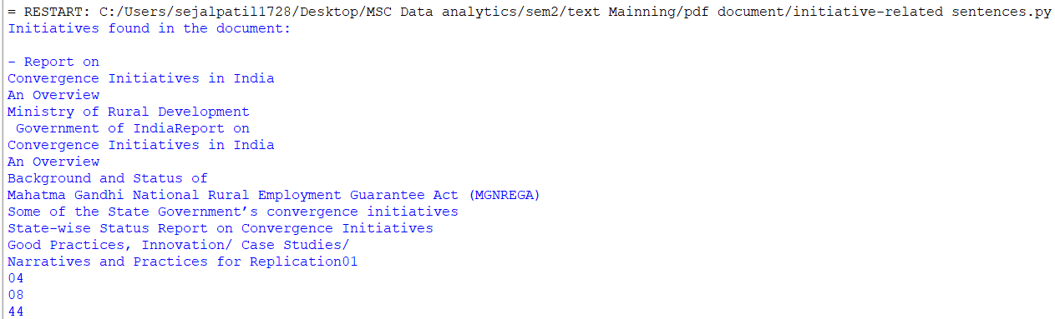

Result
Thus, the program successfully performs Information Extraction by identifying and extracting initiative-related sentences from the given document.

Practical No. 6

Aim: To create a synthetic clustering dataset and summarize its characteristics.

Theory
A synthetic dataset is an artificially generated dataset created using mathematical functions instead of real-world data.
Synthetic datasets are commonly used in machine learning for testing, learning, and experimenting because they are easy to control and understand.
Clustering is an unsupervised learning technique that groups similar data points into clusters based on their features.
Before applying clustering algorithms, it is important to understand and summarize the dataset, such as:
- Number of data points
- Number of features
- Number of clusters
- Mean and distribution of data
In this practical, we create a synthetic dataset suitable for clustering and then summarize its basic properties.

Algorithm / Steps
- Generate a synthetic dataset with multiple clusters.
- Store the dataset in variables.
- Display the total number of data points.
- Display the number of features.
- Display sample data points.
- Summarize the dataset using basic statistics.

Code:

from sklearn.datasets import make_blobs
import numpy as np

# Create synthetic clustering dataset
X, y = make_blobs(n_samples=100, centers=3, n_features=2, random_state=42)

print("Synthetic Clustering Dataset Summary\n")

# Number of data points
print("Total Data Points:", X.shape[0])

# Number of features
print("Number of Features:", X.shape[1])

# Number of clusters
print("Number of Clusters:", len(set(y)))

# Display first 5 data points
print("\nFirst 5 Data Points:")
print(X[:5])

# Summary statistics
print("\nMean of Features:")
print(np.mean(X, axis=0))

Output:

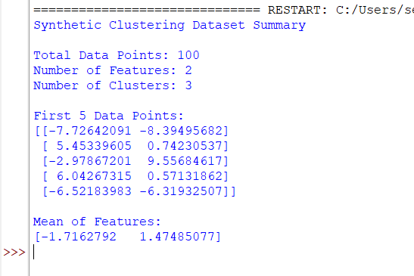

Result
Thus, the synthetic clustering dataset was successfully created and summarized, showing the number of data points, features, clusters, and basic statistical information.

Practical No. 7

Aim : To fit the BIRCH clustering model on a training dataset and predict cluster labels for each data point.

Theory :

BIRCH (Balanced Iterative Reducing and Clustering using Hierarchies) is an unsupervised clustering algorithm designed to handle large datasets efficiently.
BIRCH works by:
- Building a Clustering Feature (CF) Tree
- Summarizing large datasets into compact representations
- Performing clustering on these summaries instead of raw data
Advantages of BIRCH:
- Fast and memory-efficient
- Suitable for large datasets
- Incremental clustering (data can be added gradually)
In this practical, the BIRCH model is fitted on a training dataset and then used to predict a cluster for each data example.

Algorithm / Steps
- Create or load a dataset.
- Import the BIRCH algorithm from scikit-learn.
- Initialize the BIRCH model with the required number of clusters.
- Fit the model on the training dataset.
- Predict the cluster for each data point.
- Display the predicted cluster labels.

Code:
from sklearn.datasets import make_blobs
from sklearn.cluster import Birch

# Create synthetic dataset
X, y = make_blobs(n_samples=100, centers=3, n_features=2, random_state=42)

# Initialize BIRCH model
birch_model = Birch(n_clusters=3)

# Fit the model on training data and predict clusters
labels = birch_model.fit_predict(X)

print("BIRCH Clustering Result\n")
print("Cluster labels for each data point:\n")
print(labels)

Output:

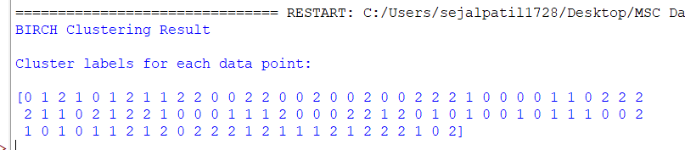

Result
Thus, the BIRCH clustering model was successfully fitted on the training dataset and cluster labels were predicted for each example in the dataset.

Practical No. 8

Aim: To extract entities and their relations from text using anaphora resolution.

Theory
In Natural Language Processing (NLP), texts often contain pronouns such as he, she, it, they. These pronouns refer back to previously mentioned nouns. This process of identifying what a pronoun refers to is called Anaphora Resolution.
- Anaphora → A word (usually a pronoun) that refers back to another word.
- Anaphora Resolution → Finding the correct noun (entity) that the pronoun refers to.
Entity Extraction
Entities are important words like:
- Person names
- Organizations
- Objects
Relation Extraction
Relations describe how entities are connected, such as:
- Person → works at → Organization
- Person → performs → Action
By resolving anaphora, we can correctly extract entities and their relationships from text.

Algorithm / Steps
- Input the text containing entities and pronouns.
- Identify named entities in the text.
- Detect pronouns in the sentences.
- Resolve pronouns by linking them to the correct entity.
- Extract entities and their relations.
- Display the extracted entities and relations.

Requirements
pip install spacy
pip install PyPDF2
python -m spacy download en_core_web_sm

Code:
import PyPDF2
import spacy

# Step 1: Load the spaCy English model
nlp = spacy.load("en_core_web_sm")

# Step 2: Provide PDF file path
pdf_path = "sample.pdf"

# Step 3: Extract text from PDF
text = ""

with open(pdf_path, "rb") as file:
reader = PyPDF2.PdfReader(file)

for page in reader.pages:
page_text = page.extract_text()
if page_text:
text += page_text

# Step 4: Process text using spaCy NLP
doc = nlp(text)

# Step 5: Print sentences
print("\nSentences in Document:\n")
for sent in doc.sents:
print(sent.text)

# Step 6: Extract named entities
print("\nEntities Found:\n")
for ent in doc.ents:
print(ent.text, "-", ent.label_)

# Step 7: Extract simple subject-object relations
print("\nRelations (Subject -> Object):\n")

subject = None

for token in doc:
if token.dep_ == "nsubj":
subject = token.text

if token.dep_ == "dobj" and subject:
print(subject, "->", token.text)

Output:

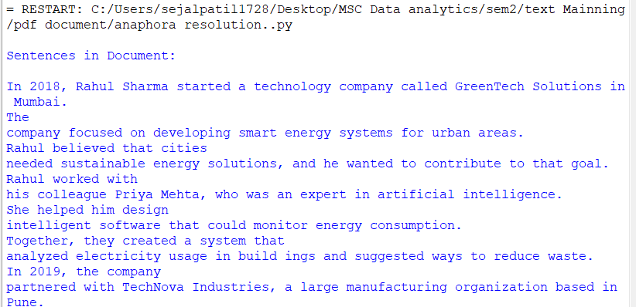

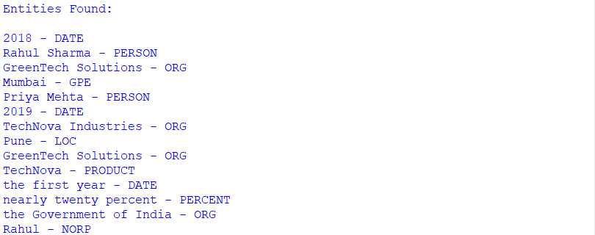

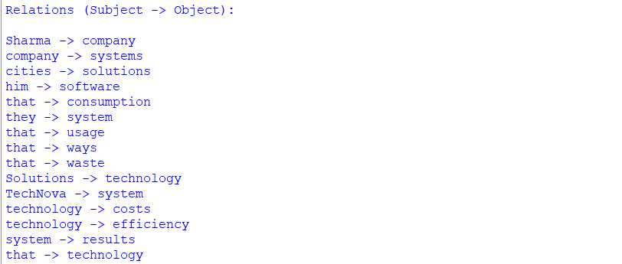

Result
Thus, the program successfully performs anaphora resolution and extracts entities and their relations from the given text.

Practical No. 9

Aim: To implement an Inductive Algorithm for extracting information from text.

Theory:
An Inductive Algorithm is a learning approach that derives general rules from specific examples.
Instead of using predefined rules, the algorithm observes patterns in data and induces rules automatically.
In Information Extraction (IE), inductive learning is used to:
- Learn patterns from example sentences
- Extract structured information such as entities, actions, and relations
- Generalize rules that can be applied to new text
For example:
- From the sentence “Ravi works at Infosys”,
the algorithm learns the pattern:
Person + works at + Organization
This learned rule can then be applied to new sentences.

Algorithm / Steps
- Provide example sentences (training data).
- Identify patterns from the examples.
- Generate extraction rules inductively.
- Apply the learned rules to new sentences.
- Extract and display information.

Code:
import PyPDF2
import spacy

# Load NLP model
nlp = spacy.load("en_core_web_sm")

# Step 1: PDF file path
pdf_path = "sample.pdf"

# Step 2: Extract text from PDF
text = ""
with open(pdf_path, "rb") as file:
reader = PyPDF2.PdfReader(file)
for page in reader.pages:
text += page.extract_text()

# Step 3: Process extracted text
doc = nlp(text)

print("Extracted Relations:\n")

# Step 4: Apply simple inductive pattern
for sent in doc.sents:
person = None
org = None

for ent in sent.ents:
if ent.label_ == "PERSON":
person = ent.text
if ent.label_ == "ORG":
org = ent.text

if person and org:
print(person, "-> works at ->", org)

Output:
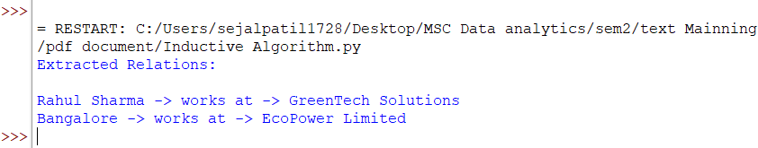

Result
Thus, the inductive algorithm successfully learned extraction rules from examples and applied them to extract information from new text.

Practical No. 10

Aim : To implement a Maximum Entropy Markov Model for Information Extraction.

Theory:
A Maximum Entropy Markov Model (MEMM) is a probabilistic sequence labeling model used in Information Extraction and Natural Language Processing.
MEMM combines:
- Markov property → Current state depends on the previous state
- Maximum Entropy principle → Choose the most uniform (least biased) model that fits the data
MEMM is mainly used for:
- Named Entity Recognition (NER)
- Part-of-Speech tagging
- Information Extraction
Why MEMM?
- It uses contextual features (current word, previous tag, etc.)
- It predicts the best label sequence for words in a sentence
In IE, MEMM helps identify entities and labels such as:
- PERSON
- ORGANIZATION
- LOCATION

Algorithm / Steps
- Prepare labeled training data.
- Extract features for each word.
- Train a Maximum Entropy classifier.
- Use previous state (label) as context.
- Predict labels for new sentences.
- Extract information based on predicted labels.

Code:
from sklearn.linear_model import LogisticRegression
from sklearn.feature_extraction import DictVectorizer

# Training data
data = [
[("John", "O"), ("is", "O"), ("a", "O"), ("Software", "JOB"), ("Engineer", "JOB")],
[("Alice", "O"), ("worked", "O"), ("as", "O"), ("Data", "JOB"), ("Scientist", "JOB")],
]

# Feature function
def get_features(sent, i):
word = sent[i][0]
return {
'word': word.lower(),
'is_cap': word[0].isupper(),
'prev': sent[i-1][0].lower() if i > 0 else "<START>",
'next': sent[i+1][0].lower() if i < len(sent)-1 else "<END>",
}

# Prepare training
X, y = [], []
for sent in data:
for i in range(len(sent)):
X.append(get_features(sent, i))
y.append(sent[i][1])

vec = DictVectorizer(sparse=False)
X_vec = vec.fit_transform(X)
clf = LogisticRegression(max_iter=200)
clf.fit(X_vec, y)

# Prediction function
def predict(sent):
tokens = [(w, "O") for w in sent]
feats = [get_features(tokens, i) for i in range(len(tokens))]
return clf.predict(vec.transform(feats))

# Test sentence
test = ["David", "is", "a", "Machine", "Learning", "Engineer"]
predicted = predict(test)
for w, tag in zip(test, predicted):
print(f"{w}: {tag}")

Output:
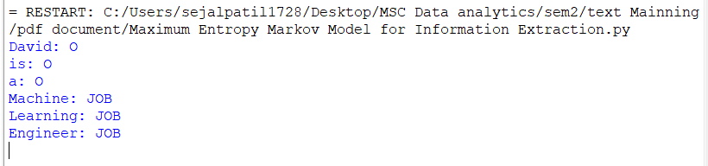

Practical No. 11

Aim: To implement a Hidden Markov Model for Information Extraction.

Theory
A Hidden Markov Model (HMM) is a probabilistic sequence model used to analyze data where:
- The system has hidden states (not directly observable)
- Each state produces an observable output
In Information Extraction,
- Hidden states → Entity labels (PERSON, ORGANIZATION, O, etc.)
- Observations → Words in the sentence
Key Components of HMM
- States (S) – Entity labels
- Observations (O) – Words
- Transition Probability (A) – Probability of moving from one state to another
- Emission Probability (B) – Probability of observing a word from a state
- Initial Probability (π) – Probability of starting in a state
HMM uses algorithms such as:
- Forward algorithm
- Viterbi algorithm (used to find the most likely label sequence)

Algorithm / Steps
- Define hidden states and observations.
- Initialize transition, emission, and initial probabilities.
- Input a sentence (observations).
- Apply the Viterbi algorithm.
- Predict entity labels for each word.
- Extract information from labeled output.

Code:
# Install required libraries
# pip install nltk hmmlearn PyPDF2

import nltk
from hmmlearn import hmm
import numpy as np
import PyPDF2

# Download tokenizer if not already
nltk.download('punkt')

# Step 1: Read text from PDF
pdf_path = "data.pdf" # Replace with your PDF path
text = ""
with open(pdf_path, "rb") as file:
reader = PyPDF2.PdfReader(file)
for page in reader.pages:
page_text = page.extract_text()
if page_text:
text += page_text + " "

# Step 2: Tokenize text
tokens = nltk.word_tokenize(text)

# Build vocabulary mapping
vocab = list(set(tokens))
word_to_idx = {word: i for i, word in enumerate(vocab)}
idx_to_word = {i: word for word, i in word_to_idx.items()}

# Convert tokens to numeric observations
observations = np.array([word_to_idx[w] for w in tokens]).reshape(-1, 1)

# Step 3: Define HMM (unsupervised)
n_states = 4 # Can interpret as PERSON, ORG, LOC, O
model = hmm.MultinomialHMM(n_components=n_states, n_iter=50, tol=0.01, random_state=42)

# Train model using Baum-Welch
model.fit(observations)

# Step 4: Decode hidden states
logprob, hidden_states = model.decode(observations, algorithm="viterbi")

print("\nTokens and Hidden States:")
for word, state in zip(tokens, hidden_states):
print(f"{word} -> State {state}")

# Step 5: Group words by hidden states (clusters)
clusters = {}
for word, state in zip(tokens, hidden_states):
clusters.setdefault(state, []).append(word)

print("\nDiscovered clusters of words (HMM Hidden States):")
for state, words in clusters.items():
print(f"State {state}: {words[:10]} ...") # show first 10 words per cluster for readability

Output:
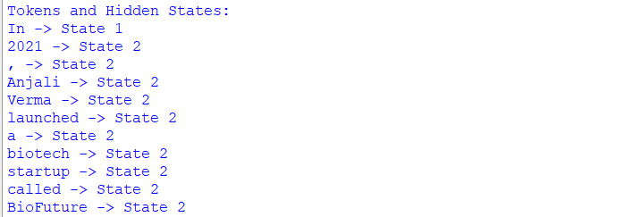

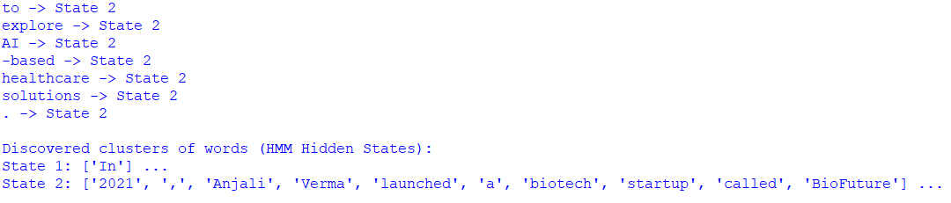

Result
Thus, the Hidden Markov Model was successfully implemented to perform Information Extraction by predicting entity labels using the Viterbi algorithm.

Practical No. 12

Aim: To demonstrate the use of Conditional Random Field (CRF) model for Named Entity Recognition (NER) using Python.

Theory
Named Entity Recognition (NER) is a key task in Natural Language Processing (NLP) that involves identifying and classifying named entities in text into predefined categories such as Person, Location, Organization, Date, etc.
A Conditional Random Field (CRF) is a probabilistic, discriminative model used for labeling sequential data. Unlike traditional classifiers that predict labels independently, CRF considers the context and dependency between neighboring words in a sentence. This property makes CRF highly suitable for NER tasks.
In CRF-based NER:
- Each word in a sentence is treated as a sequence element.
- Various features such as the word itself, capitalization, part-of-speech (POS) tag, and surrounding words are extracted.
- CRF predicts the most probable sequence of entity labels for the entire sentence.
- Common tags include B-PER, I-PER, B-LOC, and O.
CRF ensures global optimization of the label sequence, resulting in better accuracy for entity recognition compared to independent word classifiers.

Algorithm
- Collect and prepare labeled training data.
- Extract relevant features from each word.
- Train the CRF model using the training data.
- Provide a test sentence as input.
- Predict named entity tags for each word.
- Display the output.

Code:
# Install required libraries
# pip install PyPDF2 spacy
# python -m spacy download en_core_web_sm

import PyPDF2
import spacy

# -----------------------------
# Step 1: Load pre-trained NLP model
# -----------------------------
nlp = spacy.load("en_core_web_sm") # Pre-trained NER model

# -----------------------------
# Step 2: Read unstructured text from PDF
# -----------------------------
pdf_path = "data.pdf" # Your PDF file
text = ""
with open(pdf_path, "rb") as file:
reader = PyPDF2.PdfReader(file)
for page in reader.pages:
page_text = page.extract_text()
if page_text:
text += page_text + " "

# -----------------------------
# Step 3: Process text with NER
# -----------------------------
doc = nlp(text)

# -----------------------------
# Step 4: Extract and display entities
# -----------------------------
print("Extracted Entities:\n")
for ent in doc.ents:
print(f"{ent.text} -> {ent.label_}")

Output:
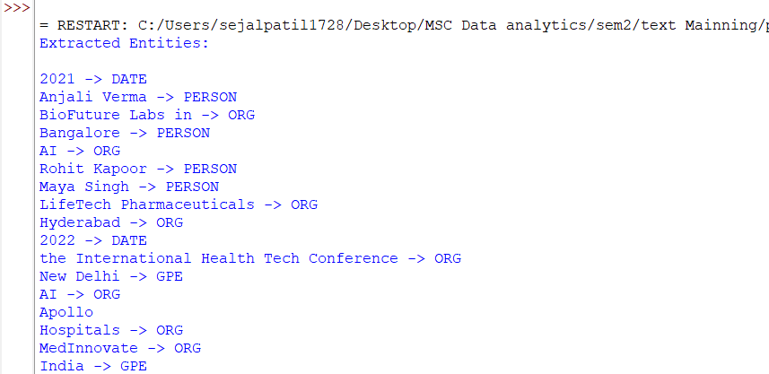

Conclusion
The CRF model effectively performs Named Entity Recognition by considering both the features of individual words and their contextual relationships. This practical demonstrates how CRF improves entity labeling accuracy in sequential text data.

Practical No. 13

Aim: To evaluate the progress of model training using performance metrics and learning curves.

Theory
In Machine Learning, model training is an iterative process where a model learns patterns from training data. Evaluating the progress of model training is important to understand whether the model is learning properly, underfitting, or overfitting.
The progress of training is commonly evaluated by monitoring:
- Training loss – error on training data
- Validation loss – error on unseen data
- Accuracy – percentage of correct predictions
- Learning curves – graphical representation of model performance over epochs
If:
- Training loss decreases and validation loss also decreases → Good learning
- Training loss decreases but validation loss increases → Overfitting
- Both losses remain high → Underfitting
Thus, evaluating training progress helps in deciding model improvements such as changing parameters, increasing data, or stopping training early.

In this practical:
- A PDF document is used as input
- Text is extracted from the PDF
- The text is converted into numerical features using TF-IDF
- A Naive Bayes model is trained
- Performance metrics and learning curves are calculated.
Machine learning algorithms such as Naive Bayes, SVM, Random Forest, etc. are widely used for text classification tasks.

Code:
import PyPDF2
import matplotlib.pyplot as plt

from sklearn.feature_extraction.text import TfidfVectorizer
from sklearn.model_selection import train_test_split, learning_curve
from sklearn.naive_bayes import MultinomialNB
from sklearn.metrics import accuracy_score, precision_score, recall_score, f1_score

# Step 1: Extract text from PDF
pdf_path = "Machine_Learning_Algorithms_for_Text_Documents_Classification.pdf"

text = ""

with open(pdf_path, "rb") as file:
reader = PyPDF2.PdfReader(file)

for page in reader.pages:
page_text = page.extract_text()
if page_text:
text += page_text

# Step 2: Split text into sentences
sentences = text.split(".")

# remove empty sentences
sentences = [s.strip() for s in sentences if len(s.strip()) > 5]

# Step 3: Create dummy labels
# (only for training demonstration)
labels = [0 if i % 2 == 0 else 1 for i in range(len(sentences))]

# Step 4: Convert text to TF-IDF
vectorizer = TfidfVectorizer(stop_words='english')

X = vectorizer.fit_transform(sentences)
y = labels

# Step 5: Train-Test Split
X_train, X_test, y_train, y_test = train_test_split(
X, y, test_size=0.2, random_state=42
)

# Step 6: Train Model
model = MultinomialNB()

model.fit(X_train, y_train)

# Step 7: Predictions
y_pred = model.predict(X_test)

# Step 8: Performance Metrics
accuracy = accuracy_score(y_test, y_pred)
precision = precision_score(y_test, y_pred)
recall = recall_score(y_test, y_pred)
f1 = f1_score(y_test, y_pred)

print("Model Performance")
print("----------------------")
print("Accuracy :", accuracy)
print("Precision:", precision)
print("Recall :", recall)
print("F1 Score :", f1)

# Step 9: Learning Curve
train_sizes, train_scores, test_scores = learning_curve(
model, X, y, cv=5, scoring='accuracy'
)

train_scores_mean = train_scores.mean(axis=1)
test_scores_mean = test_scores.mean(axis=1)

plt.plot(train_sizes, train_scores_mean, label="Training Score")
plt.plot(train_sizes, test_scores_mean, label="Validation Score")

plt.title("Learning Curve")
plt.xlabel("Training Size")
plt.ylabel("Accuracy")
plt.legend()

plt.show()

Output:
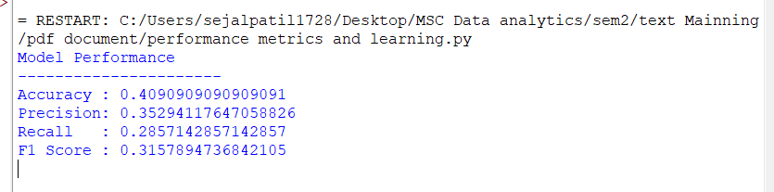
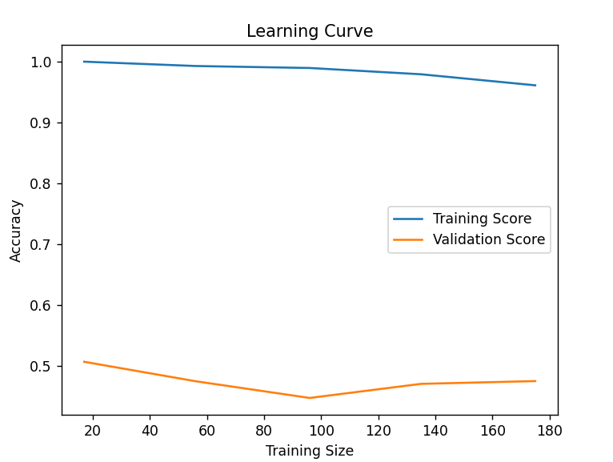

Conclusion
Evaluating the progress of model training helps in understanding model performance and learning behavior. By comparing training and testing accuracy, we can decide whether the model is learning effectively or needs improvement.

Practical No. 14

Aim: To perform book recommendation based on user interest in Python.

Theory
A Recommendation System is an intelligent system that suggests items to users based on their preferences or interests. In this practical, a content-based recommendation approach is used.
In content-based recommendation, items are suggested by matching the user’s interest with item features. Here:
- Books are described using keywords such as Python, Data Science, Machine Learning, Web Development.
- The user’s interest is given as “Python”.
- Books containing the keyword Python in their description are recommended.
This approach does not depend on other users and works well for personalized recommendations.

Algorithm
- Create a dataset of books with their categories/interests.
- Accept user interest as input.
- Compare user interest with book categories.
- Select books matching the interest.
- Display the recommended books.

Code:
books = [
{"title": "Python Programming Basics", "interest": "Python"},
{"title": "Advanced Python Concepts", "interest": "Python"},
{"title": "Machine Learning Fundamentals", "interest": "Machine Learning"},
{"title": "Data Science with Python", "interest": "Python"},
{"title": "Web Development Essentials", "interest": "Web Development"},
{"title": "Artificial Intelligence Overview", "interest": "AI"}
]

# -----------------------------
# User Interest
# -----------------------------
user_interest = "Python"

# -----------------------------
# Recommendation Logic
# -----------------------------
recommended_books = []

for book in books:
if book["interest"] == user_interest:
recommended_books.append(book["title"])

# -----------------------------
# Output
# -----------------------------
print("User Interest:", user_interest)
print("\nRecommended Books:")

if recommended_books:
for book in recommended_books:
print("-", book)
else:
print("No books found for this interest.")

Output:

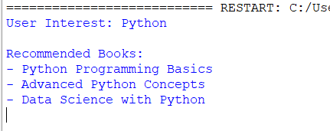

Result
Books related to the user’s interest Python are successfully recommended using a content-based filtering approach.

Practical No. 15

Aim: To perform movie recommendation based on user emotion using Python.

Theory
A Movie Recommendation System suggests movies to users based on their preferences or emotional state.
In this practical, an emotion-based recommendation approach is used.
Human emotions strongly influence movie choices. For example:
- A happy person prefers comedy or feel-good movies.
- A sad person may prefer emotional or motivational movies.
- An excited person may enjoy action or adventure movies.
In this method:
- Movies are grouped according to emotions.
- The user provides their current emotion.
- Movies matching that emotion are recommended.
This approach improves user satisfaction by aligning recommendations with emotional needs.

Algorithm
- Create a dataset of movies categorized by emotions.
- Accept user emotion as input.
- Match the emotion with movie categories.
- Recommend movies related to the emotion.
- Display the recommended movies.

Code:

# -----------------------------
# Movie Dataset based on Emotion
# -----------------------------
movies = {
"happy": [
"3 Idiots",
"The Intern",
"Zindagi Na Milegi Dobara"
],
"sad": [
"The Pursuit of Happyness",
"Taare Zameen Par",
"Hachi: A Dog's Tale"
],
"excited": [
"Avengers",
"Mission Impossible",
"Fast and Furious"
],
"romantic": [
"Titanic",
"The Notebook",
"Dilwale Dulhania Le Jayenge"
]
}

# -----------------------------
# User Emotion
# -----------------------------
user_emotion = input("Enter your emotion (happy/sad/excited/romantic): ").lower()

# -----------------------------
# Recommendation Logic
# -----------------------------
print("\nMovie Recommendations:")

if user_emotion in movies:
for movie in movies[user_emotion]:
print("-", movie)
else:
print("Sorry, no movies found for this emotion.")

Output:
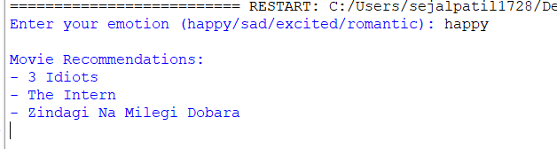

Result
Movies are successfully recommended based on the user’s emotional state.

