**Sales Data Analysis & Growth Recommendations**

**Key Insights**

# Data Cleaning

* The dataset was checked for missing values and duplicates, and a redundant column (Region_and_Sales_Rep) was dropped.
* A new column, Profit, was calculated

# General EDA (Exploratory Data Analysis)

* Descriptive statistics (via .describe() and .info()) were performed to understand data distribution and structure.
* No advanced statistical or predictive analysis was done; the focus remained on visualization and basic profit computation.

# Sales Analysis by Product

* A barplot shows the total sales amount for each product category. From the code, we have used distinct color palettes to highlight different products.

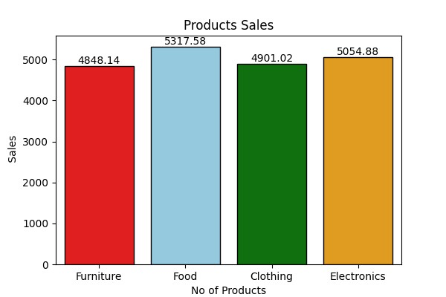

# Regional Sales Analysis

* The number of products sold was plotted by region, showing differences in regional performance.
* This reveals which regions have higher product demand.

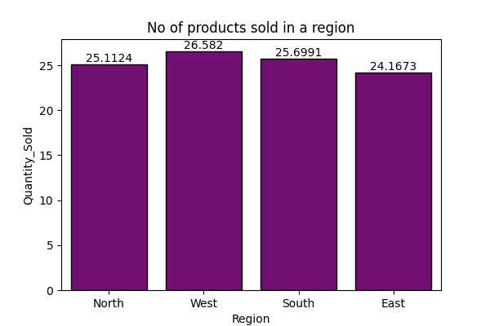

# Payment Methods

• A countplot revealed the most frequently used payment methods, highlighting customer preferences in transaction modes.

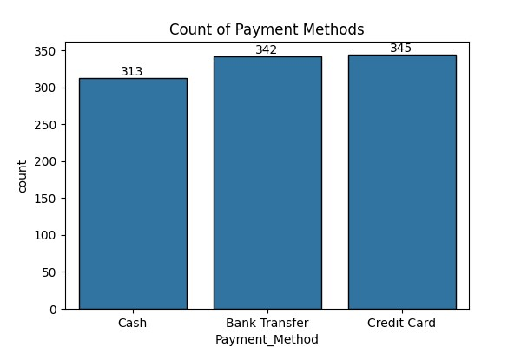

# Sales Channel Recommendation

• **Diversify and Optimize Sales Channels**: Analyze which sales channels (e.g., retail stores, e-commerce, distributors) contribute the most revenue and profit.

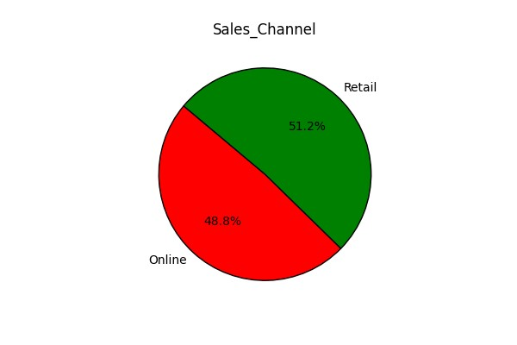

# Recommended Decisions to Improve Sales

## 1. Focus on High-Profit Products

* Promote and prioritize product categories with the highest profit margins through targeted marketing campaigns.
* Consider bundling these high-profit products with slower-selling ones to increase overall revenue.

## 2. Strengthen Regional Strategy

* Allocate more resources (ads, stock, staff) to regions with higher product demand to maximize sales.
* Investigate underperforming regions for potential issues (e.g., logistics, pricing, awareness) and address them.

## 3. Optimize Payment Methods

* Ensure seamless support for the most popular payment methods to remove friction at checkout.
* Consider offering incentives for using lower-fee payment methods to improve your margins.

## 4. Data-Driven Promotions

• Use the insights from sales patterns to design promotions at the right time and place — for example, discounts on products with declining sales, or loyalty programs in low-sales regions.

## 5. Product Diversification

* If a few products dominate sales, explore introducing similar products to capture related customer interests.
* This reduces reliance on a single product category.