PROJECT REPORT
Smart Parking Management System
A Web-Based Application Using C++ (Crow), MySQL and Data Structures
Subject: Advanced Data Structures
Submitted by
Sumanpreet Kaur (25BCS11242)
Sejal Gupta (25BCS10328)
Ranjini (25BCS12371)
Class: 801-A
in partial fulfillment for the award of the degree of
BACHELOR OF ENGINEERING
IN
COMPUTER SCIENCE AND ENGINEERING

Chandigarh University
Institute of Engineering, UIE
Under the Guidance of
Mr. Tauseef
November 2026
BONAFIDE CERTIFICATE
Certified that this project report "Smart Parking Management System" is the Bonafide work of Sumanpreet Kaur (25BCS11242) who carried out the project work for the subject Advanced Data Structures under our supervision.
SIGNATURE  Head of the Department  Mrs. Jaspreet Kaur  Department of CSE  Chandigarh University | SIGNATURE  Supervisor / Guide  Mr. Tauseef  Assistant Professor, UIE  Chandigarh University

Submitted for the project viva-voce examination held on ____________________
INTERNAL EXAMINER | EXTERNAL EXAMINER

ABSTRACT
Finding a free parking space is a daily problem in colleges, offices, markets and residential areas. When parking is managed on paper registers or by simple guesswork, drivers lose time searching for a space, slots are allotted without a clear rule, vehicles that arrive when the parking area is full have no fair order of waiting, and no proper record of parking activity is kept. This project presents the design and development of the Smart Parking Management System, a web-based application that automates parking slot management. A user can register, log in, view available and occupied parking slots, book a slot, enter the vehicle registration number and release the slot when leaving. An admin dashboard allows the administrator to manage parking slots, monitor occupied and available spaces, view vehicle details and track the booking history.
The frontend is built with HTML, CSS and JavaScript, the backend is written in C++ using the Crow framework, the data is stored in a MySQL database, and the frontend and backend communicate through a REST API using JSON. Since the project is developed for the subject Advanced Data Structures, its main focus is the use of suitable data structures for each part of the problem. A Queue maintains the waiting list so that the vehicle that arrives first gets the first available slot (FIFO). A Min Heap (priority queue) keeps the free slot numbers so that the smallest-numbered available slot is allocated efficiently. A HashMap uses the vehicle registration number as the key and gives average O(1) vehicle lookup. A Stack records the recent parking entry and exit operations (LIFO) and can support an undo feature.
The project is intended as a practical demonstration of how Queue, Min Heap, HashMap and Stack solve a real-world parking management problem when they are combined with C++ backend development and MySQL database management.
TABLE OF CONTENTS
ABSTRACT i
LIST OF ABBREVIATIONS iii
CHAPTER 1: INTRODUCTION 1
1.1 Identification of Client / Need / Relevant Contemporary Issue 1
1.2 Identification of Problem 1
1.3 Identification of Tasks 1
1.4 Timeline 2
1.5 Organization of the Report 2
CHAPTER 2: LITERATURE REVIEW / BACKGROUND STUDY 3
2.1 Timeline of the Reported Problem 3
2.2 Existing Solutions 3
2.3 Bibliometric Analysis 3
2.4 Review Summary 4
2.5 Problem Definition 4
2.6 Goals / Objectives 4
CHAPTER 3: DESIGN FLOW / PROCESS 5
3.1 Evaluation and Selection of Specifications / Features 5
3.2 Design Constraints 5
3.3 Analysis of Features and Finalization 5
3.4 Design Flow 6
3.5 Design Selection 7
3.6 Implementation Plan / Methodology 11
CHAPTER 4: RESULTS ANALYSIS AND VALIDATION 13
4.1 Implementation of Solution 13
4.2 Complexity Analysis 13
4.3 Testing and Validation 14
CHAPTER 5: CONCLUSION AND FUTURE WORK 16
5.1 Conclusion 16
5.2 Future Work 16
REFERENCES 17
APPENDIX 18
DESIGN CHECKLIST 19

LIST OF ABBREVIATIONS
Abbreviation | Full Form
ADS | Advanced Data Structures
API | Application Programming Interface
CSS | Cascading Style Sheets
DB | Database
DSA | Data Structures and Algorithms
ER | Entity Relationship
FIFO | First In, First Out
HTML | HyperText Markup Language
HTTP | HyperText Transfer Protocol
JS | JavaScript
JSON | JavaScript Object Notation
LIFO | Last In, First Out
PK / FK | Primary Key / Foreign Key
REST | Representational State Transfer
SQL | Structured Query Language
UI | User Interface

CHAPTER 1: INTRODUCTION

1.1 Identification of Client / Need / Relevant Contemporary Issue
The number of vehicles keeps growing, but the space available for parking in colleges, offices, hospitals, markets and residential societies is limited. At busy times a driver may drive around the parking area for several minutes only to find that every slot is occupied. The parking staff, on the other hand, often keep the details of incoming and outgoing vehicles in a paper register, which is slow to search, easy to get wrong and difficult to summarise. Time lost in searching for parking, queues at entry gates and unclear slot allotment are widely recognised as everyday problems of crowded places.
There are two clients for this project. The first is the vehicle user, who wants to know quickly which slots are free, book one and release it when leaving. The second is the parking administrator, who wants to manage the slots, see how many are occupied or available, look up vehicle details and check the history of bookings. Both need a single, simple tool that replaces the register and the guesswork.

1.2 Identification of Problem
A manual or loosely organised parking system has the following problems:
- No live view of slots: the driver cannot know which slots are free without going and looking.
- Unclear allotment rule: slots are given at the staff member's choice, so the same area may be crowded while other slots stay empty.
- No fair waiting order: when the parking area is full, there is no record of which vehicle came first, so the order of waiting vehicles is decided by argument or favour.
- Slow searching: finding the details of one vehicle in a long register or an unsorted list means checking records one by one, and this becomes slower as the records grow.
- No history: entry and exit records are scattered or lost, so the administrator cannot easily review past bookings or correct a recent mistake.
There is a need for a web-based parking management system that automates slot allocation, keeps a fair waiting list, finds a vehicle quickly, records recent operations and stores all data safely in a database. The system should use data structures that are suited to each of these jobs so that it stays fast when the number of slots and vehicles increases.

1.3 Identification of Tasks
The following tasks were identified for the completion of this project:
- Study the working of parking systems and decide the scope of the application.
- Select the technology stack: HTML, CSS and JavaScript for the frontend, C++ with the Crow framework for the backend, MySQL for the database, and REST API with JSON for communication.
- Select the data structures for the project and decide where each one is used: Queue, Min Heap, HashMap and Stack.
- Design the relational database and the relationships between its tables.
- Develop user registration and login.
- Develop viewing of available and occupied slots, and automatic slot allocation using a Min Heap.
- Develop vehicle registration management and fast vehicle search using a HashMap.
- Develop parking booking and release, the waiting list using a Queue, and the record of recent operations using a Stack.
- Develop the booking history and the admin dashboard.
- Connect the frontend with the backend through the REST API, test every module and document the project.

1.4 Timeline
The project was planned to be completed in one week (7 days), carried out phase by phase.
Day | Activity
Day 1 | Problem study, scope decision, selection of data structures and design of the MySQL database (Phases 1 and 2)
Day 2 | C++ backend setup with Crow, database connection, user registration and login (Phases 3 and 4)
Day 3 | Min Heap based slot allocation and slot booking (Phase 5)
Day 4 | HashMap based vehicle management and release, waiting list Queue and operations Stack (Phases 6 and 7)
Day 5 | Frontend pages in HTML, CSS and JavaScript and connection with the REST API (Phase 8)
Day 6 | Admin dashboard and booking history (Phase 9)
Day 7 | Testing, documentation and viva preparation (Phase 10)

A Gantt chart of this plan is given in Appendix A.

1.5 Organization of the Report
Chapter 1 introduces the need, the problem and the tasks of the project. Chapter 2 reviews existing approaches to parking management and states the problem definition and objectives. Chapter 3 explains the design flow, the selected technology, the system architecture, the database design, the design of the four data structures and the implementation methodology. Chapter 4 presents the implementation of each module, the complexity analysis and the testing carried out. Chapter 5 concludes the work and lists directions for future work. References, an appendix and the design checklist follow.

CHAPTER 2: LITERATURE REVIEW / BACKGROUND STUDY

2.1 Timeline of the Reported Problem
Parking has been managed in many ways over time. Early arrangements depended on an attendant who allowed vehicles in and kept a handwritten register. Ticket machines and barrier gates later reduced the manual work at the entry and exit, but they only count or control vehicles at the gate and do not tell the driver which slot is free. More recent smart parking systems use sensors or cameras to detect occupied slots, and mobile and web applications now let users look for and reserve parking in advance. These systems improve convenience, but many college-level and small-scale parking systems still depend on registers or on simple database applications that store records without using efficient data structures.
On the algorithmic side, the data structures used in this project are well established. The binary heap, which is the basis of the priority queue, was introduced by J. W. J. Williams in 1964 [6], and the queue, stack and hash table are standard structures taught in every data structures course [4], [5]. The problem of parking management matches these structures naturally: waiting vehicles form a queue, the choice of the best free slot is a priority problem, vehicle lookup is a search problem and the latest operation is a stack problem.

2.2 Existing Solutions
The approaches commonly used for parking management can be grouped as follows:
- Manual register and attendant: simple and cheap, but slow to search, error-prone and without a summary or history.
- Ticket machine and barrier gate systems: control entry and exit and count vehicles, but do not guide the driver to a free slot and do not keep a waiting list.
- Sensor and camera based smart parking: detect free slots automatically, but need extra hardware, installation and maintenance cost.
- Mobile parking applications: convenient for booking, but many are online services that depend on an internet connection and on an external company.
- Simple database web applications: store users, slots and bookings, but often allot slots without a rule, search records linearly and have no waiting list order.

2.3 Bibliometric Analysis
The table compares the main approaches in general terms. It is a qualitative comparison and not a ranking of any specific product.
Approach | Key Features | Effectiveness | Drawbacks
Manual register | Handwritten entry and exit records | Easy to start | Slow search, no totals, no history, no waiting order
Ticket and barrier system | Controls the gate, counts vehicles | Good for gate control | Does not show free slots or keep a waiting list
Sensor based smart parking | Automatic detection of free slots | Very accurate | Needs extra hardware and maintenance cost
Mobile parking application | Online search and booking | Convenient for users | Needs internet and an external service
Simple database web application | Stores slots, users and bookings | Keeps records | No allocation rule, linear search, no waiting order
Smart Parking Management System (this project) | Min Heap allocation, Queue waiting list, HashMap vehicle search, Stack of recent operations, admin dashboard | Fast, fair and organised slot management on a MySQL database | No sensors or online payment; slot status depends on bookings and releases

2.4 Review Summary
The review shows that existing approaches solve parts of the problem. Manual systems are cheap but slow, gate systems control entry but do not guide the driver, and sensor based systems are effective but costly. Simple software systems keep records, but they often do not use data structures that make allocation, waiting and searching efficient and fair. A web-based system with a C++ backend and a MySQL database can combine all these needs at low cost, and the choice of Queue, Min Heap, HashMap and Stack gives the project a clear and explainable algorithmic design, which suits a project for the subject Advanced Data Structures.

2.5 Problem Definition
The problem is to design and develop a web-based parking management application in which a user can register, log in, view available and occupied slots, book a slot with a vehicle registration number and release it when leaving, in which the smallest-numbered free slot is allotted automatically, vehicles wait in first-come first-served order when the parking area is full, vehicles can be found quickly by registration number, and recent entry and exit operations are recorded, while an administrator manages the slots and monitors vehicles and bookings from a dashboard and all data is stored in a MySQL database.

2.6 Goals / Objectives
- To develop a web-based application with an HTML, CSS and JavaScript frontend, a C++ backend using the Crow framework and a MySQL database.
- To provide user registration and login.
- To show the available and occupied parking slots to the user.
- To allocate parking slots automatically using a Min Heap so that the smallest-numbered available slot is given first.
- To manage vehicle registration and search vehicles quickly by registration number using a HashMap.
- To provide parking booking and release.
- To manage the waiting list using a Queue (FIFO) when all slots are occupied.
- To record recent entry and exit operations using a Stack (LIFO), which can support an undo feature.
- To maintain the booking history and to provide an admin dashboard for slot management and monitoring.
- To demonstrate how Queue, Min Heap, HashMap and Stack solve real-world parking problems, and to test and document the application.

CHAPTER 3: DESIGN FLOW / PROCESS

3.1 Evaluation and Selection of Specifications / Features
After studying the problem, the following specifications were finalized for the project.
Parameter | Selected Specification
Application type | Web-based application used through a web browser
Frontend | HTML, CSS and JavaScript
Backend | C++ using the Crow framework
Database | MySQL
Communication | REST API with data exchanged in JSON format
Data structures | Queue, Min Heap (priority queue), HashMap and Stack
Users of the system | Normal user and Administrator

3.2 Design Constraints
- Scope constraint: The project is developed for the subject Advanced Data Structures, so only the listed modules are built and the design is kept simple enough to be explained in a viva.
- Cost constraint: Only free tools and technologies are used (HTML, CSS, JavaScript, C++, the Crow framework and MySQL).
- Consistency constraint: The data structures that are kept in the memory of the backend must always agree with the data stored in MySQL, so every change is written to both.
- Performance constraint: Slot allocation, vehicle search and waiting list operations must stay fast even when the number of slots and vehicles grows, which is why efficient data structures are selected.
- Security constraint: Only registered users can book slots, and the admin functions are available only to the administrator.
- Usability constraint: The web interface must be clean and easy for a first-time user.
- Platform constraint: The user needs only a web browser; the server needs the C++ backend and a running MySQL database.

3.3 Analysis of Features and Finalization
The following modules and features were finalized. No feature outside this list was added.
No. | Module / Feature | Description
1 | User Registration and Login | A new user registers and then logs in to use the system
2 | Slot View | Shows the available and occupied parking slots
3 | Automatic Slot Allocation | Allocates the smallest-numbered available slot using a Min Heap
4 | Vehicle Registration Management | Stores the vehicle registration number and finds vehicles quickly using a HashMap
5 | Parking Booking and Release | The user books a slot, enters the vehicle registration number and releases the slot when leaving
6 | Waiting List Management | Vehicles wait in a Queue (FIFO) when all slots are occupied
7 | Recent Operations Record | Recent entry and exit operations are kept in a Stack (LIFO), which can support an undo feature
8 | Booking History | Keeps a record of past and current bookings
9 | Admin Dashboard | Manages parking slots, shows occupied and available spaces, vehicle details and booking history

Features such as online payment, sensor integration, a mobile application and notifications were deliberately left out to keep the project manageable. They are listed under Future Work.

3.4 Design Flow
The application follows a layered design. Each layer has one responsibility and talks mainly to the layer next to it.
Layer | Technology | Responsibility
Presentation | HTML, CSS, JavaScript | Web pages for the user and the administrator; collect input and display data
Communication | REST API, JSON | Carries requests from the browser to the backend and responses back
Application | C++ with Crow | Receives requests, applies the booking rules and sends responses
Data Structure | Queue, Min Heap, HashMap, Stack | Keeps the waiting list, free slots, vehicle lookup table and recent operations in memory
Database | MySQL | Stores users, slots, vehicles, bookings and the waiting list permanently

The flow of a request is: Browser (JavaScript) → REST API request in JSON → Crow route in the C++ backend → data structure operation and MySQL update → JSON response → Browser. Figure 3.1 shows the architecture, and Figure 3.2 shows the flow of booking and releasing a slot.
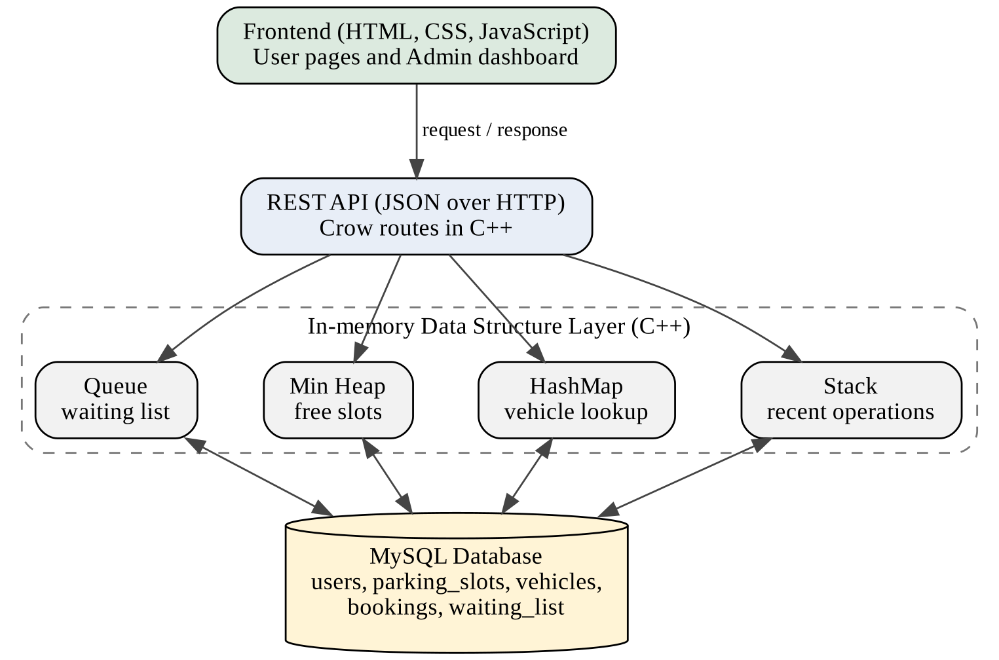
Figure 3.1: System architecture of the Smart Parking Management System
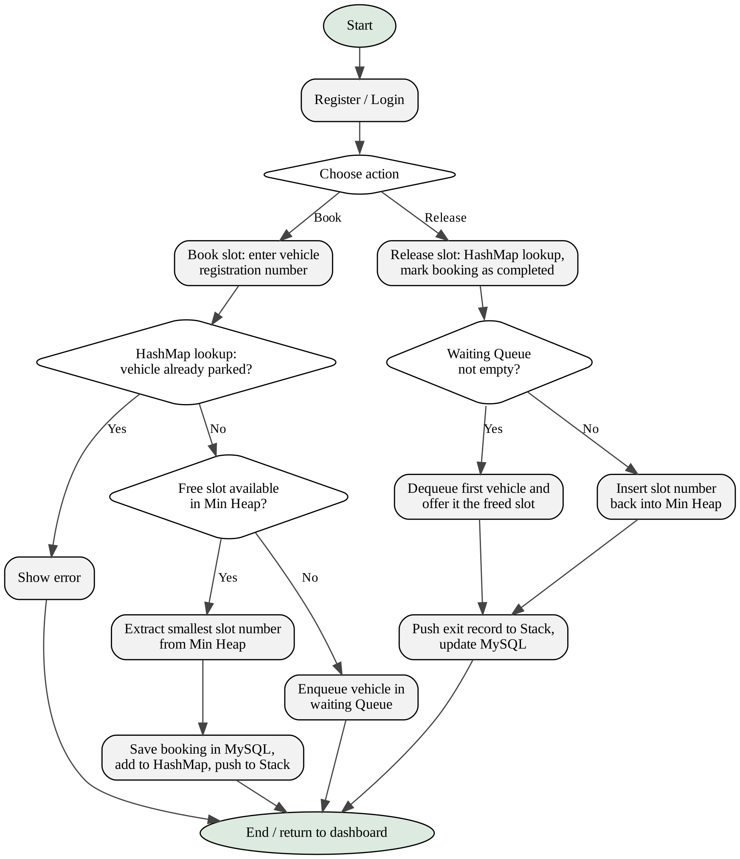
Figure 3.2: Flowchart of booking and releasing a parking slot

3.5 Design Selection

3.5.1 Database Design
The MySQL database contains five tables: users, parking_slots, vehicles, bookings and waiting_list. The foreign keys connect each booking and each waiting entry to its user, vehicle and slot, so the records of one parking operation can always be traced.
Relationships
Parent table | Child table | Relationship
users | vehicles | One user can register many vehicles
users | bookings | One user can have many bookings
vehicles | bookings | One vehicle can have many bookings over time
parking_slots | bookings | One slot can be booked many times over time
users | waiting_list | One user can have many waiting entries
vehicles | waiting_list | One vehicle can have many waiting entries over time

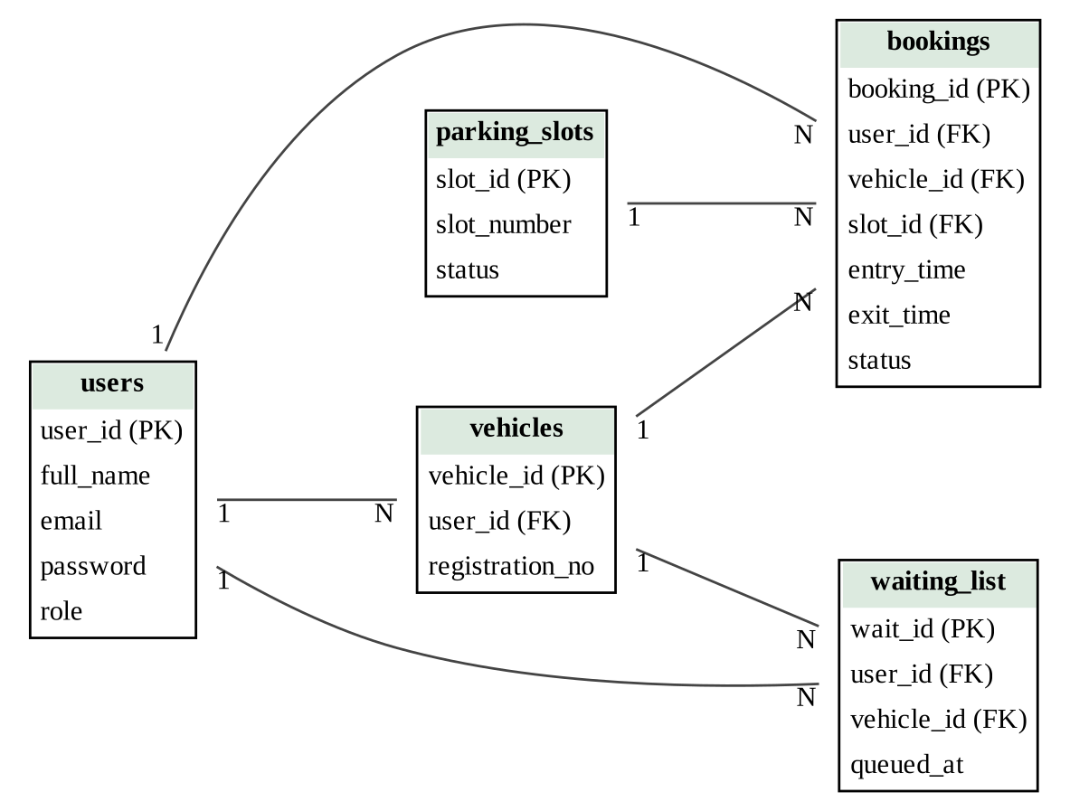
Figure 3.3: ER diagram of the five tables (PK = primary key, FK = foreign key; 1 = one side, N = many side)
Table 1: users
Column | Type | Constraint
user_id | INT | Primary key, auto increment
full_name | VARCHAR | Not null
email | VARCHAR | Unique, not null
password | VARCHAR | Not null
role | ENUM | 'User', 'Admin'

Table 2: parking_slots
Column | Type | Constraint
slot_id | INT | Primary key, auto increment
slot_number | INT | Unique, not null
status | ENUM | 'Available', 'Occupied'

Table 3: vehicles
Column | Type | Constraint
vehicle_id | INT | Primary key, auto increment
user_id | INT | Foreign key to users
registration_no | VARCHAR | Unique, not null (vehicle registration number)

Table 4: bookings
Column | Type | Constraint
booking_id | INT | Primary key, auto increment
user_id | INT | Foreign key to users
vehicle_id | INT | Foreign key to vehicles
slot_id | INT | Foreign key to parking_slots
entry_time | DATETIME | Time of booking / entry
exit_time | DATETIME | Time of release; NULL while the vehicle is parked
status | ENUM | 'Active', 'Completed'

Table 5: waiting_list
Column | Type | Constraint
wait_id | INT | Primary key, auto increment
user_id | INT | Foreign key to users
vehicle_id | INT | Foreign key to vehicles
queued_at | TIMESTAMP | Default current time; shows the order of arrival

The Stack of recent operations does not need its own table in this design; it is maintained in the memory of the backend, while the permanent record of every parking operation is kept in the bookings table. When the server starts, the Min Heap, the Queue and the HashMap are filled from the database so that they match the stored data.

3.5.2 Data Structure Design
The central idea of the project is to select a data structure that fits each job. The four selected structures, the job each one does and the reason for the choice are given below.
Data structure | Application | Why it is used | Main operation cost
Queue | Waiting list for vehicles | FIFO: the vehicle arriving first gets the first available slot | Enqueue and dequeue: O(1)
Min Heap (priority queue) | Parking slot allocation | Finds the smallest-numbered available slot efficiently | Peek: O(1); insert and extract: O(log n)
HashMap | Vehicle search by registration number | Average O(1) lookup instead of searching every vehicle | Insert, search, delete: O(1) average
Stack | Recent parking entry and exit operations | LIFO: the most recent operation is accessed first; can support an undo feature | Push, pop, top: O(1)

(a) Queue: waiting list (FIFO)
When every parking slot is occupied, a new booking request cannot be served immediately. The vehicle is added to the back of a Queue. When a slot is released, the vehicle at the front of the Queue, which is the vehicle that has waited the longest, is offered the slot. In this way no vehicle can be served before another vehicle that arrived earlier. For example, if vehicles V1, V2 and V3 arrive in this order while the parking area is full, the first freed slot is offered to V1, the next to V2 and the next to V3. Enqueue and dequeue both take constant time, O(1). The waiting_list table stores the same order permanently through the queued_at column.
(b) Min Heap: slot allocation (priority queue)
The numbers of all free slots are kept in a Min Heap, which is a complete binary tree in which every parent is smaller than or equal to its children, so the smallest slot number is always at the root. To allot a slot, the root is read in O(1) and removed in O(log n). When a slot is released, its number is inserted back into the heap in O(log n). For example, if the free slots are 1, 3, 4 and 5, the next booking receives slot 1; if slot 2 is released later, it is inserted into the heap and becomes the next slot to be allotted, because 2 is smaller than 3, 4 and 5. A simple list of free slots would need O(n) time to find the smallest number every time.
(c) HashMap: vehicle lookup
The HashMap stores the vehicle registration number as the key and the booking or parking information (slot number, user and entry time) as the value. A hash function converts the key into a position in the table, so a vehicle can be found without checking the other vehicles. The HashMap is used in three places: to check at booking time whether the same vehicle is already parked, to find the slot of a vehicle quickly when it is released, and to search vehicle details from the admin dashboard. The average cost of insert, search and delete is O(1); in the rare worst case of many collisions it can rise to O(n).
(d) Stack: recent operations (LIFO)
Every parking entry and exit operation is pushed onto a Stack as a record containing the type of operation, the vehicle registration number, the slot number and the time. Because a Stack gives the most recent item first, the latest operation can be read with a top operation in O(1) time. This makes it easy to show recent activity and also makes an undo feature possible, because undoing the last action means taking the top record and reversing it.
Simplified representation of the four structures (C++ style)
std::queue<std::string> waitingQueue; // FIFO waiting list
std::priority_queue<int, std::vector<int>,
std::greater<int>> freeSlots; // Min Heap of free slots
std::unordered_map<std::string, Booking>
parkedVehicles; // key: registration no.
std::stack<Operation> recentOperations; // LIFO entry/exit log

This code only illustrates the idea; the structures may be implemented with the standard library containers or with user-defined classes.

3.5.3 REST API Design
The frontend and the backend are separate. The JavaScript code of the web pages sends HTTP requests to routes defined in the Crow backend, and the backend answers with JSON. The routes are grouped by the job they do.
Group | Purpose
Authentication | Register a new user and log in an existing user
Slots | Return the list of available and occupied slots
Booking | Book a slot for a vehicle (automatic allocation) and release a slot
Waiting list | Add a vehicle to the waiting list and show the waiting list
History | Return the booking history of the logged-in user
Admin | Manage slots; return occupied and available counts, vehicle details and all booking history

3.5.4 User Interface Design
The interface is made of simple web pages written in HTML and styled with CSS, and JavaScript fetches data from the REST API and updates the page without manual refresh of the database. A normal user sees a registration page, a login page, a page showing available and occupied slots with a booking form for the vehicle registration number, a release option and the booking history. The administrator sees a separate dashboard with the slot management controls, the count of occupied and available spaces, the vehicle details and the booking history of all users.

3.5.5 Security Design
- Only registered users who have logged in can book or release a slot.
- The admin dashboard and its functions are available only to a user whose role is Admin.
- A normal user can see only his or her own booking history.
- Input is checked before it is used: empty fields, an already registered email and a vehicle that is already parked are refused.
- Every change in the in-memory data structures is also written to MySQL, so the stored data stays consistent.

3.6 Implementation Plan / Methodology
The project was built phase by phase, and each phase was tested before the next one started.
Phase | Work done
1 | Problem study, scope decision and selection of technology and data structures
2 | MySQL database design: five tables with keys
3 | C++ backend with the Crow framework and connection to MySQL
4 | User registration and login
5 | Slot view, Min Heap based slot allocation and slot booking
6 | Vehicle registration management with HashMap and slot release
7 | Waiting list with Queue and recent operations record with Stack
8 | Frontend pages in HTML, CSS and JavaScript and connection with the REST API
9 | Admin dashboard and booking history
10 | Testing and documentation

Booking algorithm
- The user enters the vehicle registration number and requests a booking.
- The backend searches the HashMap with the registration number. If the vehicle is already parked, an error is returned.
- If the Min Heap is not empty, the smallest slot number is extracted from it and assigned to the vehicle.
- The booking is saved in MySQL, the vehicle is added to the HashMap and an entry record is pushed onto the Stack.
- If the Min Heap is empty, the vehicle is added to the waiting Queue and the user is told that the vehicle is on the waiting list.
Release algorithm
- The user releases the slot. The backend finds the vehicle in the HashMap using its registration number.
- The booking is marked as completed in MySQL, the vehicle is removed from the HashMap and an exit record is pushed onto the Stack.
- If the waiting Queue is not empty, the first vehicle is removed from the Queue and offered the freed slot.
- If the waiting Queue is empty, the slot number is inserted back into the Min Heap and the slot becomes available again.
Concepts of Advanced Data Structures applied
- Abstract data types: Queue, Stack and priority queue are used through their operations, and the booking logic does not depend on how they are stored internally.
- Heap property: the Min Heap keeps the smallest free slot number at the root after every insert and extract.
- Hashing: the registration number is converted into a table position, which gives average constant time search.
- FIFO and LIFO ordering: the Queue gives fairness to waiting vehicles and the Stack gives quick access to the latest operation.
- Time complexity analysis: each structure is selected after comparing its cost with the simple alternative (Section 4.2).
- Persistence: the structures live in memory for speed, and MySQL keeps the permanent copy of the data.

CHAPTER 4: RESULTS ANALYSIS AND VALIDATION

4.1 Implementation of Solution
The application was built using the layered design described in Chapter 3. Each module is described below.
Communication and Data Storage. The web pages send requests to the Crow backend through the REST API. The backend applies the data structure operations, updates MySQL where required and returns the answer as JSON, which the JavaScript code uses to update the page.
User Registration and Login. A new user registers with a name, email and password and then logs in. The input is checked before it is accepted, and the role of the user (normal user or administrator) decides which pages and functions are available.
Slot View. The user can see which parking slots are available and which are occupied. The information comes from the backend, so it changes as soon as a slot is booked or released.
Automatic Slot Allocation. The numbers of the free slots are kept in a Min Heap. When a booking is made, the smallest slot number is extracted and given to the vehicle, so the user does not have to choose a slot and the allocation always follows the same rule.
Vehicle Registration Management. The user enters the vehicle registration number while booking. The registration number is the key of the HashMap, and the value holds the parking information of that vehicle. A vehicle that is already parked cannot be booked again, and the admin can find the details of a vehicle quickly.
Parking Booking and Release. A booking stores the user, vehicle, slot and entry time in the bookings table. When the user leaves, the release operation finds the vehicle through the HashMap, closes the booking and frees the slot.
Waiting List Management. If no free slot is available, the vehicle is added to the waiting Queue. When a slot is released, the vehicle at the front of the Queue is offered the slot, so the waiting vehicles are served in the order in which they arrived. If the Queue is empty, the slot number goes back into the Min Heap.
Recent Operations Record. Every entry and exit is pushed onto a Stack. The most recent operation is always at the top, so it can be read immediately, and the same structure can be extended to support an undo feature.
Booking History. Every booking is stored with its entry time, exit time and status, so the user can see his or her past and current bookings.
Admin Dashboard. The administrator can manage the parking slots, see how many slots are occupied and how many are available, view vehicle details and track the booking history of all users.

4.2 Complexity Analysis
The table compares the cost of the main operations with the simple approach that a basic system would use. Here n is the number of slots or vehicles involved.
Operation | Structure used | Cost | Simple alternative | Alternative cost
Find the smallest free slot | Min Heap | O(1) | Scan the list of free slots | O(n)
Allocate a slot and remove it from the free set | Min Heap | O(log n) | Find the minimum and delete from a list | O(n)
Return a released slot to the free set | Min Heap | O(log n) | Append and keep the list sorted | O(n)
Add a vehicle to the waiting list | Queue | O(1) | Append to a list | O(1)
Serve the longest-waiting vehicle | Queue | O(1) | Remove the first element of an array | O(n)
Find a vehicle by registration number | HashMap | O(1) average | Check every vehicle one by one | O(n)
Record or read the latest operation | Stack | O(1) | Search the history for the latest entry | O(n)

The Queue gains over a plain list mainly at the front, where removal from an array needs shifting of the remaining elements. The HashMap has an O(n) worst case when many keys collide, but with a good hash function the average cost remains constant. The memory needed by all four structures is O(n).

4.3 Testing and Validation
The application is tested module by module on the running system, and the MySQL database is checked wherever needed. The Result column of the table is filled after each test is run.
ID | Module | Test | Expected result | Result
T1 | Registration | Register with valid details; then try empty fields and an email that is already registered | Valid details create the account; every invalid case shows an error and no account is created | Yes
T2 | Login | Log in with correct details; then with a wrong password | Correct details open the dashboard; wrong details are refused | Yes
T3 | Slot view | Open the slot page before and after a booking | Available and occupied slots are shown correctly and change after the booking | Yes
T4 | Min Heap allocation | Book several vehicles one after another | Slots are allotted in increasing slot number order | Yes
T5 | HashMap check | Book the same registration number twice | The second booking is refused because the vehicle is already parked | Yes
T6 | Queue (waiting) | Book vehicles until all slots are full, then book three more | The extra vehicles are added to the waiting list in order of arrival | Yes
T7 | Queue (release) | Release a slot while vehicles are waiting | The first waiting vehicle is offered the freed slot | Yes
T8 | Min Heap (release) | Release a slot when no vehicle is waiting, then book a vehicle | The released slot returns to the free set and is allotted again if it is the smallest | Yes
T9 | Vehicle search | Search a parked vehicle by its registration number from the admin dashboard | The correct vehicle and slot details are shown | Yes
T10 | Stack | Perform an entry and then an exit and view recent operations | The latest operation (exit) appears first | Yes
T11 | Booking history and admin | Open the booking history and the admin dashboard | Bookings are listed correctly; occupied and available counts match the database | Yes

CHAPTER 5: CONCLUSION AND FUTURE WORK

5.1 Conclusion
This project presents the design and development of the Smart Parking Management System, a web-based application that automates parking slot management. A user can register, log in, view available and occupied slots, book a slot with a vehicle registration number and release it when leaving, and an administrator can manage slots and monitor vehicles and bookings from a dashboard. The application uses HTML, CSS and JavaScript for the frontend, C++ with the Crow framework for the backend, MySQL for storage and a REST API with JSON for communication.
The main strength of the project is the use of data structures that suit each job. The Min Heap gives the smallest free slot efficiently, the Queue serves waiting vehicles in first-come first-served order, the HashMap finds a vehicle by its registration number in average constant time, and the Stack gives instant access to the most recent operation and can support an undo feature. The comparison in Section 4.2 shows that these structures reduce the cost of the main operations compared with simple list based methods.
The objectives listed in Chapter 2 were achieved. The project also helped in understanding the Queue, Min Heap, HashMap and Stack and their time complexity, C++ backend development with a web framework, REST API design, relational database design and the way in-memory data structures and a database can work together.

5.2 Future Work
- A complete undo feature built on the operations Stack.
- Notifications to a waiting user when a slot is offered to him or her.
- Online payment and automatic calculation of the parking charge from entry and exit time.
- Support for several parking areas or floors and for different vehicle types.
- Sensors for automatic detection of occupied slots.
- Reports for the administrator, with export to PDF or Excel.
- Password reset and change options.
- A mobile application and deployment on a cloud server.

REFERENCES
[1] CrowCpp, "Crow: A fast and easy to use C++ microframework for the web." [Online]. Available: https://crowcpp.org/
[2] Oracle Corporation, "MySQL 8.0 Reference Manual." [Online]. Available: https://dev.mysql.com/doc/refman/8.0/en/
[3] cppreference.com, "C++ reference." [Online]. Available: https://en.cppreference.com/
[4] T. H. Cormen, C. E. Leiserson, R. L. Rivest and C. Stein, Introduction to Algorithms, MIT Press.
[5] M. A. Weiss, Data Structures and Algorithm Analysis in C++, Pearson Education.
[6] J. W. J. Williams, "Algorithm 232: Heapsort," Communications of the ACM, vol. 7, no. 6, pp. 347-348, 1964.
[7] R. T. Fielding, "Architectural Styles and the Design of Network-based Software Architectures," Ph.D. dissertation, University of California, Irvine, 2000.
[8] T. Bray (Ed.), "The JavaScript Object Notation (JSON) Data Interchange Format," RFC 8259, IETF, 2017.
[9] Mozilla, "MDN Web Docs: HTML, CSS and JavaScript." [Online]. Available: https://developer.mozilla.org/
[10] B. Stroustrup, The C++ Programming Language, Addison-Wesley.
[11] R. Elmasri and S. B. Navathe, Fundamentals of Database Systems, Pearson Education.

APPENDIX

Appendix A: Gantt Chart (7 days)
Activity | Day 1 | Day 2 | Day 3 | Day 4 | Day 5 | Day 6 | Day 7
Problem study and database design | X
Backend setup, login and registration |  | X
Min Heap allocation and booking |  |  | X
HashMap, release, Queue and Stack |  |  |  | X
Frontend pages and REST API connection |  |  |  |  | X
Admin dashboard and booking history |  |  |  |  |  | X
Testing and documentation |  |  |  |  |  |  | X

Appendix B: Summary of Data Structures and Operations
Structure | Operations used | Where it is used in the project
Queue | enqueue, dequeue, front, empty | Adding a vehicle to the waiting list when no slot is free; offering a released slot to the first waiting vehicle
Min Heap | insert, extract-min, peek | Allocating the smallest-numbered free slot; returning a released slot to the free set
HashMap | insert, find, erase | Checking for a duplicate booking; finding the slot of a vehicle at release; vehicle search by the admin
Stack | push, pop, top | Recording entry and exit operations; reading the latest operation; supporting undo

Appendix C: Technology Stack
Component | Technology | Purpose
Frontend | HTML, CSS, JavaScript | User and admin web pages
Backend | C++ using the Crow framework | Routes, booking logic and data structures
Database | MySQL | Permanent storage of users, slots, vehicles, bookings and the waiting list
Communication | REST API and JSON | Data exchange between frontend and backend

DESIGN CHECKLIST
Criteria | Description | Status
Cost | Uses only free technologies: HTML, CSS, JavaScript, C++, Crow and MySQL | Yes
Safety and Security | Login required for booking; admin functions limited to the administrator; user data separated by user | Yes
Environmental Impact | No extra hardware needed; quicker slot finding reduces the time vehicles spend searching for parking | Yes
Technical Feasibility | Built with standard web technologies, C++ and MySQL | Yes
Reliability | Every operation is stored in MySQL, and the in-memory structures can be rebuilt from the database | Yes
Ethical Consideration | Vehicle and booking details are used only inside the application | Yes
Standards | Uses REST, JSON and standard SQL | Yes
Usability | Simple web pages for the user and a separate admin dashboard | Yes

