DIGITAL LITERACY PROJECT REPORT

Submitted by

Sejal Dixit
Reg No: 25BAI11358

B.Tech , CSE(AIML)
VIT Bhopal University

Course: CSE0001
Digital Literacy

Date: 28 March 2026

Introduction
In today’s digital world, having strong digital literacy skills is essential for students. This project focuses on understanding and applying key aspects of digital literacy, including the effective use of online tools, maintaining a professional digital presence, practicing safe internet habits, and communicating responsibly online.

As part of this project, I completed five tasks that helped me explore different digital platforms and improve my practical knowledge. These tasks included creating an awareness infographic, building a digital portfolio, using coding and collaboration platforms, learning professional email etiquette, and understanding cybercrime and its prevention.

Through this project, I gained valuable insights into how digital technologies can be used productively and safely in both academic and professional environments.

INDEX
- Task 1: Infographic
- Task 2: Digital Portfolio
- Task 3: Coding + Google Form
- Task 4: Email Etiquette
- Task 5: Cybercrime Awareness

Task1 : Digital Literacy Infographic
For this task, I created a digital literacy awareness infographic using Canva, which is an easy-to-use online design tool. The purpose of this infographic was to help students understand the importance of digital literacy in their daily academic and personal lives.

The infographic includes key topics such as the meaning of digital literacy, safe internet practices, professional online presence, and email etiquette. It explains how students can use digital tools effectively, communicate responsibly online, and protect themselves from online risks. The design uses clear headings, icons, and structured points to make the information easy to understand.

While creating this infographic, I found it interesting to explore different design elements like colors, layouts, and icons to make the content visually appealing. One challenge I faced was arranging all the information in a clear and organized way without overcrowding the design. Overall, this task helped me improve both my digital awareness and creativity skills.

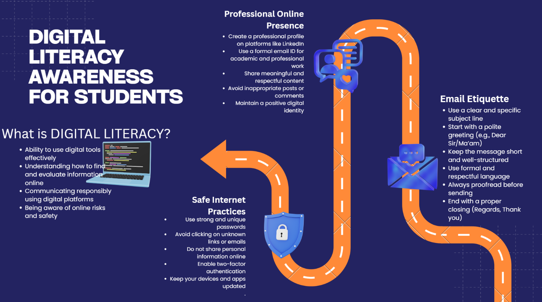
Figure 1: Digital Literacy Infographic
Canva Link: https://www.canva.com/design/DAHE9tu7Ul0/jmiZQ9oysxcgUG9gOUTp6A/edit?utm_content=DAHE9tu7Ul0&utm_campaign=designshare&utm_medium=link2&utm_source=sharebutton

- Task2: Build Your Student Digital Portfolio
For this task, I created and updated my digital profiles on multiple professional platforms, including GitHub, LinkedIn, and Kaggle. These platforms are important for building a strong digital presence and showcasing skills, projects, and achievements.

GitHub is mainly used for sharing coding projects, managing repositories, and collaborating with others. I created my GitHub profile and added a profile README that includes my name, branch, year, and my learning goals. This will help me track my progress and improve my technical skills over time.

LinkedIn is a professional networking platform that allows students to connect with peers, faculty, and industry professionals. I updated my LinkedIn profile by adding my education details, including my degree, institution, and expected graduation year. This platform will help me explore internship and career opportunities.

Kaggle is a platform used for data science and machine learning. It provides datasets, competitions, and learning resources. I created my Kaggle profile to start exploring data analysis and to learn new skills related to data science.

I plan to actively use these platforms over the next four years to build my professional identity, improve my skills, and connect with professionals. This task helped me understand the importance of maintaining a strong and professional digital presence.

- Insert GitHub screenshot
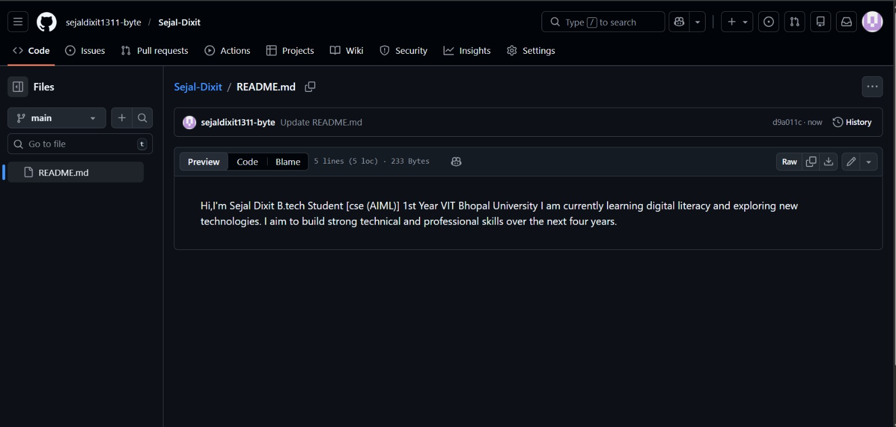
Figure 2: GitHub Profile
- Insert LinkedIn screenshot
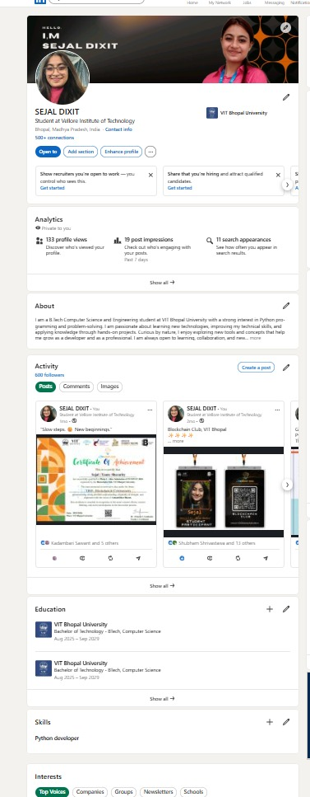
Figure 3: LinkedIn Profile
- Insert Kaggle screenshot
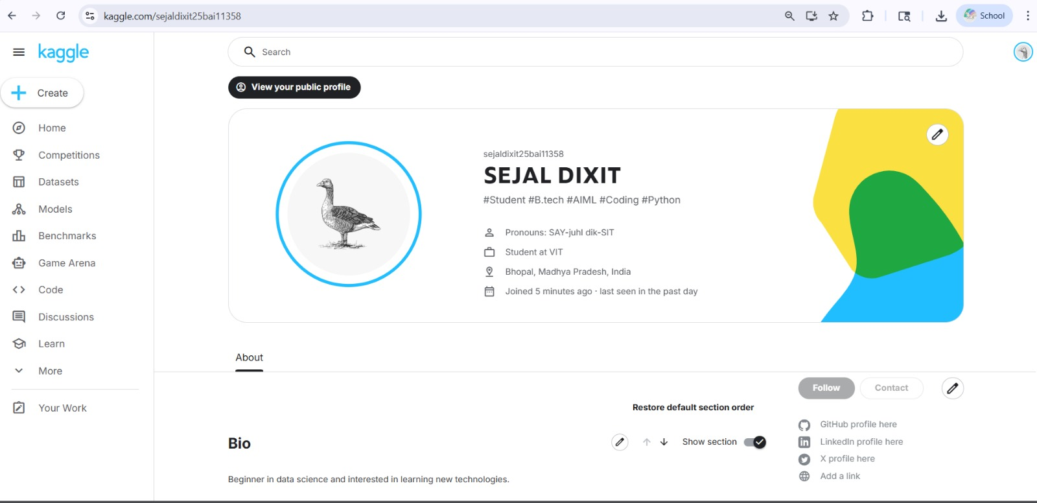
Figure 4: Kaggle Profile

- Task 3: Explore Coding & Collaboration Platforms

For this task, I explored both coding practice platforms and collaboration tools. I created an account on HackerRank, which is a popular platform used to practice coding and improve problem-solving skills. I completed a beginner-level challenge, which helped me understand basic programming logic and how to approach coding problems step by step.

In addition to coding practice, I used Google Forms to create a Digital Literacy Awareness Quiz. The form included five questions, with a mix of multiple-choice and short-answer questions, designed to test basic understanding of digital literacy concepts. I also viewed the responses in Google Sheets, which helped me understand how data can be collected and analyzed effectively.

These platforms are very useful for students. Coding platforms like HackerRank help improve logical thinking and programming skills, while tools like Google Forms support collaboration and data collection. I plan to continue using these tools in my academic journey for learning, practice, and project work. This task helped me gain practical exposure to important digital tools used in education.

Part A (Coding)
- Screenshot of :
Completed problem (HackerRank)
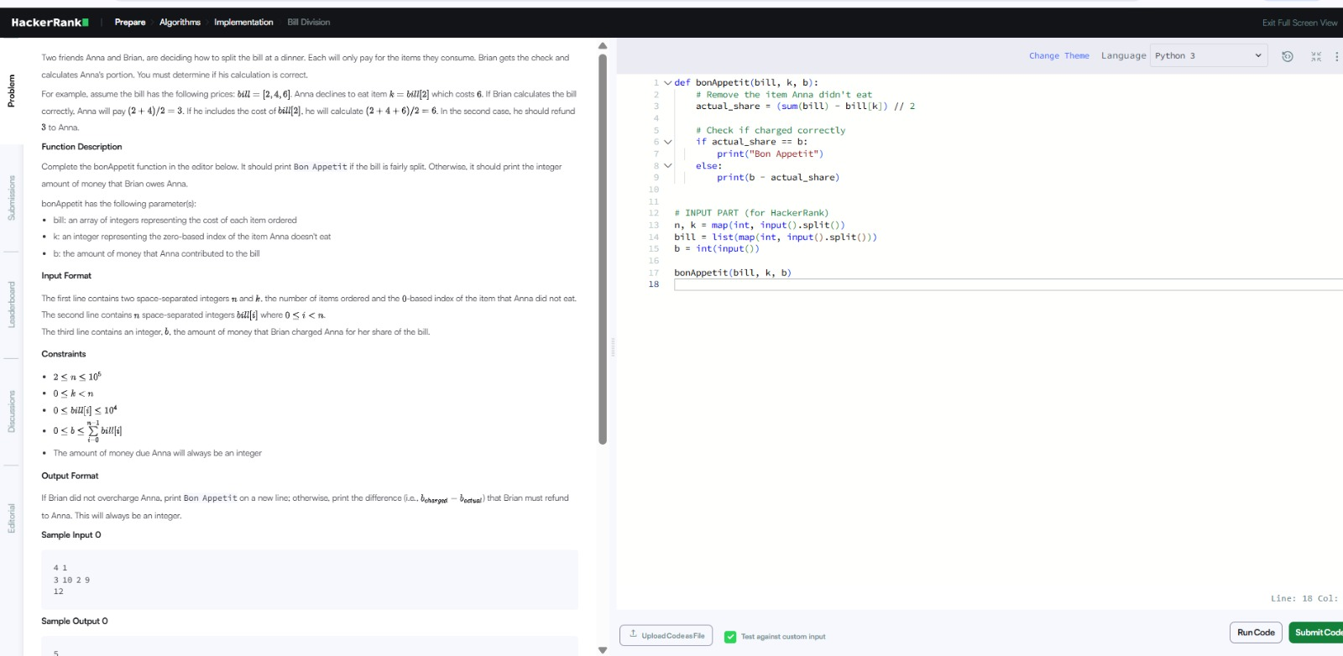
Figure 5: Coding on HackerRank

Badge/score
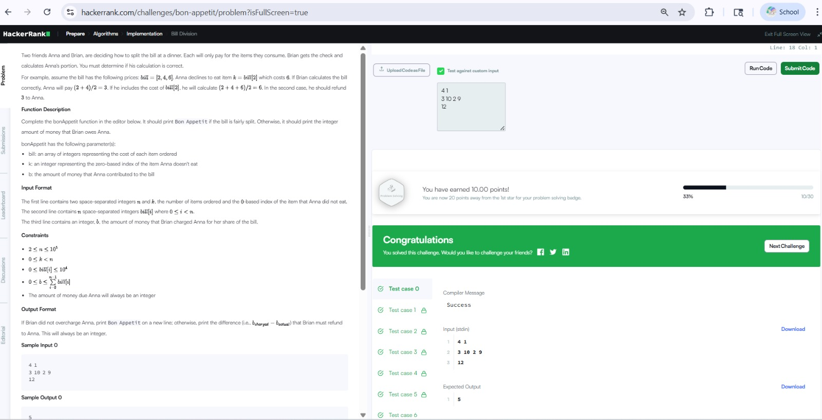
Figure 6: Coding Challenge Completed on HackerRank

Part B (Google Forms)
- Screenshot of:
Google form
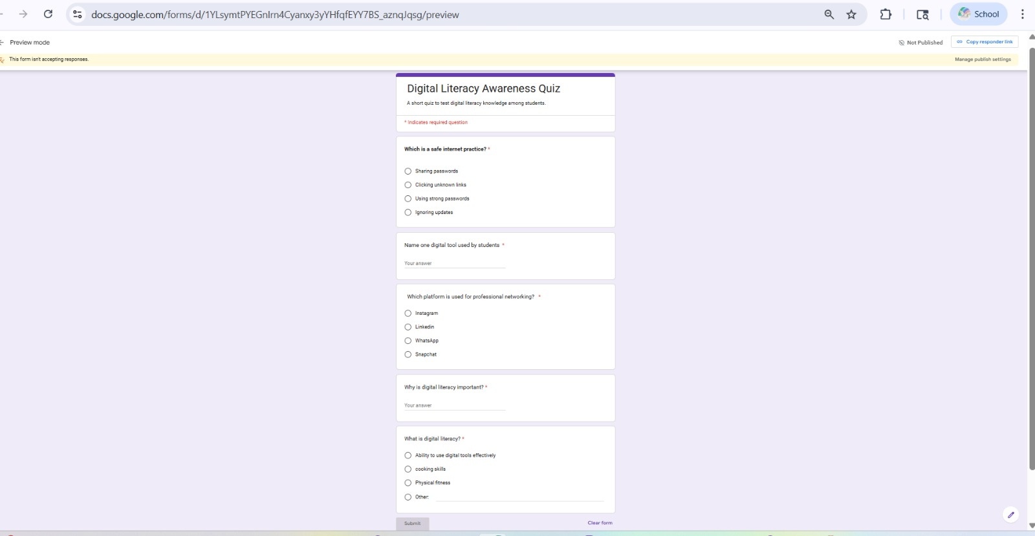
Figure 7: Google Form – Digital Literacy Quiz

Response Sheet (Google Sheets)
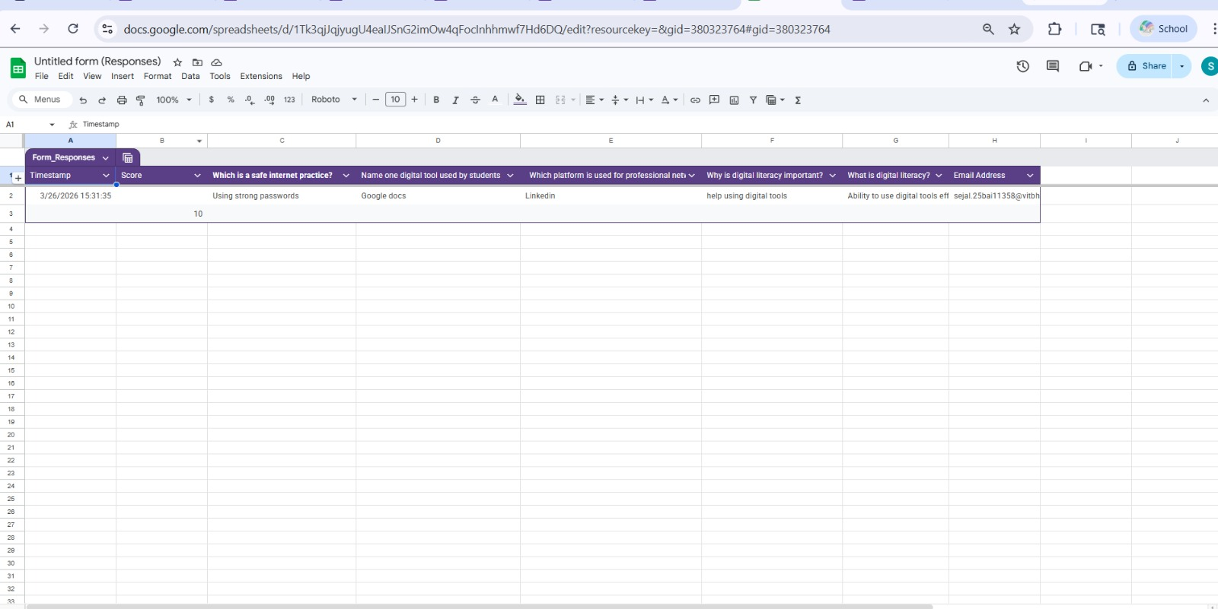
Figure 8: Google Form Responses (Google Sheets)

Link of google form: https://docs.google.com/forms/d/1YLsymtPYEGnIrn4Cyanxy3yYHfqfEYY7BS_aznqJqsg/edit

- Task 4: Draft a professional Email & Etiquette Guide

In this task, I learned the importance of professional communication and responsible online behavior. Writing formal emails requires a proper structure, including a clear subject line, polite greeting, and a well-organized message.

I created two emails: one requesting an assignment extension and another applying for a summer internship. This helped me understand how to communicate effectively in academic and professional situations.

A common issue caused by poor digital communication is misunderstanding due to informal language. For example, sending emails without a proper subject or greeting can create a negative impression. This can be avoided by following proper email etiquette and maintaining a professional tone. This task improved my communication skills and awareness of digital responsibility.

- Task 5: Cybercrime Awareness Case study & Prevention Guide

While working on this task, I was surprised to learn how easily people can become victims of phishing attacks. The methods used by attackers are very convincing and can trick even careful users.

This task made me realize the importance of being cautious while using digital platforms. One habit I will change is that I will always verify links and messages before clicking on them. I will also avoid sharing personal or financial information online without proper verification.

Overall, this task increased my awareness about cybercrime and helped me understand how to stay safe online.

