Project Design Phase
Proposed Solution Template
Date | 12 October 2026
Team ID | SWUID2026402452
Project Name | StaffSync – Human Resource Management System
Maximum Marks | 2 Marks

Figure 1. StaffSync Main User Workflow
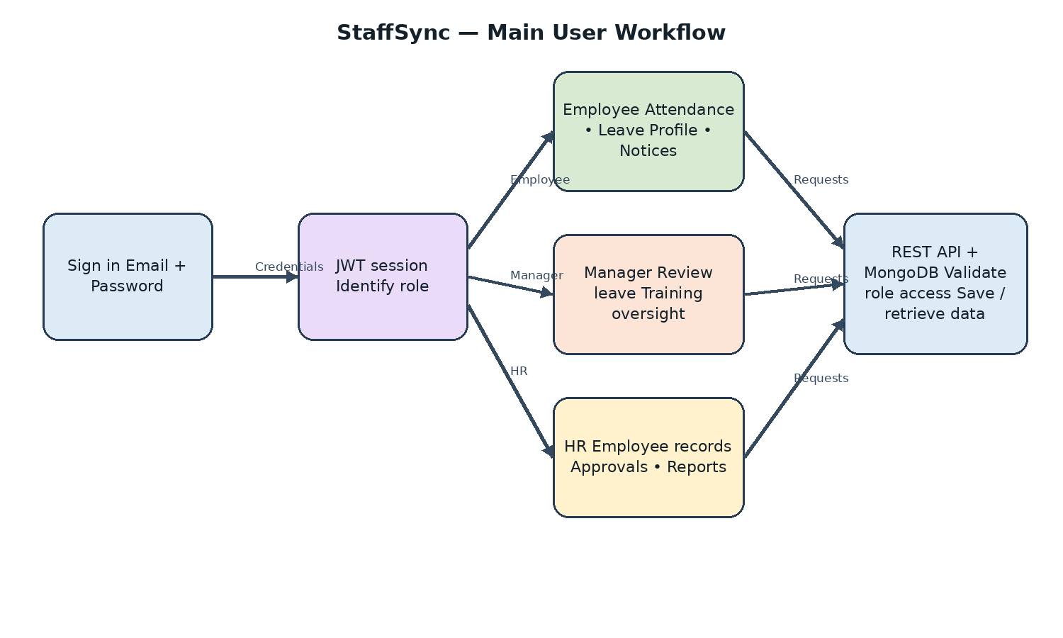

Proposed Solution for StaffSync
S. No. | Parameter | Description
1 | Problem Statement (Problem to be solved) | Employee information, attendance, leave requests, announcements and training may be managed through separate records and messages. Employees may not know attendance or leave status, managers spend time reviewing requests, and HR repeatedly collects information for reporting.
2 | Idea / Solution Description | StaffSync is a MERN web application with React frontend, Express/Node.js REST API and MongoDB database. Role-based access is provided for HR, managers and employees. Features include staff records, attendance, leave workflows, announcements, training, notifications, dashboards and HR reports.
3 | Novelty / Uniqueness | • Centralized HR workflow for three roles.  • Role-specific dashboards and protected routes.  • Leave balance and review workflow.  • Attendance check-in/out and HR oversight.  • Training enrolment and team coordination.  • In-app notifications and report export.
4 | Social Impact / Customer Satisfaction | • Reduces repetitive administrative tasks.  • Makes attendance and leave status more transparent.  • Improves access to announcements and training.  • Helps managers coordinate teams and HR maintain records.  • Supports convenient browser-based access.
5 | Business Model (Revenue Model) | The current version is an academic project/demo, not a commercial product. Future options could include organization subscriptions, per-employee pricing, onboarding/support and optional integrations.
6 | Scalability of the Solution | The frontend and API are deployed separately, while MongoDB stores workforce records. Pagination and indexes support common queries. Future improvements could include monitoring, audit trails, payroll/biometric integrations and horizontal scaling after load testing.

