Project Design Phase
Date | 12 October 2026
Team ID | SWUID2026402452
Project Name | StaffSync – Human Resource Management System
Maximum Marks | 4 Marks

Figure 1. StaffSync Layered System Architecture
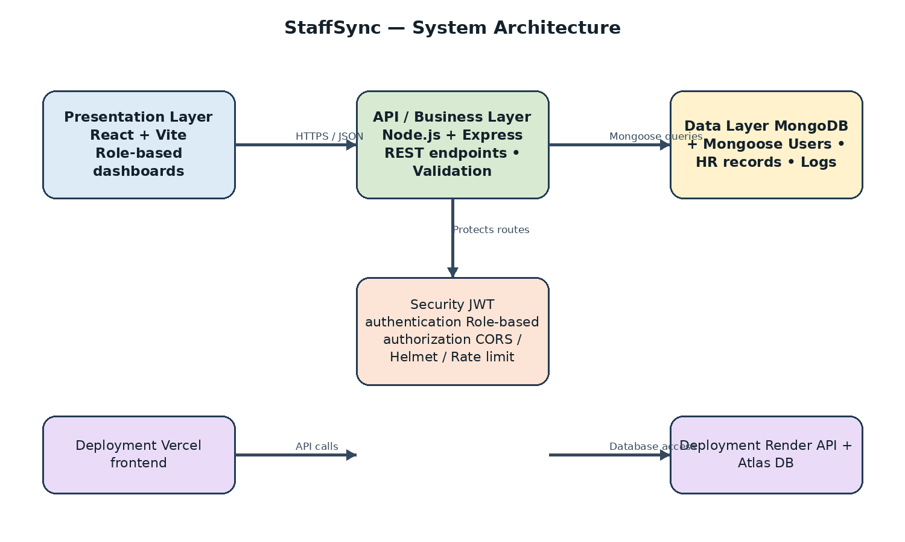
Solution Architecture

Solution Architecture
StaffSync follows a layered web architecture. The React/Vite frontend presents role-specific pages. It sends JSON requests to a Node.js/Express REST API, which authenticates users, checks permissions, validates requests and reads or updates MongoDB data. The live frontend is hosted on Vercel, the backend API on Render and the database on MongoDB Atlas.
- Presentation: React pages for HR, managers and employees.
- API/business logic: Express routes and controllers for authentication, profiles, employees, managers, team, attendance, leaves, announcements, trainings, notifications, dashboard and reports.
- Security: JWT authentication, role-based authorization, protected routes, Helmet, CORS and rate limiting.
- Data layer: MongoDB models for users, employees, managers, attendance, leaves, announcements, trainings and notifications.
- Reporting: role-based dashboards, HR analytics and CSV export.

Example – Solution Architecture Diagram
Layer | Components | Flow
Presentation | Browser, React + Vite, forms, dashboards | User actions and displayed results
API / Business logic | Node.js + Express, REST routes/controllers, validation, JWT/role middleware | HTTPS/JSON requests and responses
Data access | Mongoose models and query logic | Validated reads and writes
Database | MongoDB Atlas / MongoDB | Users, employee/manager records, attendance, leaves, announcements, trainings and notifications
Deployment | Vercel frontend → Render API → MongoDB Atlas | Environment-configured URLs and secrets
Request flow: User → React frontend → Express REST API → authentication/authorization and controllers → MongoDB → API response → React UI.

