Report (prepared by- Sejal, Catherine, Priyanka)
- Completed the review of the paper. Understanding and basic implementation of major algorithms are done.
- Tested the algorithm in the research paper on different dataset.
a. Delhi metro dataset
b. NYC metro dataset
- Completed stepwise implementation as described in the paper.
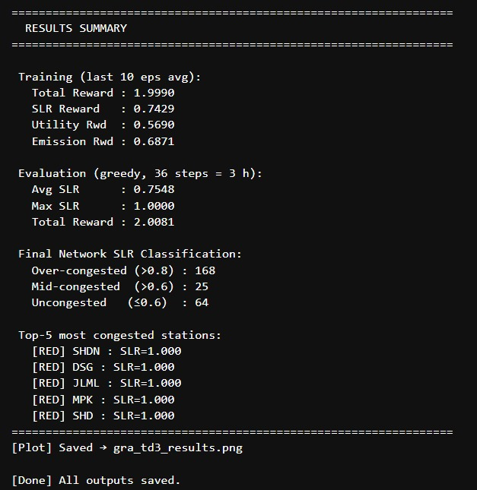-
Result of Delhi metro dataset
Algorithm successfully implemented here are:
a. GRA TD3
b. Actor Critic
c. SDNE Embedding
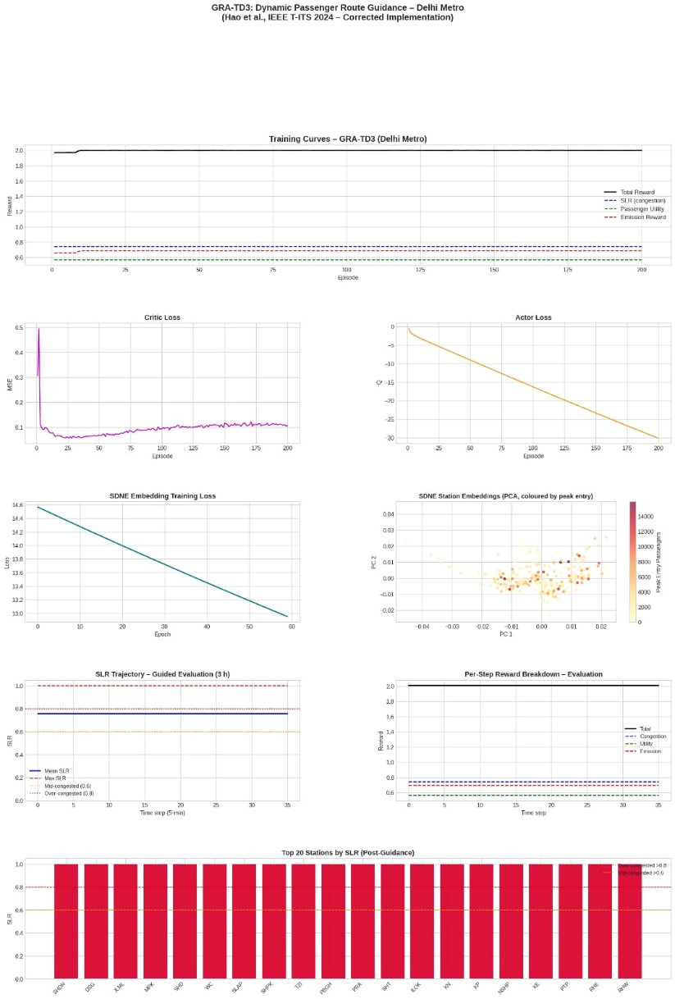

Future for further development
The paper DOES mention multi-agent RL in related work:
“multi-agent-based algorithms are widely considered a better choice...”
But that’s only discussing previous research.
They themselves did NOT implement MARL.

Proposed idea
Current paper
SDNE + TD3
↓
Better version
Transformer Encoder + TD3
↓
Advanced version
Graph Transformer + Multi-Agent

Further Work
Implemented MATD3: Multi-Agent Twin Delayed Deep Deterministic Policy Gradient
for Delhi Metro Passenger Route Guidance.
Code explanation
- Agents: one per station (257 agents)
Parameters: SHARED actor network (same weights, different local obs) "parameter-sharing MATD3", standard for homogeneous agents in large-scale MARL (Lowe et al. MADDPG extended to TD3-style twin critics + smoothing).
- Reward: single shared GLOBAL reward, broadcast identically to every agent (fully cooperative).
- Critics: CENTRALIZED — see the full joint state (all stations SLR + waiting + global PDER) and the full joint action (all 257 recommendation degrees), output ONE global Q. This is the standard CTDE (centralized training decentralized execution) pattern: at execution time each agent only needs its own local observation to act.

Each agent's LOCAL observation = [own SLR, own waiting (norm.), mean SLR of 1-hop neighbours, mean waiting of 1-hop neighbours, own PDER-weighted demand scalar] -> a small fixed-size vector, fed through the SHARED actor to produce that agent's own recommendation degree in [-1, 1].

The CENTRAL critic takes the concatenation of all 257 local observations plus all 257 actions (the joint state/action) and predicts the single shared Q-value — this lets the policy gradient for any one agent account for system-wide consequences, matching the paper's "weighted summation SLR" congestion objective which is inherently global.

MULTI-AGENT ENVIRONMENT (detailed)
Builds the per-agent local observation vectors + the same global reward mechanics (route guidance + Eq.18 reward) as the centralized version, but now exposes the JOINT local-obs matrix instead of two flat (1,N) state vectors.
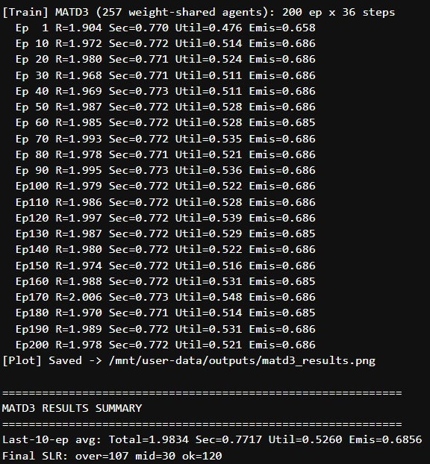
Multi-Agent TD3 (parameter-sharing, CTDE) & Results
ONE shared actor network π_φ used by every agent: each agent feeds its own local obs (5-dim) through π_φ and gets its own scalar action. Executed independently at runtime — this is the "decentralized execution" half of CTDE.
TWO centralized critics Q_ψ1, Q_ψ2 (+ matching targets), each seeing the FULL joint observation (N x 5 flattened) and FULL joint action (N,) to output ONE shared Q-value — the "centralized training" half of CTDE, exactly mirroring TD3's twin critics + delayed policy update + target-policy smoothing, but at the joint level instead of single-agent level.

The actor's policy gradient for EVERY agent's action dimension is obtained from a single backward pass through the joint critic (dQ/d(joint_action)), then we update the shared actor using the per-agent (obs, dQ/da) pairs stacked into one big batch – this means the shared actor learns from all 257 agents' experiences simultaneously every update.

