Report (prepared by- Sejal, Catherine, Priyanka)
- Completed the review of the paper. Understanding and basic implementation of major algorithms are done.
- Tested the algorithm in the research paper on different dataset.
a. Delhi metro dataset
b. NYC metro dataset
- Completed stepwise implementation as described in the paper.
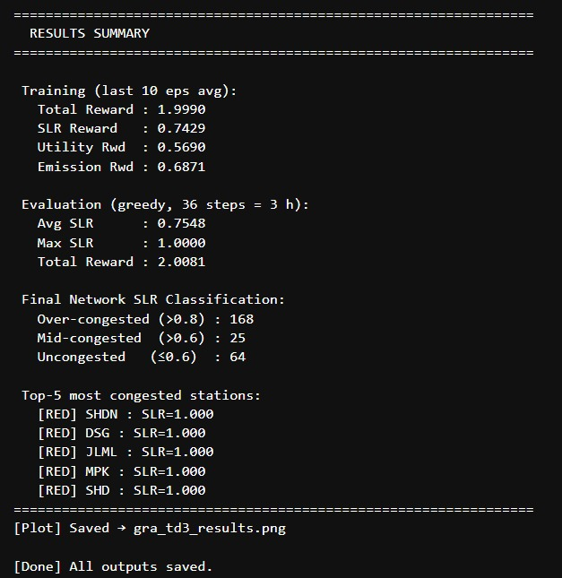-
Result of Delhi metro dataset
Algorithm successfully implemented here are:
a. GRA TD3
b. Actor Critic
c. SDNE Embedding
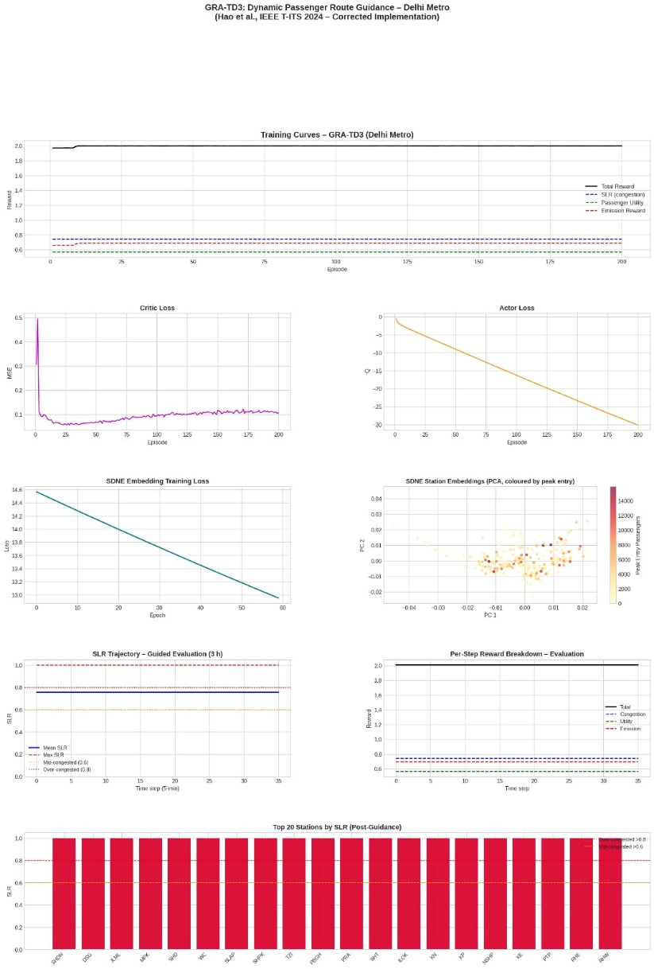

Future for further development
The paper DOES mention multi-agent RL in related work:
“multi-agent-based algorithms are widely considered a better choice...”
But that’s only discussing previous research.
They themselves did NOT implement MARL.

Proposed idea
Current paper
SDNE + TD3
↓
Better version
Transformer Encoder + TD3
↓
Advanced version
Graph Transformer + Multi-Agent RL

Time in completion for the development: 1 week

