LAB MST

Student Name: Sejal UID: 24BAI70050
Branch: CSE-AIML Section: 24AIT_KRG-1_B
Semester: 5 Date of Performance: 28/9/26
Subject Name: ADBMS

Q1
SELECT d.dept_name, e.emp_name, e.salary
FROM employee e
JOIN department d
ON e.dept_id = d.dept_id
WHERE e.salary > (
SELECT AVG(e2.salary)
FROM employee e2
WHERE e2.dept_id = e.dept_id
)
AND e.dept_id IN (
SELECT dept_id
FROM employee
GROUP BY dept_id
HAVING COUNT(*) >= 3
);
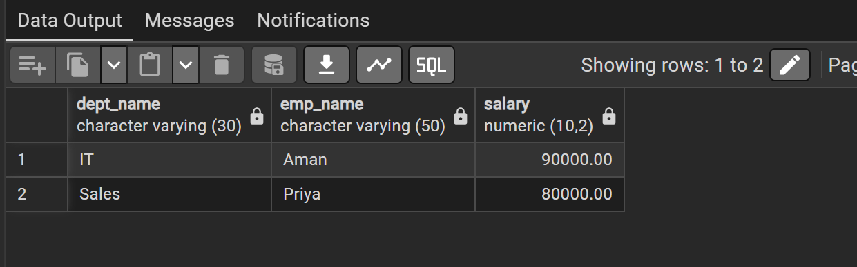

Q2.
CREATE OR REPLACE FUNCTION customer_audit_function()
RETURNS TRIGGER
LANGUAGE plpgsql
AS $$
BEGIN
IF TG_OP = 'INSERT' THEN
INSERT INTO customer_audit
(customer_id, customer_name, action, action_time)
VALUES
(NEW.customer_id, NEW.customer_name, 'ADDED', CURRENT_TIMESTAMP);
RETURN NEW;
ELSIF TG_OP = 'DELETE' THEN
INSERT INTO customer_audit
(customer_id, customer_name, action, action_time)
VALUES
(OLD.customer_id, OLD.customer_name, 'REMOVED', CURRENT_TIMESTAMP);
RETURN OLD;
END IF;
END;
$$;
CREATE TRIGGER customer_audit_trigger
AFTER INSERT OR DELETE
ON bank_customer
FOR EACH ROW
EXECUTE FUNCTION customer_audit_function();
INSERT INTO bank_customer
VALUES (3, 'Aman', 60000);
DELETE FROM bank_customer
WHERE customer_id = 1;
SELECT * FROM bank_customer;
SELECT * FROM customer_audit;

