EXPERIMENT-2

NAME-SEJAL
UID-24BAI70050
SUBJECT-ADBMS
SECTION – 24AIT KRG 1-B
DATE-14/07/2026

Q1.
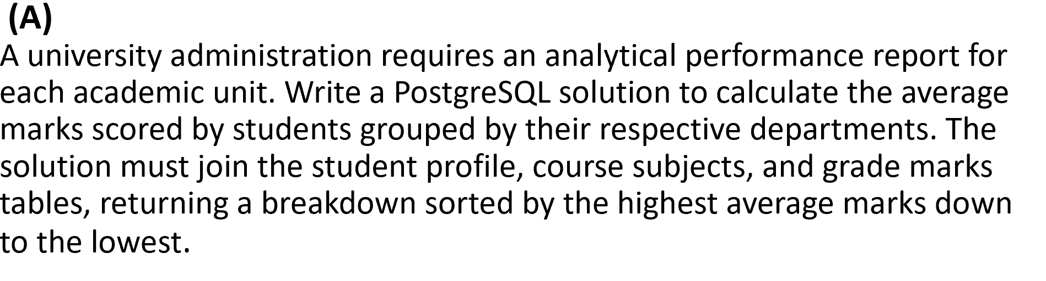

SELECT D.DEPT_ID AS DEPARTMENT,
AVG(M.MARKS_SCORED) AS AVERAGE_MARKS
FROM DEPARTMENTS AS D
JOIN STUDENTS AS S
ON D.DEPT_ID=S.DEPT_ID
JOIN MARKS AS M
ON S.STUDENT_ID=M.STUDENT_ID
GROUP BY D.DEPT_NAME
ORDER BY AVERAGE_MARKS DESC;

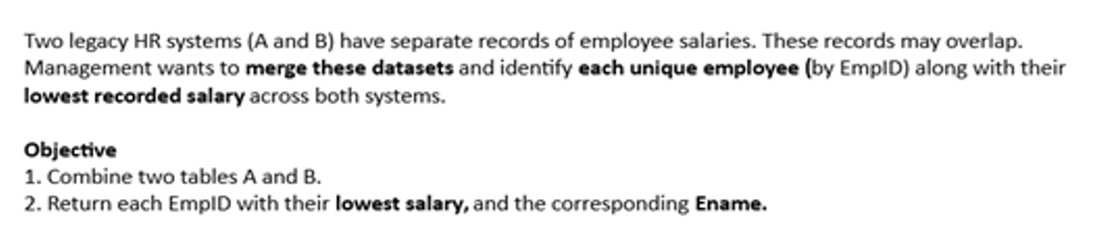

SELECT EMPID,MIN(ENAME) AS ENAME,MIN(SALARY) AS SALARY
FROM
(
SELECT * FROM A
UNION ALL
SELECT * FROM B
) AS INTERMEDIAT_RESULT
GROUP BY EMPID

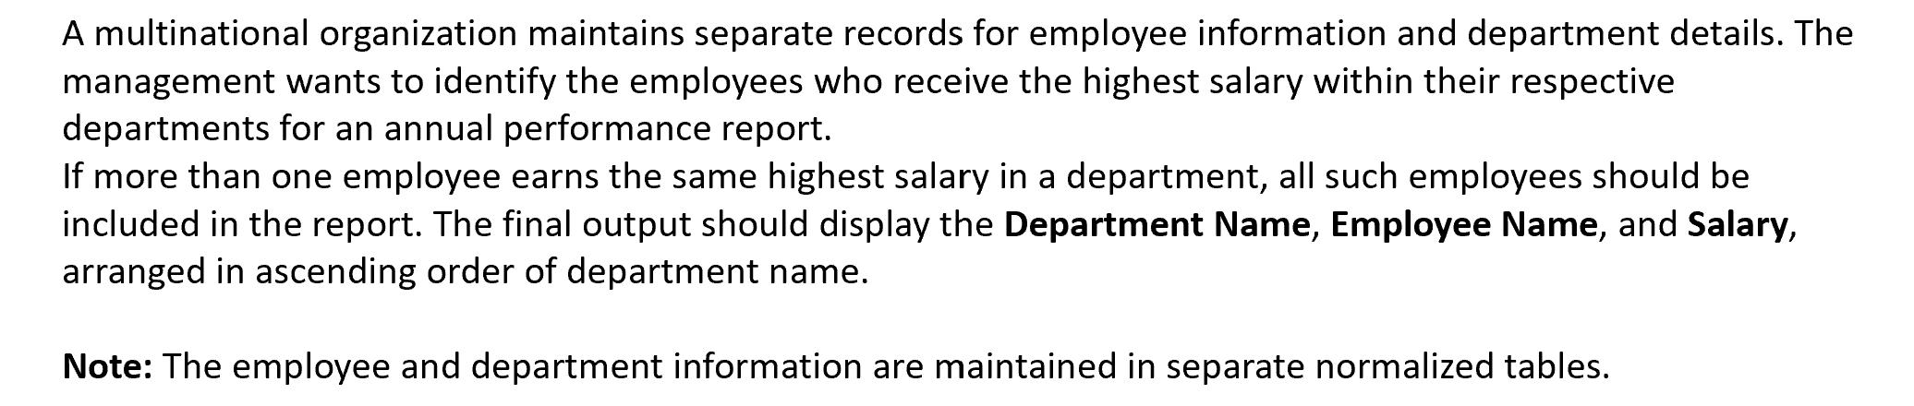

SELECT D.DEPT_NAME ,E.NAME,E.SALARY
FROM EMPLOYEE AS E
INNER JOIN DEPARTMENT AS D
ON E.DEPARTMENT_ID=D.ID
WHERE E.SALARY IN(
SELECT MAX(SALARY)
FROM EMPLOYEE AS E1
WHERE E1.DEPARTMENT_ID=E.DEPARTMENT_ID
AND
E1.SALARY NOT IN(
SELECT MAX(SALARY)
FROM EMPLOYEE AS E2
WHERE E2.DEPARTMENT_ID=E.DEPARTMENT_ID
)
)

