Experiment 4

Student Name: SEJAL UID: 24BAI70050
Branch: CSE - AIML Section/Group: 24ait_Krg G1
Semester: 4 Subject Code: 24CSH-298
Subject Name: DBMS

Aim
To design and implement PL/SQL programs utilizing conditional control statements such as IF–ELSE, ELSIF, ELSIF ladder, and CASE constructs in order to control the flow of execution based on logical conditions and to analyze decision-making capabilities in PL/SQL blocks

Software Requirements
  - PostgreSQL
  - pgAdmin

Objectives
Implement control structures in PL/SQL (IF-ELSE, ELSE-IF,ELSE-IF LADDER, CASE STATEMENTS in PL-SQL BLOCK).

Problem Statement
Develop and execute PL/SQL programs that demonstrate the use of conditional control statements. The programs should employ IF–ELSE, ELSIF, ELSIF ladder, and CASE statements to evaluate given conditions and control the flow of execution accordingly, thereby illustrating decision-making capabilities in PL/SQL blocks.

Practical/Experiment Steps

Start SQL*Plus / Oracle Live SQL.

Enter SET SERVEROUTPUT ON.

Copy and run the above PL/SQL program.

Enter the required values when prompted.

Observe the displayed output.

Procedure

Open Oracle SQL*Plus / Oracle Live SQL.

Enable output using SET SERVEROUTPUT ON.

Declare required variables in the DECLARE section.

Use conditional control statements (IF–ELSE, IF–ELSIF–ELSE, ELSIF ladder).

Display results using DBMS_OUTPUT.PUT_LINE.

Execute the program and observe the output.

Input/Output Analysis

PROBLEM STATEMENT 1

DECLARE

num NUMBER := 4;

BEGIN

IF num > 0 THEN

DBMS_OUTPUT.PUT_LINE('The number is POSITIVE');

ELSE

DBMS_OUTPUT.PUT_LINE('The number is NON-POSITIVE');

END IF;

END;

Output
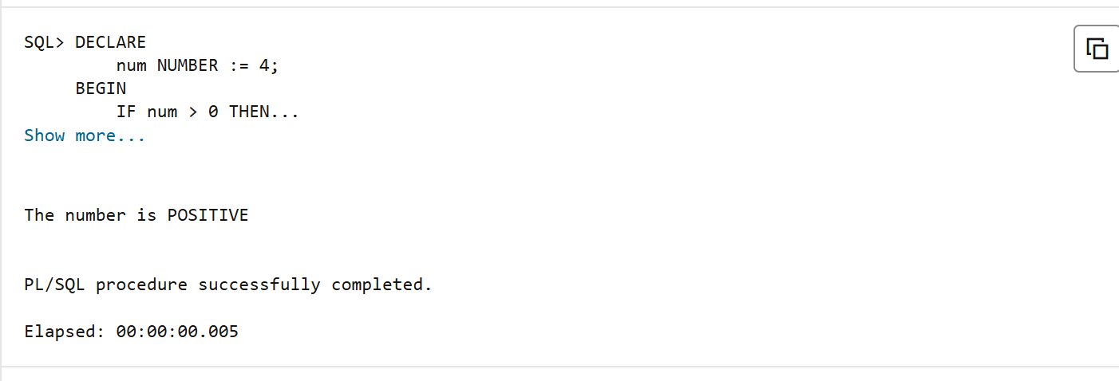

PROBLEM STATEMENT 2
DECLARE
marks NUMBER := &marks;
BEGIN
IF marks >= 90 THEN
DBMS_OUTPUT.PUT_LINE('Grade: A');
ELSIF marks >= 75 THEN
DBMS_OUTPUT.PUT_LINE('Grade: B');
ELSIF marks >= 60 THEN
DBMS_OUTPUT.PUT_LINE('Grade: C');
ELSIF marks >= 40 THEN
DBMS_OUTPUT.PUT_LINE('Grade: D');
ELSE
DBMS_OUTPUT.PUT_LINE('Grade: F (Fail)');
END IF;
END;
/

Output
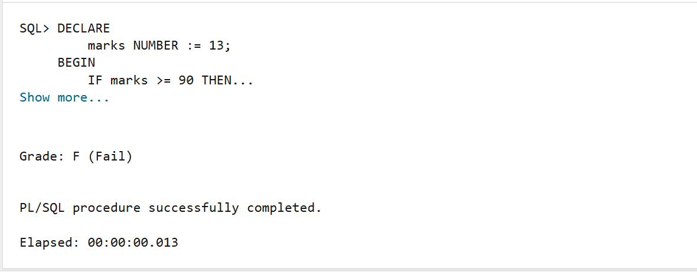

PROBLEM STATEMENT 3
DECLARE
marks NUMBER := &marks;
BEGIN
IF marks >= 85 THEN
DBMS_OUTPUT.PUT_LINE('Performance: Excellent');
ELSIF marks >= 70 THEN
DBMS_OUTPUT.PUT_LINE('Performance: Very Good');
ELSIF marks >= 55 THEN
DBMS_OUTPUT.PUT_LINE('Performance: Good');
ELSIF marks >= 40 THEN
DBMS_OUTPUT.PUT_LINE('Performance: Average');
ELSE
DBMS_OUTPUT.PUT_LINE('Performance: Poor');
END IF;
END;
/
Output

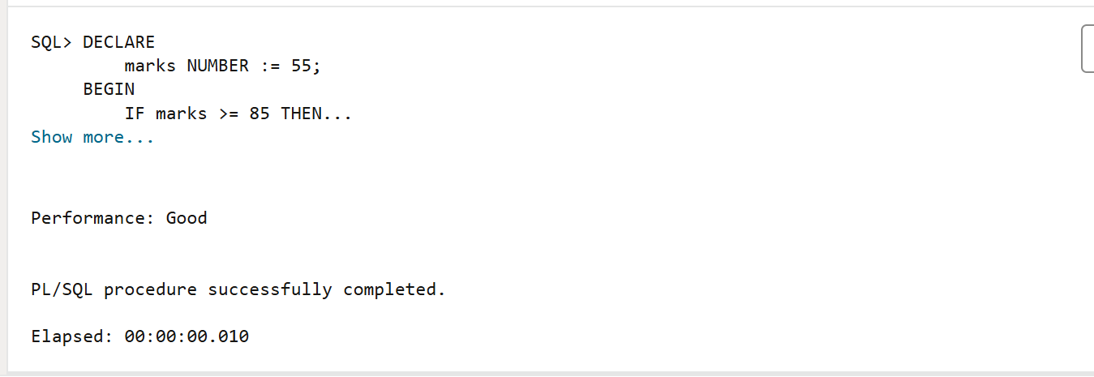

PROBLEM STATEMENT 4

CASE STATEMENT:
DECLARE
NUM1 NUMBER:=10;
NUM2 NUMBER :=20;

CHOICE NUMBER :=1;

RESULT NUMBER;
BEGIN
RESULT := CASE CHOICE
WHEN 1 THEN NUM1+NUM2
WHEN 2 THEN NUM1*NUM2
WHEN 3 THEN NUM2-NUM1
WHEN 4 THEN
CASE WHEN NUM1 =0 THEN NULL
ELSE NUM2/NUM1
END
ELSE NULL

END;

IF RESULT IS NULL THEN
DBMS_OUTPUT.PUT_LINE('WRONG CHOICE OR DIVIDE BY ZERO EXCETION');
ELSE
DBMS_OUTPUT.PUT_LINE(RESULT);
END IF;
END ;

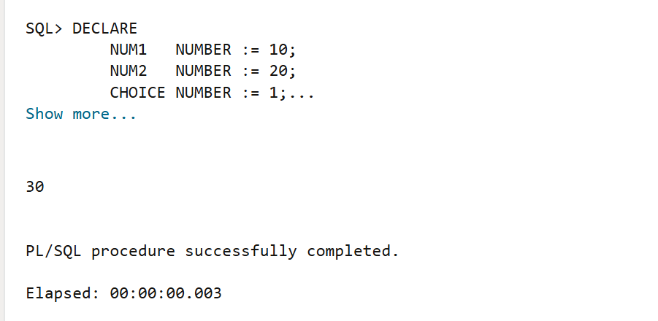

Learning Outcomes
- Understand the structure of a PL/SQL block (DECLARE, BEGIN, END).
- Use conditional control statements such as IF–ELSE, IF–ELSIF–ELSE, and ELSIF ladder in PL/SQL.
- Accept user input using substitution variables.
- Implement decision-making logic in database programs.
- Display output using the DBMS_OUTPUT.PUT_LINE statement.
- Analyze and classify data based on given conditions.
- Develop basic problem-solving skills using PL/SQL.

