Experiment 10

Student Name: Sejal UID: 24BAI70050
Branch: CSE - AIML Section/Group: 24AIT_KRG G1
Semester: 4 Date of Performance: 17/4/26
Subject Name: DBMS Subject Code: 24CSH-298

AIM
To design and implement a database trigger that automatically generates or enforces a primary key, ensuring unique identification of records without manual intervention.

SOFTWARE REQUIREMENTS

Database Management System:
- Oracle Database Express Edition
- PostgreSQL
Database Administration Tool / Client Tool:
- Oracle SQL Developer
- pgAdmin

OBJECTIVE

- To create a trigger that automatically generates unique primary key values during record insertion.
- To replicate stored procedure-like logic using triggers.
- To ensure data integrity and eliminate manual errors in primary key assignment.

PROBLEM STATEMENT

In enterprise-level databases, each record must have a unique primary key. Manual entry of primary keys may lead to duplication or inconsistencies.
Design a trigger that:
- Automatically assigns a unique primary key value before inserting a record.
- Ensures no duplicate or null primary key values exist.
- Implements logic similar to a stored procedure for automation.
This concept is widely used in real-world applications such as e-commerce platforms (Amazon, Flipkart) and enterprise database systems.

PROCEDURE

- Create a table where the primary key will be automatically generated.
- Create a sequence (in Oracle/PostgreSQL) to generate unique numbers.
- Write a trigger that executes BEFORE INSERT on the table.
- Inside the trigger, assign the next value of the sequence to the primary key field.
- Insert multiple records without specifying the primary key.
- Verify that each record gets a unique primary key automatically.

INPUT/OUTPUT ANALYSIS
SQL Input Queries
CREATE TABLE students (
id INT PRIMARY KEY,
name VARCHAR(50),
age INT
);
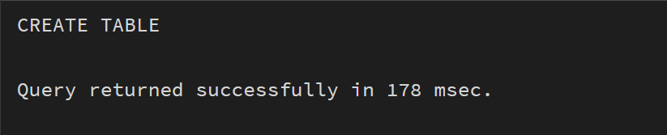

CREATE SEQUENCE student_seq START 1;

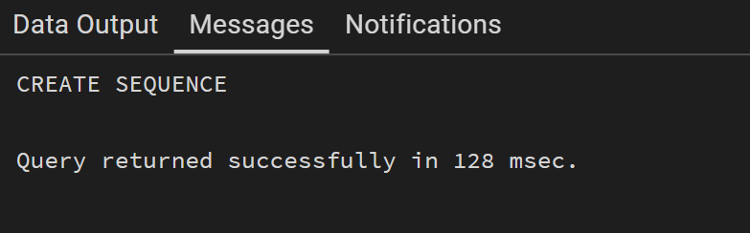

CREATE OR REPLACE FUNCTION student_trigger_function()
RETURNS TRIGGER AS $$
BEGIN
IF NEW.id IS NULL THEN
NEW.id := nextval('student_seq');
END IF;
RETURN NEW;
END;
$$ LANGUAGE plpgsql;

Output
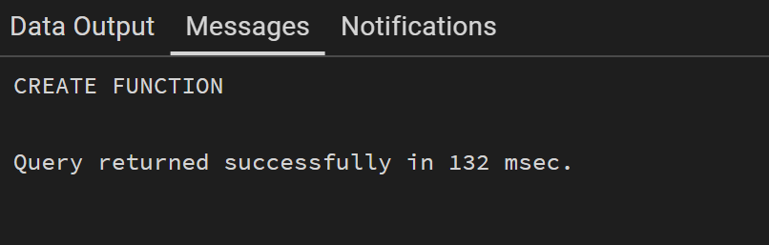

CREATE TRIGGER student_trigger
BEFORE INSERT ON students
FOR EACH ROW
EXECUTE FUNCTION student_trigger_function();
Output
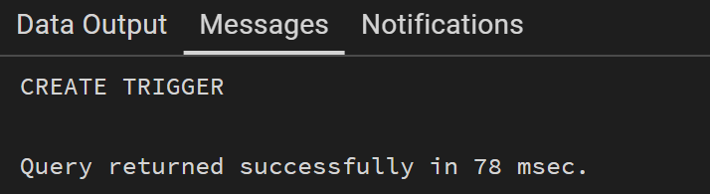

INSERT INTO students (name, age) VALUES ('Sejal', 20);
INSERT INTO students (name, age) VALUES ('Riya', 21);

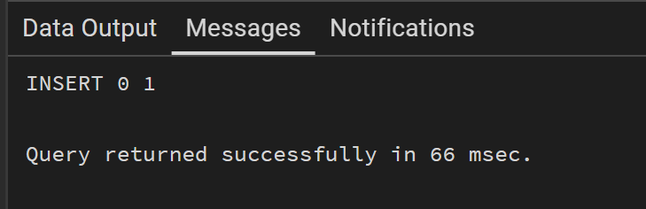

SELECT * FROM students;

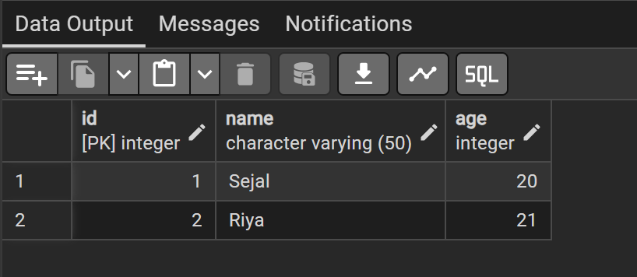

Learning Outcomes
- Understand the concept and working of database triggers.
- Implement automatic primary key generation using triggers.
- Ensure data integrity and avoid duplication errors.
- Apply trigger-based automation in real-world enterprise systems.

