Experiment 8

Student Name : Sejal UID: 24BAI70050
Branch: CSE - AIML Section/Group: 24AIT_KRG G1
Semester: 4 Subject Code: 24CSH-298
Subject Name: DBMS

Aim

To create and execute a PL/pgSQL stored procedure that counts the number of employees based on gender using input, output, and inout parameters.

Software Requirements
- PostgreSQL (version 10 or above)
- pgAdmin / SQL Shell (psql)
- Operating System: Windows

Objectives

To understand the concept of stored procedures in PL/pgSQL

To learn the use of IN, OUT, and INOUT parameters

To perform data retrieval using SELECT INTO

To execute procedures using the CALL statement

To display output using RAISE NOTICE

Practical/Experiment Steps

Create a table employees with required fields.

Insert sample data into the table.

Create a stored procedure using PL/pgSQL.

Use input parameter to pass gender.

Use output parameter to store count.

Use INOUT parameter to track status.

Call the procedure inside a DO block.

Display results using RAISE NOTICE.

Procedure
1. Table Creation
- A table employees is created with:
  - emp_id → Primary key
  - emp_name → Employee name
  - gender → Gender of employee
  - salary → Salary
2. Data Insertion
- Sample employee records are inserted into the table.
3. Stored Procedure Creation
- Procedure name: get_Employee_Count_BY_Gender
- Parameters:
  - IN_GENDER → Input gender
  - OUT_COUNT → Stores employee count
  - STATUS → Stores execution status
4. Logic Used
- SELECT COUNT(*) INTO OUT_COUNT counts employees.
- STATUS := 'SUCCESS' updates execution status.
5. Execution Block
- A DO block is used to:
  - Declare variables
  - Call the procedure
  - Print output using RAISE NOTICE

Input/Output Analysis
CREATE TABLE employees (
emp_id SERIAL PRIMARY KEY,
emp_name VARCHAR(50),
gender VARCHAR(10),
salary NUMERIC(10,2)
);
Output

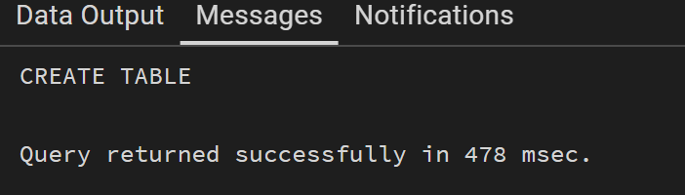

INSERT INTO employees (emp_name, gender, salary) VALUES
('Amit', 'Male', 30000),
('Riya', 'Female', 35000),
('John', 'Male', 28000),
('Sneha', 'Female', 40000),
('Rahul', 'Male', 32000);

Output
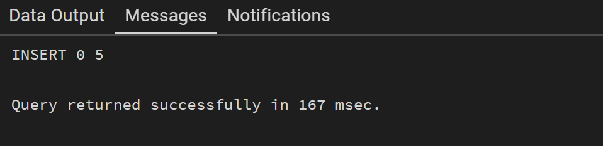

CREATE OR REPLACE PROCEDURE get_Employee_Count_BY_Gender (IN IN_GENDER VARCHAR(20), OUT OUT_COUNT INT, INOUT STATUS VARCHAR(20))
AS
$$
BEGIN

SELECT COUNT(*) INTO OUT_COUNT FROM employees WHERE GENDER='Male';
STATUS:='SUCCESS';

END;

$$ LANGUAGE PLPGSQL;
Output
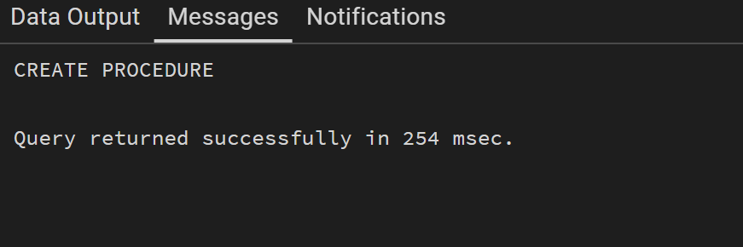

DO
$$
DECLARE
GEN VARCHAR(20):='Male';
Count_of_Employee int;
STATUS VARCHAR:='Pending';
BEGIN
CALL get_Employee_Count_BY_Gender(GEN,Count_of_Employee,STATUS);
RAISE NOTICE 'YOUR COUNT OF EMPLOYEE BY GENDER IS % AND YOUR STATUS IS %',Count_of_Employee,STATUS;
END;

$$
Output
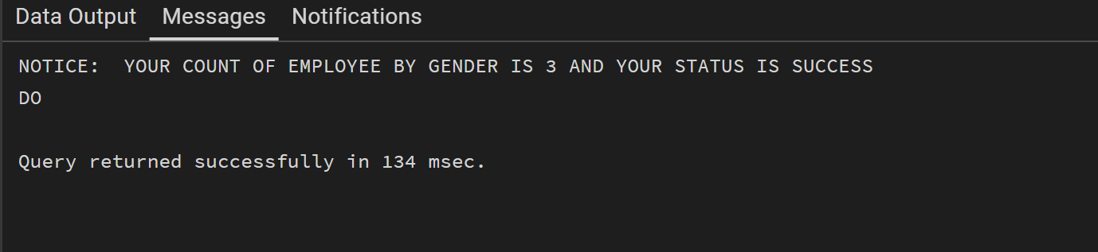

Learning Outcomes
- Understand how to create stored procedures in PostgreSQL
- Use IN, OUT, INOUT parameters effectively
- Perform data retrieval using SELECT INTO
- Execute procedures using CALL
- Handle procedural logic in PL/pgSQL

