1. Objective
Fickling Evaluation
Small evaluation was to first build a completely normal machine-learning model and then use Fickling to inspect and check the saved pickle model

2. Project Setup
Project folder:
C:\sejalseptemberfiles\house_prediction_model
A Python virtual environment was used. The following packages were installed:
- pandas
- scikit-learn
- matplotlib
Fickling was also installed and its missing dependency was resolved by installing typing_extensions.

3. Dataset Created
A small house-price dataset named house_data.csv was created. It contains the following columns:
- area_sqft
- bedrooms
- bathrooms
- age_years
- price_lakh
The dataset contains 20 house records. Example rows:
area_sqft | bedrooms | bathrooms | age_years | price_lakh
600 | 1 | 1 | 25 | 28
1000 | 2 | 2 | 12 | 48
1500 | 3 | 2 | 7 | 74
2000 | 4 | 3 | 5 | 105
3000 | 5 | 4 | 1 | 175

4. Model Training
The model was trained using Scikit-learn LinearRegression. The input features were:
area_sqft, bedrooms, bathrooms, age_years
The target value was price_lakh.
The data was split into training and test data using train_test_split with test_size=0.2 and random_state=42.
Training results:
- Mean Absolute Error (MAE): 3.7546149174886203
- R2 Score: 0.9912039119736697
The trained model was saved as house_model.pkl using Python pickle.

5. Model Loading and Prediction Test
A separate load_model.py script was created to load house_model.pkl and make predictions for three sample houses.
Test house | Predicted price
1500 sqft, 3 bedrooms, 2 bathrooms, age 7 | 74.21 lakh
1000 sqft, 2 bedrooms, 2 bathrooms, age 12 | 45.75 lakh
2000 sqft, 4 bedrooms, 3 bathrooms, age 5 | 104.90 lakh
The model loaded successfully and produced predictions without the earlier feature-name warning after the input was changed to a pandas DataFrame with matching feature names.

6. Fickling Installation and Version
Fickling was installed successfully. The command: 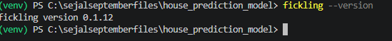

7. Fickling Safety Check
The clean house_model.pkl was checked with Fickling using:
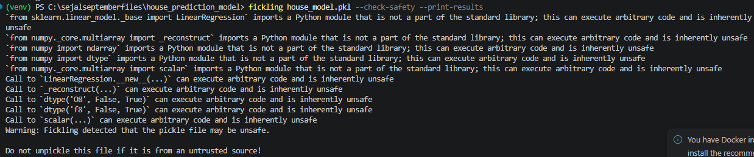
The reported reasons included legitimate ML reconstruction operations involving:
- sklearn.linear_model._base.LinearRegression
- numpy._core.multiarray._reconstruct
- numpy.ndarray
- numpy.dtype
- numpy scalar
- LinearRegression.__new__
Important interpretation: The model is not poisoned or malicious. The model was created normally by this evaluation
Fickling's safety checker can flag a legitimate Scikit-learn pickle as potentially unsafe.

8. JSON Safety Report
The same safety check was also run with JSON output:
fickling house_model.pkl --check-safety --print-results --json-output safety_results.json
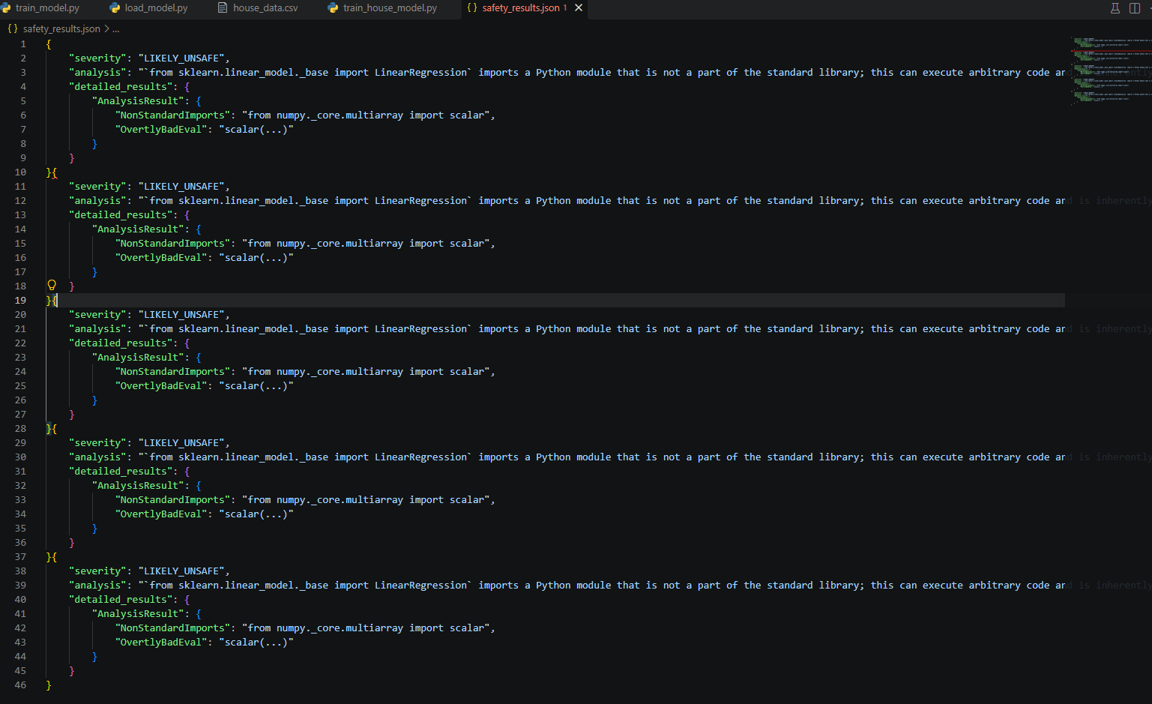

9. Fickling Trace Test
Fickling’s --trace was supposed to show the step-by-step execution/reconstruction process inside the pickle file.
fickling house_model.pkl –trace
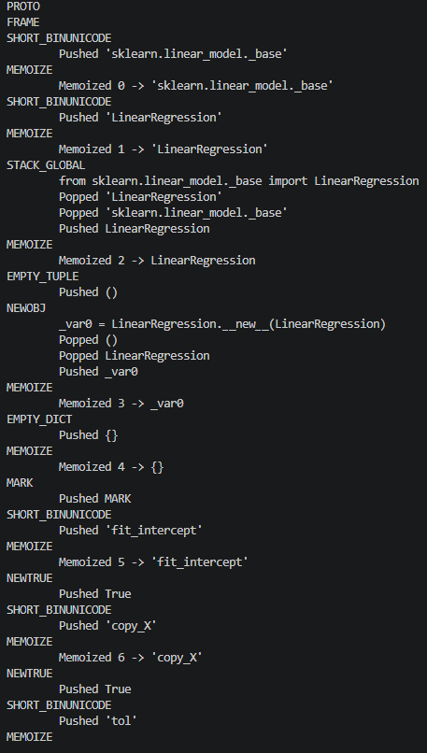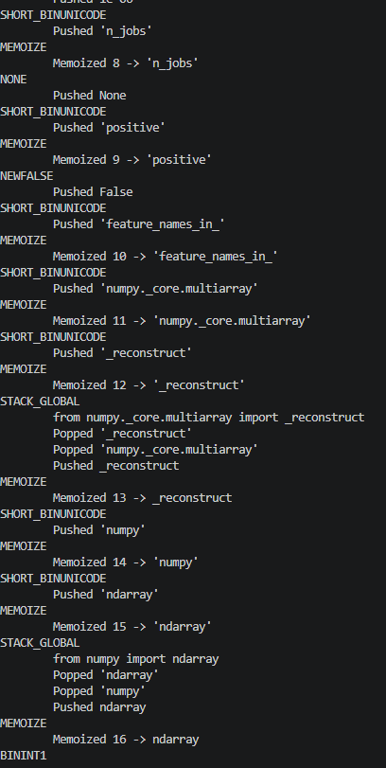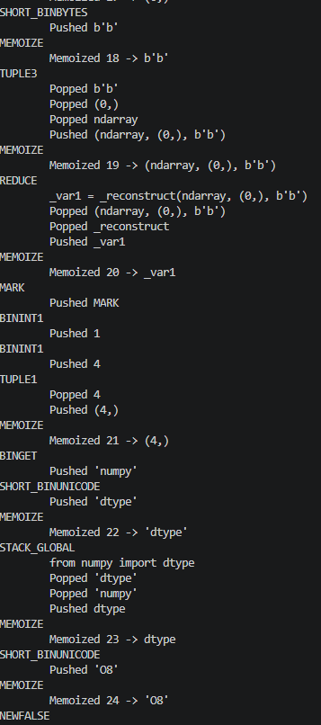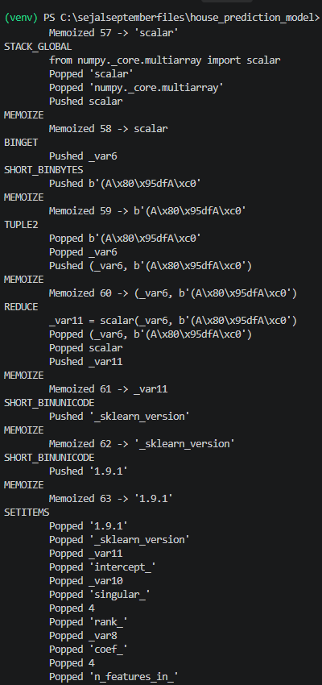
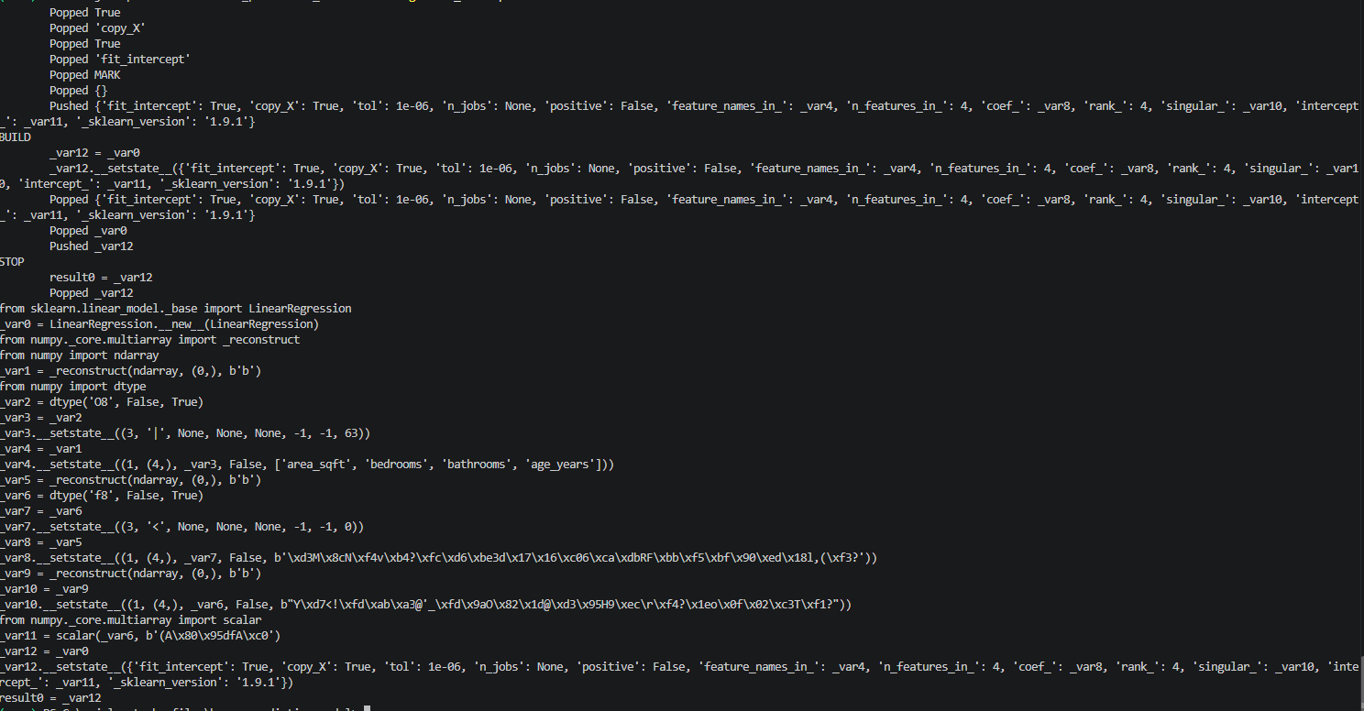
The trace showed Fickling interpreting the pickle and reconstructing the LinearRegression object, NumPy arrays, feature names, coefficients, singular values, intercept, and Scikit-learn model state.

Test 1 — Basic Fickling analysis
Input: Clean house_model.pkl containing a scikit-learn LinearRegression model.
Command:
fickling house_model.pkl
Result: Fickling read the pickle and produced a Python-like reconstruction of the model.
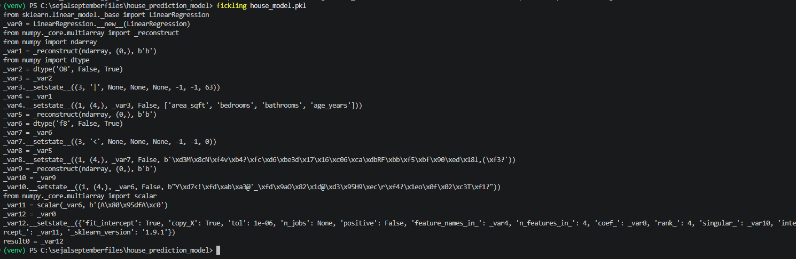
Fickling produced human-readable Python-like instructions showing the reconstruction of the LinearRegression object, NumPy arrays, feature names, learned coefficients, intercept, model configuration, and stored scikit-learn version.
Finding: Fickling can decompile/interpret the pickle into a representation that allows an analyst to understand what objects and reconstruction operations are contained in the file.
malicious test code
Step 1 — We had the clean model
Our original file was:
house_model.pkl
This was our normal, clean Scikit-learn house-price model.
Step 2 — We chose a harmless malicious test
We used this code:
print('FICKLING_MALICIOUS_TEST')
It is called a malicious test payload because we are intentionally adding code that should execute when the pickle is loaded.
It does not delete files, steal data, or do anything harmful. It only prints:
FICKLING_MALICIOUS_TEST

Step 3 — We used Fickling's --inject
We ran:
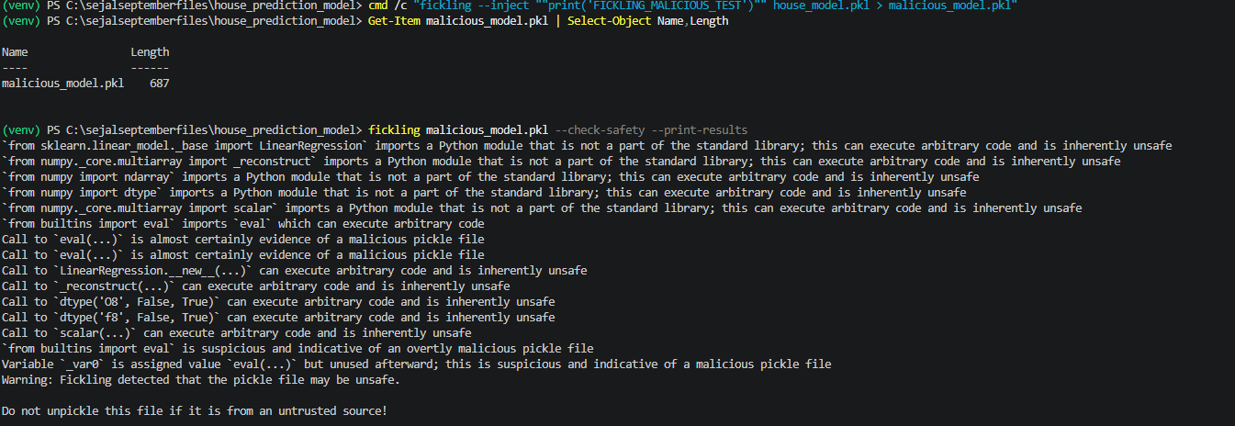
Successful malicious file addition
We successfully used Fickling's --inject feature to add the test:
print('FICKLING_MALICIOUS_TEST')
to the clean house_model.pkl.
The modified file was successfully created as:
malicious_model.pkl
File size: 687 bytes ✅
Result: Malicious test file successfully injected into the pickle.
Fickling detects the suspicious eval() → malicious pickle detected. ✅
Injecting malicious file
--run-last test — file creation successful
We created:
malicious_run_last.pkl
Size: 675 bytes
So the --run-last injection successfully produced a pickle file.
What this test proves so far
--run-last successfully changed the injection mode from the normal behavior to:
Inject the test code at the end of the existing pickle operations.

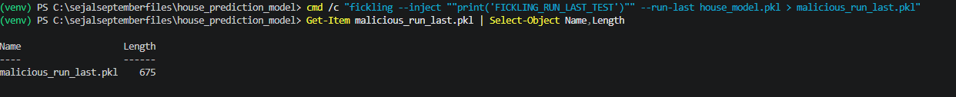
Testing --inject-target
Test: --inject-target
Purpose:
Tests whether Fickling can choose a specific pickle object inside a model file for code injection.
Command used:
cmd /c "fickling --inject ""print('FICKLING_INJECT_TARGET_TEST')"" --inject-target 0 house_model.pkl > malicious_inject_target.pkl"

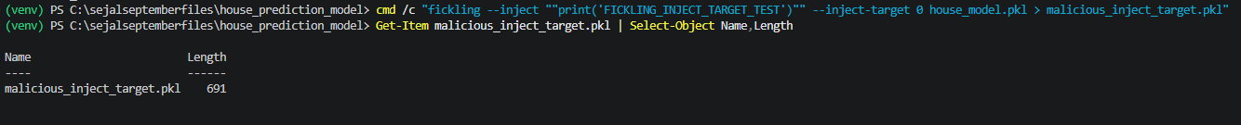
Result:
- File created successfully: malicious_inject_target.pkl
- File size: 691 bytes
- Trace showed the injected code:
_var0 = eval("print('FICKLING_INJECT_TARGET_TEST')")
- The original LinearRegression model was still reconstructed.
- Final result remained:
result0 = _var13
Conclusion:
✅ PASS — --inject-target 0 successfully selected target 0 and inserted the test code.
--inject-target: PASS — Fickling successfully accepted target index 0 and injected the test code into the selected pickle target.

Fickling Python API – load() Test
Purpose: Test Fickling's safe-loading API, fickling.load(), using the existing clean house_model.pkl.
Result: BLOCKED – UnsafeFileError
Fickling classified the known-clean Scikit-learn model as LIKELY_UNSAFE and refused to load it. The analysis flagged non-standard Scikit-learn/NumPy imports and reconstruction operations.
Interpretation: This confirms that fickling.load() performs a safety check before loading. It also reproduces the false-positive/compatibility issue already observed with --check-safety: our known-clean Scikit-learn model is blocked.

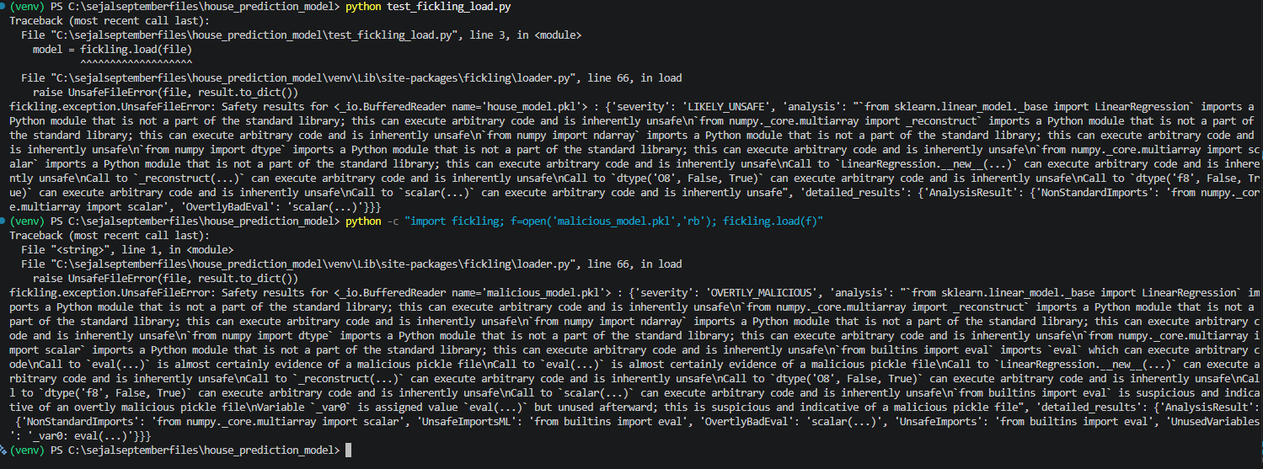
Test: fickling.is_likely_safe()
Purpose: Check whether Fickling considers a pickle file likely safe without loading it.
Input: Existing malicious_model.pkl
Command:
python -c "import fickling; print(fickling.is_likely_safe('malicious_model.pkl'))"
Result: PASS — False
Interpretation: Fickling correctly identified the injected pickle as not safe.
Important: False means “not likely safe”. It does not itself explain why the file was unsafe; the detailed reason comes from the safety analysis we already tested.

Test: fickling.always_check_safety()
Purpose: Test whether Fickling can automatically enforce safety checking when normal Python pickle.load() is used.
Input: Existing malicious_model.pkl
Result: PASS — Fickling automatically intercepted pickle.load() and raised UnsafeFileError, classifying the pickle as OVERTLY_MALICIOUS. 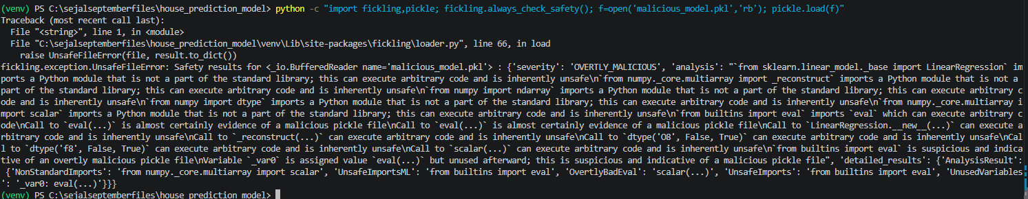
- fickling.always_check_safety() enabled Fickling's automatic safety checking.
- We then used normal Python pickle.load().
- Fickling intercepted the load.
- It analyzed malicious_model.pkl.
- It stopped the load with:
UnsafeFileError
- It classified the file as:
OVERTLY_MALICIOUS
- It specifically detected the injected:
from builtins import eval
Call to eval(...)
Test: activate_safe_ml_environment()
Purpose: Test Fickling's global ML environment protection inside the actual model-loading application.
Input: Existing house_model.pkl
Result: PASS — the Fickling hook intercepted the normal pickle.load() call and blocked the model with UnsafeFileError. 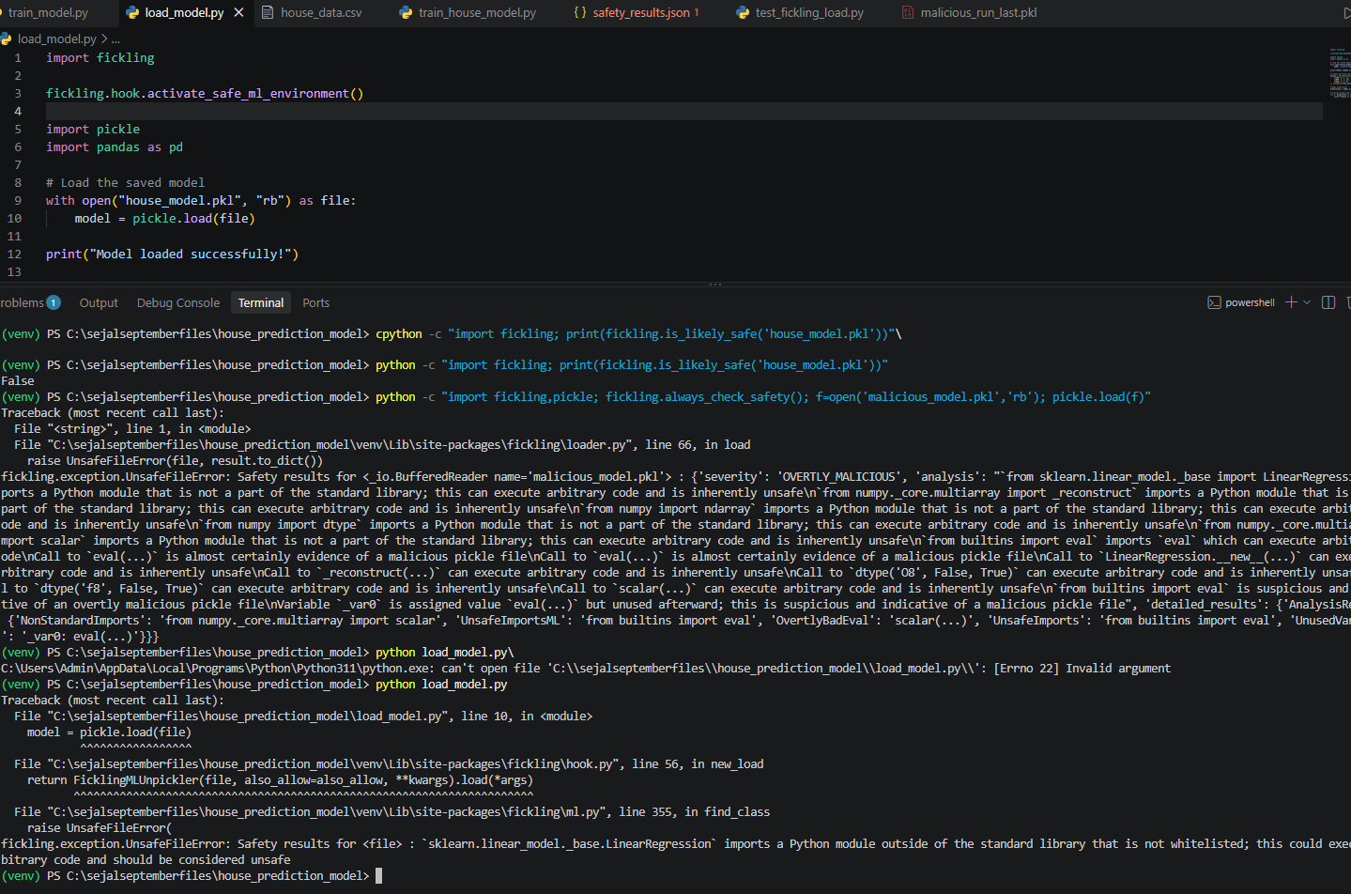
Observation: The known-clean sklearn model was blocked because sklearn.linear_model._base.LinearRegression is not whitelisted.
Conclusion: The hook successfully protects the ML application, but its allowlist can cause compatibility/false-positive blocking for legitimate ML models
Test: also_allow
Purpose: Test whether additional ML imports can be manually added to Fickling's allowlist.
Input: Existing house_model.pkl
Configuration: also_allow=["sklearn.linear_model._base"]
Result: PARTIAL — the model was still blocked because LinearRegression remained unwhitelisted.
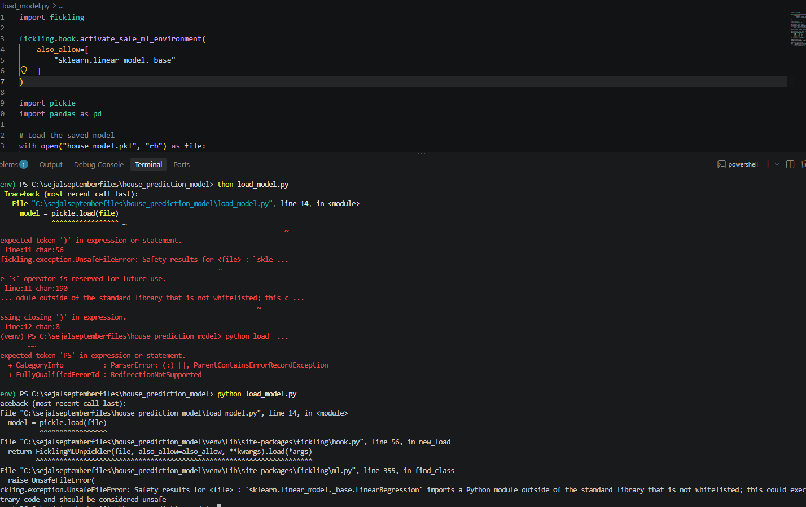
Conclusion: also_allow did not make the model load successfully with this single module entry. Additional dependencies/imports may need to be explicitly allowed.
Feature: Hugging Face model scanning
Purpose:
Fickling provides a CLI option to scan a model directly from the Hugging Face Hub instead of requiring the model file to already be downloaded locally.
Fickling option:
--huggingface REPO_ID
It accepts a Hugging Face repository ID, for example:
bert-base-uncased
Step 1 — Install Hugging Face support
We installed the optional Hugging Face dependency:
pip install "fickling[huggingface]"
Result: Installation completed successfully.
Step 2 — Verify the dependency
We ran:
python -c "import huggingface_hub; print('Hugging Face support installed')"
Output:
Hugging Face support installed
Result: PASS ✅
This confirms that the required Hugging Face package is available in our current Fickling virtual environment.
Step 3 — Actual Fickling Hugging Face scan
Not completed yet.
The next command we proposed was:
fickling --huggingface "bert-base-uncased"
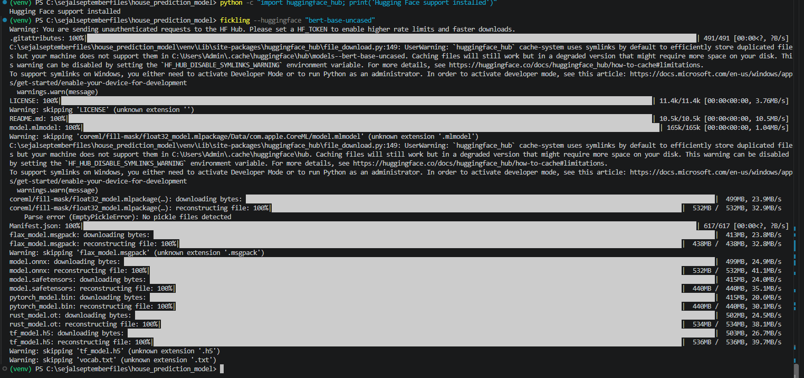

Area | Result | What we learned
Normal Pickle decompilation | ✅ | Can reconstruct Pickle contents as Python-like code
Safety analysis | ✅ | Detects suspicious operations
Malicious injected Pickle | ✅ | Detected injected eval()
JSON reporting | ✅ | Can produce machine-readable results
Trace | ✅ | Shows Pickle execution/reconstruction steps
fickling.load() | ✅ | Can block files classified as unsafe
is_likely_safe() | ✅ | Provides a simple safety decision
always_check_safety() | ✅ | Can automatically protect normal pickle.load()
Safe ML environment | ✅ | Can intercept ML model loading
also_allow | ⚠️ | Allowlisting can require more dependency handling
Injection | ✅ | Can rewrite Pickle files
--run-last | ✅ | Can place injected code at the end
--replace-result | ✅ | Can replace the final Pickle result
--inject-target | ✅ | Basic target selection works
Hugging Face | ✅/⚠️ | Can scan supported Pickle content in repositories
PyTorch | ✅/⚠️ | Dedicated wrapper supports PyTorch formats
PyTorch injection | ✅ | Both insertion and combination worked
Polyglot utilities | ⚠️ | Format inspection worked; polyglot creation failed in our case
Corruption handling | ⚠️ | Detects invalid ZIP structure, but corruption helper wasn't a complete integrity verdict
Pickle protocols 0–3 | ✅ | Successfully parsed
Malformed Pickle | ✅ | Rejected cleanly
Non-Pickle text file | ✅ | Rejected cleanly

