

project (SNAKE GAME)

Instructor Sir Syed Muzamil Hussain.



sUMBITTED BY:

Khursheed ahmed

SEJAL SEETLANI

Contents

Introduction: 2

Libraries: 2

Requirement: 3

Software requirement: 3

Hardware requirement: 3

Objectives: 3

Features of project: 4

Changes in project: 4

# Introduction:

The project is basically a game , written in java programming language , typically involve the player controlling a line of snake , this game is based on snake , therefore it is called snake game . The game involves the snake or line eating items in will make snake longer , with the object being to avoid running into a border or the snake itself for as long as possible.

* The player will lose, when the snake either runs into a border or its own body.
* Because of this, the game becomes more difficult as it goes on, due to the growth of snake.
* Nokia has installed the snake game on many of its phones.
* This game is simple and mind relaxing.

# Libraries:

Import.java.swing.*;

Import.java.awt.*;

Import.java.awt.event.ActionEvent;

Import.java.awt.event.Actionlitsner;

Import.java.awt.Event.keyEvent;

Import.java.awt.Event.KeyListener;

Import.java.util.random;

# Requirement:

## Software requirement:

Oprating system: -Any (linix, window).

Application System: -Any (codeblocks, tarbo).

Language: -Any (Java, C++).

## Hardware requirement:

Hard disk: -Any.

Ram: -Any, which you prefer.

Processor: -Any.

# Objectives:

This project is in java language named as snake game. It is simple console application with very simple graphics. You can play at desktop, just like you played it elsewhere. Just what you have to do is use the up, down, right, left arrows to move the snake as per your direction. Items are provided at a several co-ordinates of the screen for the snake to eat, every time the snake eats the food, its length will be increased by one element along with the score.

# Features of project:

* This snake game is just similar to games which are found under mobile games section.
* It uses the concept of graphics to display the menu items and all objects on a single screen.
* Player will able to check their result during game playing and after the game also.
* The food object of snake game appears randomly every time because we abstract the object of random class.
* The snake’s direction always start from right.

# Changes in project:

* Firstly, when the snake hits the wall, then it outs from another was from same direction but, now when it hits with the wall then the game will be over.
* Firstly, when snake eats an item it’s size increased by one but, now the score is increased by two.
* Third change that we add in project is related to speed, snake speed is increased by some certain eaten items that we had defined already.
* Firstly, it was a simple graphics based but, now we add more colors into it using Image icon library that helps us to place pictures where we want.

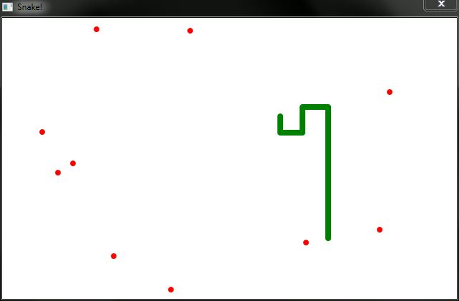Before our game screen was look like this.

But now it looks like.



