**Document**

Gitlab URL: <https://gitlab.kingston.ac.uk/CI5105-2020-21-K1907860/TaskManagerPhase2.git>

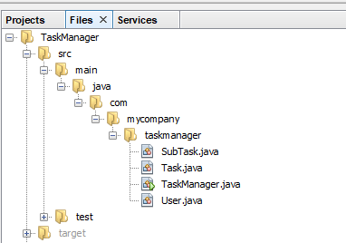

Figure 1: Directory that contains all the .java file.

…\TaskManager\src\main\java\com\mycompany\taskmanager\(contains .java files)

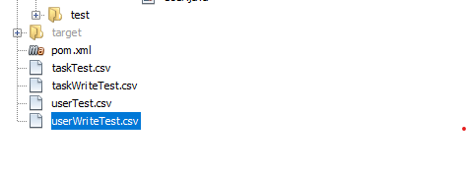

Figure 2: Contains all the .csv files

…\TaskManager\(all .csv files)