Question 1:

Setting up environment:
Step 1: Launching the necessary programs
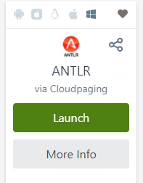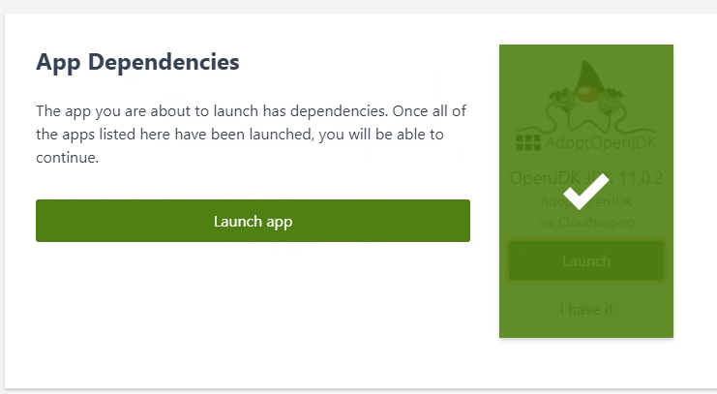
ANTLR needs OpenJDK app dependences to start running.

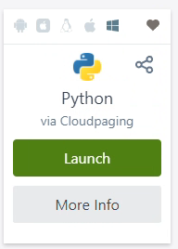
Visual studio code is an source code editor where all the necessary source code will be easily edited. Python needed to be launched as this project will be written in python.
In Cloud shell: alias python='/usr/bin/python3'needed to be written in .bashrc file.

Step 2: Setting up the directories
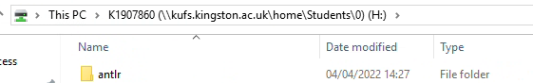
Above shows that a folder in H drive has been created and called it antlr.
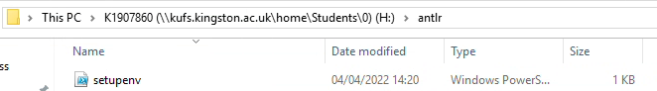
setupenv.ps1, a PowerShell file is downloaded and added to the folder.
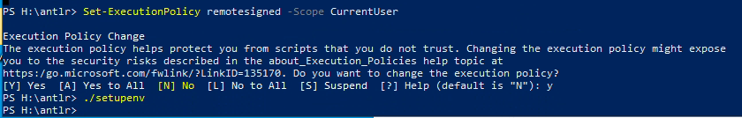
In PowerShell, a command “Set-ExecutionPolicy remotesigned -Scope CurrentUser” is executed followed by the “./setupenv” which is the PowerShell file that was downloaded. This will set up the environment for ANTLR to work.
In Cloud Shell: Similar directory is created.
Step 3: Checking Python, Java and ANTLR4 working.
Python –version;
Java
Python and java are called to see if they work correctly.
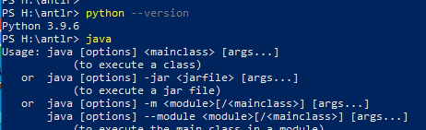

Testing ANTLR Installation.

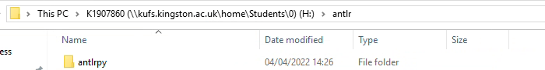
To make sure not to lose in between session, ANTLR must be installed in local directory. There was within antlr file, antlrpy is created.
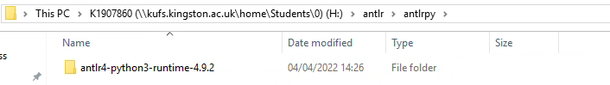
Within antlrpy, antlr4-python3-runtime-4.9.2 is downloaded and added
Antlr4 command is typed to see if the ANTLR is installed correctly
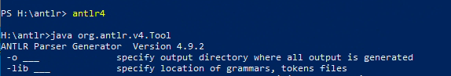
In Cloud Shell:
The URL of the installation is copied and downloaded to cloud shell.
antlr4-python3-runtime-4.9.2
tar zxvf antlr4-python3-runtime-4.10.tar.gz
with this command the file is unzipped.
ANTLR is downloaded from the URL.
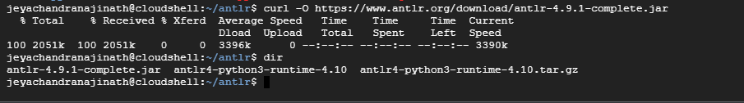
Referencing them in .bashrc file.
Checking that antlr4 is installed in cloud shell.
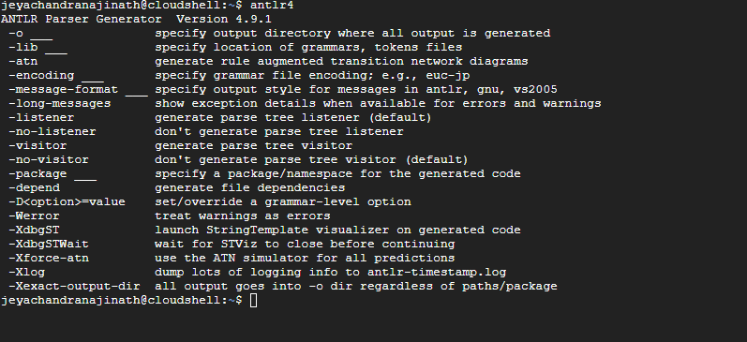

Parsing a simple script of a toy language,
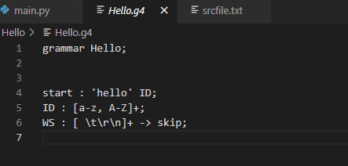
With an extension. g4, I created a grammar file called Hello.g4, which contains the grammar.
Using the command ‘antlr4 -Dlanguag=Python3 Hello.g4’ I created parser files in python. ‘-Dlanguage’ makes sure that the files are in python because by default the antlr4 produces java files.
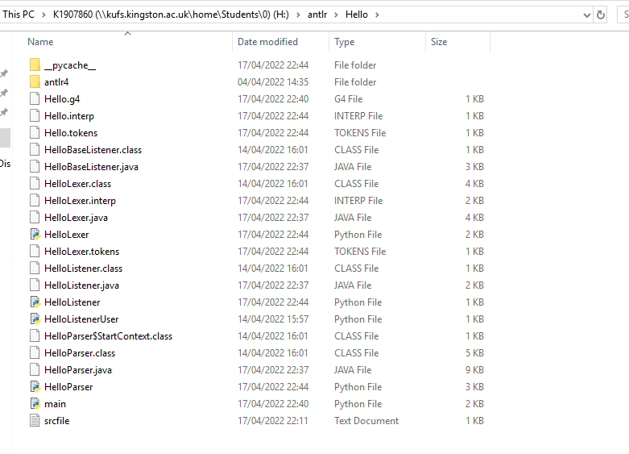
By copying antlr4 python library from the antlr4-python3-runtime-4.9.2 into the Hello folder I have, I was able to run the HelloParser.py without an error.
To test a script file, I created a script and run it through main.py which contains parser codes.
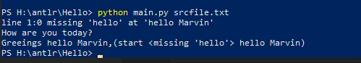
Is it talk about main.py file and its code?

ANTLR to generate python parser,

First a python file called main.py is created and following inputs from python library has been inputted. Some files are created when antlr file Hello.g4 is run using the command antlr4 -Dlanguage=Python3 Hello.g4.these files are from symbolic links (such as antlr directory within Hello folder)

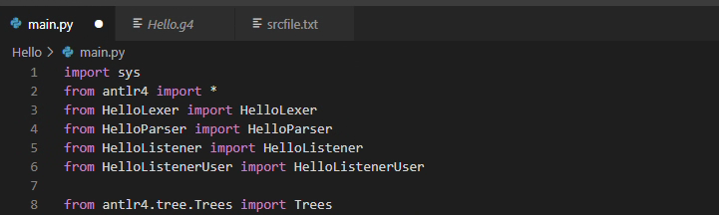

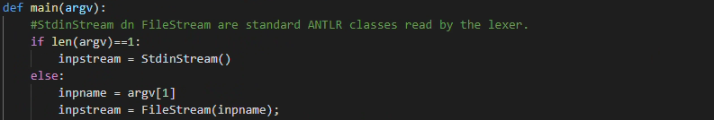
Above if statement makes sure to use the entered word, otherewise use a file that is provided.

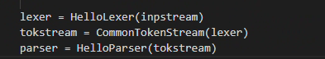
This code is what created a parser. First the lexer will takes whatever the user has inputted and this will be parsed into the tokstream which will act as a siccorr and breaks or split the word so it can be inputted into a parser is done under parser variable using the HelloParser function that decide which tree structure to do.
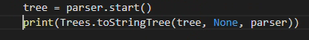
By saying start() the parse tree is created. The print statement is a visual representation of the parse tree.

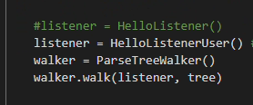
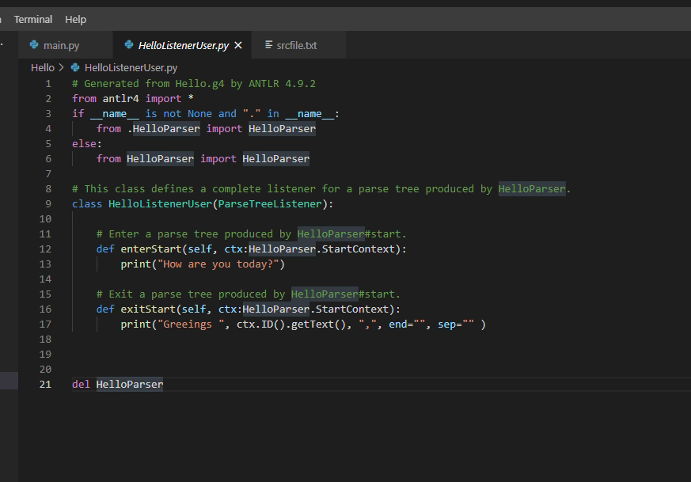
I created a HelloListenerUser.py to be able to use it without it making drastic change to the written code because antlr4 will overwrite the code when it run on Grammar file. This default code is generated by ANTLR4.

Thoughts and reflection.

Starting off understanding the basic of was bit difficult as it took some time to get the grammar of .g4 file. However, with little practise and examples it become easier. Furthermore, using python – an easier language – to write code made it easier to learn as it would have been difficult to code using Java as it requires a lot of attention and requires lots of debugging compared to Python. Installation process is minimal and quicker to do.

Setting up the environment was easy, python, visual studio code and antlr are needed to be loaded. Learning the basic of Grammar syntax is simple and can use to create different grammar ‘hello | hi’. However, using python with antlr can be difficult to understand at first, but with little practise it become easier to understand the concept.

