Question 2:

Grammar Syntax
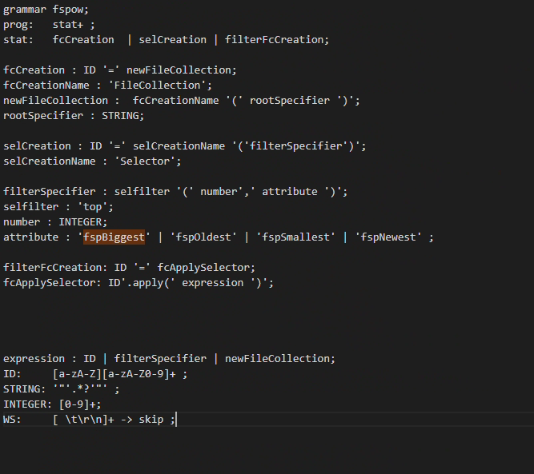
Figure 1
Figure 1 shows that selCreation and filterFcCreation is created, so variable can be in the program.

Figure 2
Figure 2 shows that these are the attributes that will needed to be passed into Selector method: Sel = Selector (top(number , attribute). These attributes can be any of the four listed.
Attribute and number is set to what type of data they could hold or it should be.

Figure 3:
Figure 3 shows: first two lines allow the creation of the variable with necessary functions, so sel=Selector(top(10,fspBiggest)) can be created.
Last two lines ensure the correct syntax the user must write and what are the parameters the user needs to put in top function.
Figure 4:
Figure 4 shows that variable with that expression topBiggest = fc.apply(sel) can be created.

Full Code:
Figure 5: Entire grammar syntax

Testing Grammar:
Pretty print or grun.

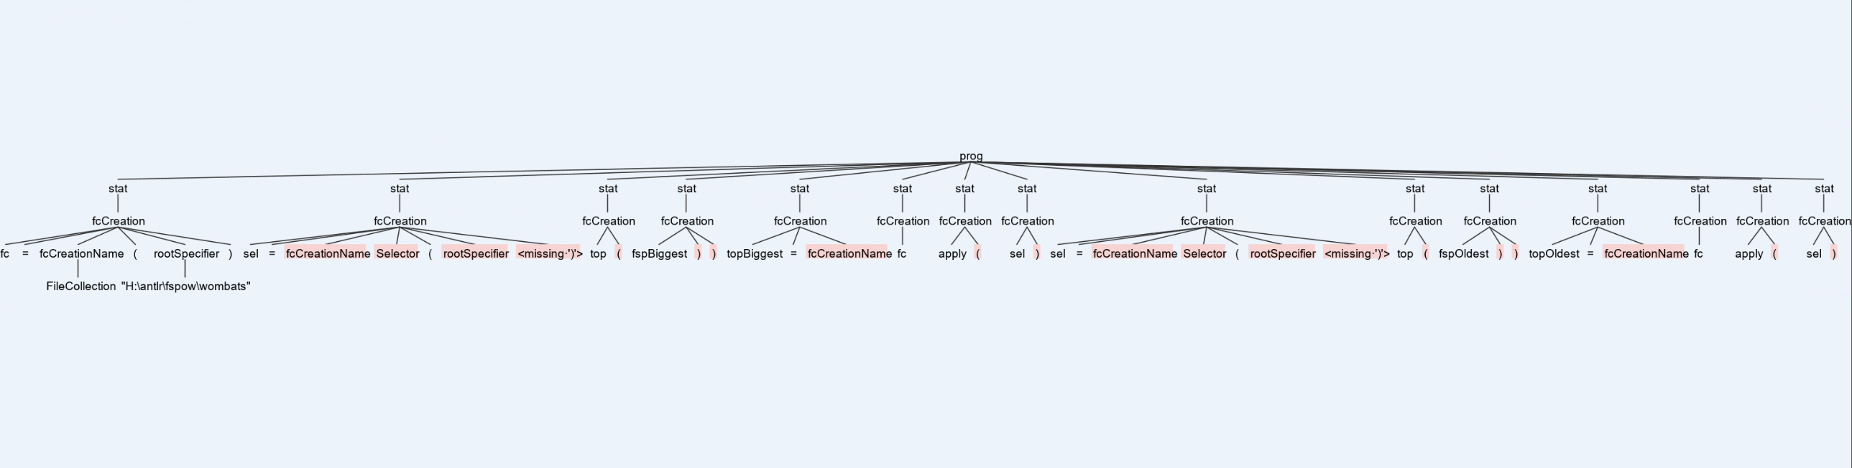
Figure 6:
Figure 6 shows evidence of walking the tree parser for the program in input.txt.
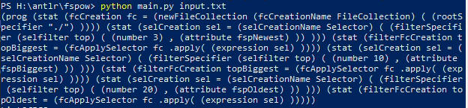
Figure 7
Figure 7 shows tree parser in LISP output for the program in input.txt. When the parser is tested the following output is generated. The parser is recognising the statements.

Figure 8
In figure 8, when run through antlr there is no error occurred suggests that the syntaxes are correct.

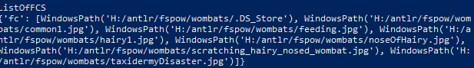
Figure 9
Testing walking of the tree. Figure 9 shows all the file within the folder called ../wombats. This shows that the variable that was defined is stored successfully.

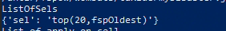
Figure 10: Storing the variable sel.

Figure 11: Storing the variable for with apply method.

Python Syntax:
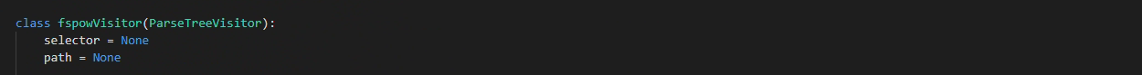
Figure 12
Figure 12 shows that the Selector instance is declared and a variable with path is created. This will allow the data to be transferred at the appropriate function in the Visitor class.
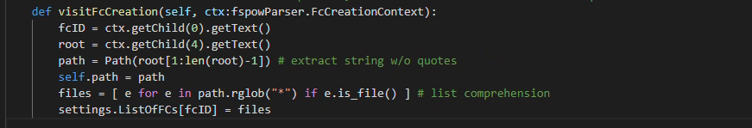
Figure 13: visitFcCreation
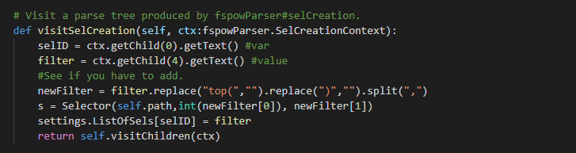
Figure 14: visitSelCreation

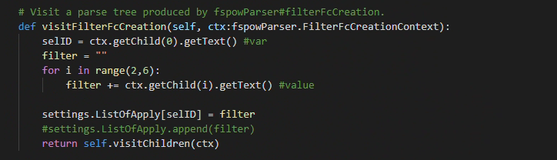
Figure 14: visitFilterFcCreation
Above figures 13, 14 and 15 shows that necessary values such as variable name and values are taken out of the program from input.txt to be stored and used.
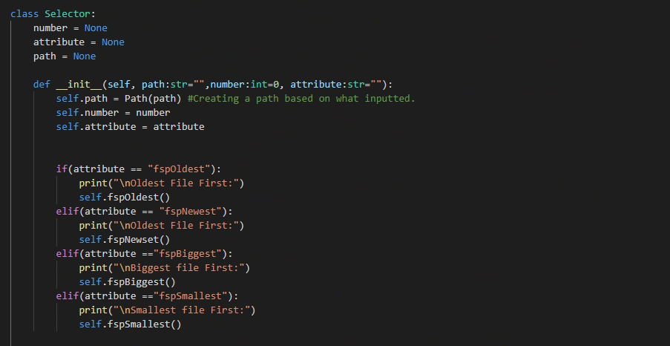
Figure 15: Start operation
Figure 15 shows that the class Selector is created and relevant variables are created. Followed by a constructor is created and values are assigned. The if statement shows that based on the user input in attribute, the following selection should be made.

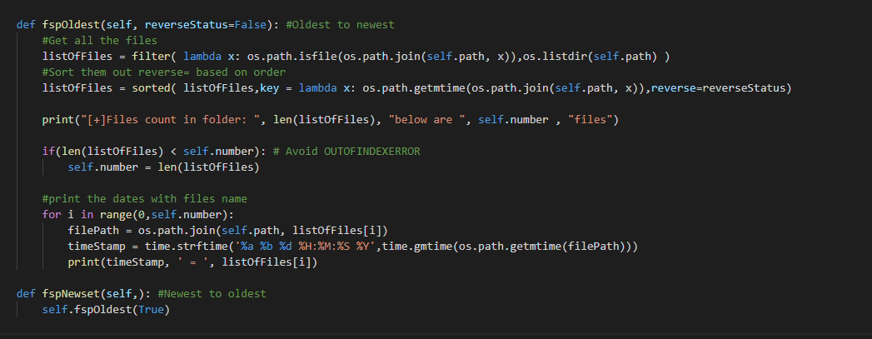
Figure 16: Print newest and oldest file
Figure 16 shows that two function, the first function fspOldest takes all the files within the given directory and will sort it and store in the variable listOfFiles. If statement is created to ensure that only limited item – specified by the user and relate to variable number – is printed. A For loop is created to print out every sorted item in the list, in this case it will print the date and the corresponding files.
fspNewest has fspOldest with parameter True, which will print the newest file.
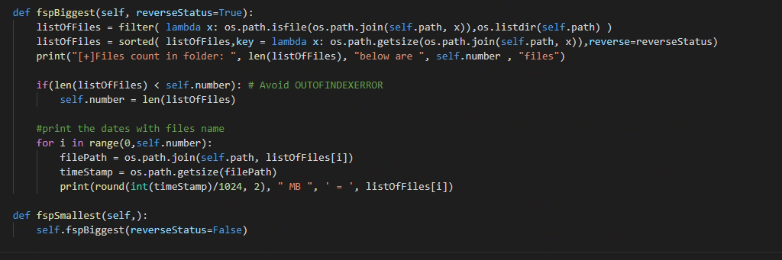
Figure 17: Print biggest and smallest files.
Figure 17 follows same structure. However, it deals with getting the size of the file instead of time. fspSmallest is has reverseStatus set to True to make it print the smallest file.

Python testing:
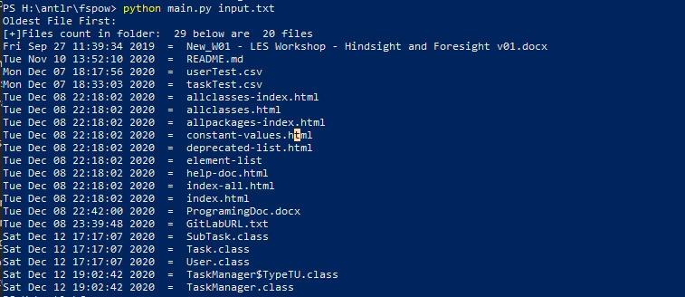
Figure 18: Testing by printing Oldest file in the given directory.
Figure 18 shows that only 20 files are printed as the program stated, and it starts from the oldest file to the latest file.

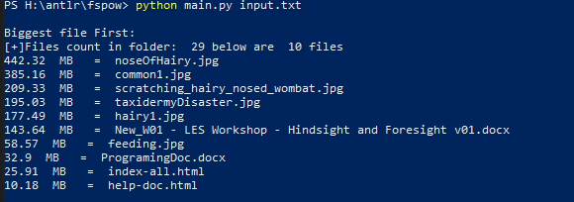
Figure 19: Testing by printing biggest file in the given directory.
Figure 19 shows that only 10 file are printed starting with the biggest (size) file in the directory.

