Question 3:

Implementation in Java

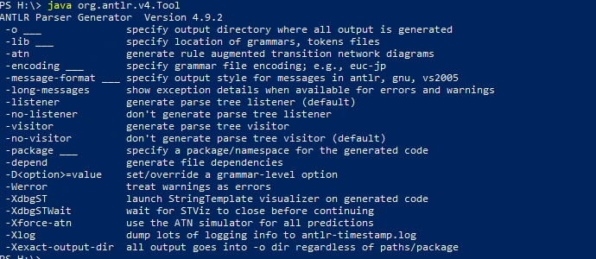
Figure 1: Ensuring java works
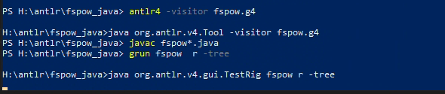
Figure 2: Creating Java Files with Visitor classes using antlr4.
For, in figure 1, to happen the OpenJDK should be running. When antlr4 runs on fspow.g4, there were not errors suggests that all generated successfully.
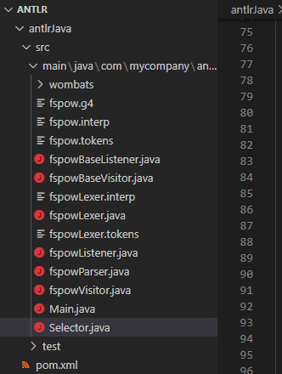
Figure 2.1: Generated java files.
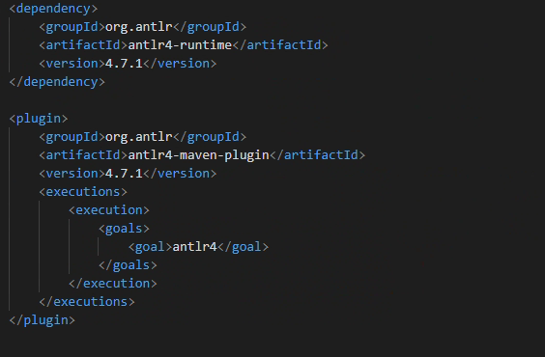
Figure 3
Figure 3 shows adding antlr plugging inside the pom.xml file.
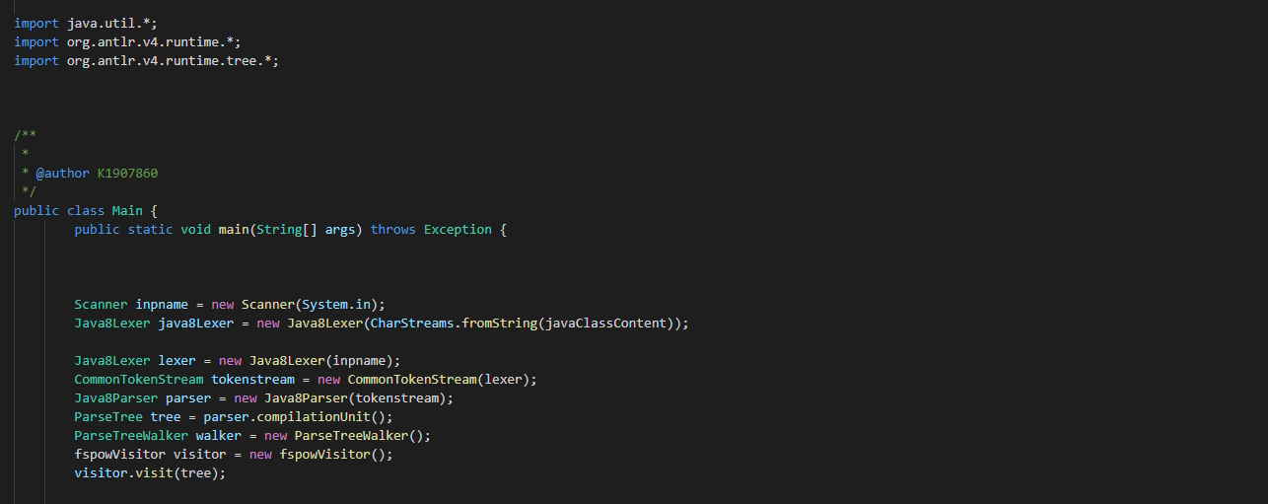
Figure 4
Figure 4 shows creating the parser and walking the tree.

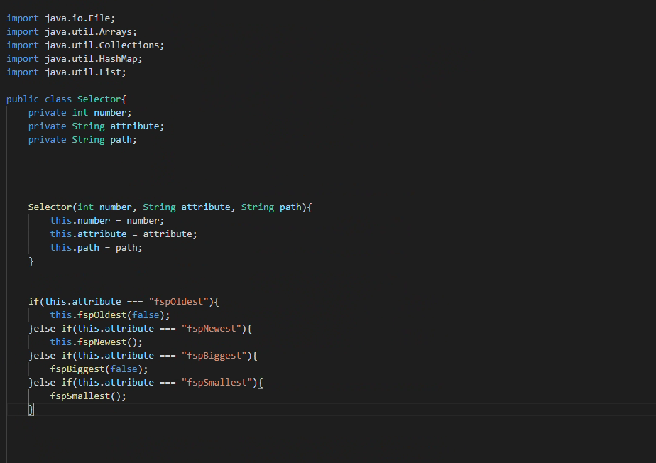
Figure 5
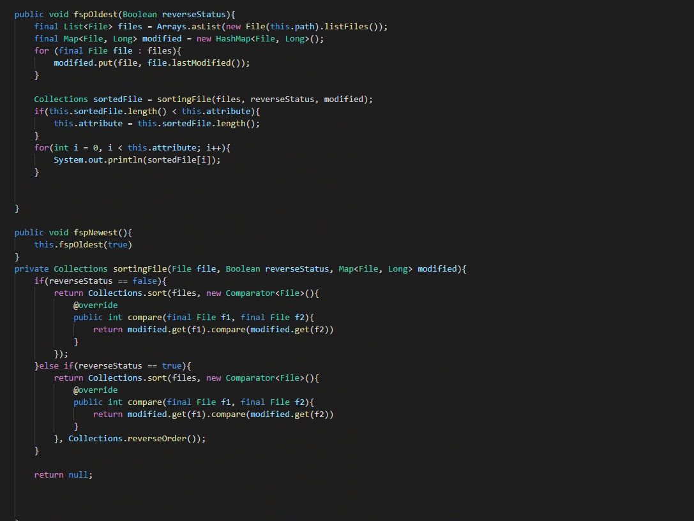
Figure 6
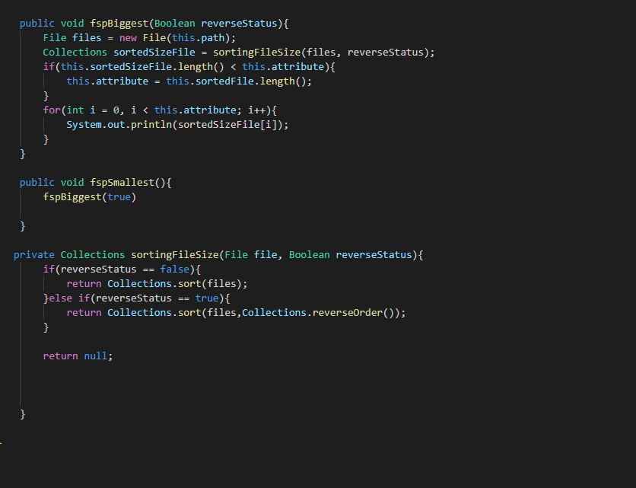
Figure 7
Figure 5, 6 and 7 shows the translation of python selector.py into java selector.java.

Reflection:
When it came to setting up the environment, it was fairly easy, there were no errors, and the execution was smooth. However, when creating parser in the main.java file, it became complicated. For python, it was straightforward and there were less code needed. But for java, there was more writing, and more code was required and often faced with errors which were hard to debug and find solution to. Even though the structure of generated java file is similar to python and the structure and principal is similar, trying to understand certain syntax in java was an extra task and was time consuming.
Overall, switching to java is not a good idea, because it will take a lot of time for the developer to develop the code. Furthermore, there are few resources available to help to with antlr and java, and for a beginner java can be hard. However, python can be easy to learn and using with antlr is very easy with python. For example, in java sorting an array took large amount of research and there were a lot of bugs needed to be fixed before it was successful. Whereas, with python this will be straightforward and can be done with less time and with available documentation this can be easier for developers.

