技术总结

Http Handler : display image

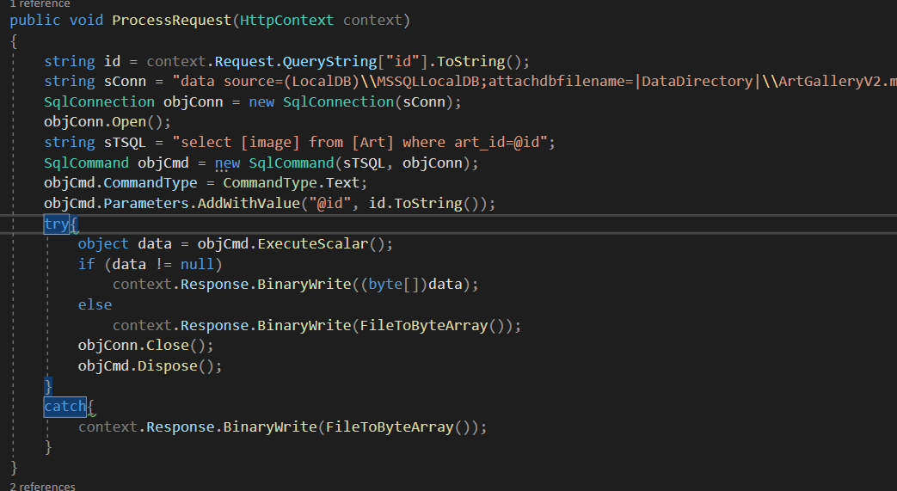

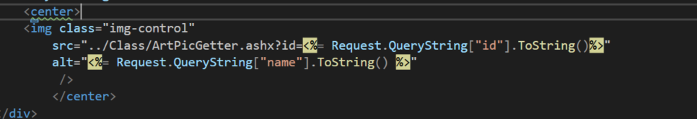

Remove Cookie : Login data

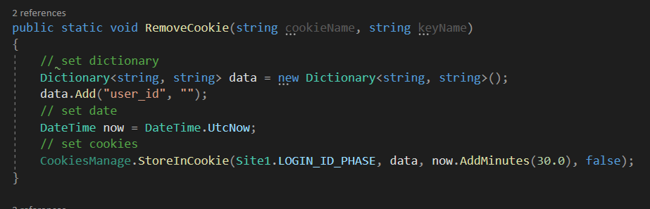

Store Cookies: Login data

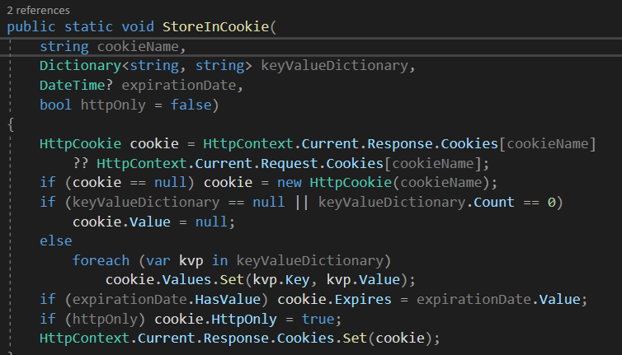

Get Cookies : Login data

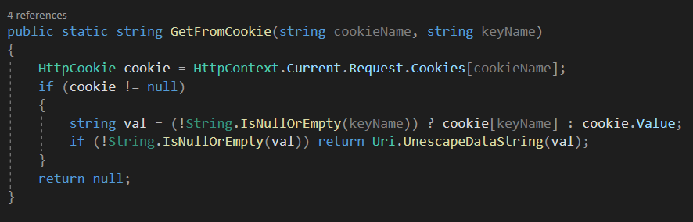

Send Mail

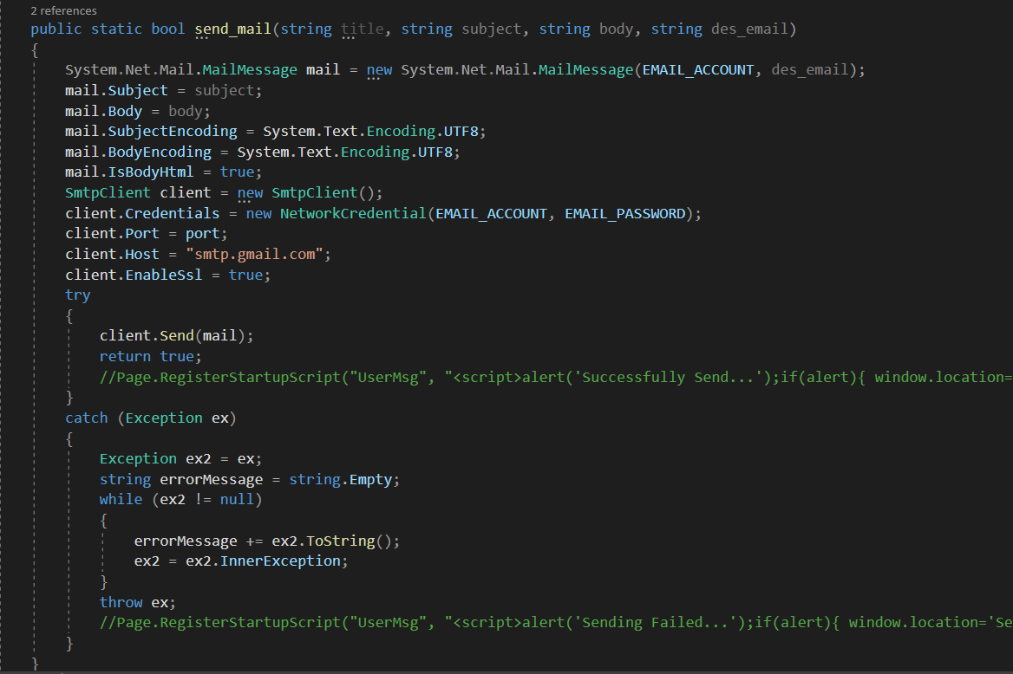

Asp: Validator

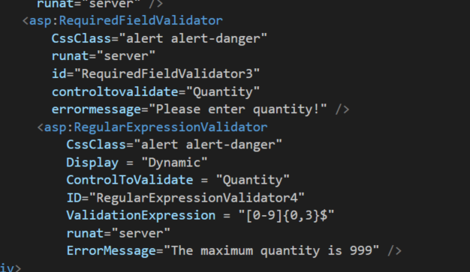

Asp:FileUpload and Javascript preview file

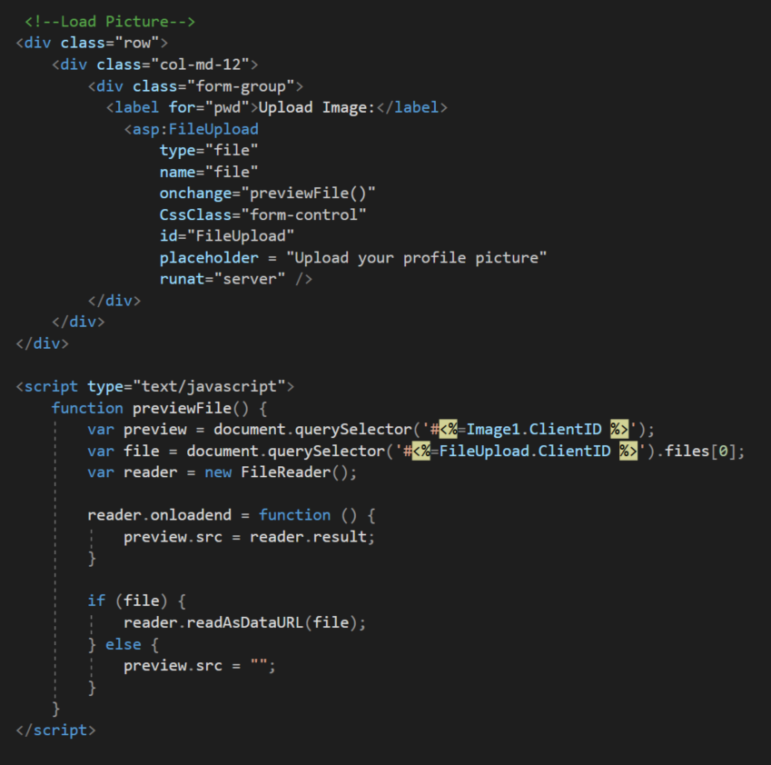

Asp:Gridview

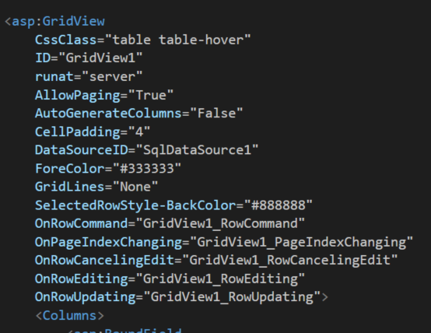

Asp:Template field

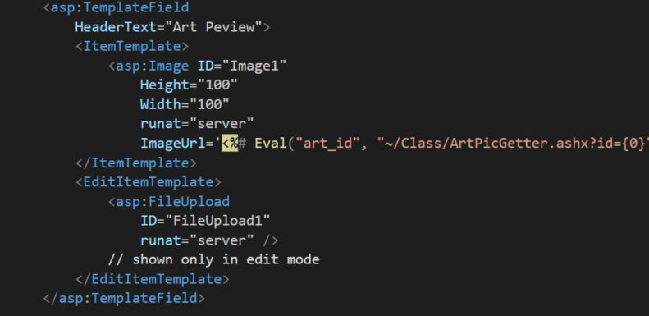

Asp: datasource (font and behine)

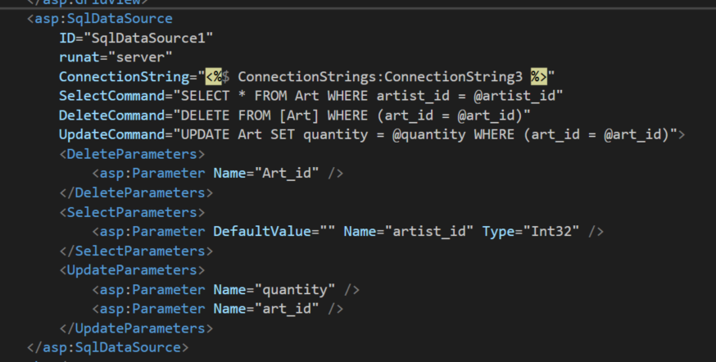

C# web: FindControl

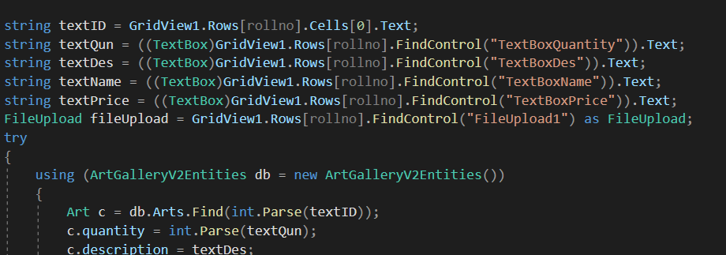

C# web: Entity Framework Default modal [DBset]

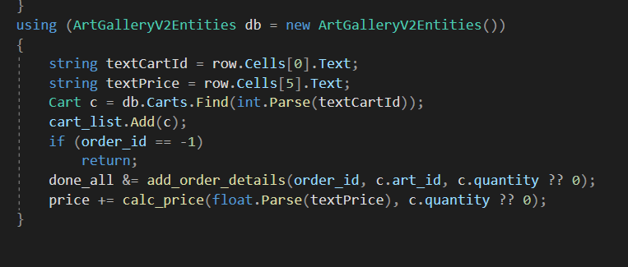

C# web: Inner html display error message

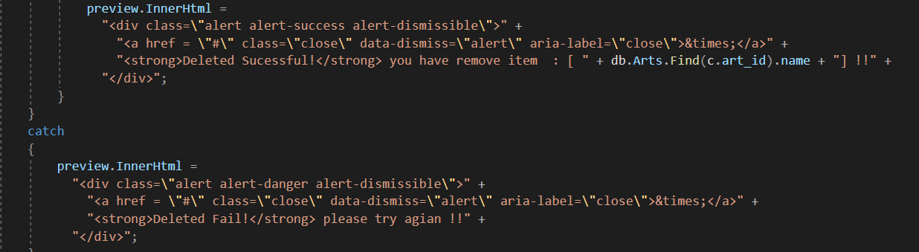

Asp: Eval , Bind function

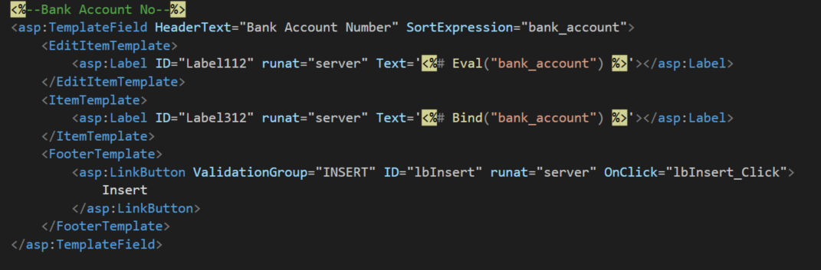

C# : ForEach

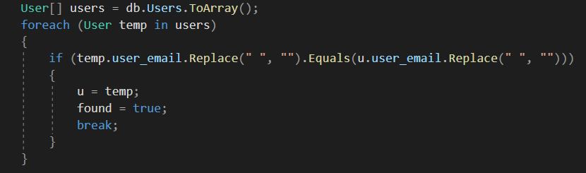

C# : Dictionary

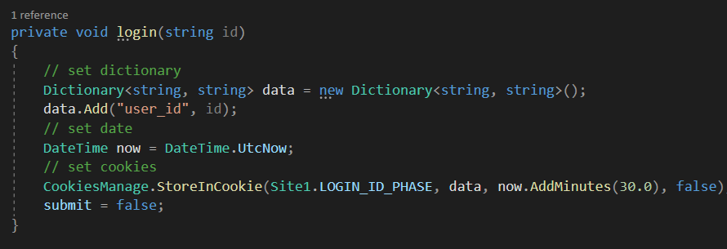

Asp:Repeater and Eval function

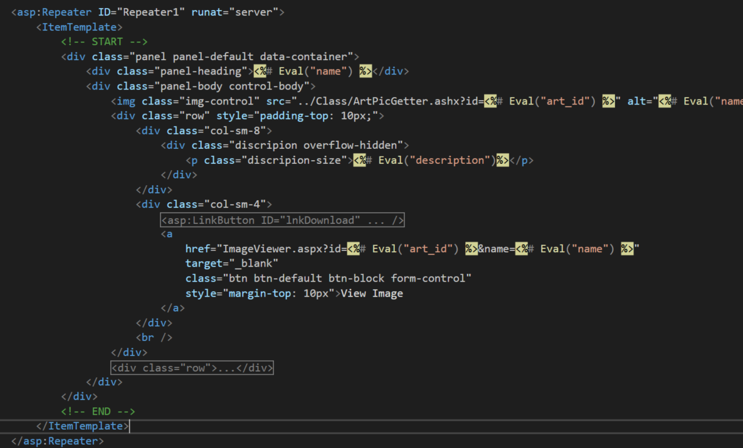

C# web: Datasource Bind data

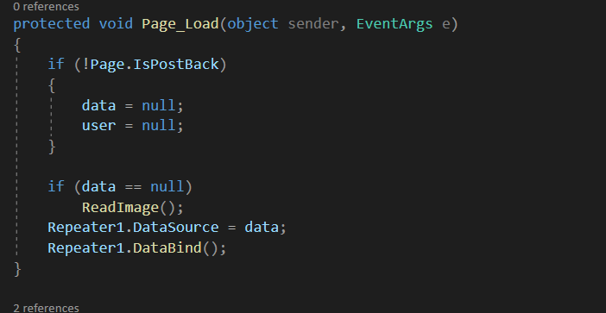

C# : List.AddRange()

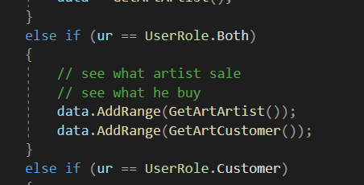

SQL Query: Select Multiple table

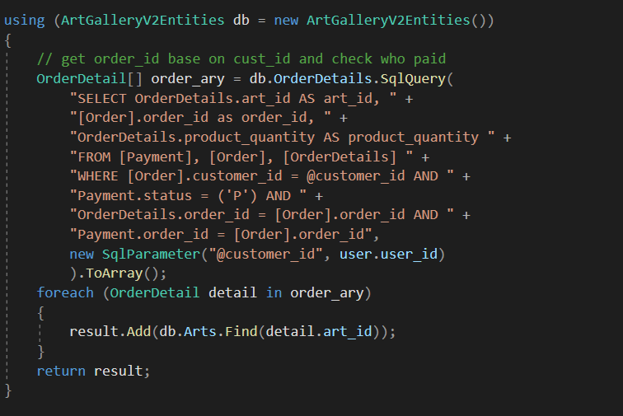

C# web: download image file

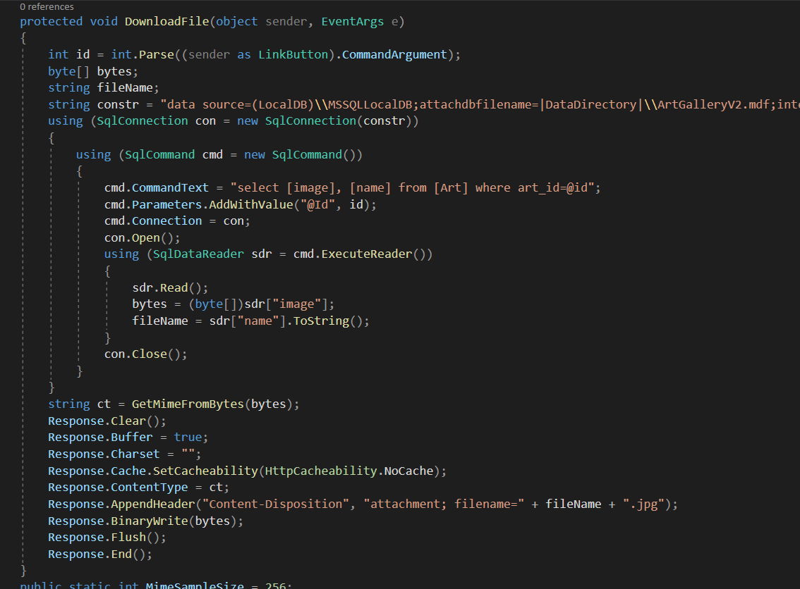

C# : Mime Type Control

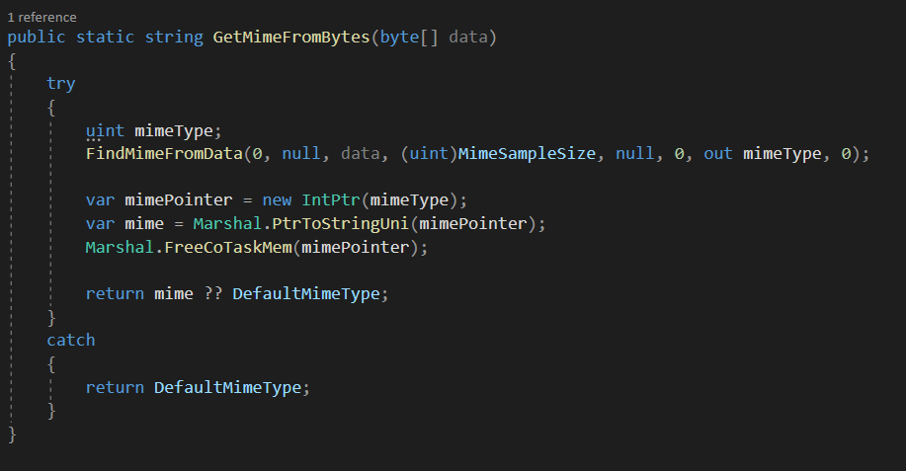

Asp: nested repeater

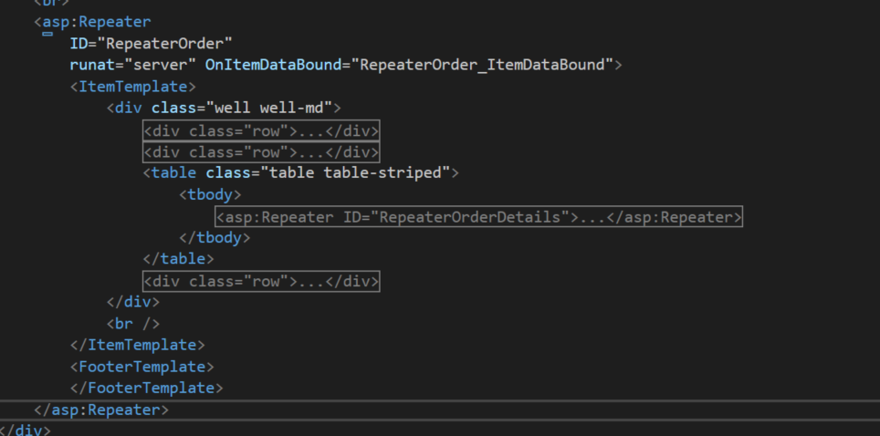

C# web : repeater Item data bound event

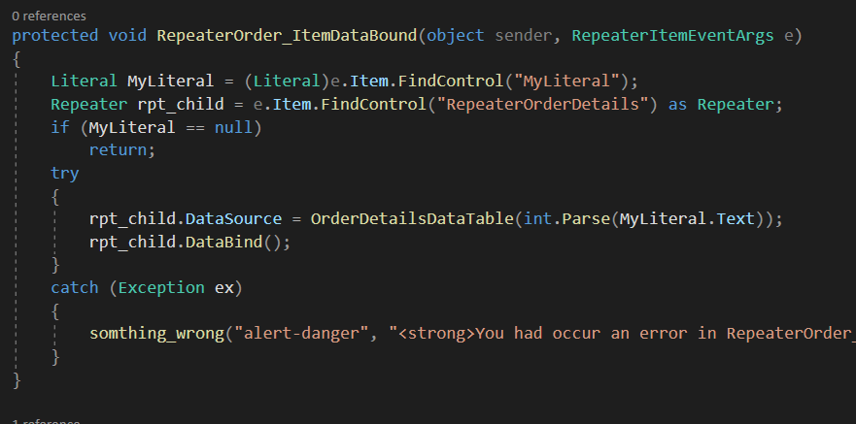

Asp: Eval Advance

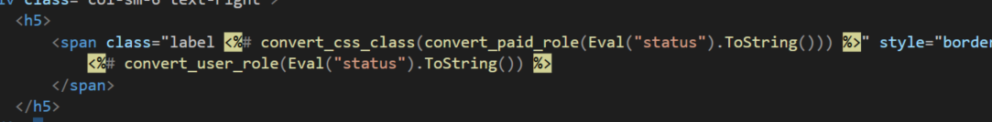

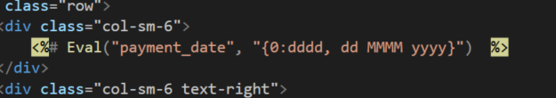



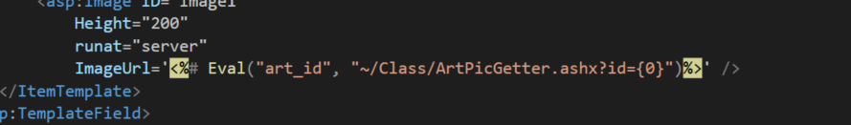

Entity Framework: Max(), Add(), Delete(), AddOrUpdate(), SvaeChnage() and other

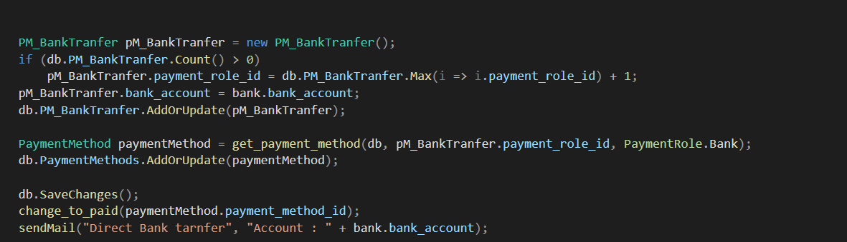

Asp & C# Web : Sql Parameter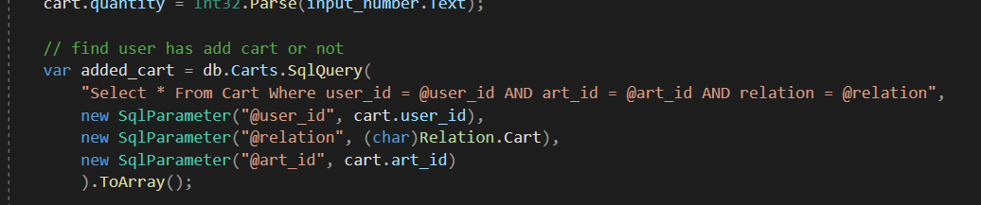

Web.config: key and value

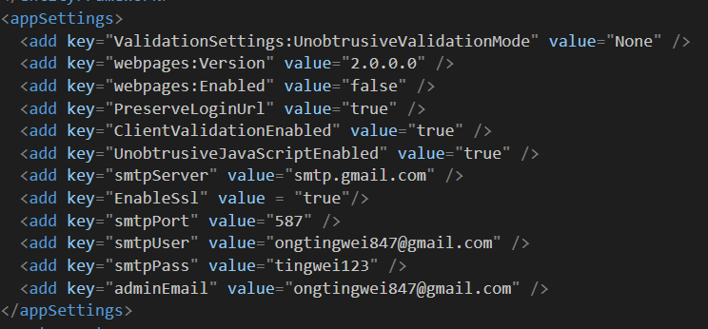

Web.config: Default Page

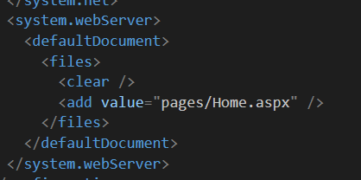

Web.confiig: Mail Setting

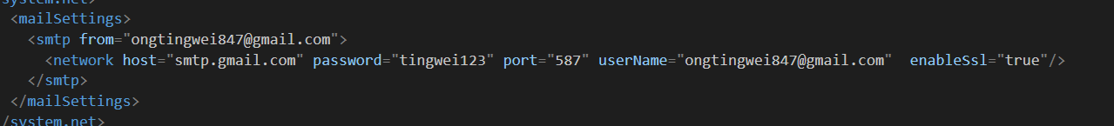

Bootstrap: Grids System

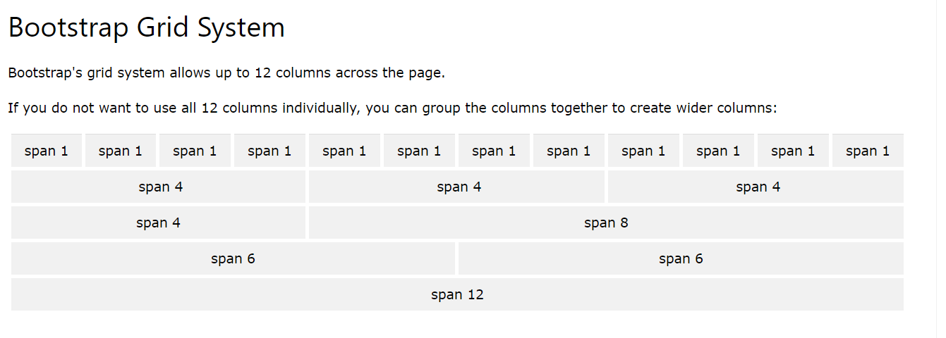

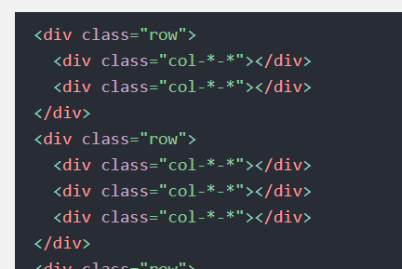

Bootstrap: Table

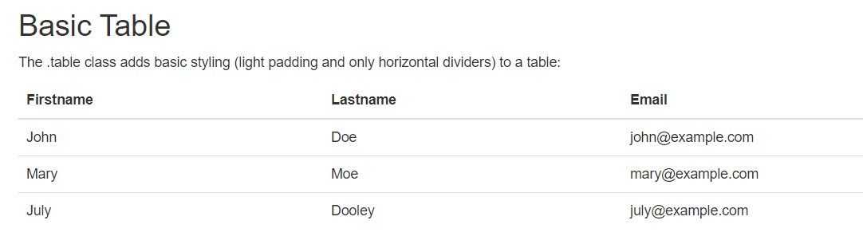

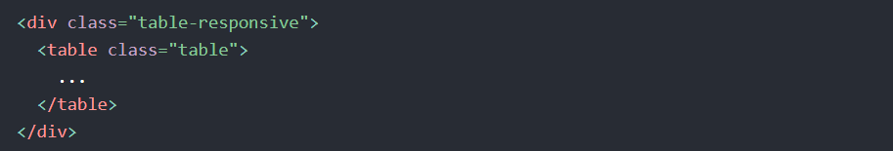

Bootstrap: Image 

Bootstrap: Container

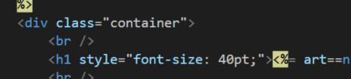

Bootstrap: Wells

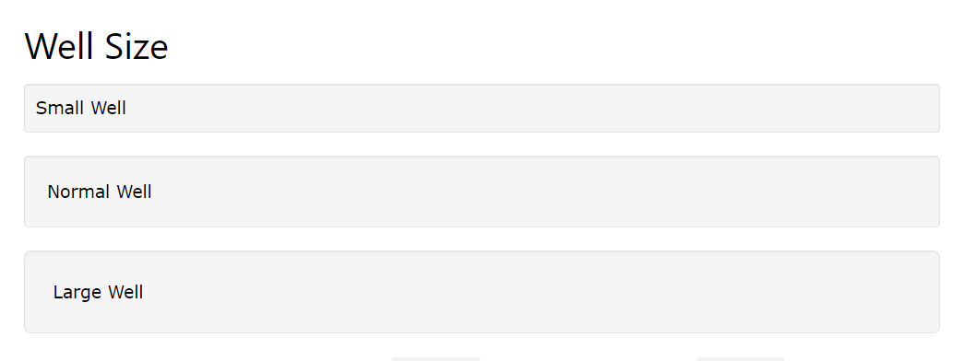

Bootstrap: Alert

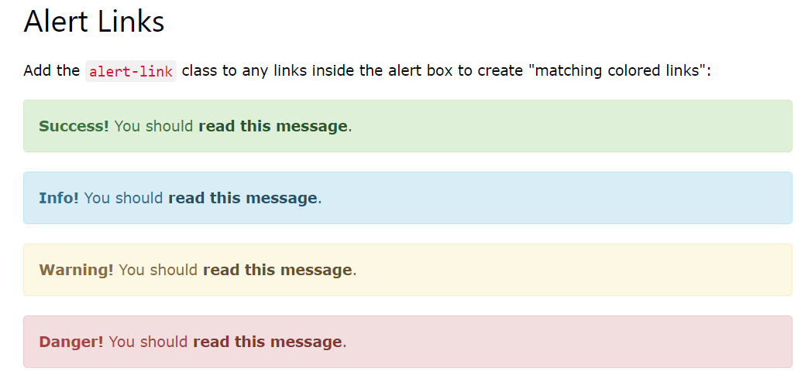

Bootstrap: Button

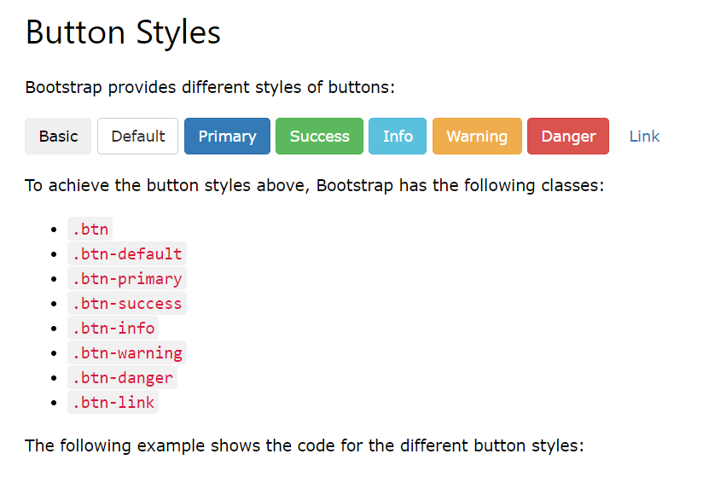

Bootstrap: Barges And Label

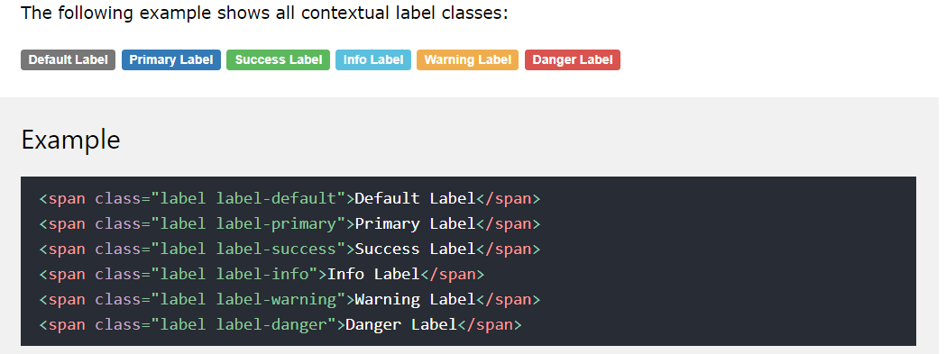

Bootstrap: Panel

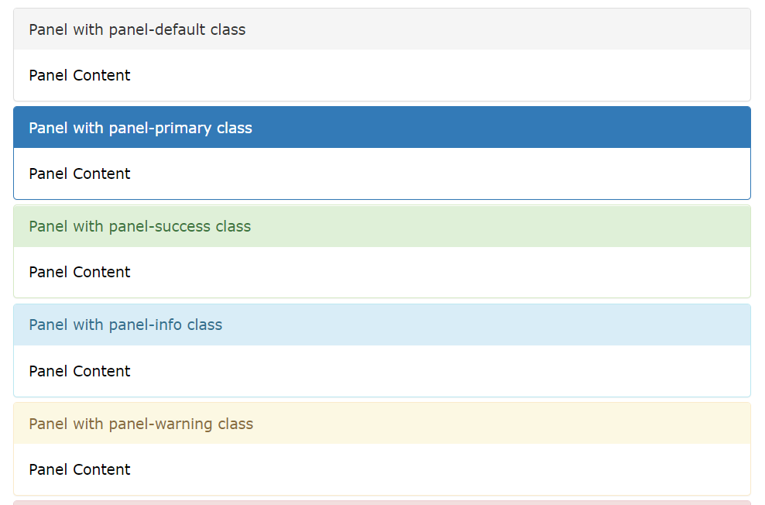

Bootstrap: Navigation Bar

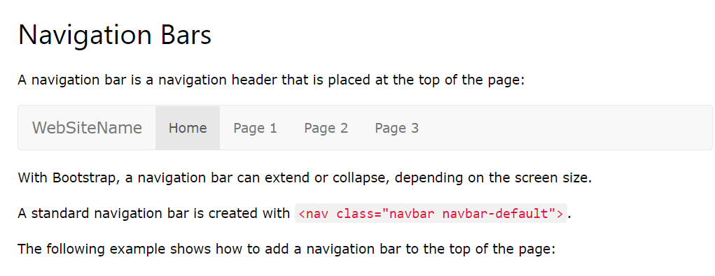

Bootstrap: Form

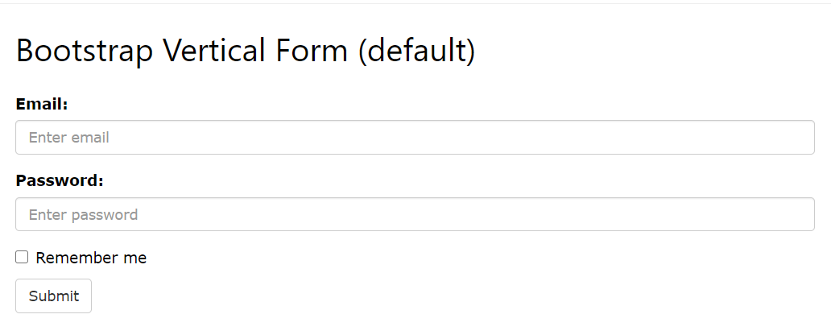

Bootstrap: Modal

