**CSCI 4125/5125**

**Data Models and Database Systems**

**Fall 2023**

**Course Project**

**Phase2: E-R Modeling (8/23)**

**Due: Thursday, 8/31 @ 11:59pm**

**Reading:** SilberschatzChapter 6

**Submission Guidelines:**

1. This assignment is worth 30 points for all students.

2. All answers in the form of images or screenshots must be readable. Any additional files must be clearly referenced and labeled.

3. It is your responsibility to make sure all files are readable and submitted on time.

4. If you work with a team member, make sure you state this at the top of your submission. Each group member is still required to submit all required work and files.

**Submission:**

- Task 1: Submit a single E-R diagram saved as a PDF worth 25 points.

- Task 2: Submit a single screenshot of a successfully ran change password command in SQL Developer worth 5 points.

**Task 1. E-R Modeling (25 points)**

We are building an online retail store. For this company to work, we must design and build a database to manage our data. Below is the verbal description of the data to be modeled. Your task is to draw an E-R diagram containing the entities discussed below, their attributes and keys (underlined), and the relationships (including cardinality and participation) among them. You can use software (e.g., PowerPoint or Visio) or draw a legible, free-hand diagram. Submit an image of your E-R diagram below. Each team member should only submit the database he/she is working on.

Our database keeps track of customers and the orders they make. For each customer, we store a unique customer ID, name, and date of birth. We also allow customers to store multiple shipping addresses. We only allow New Orleanians to be customers so an address is just the street address; we don’t store city, state or zip.

Once a customer registers their account, they can place as many orders as they want. However, an order is only made by one customer, no split orders. For each order, we store a unique confirmation number, the order date, the cost of products in the order, the shipping cost, and the total order cost. The cost of the products is computed from the sum of all the items and their quantities. The shipping cost is determined based on the cost of the products. If the order is at least $35, we offer free shipping. Otherwise, we charge a standard $10 for shipping. The total cost is the sum of the product costs and the shipping cost.

Orders may include many products and a product may be part of many orders. For each product, we store a unique ID, name, price, and the inventory. When a product is included in an order, we also record the quantity of the product included in the order; this quantity also needs to be subtracted from the inventory.

We also store anonymous reviews for products. For each review, we store a number, which is only unique for each product, a rating (1 to 5), and the review text, which is limited to 255 characters.

We also have a rewards program where customers can receive credit for referring other customers. A current customer can refer as many people they want (for more credits), but only one person can receive credit for referencing another customer.

**Task 2. SQL Developer Connection (5 points)**

In Phase 4 of the project, you will execute SQL DDL to build your tables and SQL DML to populate your tables and execute queries. This task has you setup your database connection to perform Phase 4. We will use a popular IDE supported by Oracle to connect to our database.

**Step 1. Access the Server through UNO WebTerminal**

* Go to the UNO [WebTerminal](https://webterminal.cs.uno.edu/) connections page.
* Select “Database Systems (Windows) for CSCI 4125/5125”
* Use your UNO credentials to log in.

**Step 2. Run SQL Developer**

Run the application, sqldeveloper.exe. There should be a shortcut on your desktop. Your application should look like the screenshot below:

**Step 3. Create a connection.**

In the upper left-hand side of the application, there is a green plus symbol. Click this to create a new database connection. Fill in the following fields. ***Note:*** *Do not include quotes or brackets.*

* + **Name:** Name your connection [Your UNO username][4125/5125].
  + **Username:** Use your UNO username.
  + **Password:** Use “NewOrleans123” (you will change this later).
  + **Save Password:** You can check this if you want to, but you will need to update this when you change your password later.
  + **Hostname:** localhost
  + **Port:** 1521
  + **SID:** Oracle21c
  + **ServiceName:** This should not be checked. We won’t use this field.
  + Click the “Test” box at the bottom. If everything is correct, the “Status” in the lower left-hand corner should say “Success”.
  + Click the “Save” box at the bottom to save your connection.
  + Click the “Connect” box.

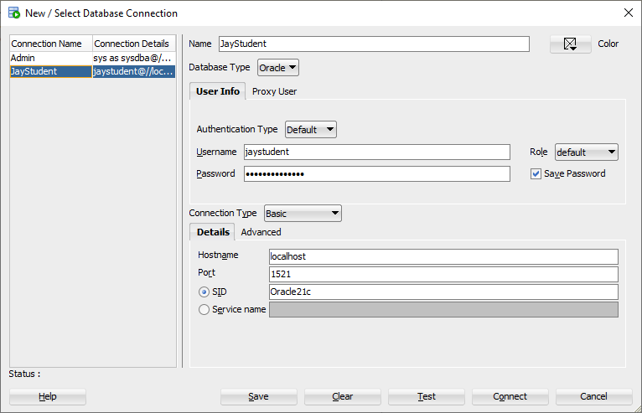

**Step 4. Change your password.**

Click on your connection on the left-hand side of SQL Developer. This should open up a blank script in the center of SQL Developer.

Type in the following command. Note the semicolon at the end and do not use the brackets. Do not use quotes for the username or password. Oracle passwords cannot include quotation marks or “@”.

ALTER USER [your username] IDENTIFIED BY [your new password];

Click the green arrow directly above the script window to run the command.

If your command properly runs, you should get a message in the script output: “User [your username] altered.”

**Submit:** A screenshot (like mine) that shows that your change password command properly ran. Note: you can obfuscate or erase your new password in the script if you would like. Your screenshot must use the “Print Screen” command. DO NOT submit a picture of your computer using your phone.