**Road Accidents Report SQL Queries**

## Current Year Casualties

select sum(number_of_casualties) as current_year_casualties

from road_accident

where year(accident_date) = '2022'

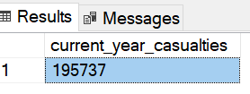

## **Testing filter applying**

## Current Year Casualties for Dry Road

select sum(number_of_casualties) as current_year_casualties

from road_accident

where year(accident_date) = '2022'and road_surface_conditions = 'Dry'

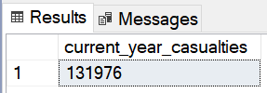

## Current Year Accidents

select count(distinct accident_index) as current_year_accidents

from road_accident

where year(accident_date) = '2022'

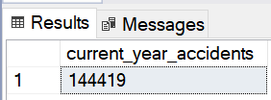

## Current Year Fatal Casualties

select sum(number_of_casualties) as current_year_fatal_casualties

from road_accident

where year(accident_date) = '2022' and accident_severity = 'Fatal'

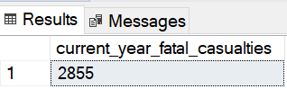

## Total Fatal Casualties

select sum(number_of_casualties) as current_year_fatal_casualties

from road_accident

where accident_severity = 'Fatal'

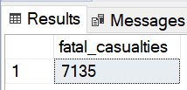

## Current Year Serious Casualties

select sum(number_of_casualties) as current_year_serious_casualties

from road_accident

where year(accident_date) = '2022' and accident_severity = 'Serious'

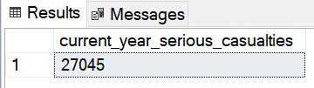

## Total Serious Casualties

select sum(number_of_casualties) as serious_casualties

from road_accident

where accident_severity = 'Serious'

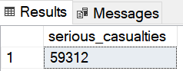

## Current Year Slight Casualties

select sum(number_of_casualties) as current_year_slight_casualties

from road_accident

where year(accident_date) = '2022' and accident_severity = 'Slight'

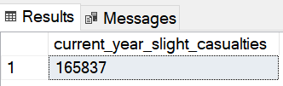

## Total Slight Casualties

select sum(number_of_casualties) as slight_casualties

from road_accident

where accident_severity = 'Slight'

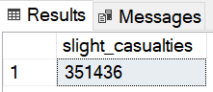

## Fatal Casualties % of Total

select cast(sum(number_of_casualties) as decimal(10,2)) * 100 /

(select cast(sum(number_of_casualties) as decimal(10,2)) from road_accident) as PCT

from road_accident

where accident_severity = 'Fatal'

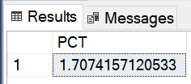

## Serious Casualties % of Total

select cast(sum(number_of_casualties) as decimal(10,2)) * 100 /

(select cast(sum(number_of_casualties) as decimal(10,2)) from road_accident) as PCT

from road_accident

where accident_severity = 'Serious'

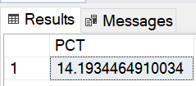

## Slight Casualties % of Total

select cast(sum(number_of_casualties) as decimal(10,2)) * 100 /

(select cast(sum(number_of_casualties) as decimal(10,2)) from road_accident) as PCT

from road_accident

where accident_severity = 'Slight'

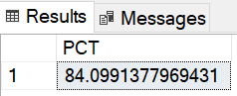

## Casualties by Vehicle Type

select

case

when vehicle_type in ('Agricultural vehicle') then 'Agricultural'

when vehicle_type in ('Car' , 'Taxi/Private hire car') then 'Cars'

when vehicle_type in ('Motorcycle 125cc and under' , 'Motorcycle 50cc and under' , 'Motorcycle over 125cc and up to 500cc' , 'Motorcycle over 500cc' , 'Pedal cycle') then 'Bike'

when vehicle_type in ('Bus or coach (17 or more pass seats)' , 'Minibus (8 - 16 passenger seats)') then 'Bus'

when vehicle_type in ('Goods 7.5 tonnes mgw and over' , 'Goods over 3.5t. and under 7.5t' , 'Van / Goods 3.5 tonnes mgw or under') then 'Van'

else 'Other'

end as vehicle_group,

sum(number_of_casualties) as casualties

from road_accident

group by

case

when vehicle_type in ('Agricultural vehicle') then 'Agricultural'

when vehicle_type in ('Car' , 'Taxi/Private hire car') then 'Cars'

when vehicle_type in ('Motorcycle 125cc and under' , 'Motorcycle 50cc and under' , 'Motorcycle over 125cc and up to 500cc' , 'Motorcycle over 500cc' , 'Pedal cycle') then 'Bike'

when vehicle_type in ('Bus or coach (17 or more pass seats)' , 'Minibus (8 - 16 passenger seats)') then 'Bus'

when vehicle_type in ('Goods 7.5 tonnes mgw and over' , 'Goods over 3.5t. and under 7.5t' , 'Van / Goods 3.5 tonnes mgw or under') then 'Van'

else 'Other'

end

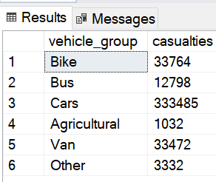

## Current Year Casualties by Vehicle Type

select

case

when vehicle_type in ('Agricultural vehicle') then 'Agricultural'

when vehicle_type in ('Car' , 'Taxi/Private hire car') then 'Cars'

when vehicle_type in ('Motorcycle 125cc and under' , 'Motorcycle 50cc and under' , 'Motorcycle over 125cc and up to 500cc' , 'Motorcycle over 500cc' , 'Pedal cycle') then 'Bike'

when vehicle_type in ('Bus or coach (17 or more pass seats)' , 'Minibus (8 - 16 passenger seats)') then 'Bus'

when vehicle_type in ('Goods 7.5 tonnes mgw and over' , 'Goods over 3.5t. and under 7.5t' , 'Van / Goods 3.5 tonnes mgw or under') then 'Van'

else 'Other'

end as vehicle_group,

sum(number_of_casualties) as current_year_casualties

from road_accident

where year(accident_date) = '2022'

group by

case

when vehicle_type in ('Agricultural vehicle') then 'Agricultural'

when vehicle_type in ('Car' , 'Taxi/Private hire car') then 'Cars'

when vehicle_type in ('Motorcycle 125cc and under' , 'Motorcycle 50cc and under' , 'Motorcycle over 125cc and up to 500cc' , 'Motorcycle over 500cc' , 'Pedal cycle') then 'Bike'

when vehicle_type in ('Bus or coach (17 or more pass seats)' , 'Minibus (8 - 16 passenger seats)') then 'Bus'

when vehicle_type in ('Goods 7.5 tonnes mgw and over' , 'Goods over 3.5t. and under 7.5t' , 'Van / Goods 3.5 tonnes mgw or under') then 'Van'

else 'Other'

end

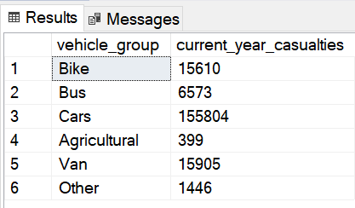

## Current Year Casualties Monthly Trend

select datename(month, accident_date) as month, sum(number_of_casualties) as casualties

from road_accident

where year(accident_date) = '2022'

group by datename(month, accident_date)

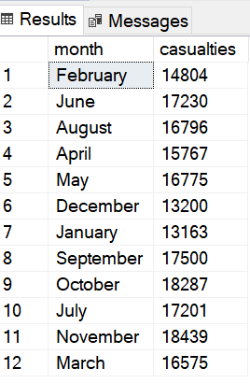

## Previous Year Casualties Monthly Trend

select datename(month, accident_date) as month, sum(number_of_casualties) as casualties

from road_accident

where year(accident_date) = '2021'

group by datename(month, accident_date)

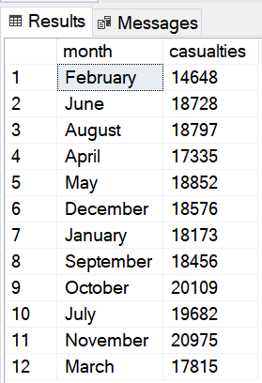

## Casualties by Road Type

select road_type, sum(number_of_casualties) as casuaties from road_accident

group by road_type

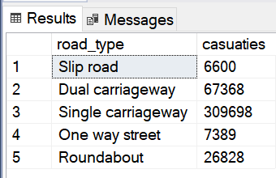

## Current Year Casualties by Road Type

select road_type, sum(number_of_casualties) as casuaties from road_accident

where year(accident_date) = '2022'

group by road_type

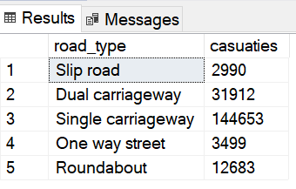

## Previous Year Casualties by Road Type

select road_type, sum(number_of_casualties) as casuaties from road_accident

where year(accident_date) = '2021'

group by road_type

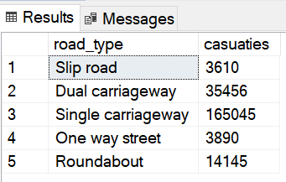

## Casualties by Urban/Rural Area

select urban_or_rural_area, sum(number_of_casualties) as casualties from road_accident

group by urban_or_rural_area

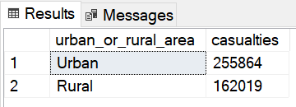

## Casualties by Urban/Rural Area % of Total

select urban_or_rural_area, cast(sum(number_of_casualties) as decimal(10, 2)) * 100 /

(select cast(sum(number_of_casualties) as decimal(10, 2)) from road_accident) as pct

from road_accident

group by urban_or_rural_area

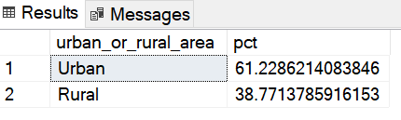

## Current Year Casualties by Urban/Rural Area

select urban_or_rural_area, sum(number_of_casualties) as casualties from road_accident

where year(accident_date) = '2022'

group by urban_or_rural_area

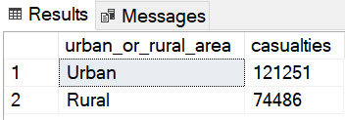

## Current Year Casualties by Urban/Rural Area % of Total

select urban_or_rural_area, cast(sum(number_of_casualties) as decimal(10, 2)) * 100 /

(select cast(sum(number_of_casualties) as decimal(10, 2)) from road_accident where year(accident_date) = '2022') as pct

from road_accident

where year(accident_date) = '2022'

group by urban_or_rural_area

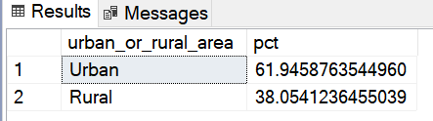

## Previous Year Casualties by Urban/Rural Area

select urban_or_rural_area, sum(number_of_casualties) as casualties from road_accident

where year(accident_date) = '2021'

group by urban_or_rural_area

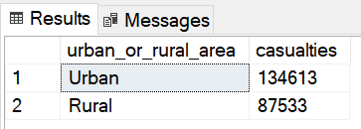

## Previous Year Casualties by Urban/Rural Area % of total

select urban_or_rural_area, cast(sum(number_of_casualties) as decimal(10, 2)) * 100 /

(select cast(sum(number_of_casualties) as decimal(10, 2)) from road_accident where year(accident_date) = '2021') as pct

from road_accident

where year(accident_date) = '2021'

group by urban_or_rural_area

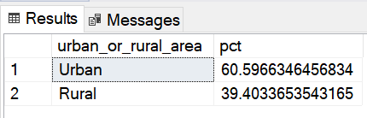

## Current Year Casualties by Light Conditions

select

case

when light_conditions in ('Daylight') then 'Day'

when light_conditions in ('Darkness - lighting unknown', 'Darkness - lights lit', 'Darkness - light unlit', 'Darkness - no lighting') then 'Night'

end as Light_Condition,

cast(cast(sum(number_of_casualties) as decimal(10, 2)) * 100 /

(select cast(sum(number_of_casualties) as decimal(10, 2)) from road_accident

where year(accident_date) = '2022') as decimal(10, 2)) as casualties_pct

from road_accident

where year(accident_date) = '2022'

group by

case

when light_conditions in ('Daylight') then 'Day'

when light_conditions in ('Darkness - lighting unknown', 'Darkness - lights lit', 'Darkness - light unlit', 'Darkness - no lighting') then 'Night'

end

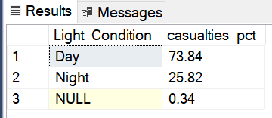

## Previous Year Casualties by Light Conditions

select

case

when light_conditions in ('Daylight') then 'Day'

when light_conditions in ('Darkness - lighting unknown', 'Darkness - lights lit', 'Darkness - light unlit', 'Darkness - no lighting') then 'Night'

end as Light_Condition,

cast(cast(sum(number_of_casualties) as decimal(10, 2)) * 100 /

(select cast(sum(number_of_casualties) as decimal(10, 2)) from road_accident

where year(accident_date) = '2021') as decimal(10, 2)) as casualties_pct

from road_accident

where year(accident_date) = '2021'

group by

case

when light_conditions in ('Daylight') then 'Day'

when light_conditions in ('Darkness - lighting unknown', 'Darkness - lights lit', 'Darkness - light unlit', 'Darkness - no lighting') then 'Night'

end

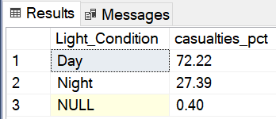

## Top 10 Locations by No of Casualties

select top 10 local_authority , sum(number_of_casualties) as total_casualties

from road_accident

group by local_authority

order by total_casualties desc

