EARLY DETECTION OF DENTAL

CARIES USING IMAGE PROCESSING TECHNIQUES

**IMAGES FROM THE RESEARCH PAPER**

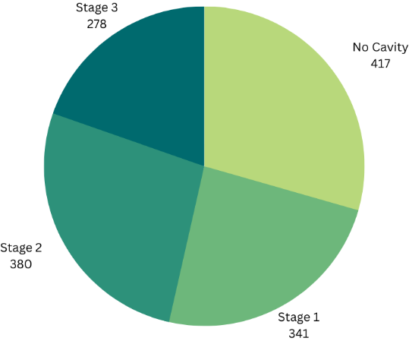

Fig.1. Dataset Class-wise Proportions

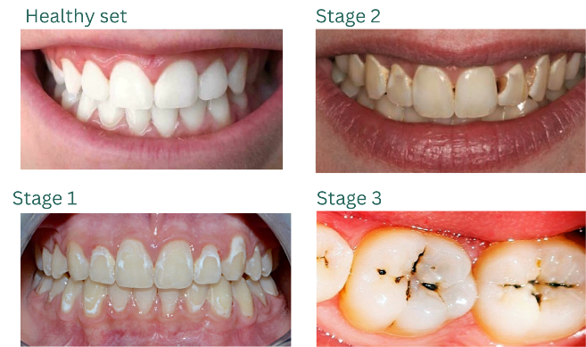

Fig.2. Classification of Teeth as per Stages

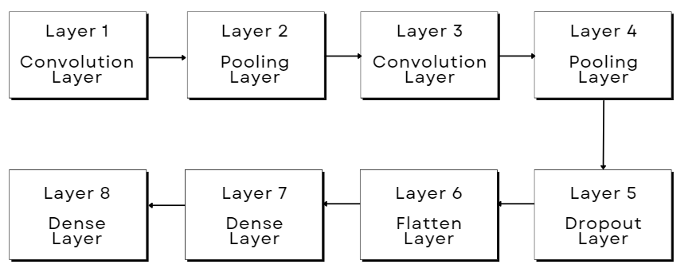

Fig.3. Layers in Fast-R CNN Model

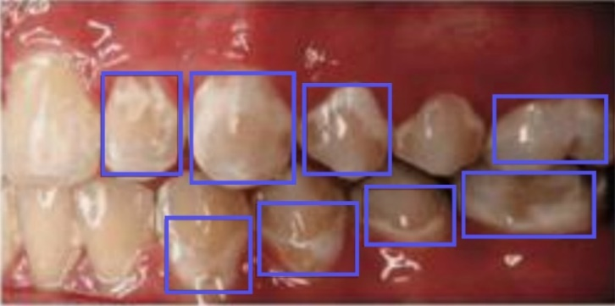

Fig.4. Example of Bounding Box Augmentation

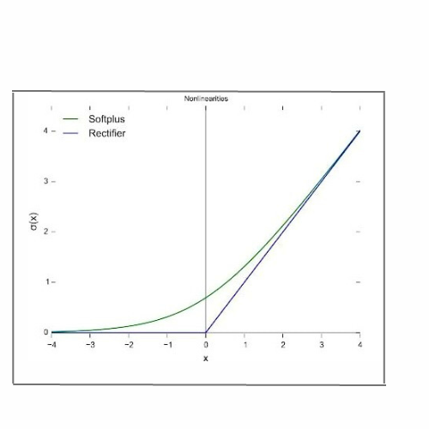

Fig.5. Graphical representation of ReLU Function

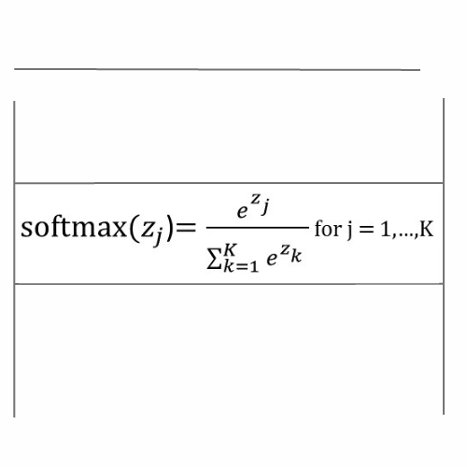

Fig.6. Formula for Softmax Function

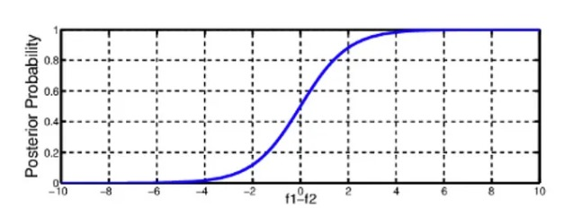

Fig.7. Graphical Representation for Softmax Function

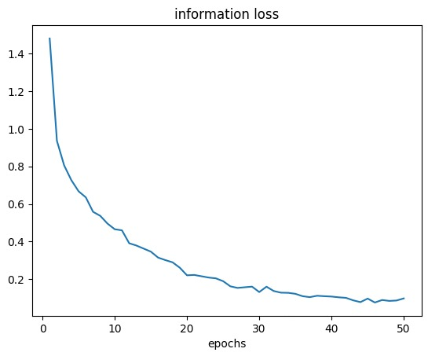

Fig.8. Graphical Representation of Information Loss

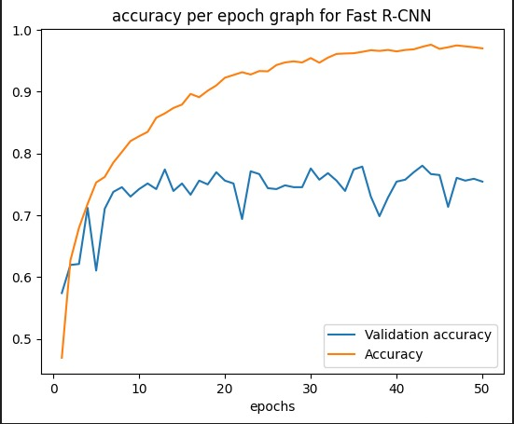

Fig.9. Graphical Representation of Accuracy per Epoch