Install Jenkins on VM:

# apt install openjdk-17-jdk -y
# curl -fsSL https://pkg.jenkins.io/debian-stable/jenkins.io-2023.key | sudo tee /usr/share/keyrings/jenkins-keyring.asc > /dev/null
# echo deb [signed-by=/usr/share/keyrings/jenkins-keyring.asc] https://pkg.jenkins.io/debian-stable binary/ | sudo tee /etc/apt/sources.list.d/jenkins.list > /dev/null
# apt install jenkins -y
# sudo wget -O /usr/share/keyrings/jenkins-keyring.asc https://pkg.jenkins.io/debian-stable/jenkins.io-2023.key
# echo "deb [signed-by=/usr/share/keyrings/jenkins-keyring.asc]" https://pkg.jenkins.io/debian-stable binary/ | sudo tee /etc/apt/sources.list.d/jenkins.list > /dev/null
# sudo apt-get update
# sudo apt-get install jenkins
# systemctl enable jenkins
# systemctl start jenkins
# systemctl status jenkins
# cat /var/lib/jenkins/secrets/initialAdminPassword
# ps -aux | grep Jenkins

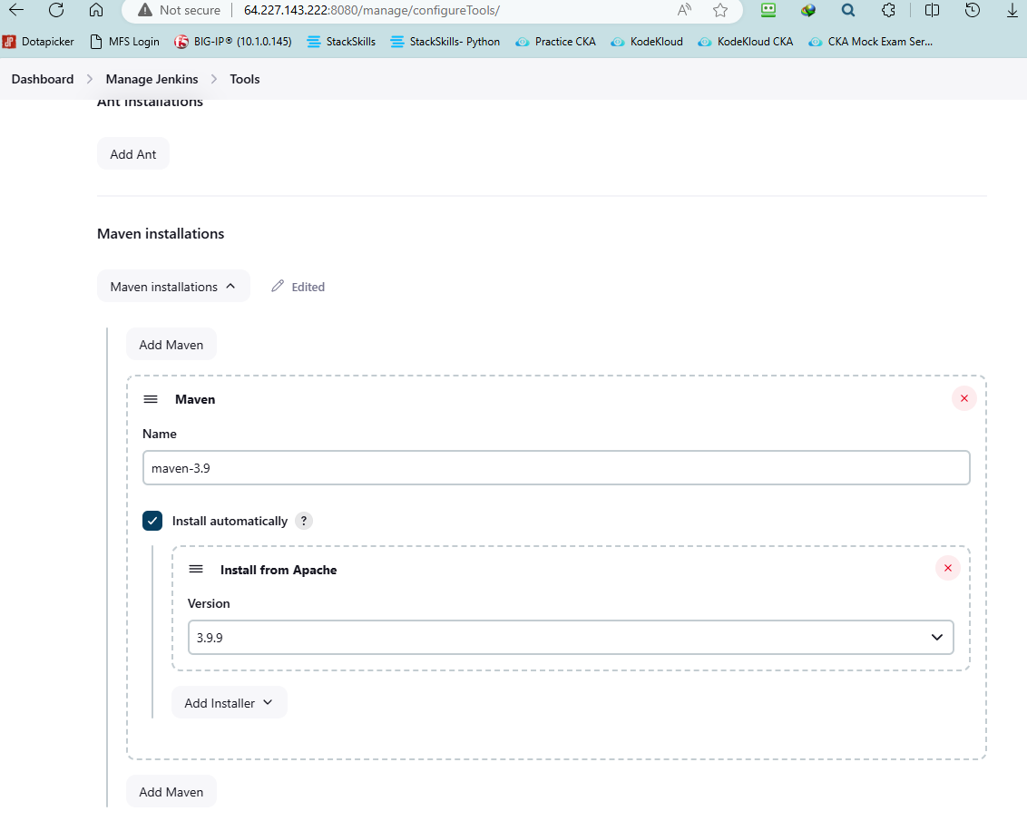

Install Nodejs and NPM

# apt-get update
# apt install curl
# curl
# cat /etc/os-release
# apt install curl apt-transport-https ca-certificates gnupg
# lsb_release -a
# apt install nodejs npm -y
# curl -sL https://deb.nodesource.com/setup_lts.x | sudo -E bash -
# apt install nodejs
# node -v; npm -v

Install Docker

# apt update
# apt-get install ca-certificates curl
# install -m 0755 -d /etc/apt/keyrings
# curl -fsSL https://download.docker.com/linux/ubuntu/gpg -o /etc/apt/keyrings/docker.asc
# chmod a+r /etc/apt/keyrings/docker.asc
# echo "deb [arch=$(dpkg --print-architecture) signed-by=/etc/apt/keyrings/docker.asc] https://download.docker.com/linux/ubuntu \
# $(. /etc/os-release && echo "$VERSION_CODENAME") stable" | sudo tee /etc/apt/sources.list.d/docker.list > /dev/null
# apt-get update
# sudo apt-get install docker-ce docker-ce-cli containerd.io docker-buildx-plugin docker-compose-plugin
# docker ps
# ls -l /var/run/docker.sock
# chmod 666 /var/run/docker.sock
Setup Job

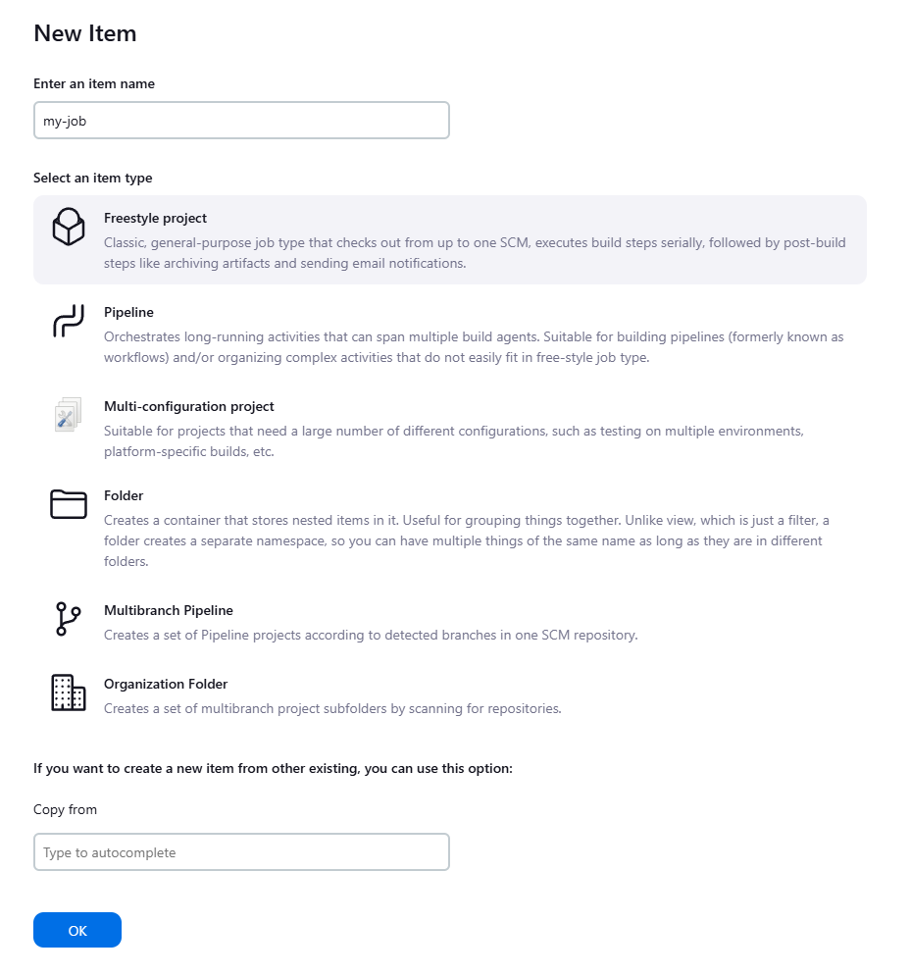
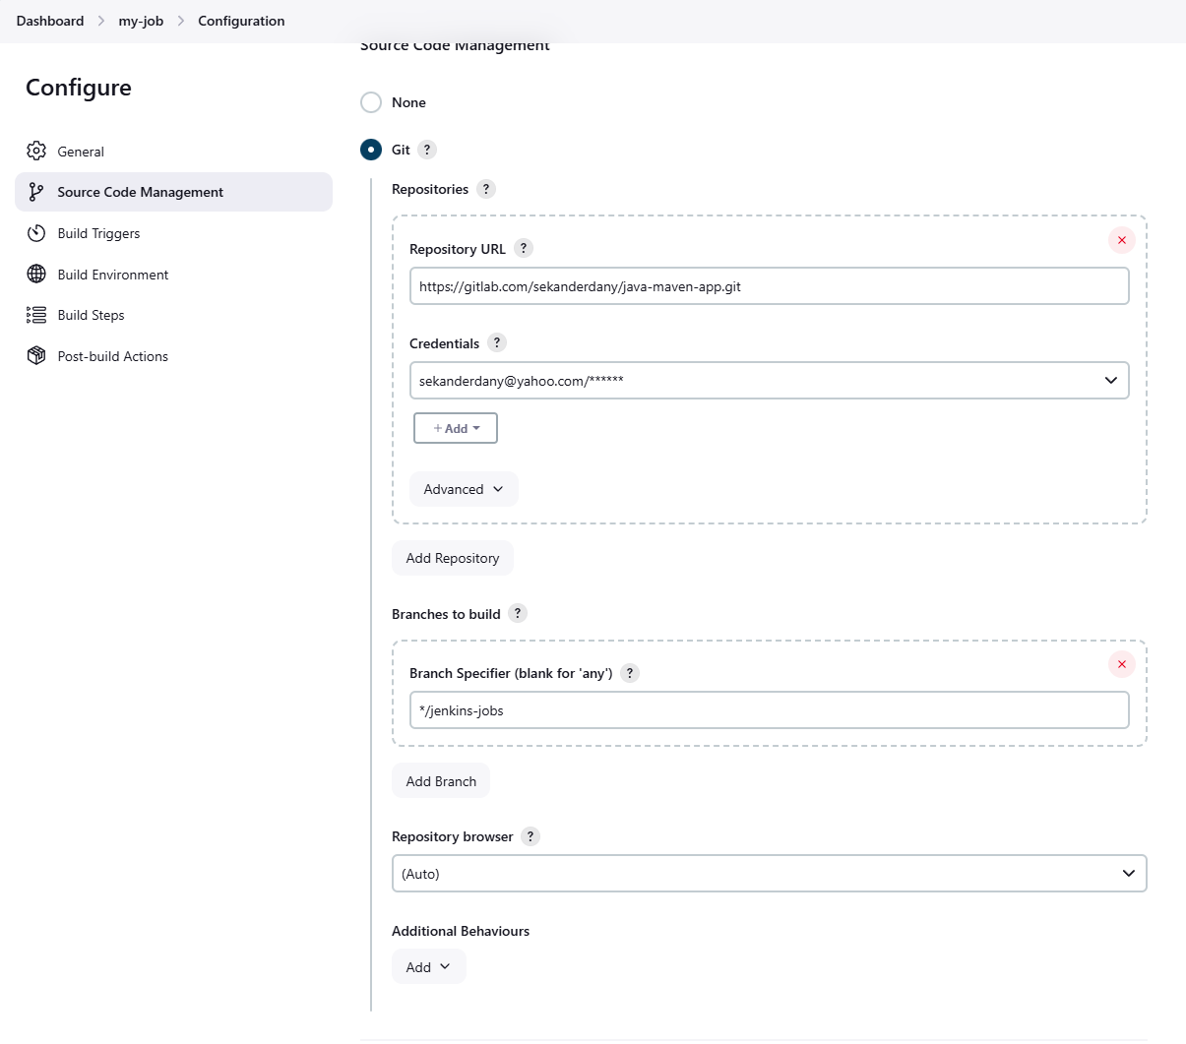
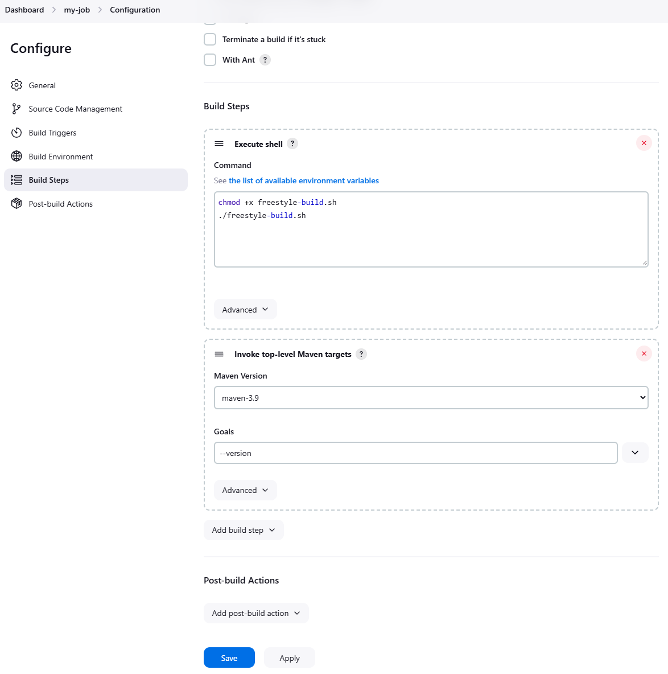

Setup Java Maven Application Pipeline (Docker in Jenkins)

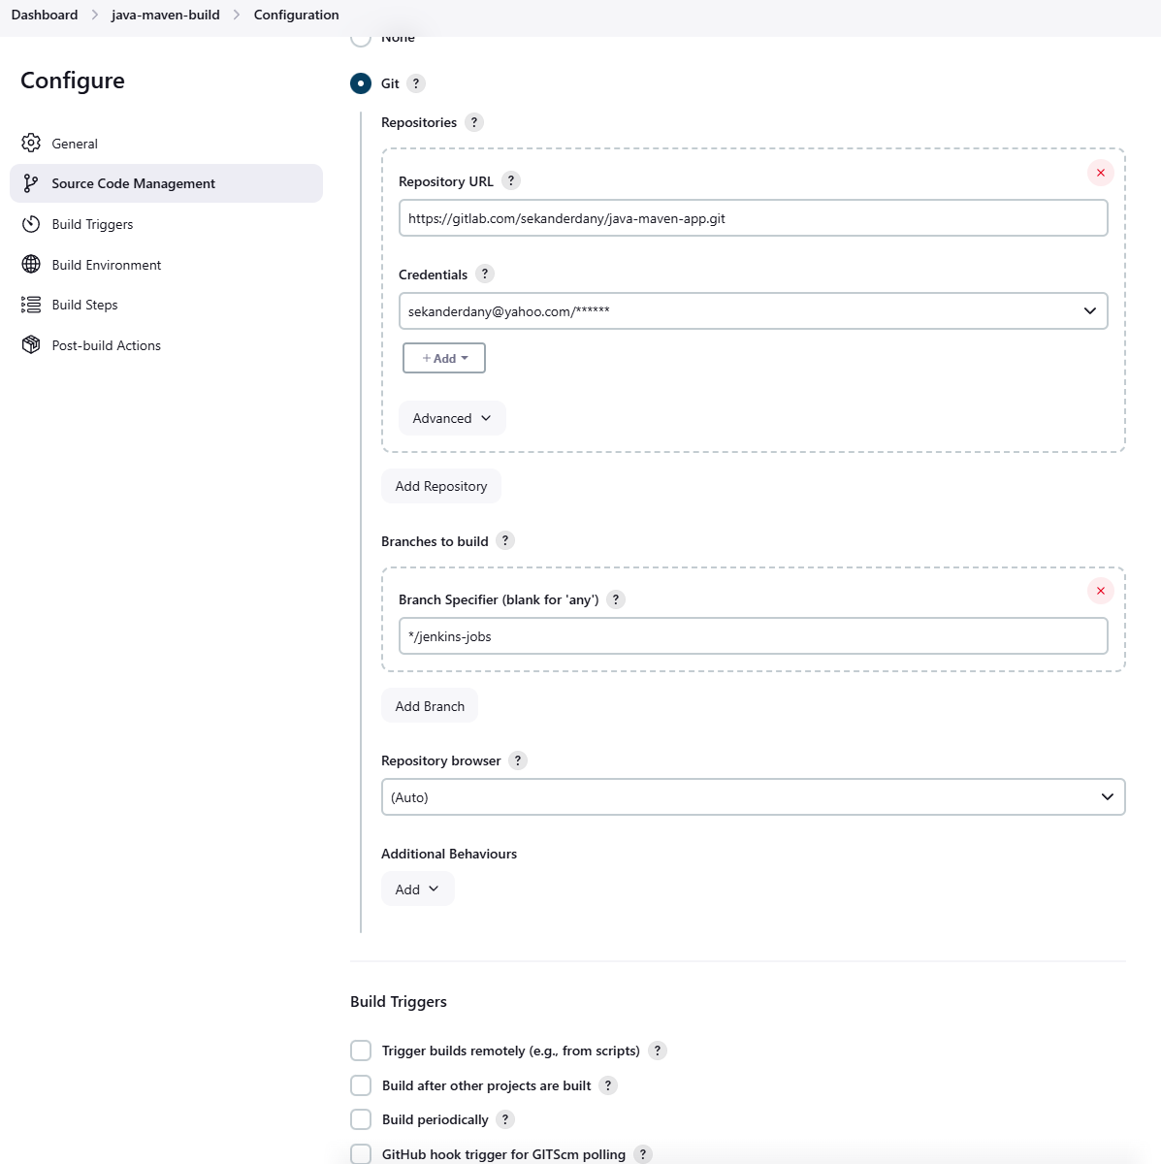

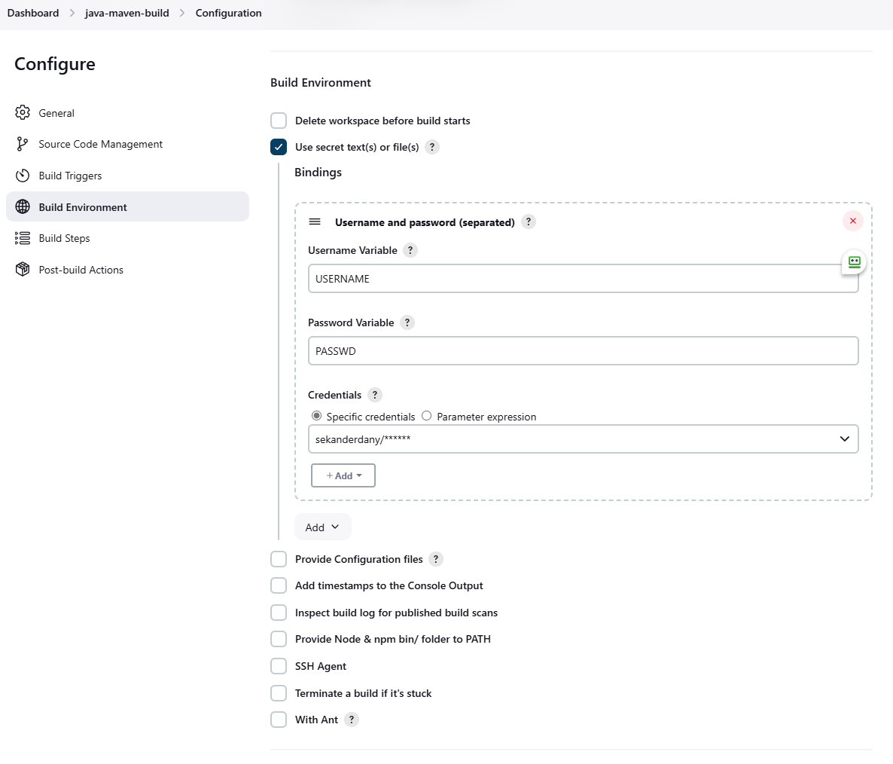

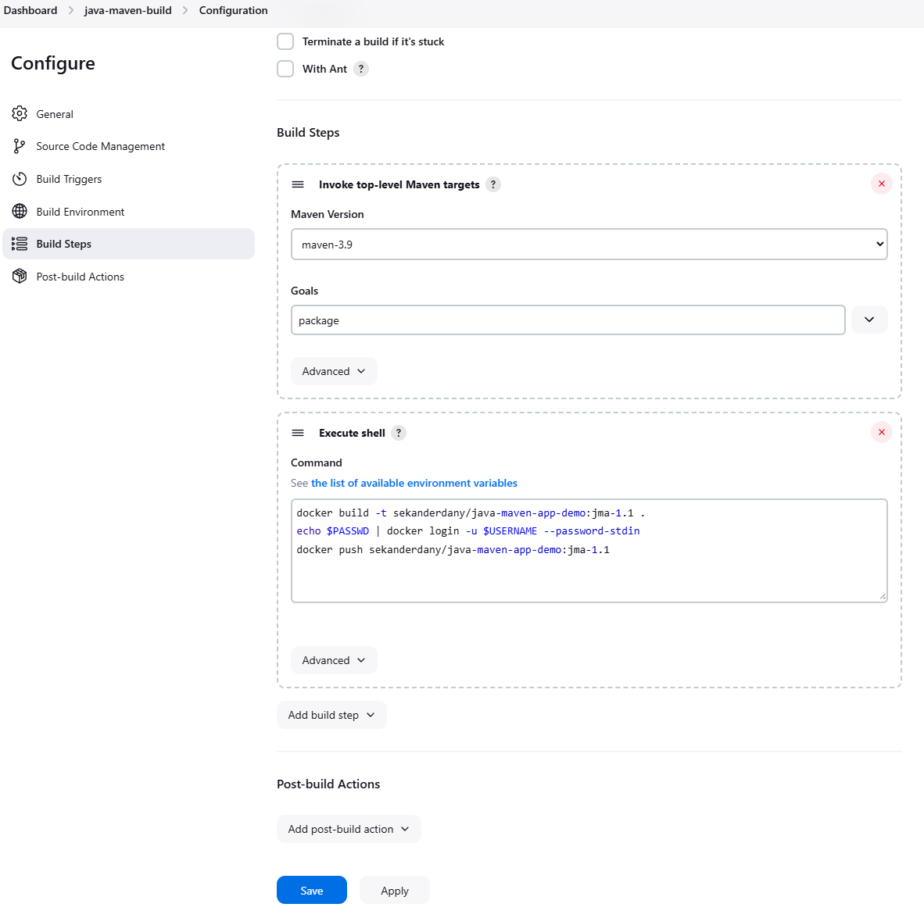

docker build -t sekanderdany/java-maven-app-demo:jma-1.1 .
echo $PASSWD | docker login -u $USERNAME --password-stdin
docker push sekanderdany/java-maven-app-demo:jma-1.1
Pipeline Jobs

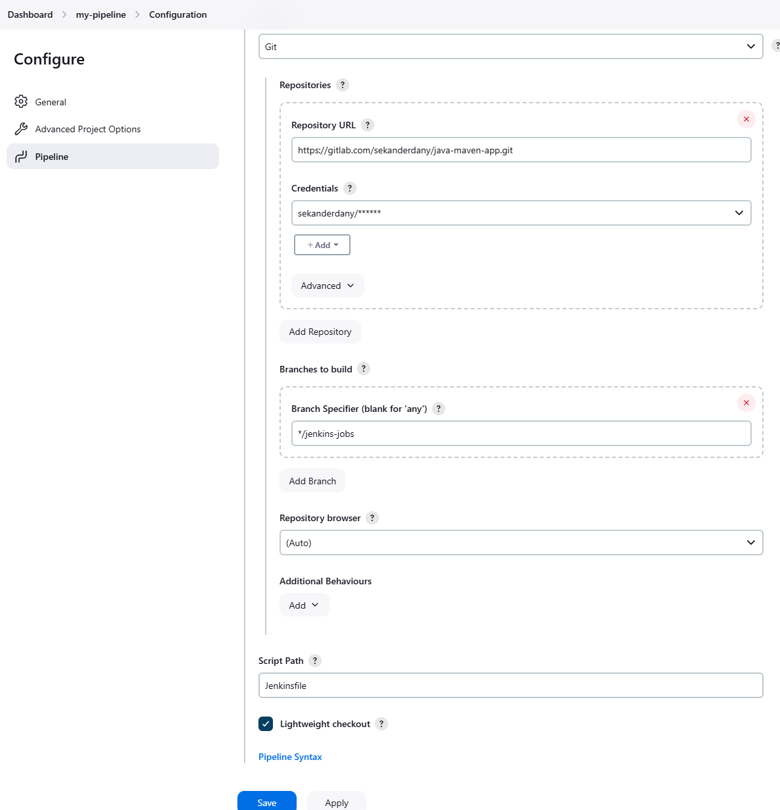

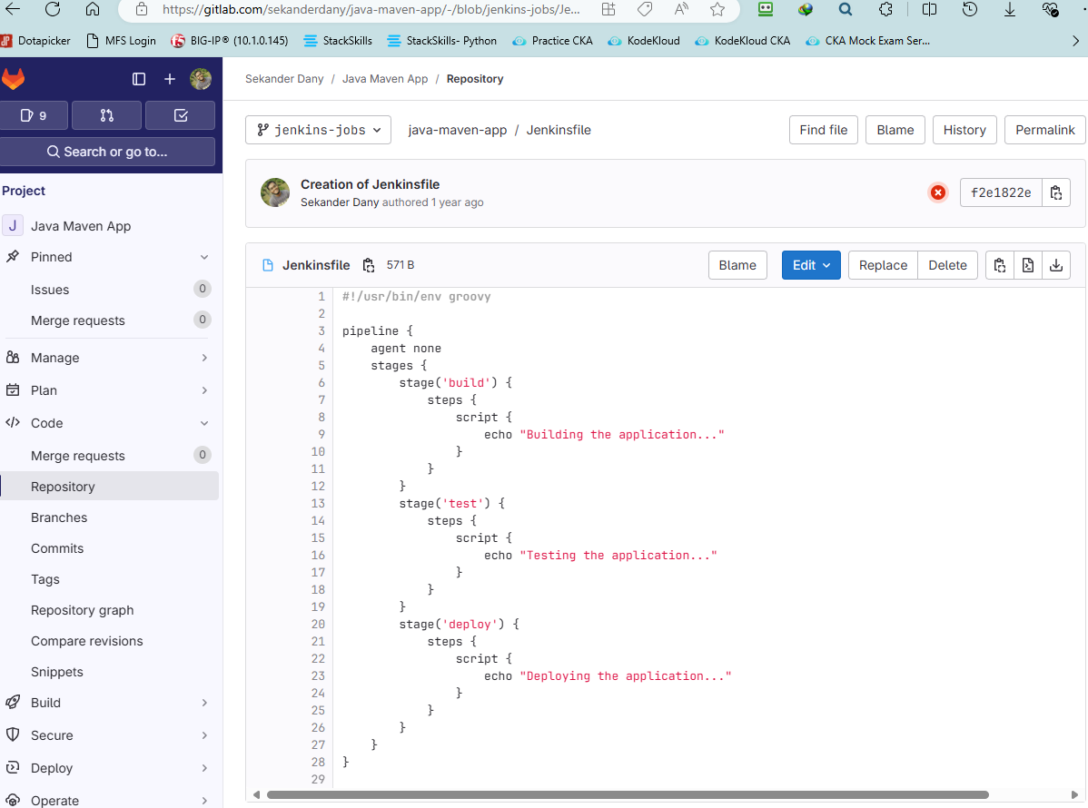

http://64.227.143.222:8080/env-vars.html/

Multibranch Pipeline

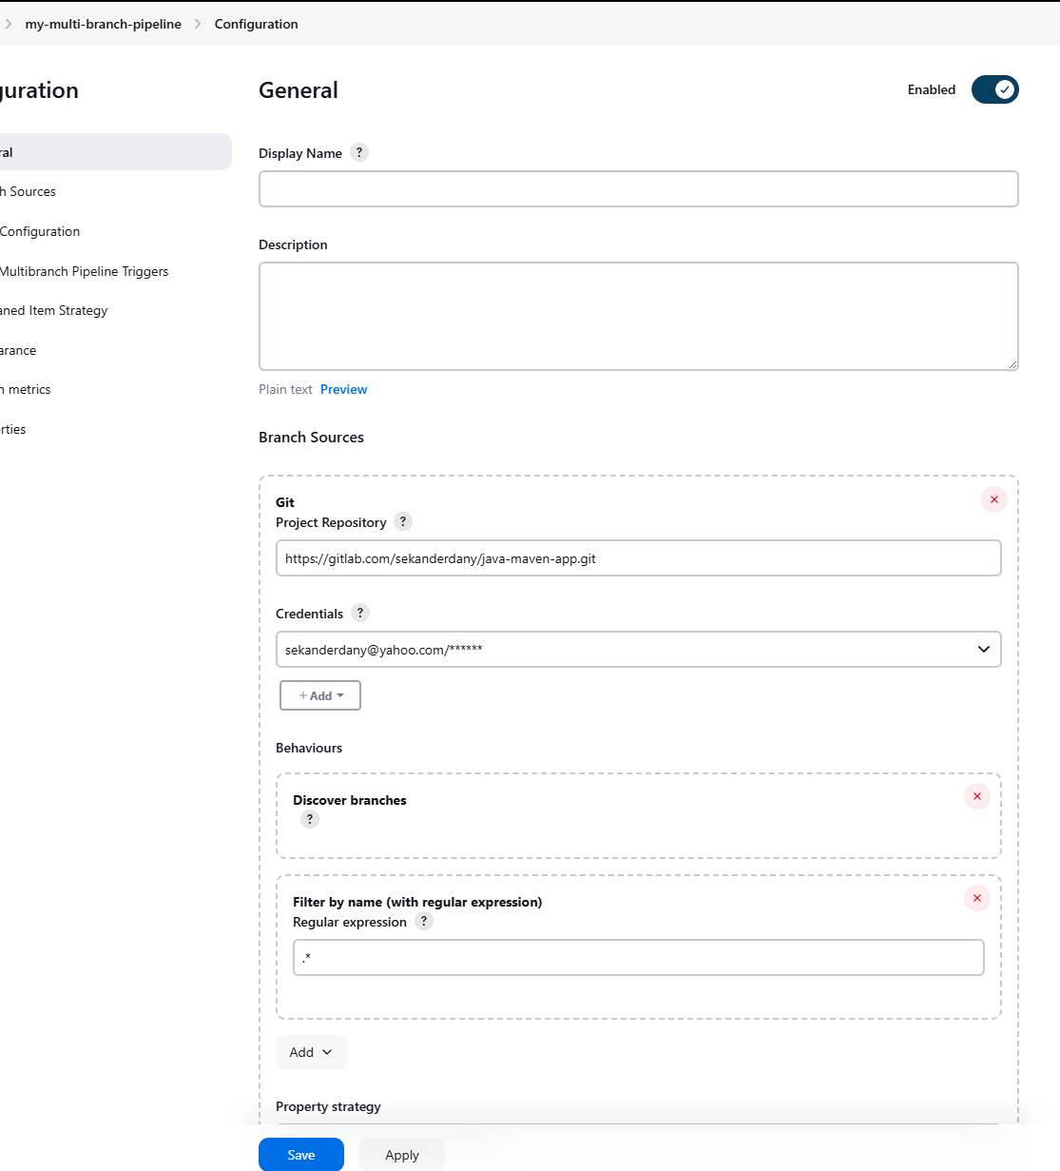

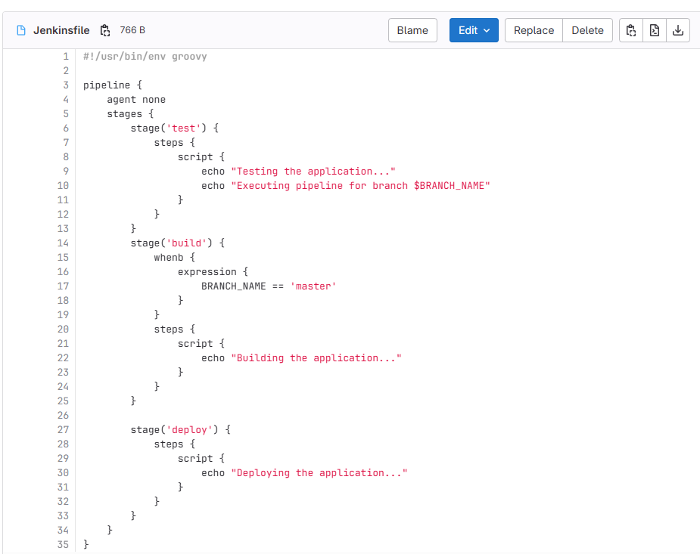

Jenkins Shared Library

