
INTERSCHOOL EXAM OF ----WEB DESIGN --------------
LEVEL: SENIOR 6
TERM:3 ^{rd}
ACADEMIC YEAR: 2013
TIME: 3HOURS
_____________________________________________________________________________
INSTRUCTION:
- This exam has three sections: A, B and C
- Section A: answer all the questions (55 marks)
- Section B: choose three section to answer (30 marks)
- Section C: This Section is Compulsory (15points)
______________________________________________________________________________
SECTION A: ANSWER ALL THE QUESTIONS ( each question carry 5 marks)
- Define the following terms: (5marks)

- Web page:
- Website:
- Web Browser:
- Web server
- Html tags are divided into two types. Explain those types (5marks)
- Establish the basic tools needed to build static and dynamic web site. (5marks)
- Explain the four types of hyperlinks (5marks)
- Differentiate different reception variables used for capturing information within a form (5marks)
- Outline 5 functions of mysql (5marks)
- What is the difference between BCC and CC as fields used while sending an email? (5marks)
- Use PHP to write program that display even numbers between 0 and 50 using do while loop(5marks)
- What is a comment in programming? Show how a comment can be introduced in scripting code(5marks)
- Suppose we have an image “Logo.png” that we want to insert in a webpage and will redirect the user to the “school.html” webpage when clicked on. Write an HTML code to do this. (5marks)
11. In one school of 12 years of basic education, the student were day scholars and the school is encouraging the student who want to be Boarding from school to send their request through the school web by using the form below. Write the codes that display the form below

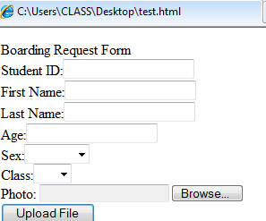 (5marks)

SECTION B: ANSWER ANLY THREE QUESTIONS ( each question carry 10 marks)
- Define the following terms:
- DNS
- Tag
- VoIP
- E-form
- CSS
- Differentiate HTML from PHP
- What does Domain name mean? State 4 country code top level domains and 4 generic domains you know
- Define Spam and hence states different ways of avoiding spammers
- What is website ergonomics? As design of websites states rules according to JACOB NIELSEN that need to be considered while designing! /5Marks

SECTION C: This QUESTIONS Compulsory (It carry 15 marks)
- Create database in PHP named STUDENTS, and insert into your database the following table called address where the StudentRegno it Auto number: (15marks)

StudentRegno | Firstname | Lastname | Location | Sex | phone
1 | Faustin | HABUMUGABE | GISAGARA | M | 0788344543
2 | Francois | MUGISHA | GASAKA | M | 0722345365
3 | Francine | UWERA | CYANIKA | F | 0757565879

ANSWER SHEET OF WEB DESIGN SENIOR 6

Section A: Answer all the questions (55marks)
- Define the following terms: (6marks)
- Web page:
- A Web page is what you see on the Net. One page with text and graphics. These can be created using HTML, DHTML and JavaScript and can be about anything the author of the page wants it to be about.
- A web page is a document that's created in html that shows up on the internet when you type in or go to the web page's address.
- Website: A set of interconnected web pages
- Web Browser: is application software (interface) that helps a computer user gain access to all the content that is on the Internet and the hard disk of the computer.
- Web server: refer to either the hardware (computer) or the software (computer application) that helps to deliver content that can be accessed through the internet.
- Html tags are divided into two types: (6marks)
- Paired tags: A tag is said to be a paired tag, if the text is placed between a tag and its companion tag. In paired tags, the first tag is referred to as Opening Tag and the second tag is referred to as Closing Tag.
- Unpaired tags: An unpaired tag does not have a companion tag. Unpaired tags are also known as Singular or Stand-Alone Tags.

- the basic tools needed to build static and dynamic web site:
- Text editor
- Web browser
- Sever tools:
- Web server (apache server)
- Database server (mysql )
- Explanation of the four types of hyperlinks (8marks)
Text hyperlink: Uses a word or phrase to take visitors to another page, file or document.
Image hyperlink: Uses an image to take visitors to another page, file or document.
Bookmark hyperlink: Uses text or an image to take visitors to another part of a web page.
E-mail hyperlink: Allows visitors to send an e-mail message to the displayed
e-mail address.
- Differentiate different reception variables used for capturing information within a form (5marks)

Answer:
$_POST Variable | $_GET variable
- Is an array of variable names and values sent by HTTP post method  - Is used to collect values from a form with method=''post''  - Variables sent with HTTP post are not shown in URL | - Is an array of variable names values sent by HTTP get method  - Is used to collect values from a form with method=''get''  - All variables and names sent with HTTP get are displayed in URL

- List five functions used in mysql and their use. (5marks)
Answer:
- Mysql_connect(): Is used to connect to the server
- Mysql_error(): Is used to check for occurred errors
- Mysql_select_db(): Is used to select the database you want to work with
- Mysql_close(): Is used to close the connection
- Mysql_query(): Is used to execute an SQL query

- The “Cc” Field
The Cc (carbon copy) field will send a copy of your email to the selected contacts.
The Cc should be used for those who need to be informed about the message, but do not need to take action on the items discussed.
The Bcc (blind carbon copy) Field
The Bcc (blind carbon copy) field sends a copy of the email to additional people but those in the Cc and To fields do not know they received a copy.
- Answers
<?php
$a=0;
do
{
if($a%2==0)
echo"$a";
echo" ";
$a++;
}
while($a<50);
?>
- Comments documents the source code and help programmer for editing, removing contents, changing styles….
In PHP, we use // to make a single-line comment or /* and */ to make a large comment block.
- <a href=’school.html’><img src=’logo.png’></a>
- The codes that display the form are: /10pts
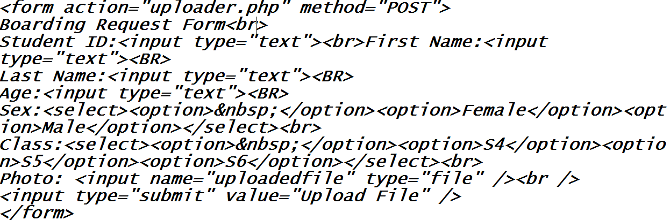

SECTION B: ANSWER ONLY THREE QUESTION (Each question carry 10 marks)

- DNS: Stands for Domain Name system and it is internet service that translate IP address into hostnames
- Tag: key word surrounded by angle brackets used while designing websites
- VoIP: Stands for Voice Over Internet Protocol and it is the use of IP network/intranet for telephony conversation.
- E-form: Stands for Electronic form and it is a computer version of a paper which consists of a group of fields to fill in but with certain restrictions.
- CSS: Stands for Cascading Style Sheet and it is used for formatting the layout of webpages while designing websites

HTML | PHP
- Stands for Hypertext Markup Language  - It is a Markup language  - Used for designing static website | - Stands For Hypertext Preprocessor  - It is a scripting language  - Used to design dynamic and interactive websites

- Domain name is a set of the sequence of the characters or abbreviations, expressions or of words, which is used as address of Internet of a computer or a network.
National domain | Generic domain
.rw:Rwanda  .ug:Uganda  .uk:united kingdom  .ke:Kenya …………. | .com: commercial  .gov:government  .biz:business  .int: international  .org: organization ……..

To Spam is to use of electronic messaging systems (including most broadcast media, digital delivery systems) to send unsolicited bulk messages indiscriminately
- Get yourself at least two email accounts. Use one for public communications (forums, communities, business cards) and keep the other one only for trusted contacts. Use only the public one for registering for Internet services/accounts. Indeed, you will still get spam, but this way at least you have a clean account.
- If you have to list your email account on public pages, try to cheat spam spiders. Instead of writing your address as "john@domain.com", write it as "john_at_domain_dot_com". People will understand how to read it, but robots will not
- Read Terms & Conditions pages. Whenever you have to subscribe to a newsletter or to create a web account on a site, make sure their Terms & Conditions page doesn't give them the right to send you unsolicited emails. Do not select to receive promotional offers by email.
- If your email client can do it, then make it to receive and display incoming emails as plain text, not as HTML.
- When receiving a spam mail, do not attempt to unsubscribe. If you didn't subscribed, then why unsubscribing? Most of spammers are using it to validate your email address, for further spamming purposes. It's simple: if you unsubscribe, it means your email address exists and someone (you) is reading the emails.
- Do not use auto-responders: an auto-responder is a clear signal for the spammer that the junk mail arrived at a real email address, which gives him a "good" reason to keep sending spam.
- If you email client is able to do it, then use auto-preview functions and erase junk email before you download it on your computer.
- Do not click/open links, images or attachments coming from not trusted sources.
- Set your browser security so it doesn't accept cookies.
- Use live updates: update your operating system, Internet browser and email client software as often as possible. Spammers, as viruses, often take advantage of your security holes.
- Use an anti-virus program and check for updates daily. Spammers and worm viruses go hand in hand.
- Report spam: no, it will not stop spam, but you will help the experts on making better software. Reporting spam will make you feel better.

Website ergonomics is defined as ability of a website to effectively respond to the needs of users and provide them with comfort when browsing.

Rules of design of J.Nielsen
- Visibility of system status
2. Match between the system and the real world
3. User control and freedom
4. Consistency and standards
5. Error prevention
6. Recognition rather than recall
7. Flexibility and efficiency of use
8. Aesthetic and minimalist design
9. Help users recognize, diagnose, and recover from errors
10. Help and documentation

SECTION C: This QUESTIONS Compulsory (It carry 15 marks)
- Create database in PHP named STUDENTDB, and insert into your database the following table called address where the StudentRegno it Auto number: (15marks)

StudentRegno | Firstname | Lastname | Location | Sex | phone
1 | Faustin | HABUMUGABE | GISAGARA | M | 0788344543
2 | Francois | MUGISHA | GASAKA | M | 0722345365
3 | Francine | UWERA | CYANIKA | F | 0757565879

Answer:

PHP MySQL Creation of Database and Tables
<?php
$con = mysql_connect("localhost","root","") or die('Could not connect: ' . mysql_error());

// Create database
if (mysql_query("CREATE DATABASE STUDENTDB ",$con))
{
echo "Database created";
}
else
{
echo "Error creating database: " . mysql_error();
}
// Create table
mysql_select_db("STUDENTDB ", $con);
$sql = "CREATE TABLE address (StudentRegno int(3) auto_increment, First_Name varchar(15),Last_Name varchar(15), Location varchar(20), Sex varchar(1), phone varchar(11))";
// Execute query
mysql_query($sql,$con);
mysql_close($con);
?>
Insertion of records into a database table
<?php
$con = mysql_connect("localhost","root","");
if (!$con)
{
die('Could not connect: ' . mysql_error());
}
mysql_select_db("example", $con);
mysql_query("INSERT INTO address (StudentRegno , First_Name, Last_Name, Location, Sex, phone) VALUES ('', 'Faustin', 'HABUMUBABE', 'GISAGARA', 'M', 'O788344543')");
mysql_query("INSERT INTO address (StudentRegno, First_Name, Last_Name, Location, Sex, phone) VALUES ('', 'Francois', 'MUGISHA', 'GASAKA', 'M', 'O722345365')");
mysql_query("INSERT INTO address (StudentRegno, First_Name, Last_Name, Location, Sex, phone) VALUES ('', 'Francine', 'UWERA', 'CYANIKA', 'F', 'O757565879')");
mysql_close($con);
?>

