**REPUBLIC OF RWANDA**

**WORKFORCE DEVELOPMENT AUTHORITY**

**ECOLE SECONDAIRE TECHNIC DE GISENYI**

**ACADEMIC YEAR: 2014**

**SENIOR SIX COMPUTER SCIENCE**

**Intranet mail client system**

**Study case: ESTG School**

**PRESENTED BY:**

* MABENDA MARCHALL HABIMANA JEAN DE DIEU
* MAYOR HABIYAMBERE DANIEL
* COL. ISHIMWE OLIVIER

**SUPERVISOR:**

Ir HODARI AUDACE

\

DECLARATION

WE, Habimana Jean de Dieu, Habiyambere Daniel**,** Ishimwe Olivierto the best of my knowledge here by declare that, this project work entitled, “**ESTG INTRANET MAIL CLIENT SYSTEM” case study ESTG SCHOOL *is*** original and has never been submitted to any high school or other institution, it is our own research where by other scholar’s writings were cited and references are provided.

**Habimana Jean de Dieu** Signature………………..

**Habiyambere Daniel**  Signature…………………

**Ishimwe Olivier** Signature………………….

**Supervisor: Ir Hodari Audace**

Signature…………………….

Date………./………./2014

**DEDICATION**

I dedicate this work to various people in particular my classmates who we share to gather studies and school life.

I dedicate also this work to all persons who studies in our school and all people had contributed differently? Either economically or advises.

More over. I dedicate this work to our leaders because they always give us the important discipline which will help us in social life.

Then this work is dedicated to our parents having taken the Initiative to send us to school in order to prepare our best future.

I dedicate also this work to the readers of our country who didn’t never give up for the support which gives to schools and laying out all the necessary to Rwandan education.

**ACKNOWLEDGEMENTS**

Our work is the result of research which comes to the teachers of ESTG that 's why we thank without forgetting our parents who took the initiative to send us at school and pay us school fees till now.

We give thanks particularly to our powerful God who does not let keeping us all our life, thanks to our Government which helps especially the Ministry for the education and W.D.A.

Our thanks is addressed to the teaching staff of ESTG who provided a remarkable effort during our formation more particularly our project supervisor and others who took the initiative to give us support of this work in order to improve our capacity of intelligence.

We thank the head master of ESTG and all his collaborators.

So we thanks also to everyone who contributed their necessary efforts during the period of our studies.

**ACCRONYMS**

CMD : Conceptual Model of Data

ESTG : Ecole Secondaire Technic Gisenyi

DBMS : Database Management System

GUI : Graphical User Interface

HTML : HyperText Markup Language

HTTP : Hyper Text Transfer Protocol

IT : Information Technology

LAN : Local Area Network

LMD : Logical Model of Data

PC : Personal Computer

PHP : Personal Hyper text Preprocessor

PMD : Physical Model Of Data

RDBMS : Relational Database Management System

W.D.A : Workforce Development Authority

WAMP : Windows Apache MySQL PHP

WWW : World Wide Web

XAMP : eXtended Apache MySQL PHP

**TABLE OF CONTENTS**

**LIST OF TABLES**

Table 1. contact_ table data dictionary 17

Table 2.message_table table data dictionary 18

Table 3. Products table data dictionary 18

Table 4. users data dictionary 18

Table 5. Sell operation table data dictionary 19

**LIST OF FIGURES**

Figure 1. estg database 17

**CHAPITER ONE. GENERAL INTRODUCTION**

**1.1. BACKGROUND OF THE STUDY**

Our world is changing with a high technology so, Estg Intranet Mail Client System is a private computer network that uses Internet Protocol technology to securely share any part of an organization's information or network operating system within that organization.    
The term Intranet is used in contrast to internet, a network between organizations, and instead refers to a network within an organization.

Sometimes the term refers only to the organization's internal website, but may be a more extensive part of the organization's information technology infrastructure.

“At intranet, we take pride in our high levels of communication that we maintain right from raw material pro cerement to delivery of the final product, which has earned the company, the market leader position in many of the product lines.”

**OUR VISION AND MISSION**

***Vision***

Develop estg staff and their member s’ company known for being a communication for in order to save money and time. (Develop estg intranet into a highly profitable and socially responsible firm.)

***Mission Statement***

To do this, it is just to make our school paperless and to save time that was used in communication.

**1.2. SIGNIFICANCE OF THE STUDY**

This project “**ESTG INTRANET MAIL CLIENT SYSTEM. STUDY CASE: ESTG INTRANET**” has a significance to us in general and to Estg school in particular.

As student of Computer Science, which is Technical Option, at the end of studies each student must present a final project in order to obtain the practical points of the National Examination for A2 Certificate. That is why we did this project with the purpose of obtaining practical points in the national examination.

In the part of Estg School, at the end of this project, if possible it will be presented to Estg school so that if they found if valuable they can use it in they activities of communication themselves. Which has a great save of time and even money like for papers.

**1.3. SCOPE OF THE STUDY**

This project will be limited in the communication of Estg in a way which will allow all members (estg and they staff).

All staff which will use it.

web application, will reach the people by providing them at home, office or business activities place.

**1.4. PROBLEM STATEMENT**

**Problem found on the existing system**

* Avoid use of papers
* No network share are in use for ESTG Intranet
* Save time
* Save money
* Only a simple Contact Us Form on the estg
* Facilitate a communication between estg staff and their member

**Proposed solutions**

- Increase relationship between estg members

- Providing of a full and useful online form to be used in most communication.

- Use of Technology in estg activities.

**1.5. HYPOTHESIS**

Will estg by using this intranet, increase they profit of time and save money even paperless?

**1.6. OBJECTIVES OF THE STUDY**

**1.6.A. GENERAL OBJECTIVES**

The general objective of this project is to create the communication for estg which will facilitate the order and communication in order to increase they paperless and ordering activities.

**1.6.B. SPECIFIC OBJECTIVES**

As specific objective this projects will allow us to put in practices programming lessons we get from school.

It will put ESTG in a high level in the region of school which use machines to provide a good communication between them.

It will help us to obtain good practical examination points on the final national examination of our Advanced Level studies.

**CHAPTER TWO. LITTERATURE REVIEW**

**2.1. System**

A collection of components that work together to realize some objectives forms a system. Basically there are three major components in every system, namely input, processing and output.In a system the different components are connected with each other and they are interdependent. For example, human body represents a complete natural system. Here we are concerned with an IT system. The objective of the IT system demands that some output is produced as a result of processing the suitable inputs .

**2.2. Information**

Information is referred to as data that have been processed and presented in a form suitable for human interpretation, often with the purpose of revealing trends or patterns.

**2.3. Information system**

Information system is a set of people, procedures and resources that collects, transforms and disseminates information in an organization; a system that accepts data resources as input and processes them into information products as output.

**2.4. Information technology**

Information technology means all computerized and auxiliary automated information handling, including systems design and analysis, conversion of data, computer programming, information storage and retrieval, voice, video, data communications, request systems controls, and simulation. The term information technology is commonly abbreviated as IT [3] .

**2.5. Database concepts**

In this project entitled Estg intranet mail client system has a need of database management system to manage and store all data related to estg intranet , in IT real world there is no management software without front end as background designed for users and the back end connected to the design as the database in which all data entered by software users are stored, each field and rows must contains their own data or information about estg intranet system [4] .

**2.5.1. Data**

**Data is** representation of facts, concepts, or instructions in a formalized manner suitable for communication, interpretation, or processing by humans or by automated means.

**2.5.2. Database**

A shared collection of logically related data designed to meet the information needs of multiple users in an organization.

**2.5.3. Entity**

A person, place, object, event, or concept in the user environment about which the organization wishes to maintain data.

**2.5.4. Table**

A table is a two-dimensional display of data values corresponding to an entity.  The columns of a table represent characteristics of the entity and the rows represent instances of the entity.

**2.5.5. Primary key**

The primary used to create relationships between tables. It's the entry keyed off of to identify the record in question. An otherwise meaningless surrogate value is often used for the primary key. The primary key for an entry must never change: if the record is referred to by a record in a different table, the relationship (link) will be often irretrievably broken.

**2.5.6. Foreign key**

The foreign key belongs to another table and has no meaning for the entity in which it is [**Database Management System (DBMS)**](http://www.webopedia.com/TERM/D/database_management_system_DBMS.html)recorded. Usually a foreign key will be a primary key in another table.

**2.5.7. Relational database**

Relational database builds the relationships between fields in tables explicitly through keyed fields. Because the relationships are not handled programmatically but are integral to the data itself, users can access the data without knowing the physical structure of the data (i.e. how the data is written on disk).

**2.2.6.**

Database management system is the software that handles all access to the database. A major role of database management system is to allow the user to deal with the data in abstract terms, rather than as the computer stores the data, Database management system is computer program (or more typically, a suite of them) designed to manage a database (a large set of structured data), and run operations on the data requested by numerous clients. Typical examples of DBMS use include accounting, human resources, and customer support systems.

MYSQL: MySQL is a relational database system, which basically means that it can store bits of information in separate areas and link those areas together.

Because MySQL is a relational database management system, it allows you to separate information into *tables* or areas of pertinent information.

**2.2.7. Data dictionary**

A data dictionary is a set of metadata that contains definitions and representations of data elements. Within the context of a DBMS, a data dictionary is a read-only set of tables and views. The data dictionary is database in its own dictionary. For example, several tables may hold telephone numbers; using a data dictionary the data dictionaries can evolve into full anthologies when discrete logic has been added to data element definitions.

**2.6. Client/server architecture**

A network architecture in which each computer or process on the network is either a Client or a Server. Servers are powerful computers or processes dedicated to managing disk drives (file servers), printers (print servers), or network traffic (network servers). Clients are PCs or workstations on which users run applications. Clients rely on servers for resources, such as files, devices, and even processing power.

**2.7. Internet**

The term internet refers to the global network of public computers running Internet Protocol. The Internet supports the public WWW and many special-purpose client/server software systems. Internet technology also supports many private corporateintranets and private home LANs

**2.8. Website**

Is a collection of web page linked between then and stored together in order to provide information to the users Web pages can contain text, images, videos, sounds and so on. The popular markup language used to create website and web pages is HTML (Hypertext Markup Language.)

**2.9. Web Application.**

A web application is an interactive web site which provides services to the visitors. It use scripts which can retrieve and save information into different types of database. A web application provide responses to all users requests and user an navigate according to they needs.

**2.10. PHP**

PHP was created in 1995 by an independent software developer named Rasmus Lerdorf. His first PHP script was a Perl/CGI program that kept a log of each visitor that came to his site.

The script then displayed how many visits he had received on each page. He soon started receiving emails from other web masters across the Internet asking how he did this (a "Counter" as this is called, were very rare back then.) Because of the interest in his script he started to develop PHP into a new language, by adding more and more features to his script.

Eventually, he decided to stop programming PHP in Perl/CGI, and start constructing it with a more powerful language, "C". Thus the interest in PHP keep growing as more features were added and soon other people started writing code for it. It is now one of the most popular languages on the Internet, with contributing programmers across the world.

**2.11. XAMP**

Is a platform which means Extended Apache Mysql PHP which is a platform which combine the Local Server Services APACHE, the popular database used online MYSQL and the interpreter of PHP Language Script. It will be used to create codes of our projects. They is also other software which support those services like WAMP, EasyPHP …

**2.12. APACHE Server**

The Apache [HTTP](http://en.wikipedia.org/wiki/Hypertext_Transfer_Protocol) Server, commonly referred to as Apache is [web server](http://en.wikipedia.org/wiki/Web_server) software notable for playing a key role in the initial growth of the [World Wide Web](http://en.wikipedia.org/wiki/World_Wide_Web) and for today Apache server is used with MySQL database to make the web site and is most married with as languages such as PHP, MySQL, XAMPP, WampServer and so on. Apache is a server used as local to make our web site.Server is known as a [computer](http://www.webopedia.com/TERM/C/computer.html) or [device](http://www.webopedia.com/TERM/D/device.html) on a [network](http://www.webopedia.com/TERM/N/network.html) that manages network [resources](http://www.webopedia.com/TERM/R/resource.html).

# CHAPTER THREE. RESEARCH METHODS AND TECHNIQUES.

**Methodology is** a [system](http://www.businessdictionary.com/definition/system.html) of broad [principles](http://www.businessdictionary.com/definition/principles.html) or [rules](http://www.businessdictionary.com/definition/rule.html) from which specific [methods](http://www.businessdictionary.com/definition/method.html) or [procedures](http://www.businessdictionary.com/definition/procedure.html) may be derived to interpret or solve different [problems](http://www.businessdictionary.com/definition/problem.html) within the [scope](http://www.businessdictionary.com/definition/scope.html) of a particular [discipline](http://www.businessdictionary.com/definition/discipline.html). ( <http://www.businessdictionary.com>)

In our research study we have used methods and techniques for collecting all data used in this work.

Technique means a systematic procedure, formula, or a routine by which a task is accomplished. But Method is a habitual, logical, or prescribed practice or systematic process of achieving certain end results with accuracy and efficiency, usually in a preordained sequence of steps. (<http://www.differencebetween.com>)

In this project research the methods and techniques used are:

## **3.1** OBSERVATION METHOD

Observation is visual study of something or someone in order to gain information. This allows us to make informed decisions and to get the facts information and also allowances based on what we have been studied. Observation is a basic and important method used to collect the real data in our research methodology of making a web based application of student registration online. We did it by collecting data about registration services directly observing them at work.

## **3.2** INTERVIEW TECHNIQUES

An interview is a technique used when we have made observation to collect a variety of information from Academic and finance departments related to student registration from the beginning up to the end of registration.

## **3.3** DOCUMENTARY TECHNIQUES

It is another technique used to collect data, and we usually know that for getting the facts information we must read the books and visiting the internet web sites in order to do effective and efficiency research. In this research study we have read the different books and visited many internet web sites for having this output which is the final product of our research study.

# **3.4 Soft ware development process Methodology**

For achieving this project, we have use the interview, documentation during the research of the informations.

The methodology that the researcher used in this project is the waterfall model which is the earliest carefully-articulated design process for software development.

## 3.5 Waterfall Model

The waterfall process model is one such approach/process used in software development .In the waterfall approach, the whole process of software development is divided into separate process phases. The phases in waterfall model are: Requirement analysis phase, software design phase, implementation phase, integration phase and maintenance phase. All these phases are cascaded to each other so that second phase is started as and when defined set of goals are achieved for first phase and it is signed off, so the name waterfall model. All the methods and processes undertaken in waterfall model are more visible.

**Diagram view of waterfall model**



*Source: Own drawing*

### Phases of waterfall model

**3.5.1Requirement analysis**

All possible requirements of the system to be developed are captured in this phase. Requirements are set of functionalities and constraints that the end-user (who will be using the system) expects from the system. The requirements are gathered from the end-user by consultation, these requirements are analyzed for their validity and the possibility of incorporating the requirements in the system to be development is also studied. Finally, a requirement specification document is created which serves the purpose of guideline for the next phase of the model

The requirements of the system have been identified using a type diagram called use case diagram.

**3.5.2 System & Software Design**

Before starting for actual coding, it is highly important to understand what is going to be created and what it should look like? The requirement specifications from first phase are studied in this phase and system design is prepared. System Design helps in specifying hardware and system requirements and also helps in defining overall system architecture. The system design specifications serve as input for the next phase of the model.

**3.5.3.Implementation & Unit Testing**

On receiving system design documents, the work is divided in modules/units and actual coding is started. The system is first developed in small programs called units, which are integrated in the next phase. Each unit is developed and tested for its functionality; this is referred to as Unit Testing. Unit testing mainly verifies if the modules/units meet their specifications.

**3.5.4 Operations & Maintenance**

This phase of the waterfall model is virtually never ending phase (very long). Generally, problems with the system developed (which are not found during the development life cycle) come up after its practical use starts, so the issues related to the system are solved after deployment of the system. Not all the problems come in picture directly but they arise time to time and needs to be solved; hence this process is referred as maintenance.

# 3.6 REQUIREMENTS SPECIFICATIONS

### Project Requirements

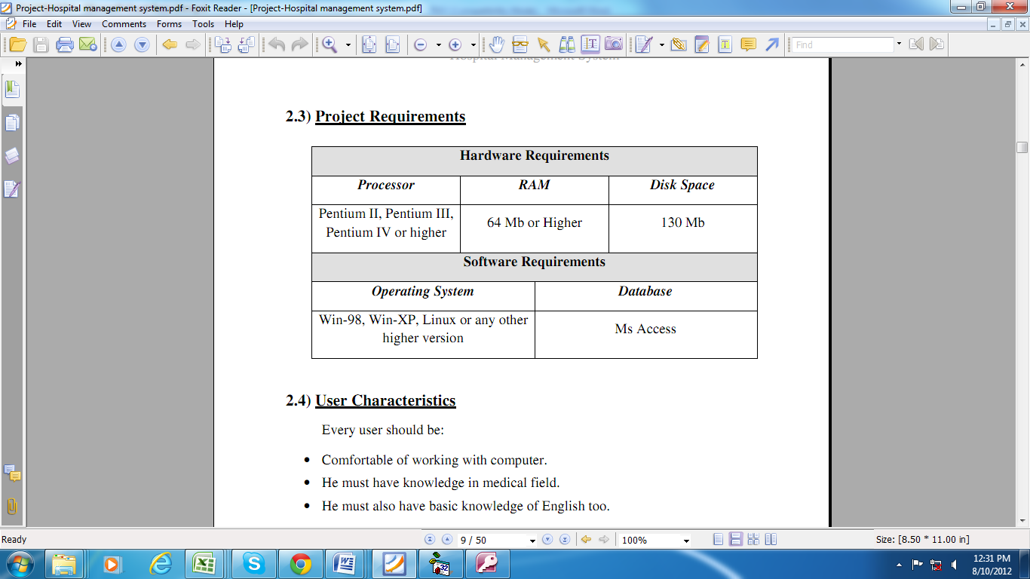

**Xammp, my sql database**

### 

### 3.6.1. User Characteristics

Every user should be:

• Comfortable of working with computer.

• He must have knowledge in information communication and technology field.

• He must also have basic knowledge of English too.

### 3.6.2. Constraints

• GUI is only in English.

• Login and password is used for identification of user and there is no facility for guest.

## 3.6. 3.LANGUAGES

### 3.6.4. PHP

PHP is easy in different web apps programming languages and use straight out of the queries and runs on many platforms including Windows, Linux, Mac OS X and Solaris.

**Characteristics**

* **Portability:** Access runs on almost every flavor of Unix, as well as Windows.
* **Speed:** Using techniques such as efficient indexing mechanisms, in memory temporary tables, and highly optimized join algorithms, Access executes most queries much faster than most other database systems.
* **Scalability and Flexibility:** Because of its modularity and its flexibility in configuration, Access can run in systems varying in size from embedded systems to large multiprocessor Unix servers hosting databases with tens of millions of records. It is not uncommon to hear of access installations supporting thousands of concurrent users.

This project will be a desktop application to be developed in Dream weaver having My sql as backend.

* + Database Design (Xampp, my sql)
  + Form Design (PhP)
  + Coding (localhost using web browser)
  + Testing (Dream weaver)

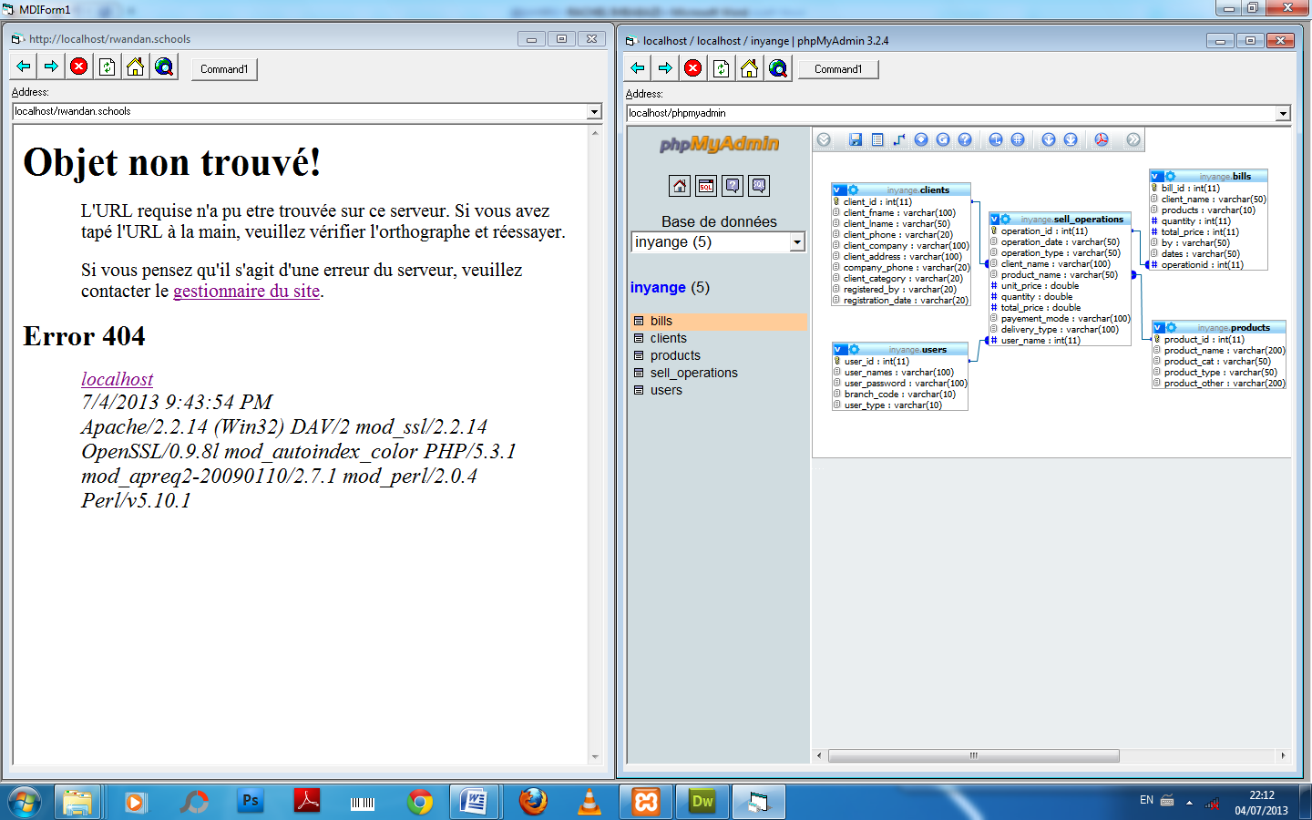

**CHAPTER FOUR. COLLECTION OF DATA, PRESENTATION AND ANALYSIS.**

We collected our data using Interview techniques by asking to questions to the estg leaders and to the administration of estg school in general.

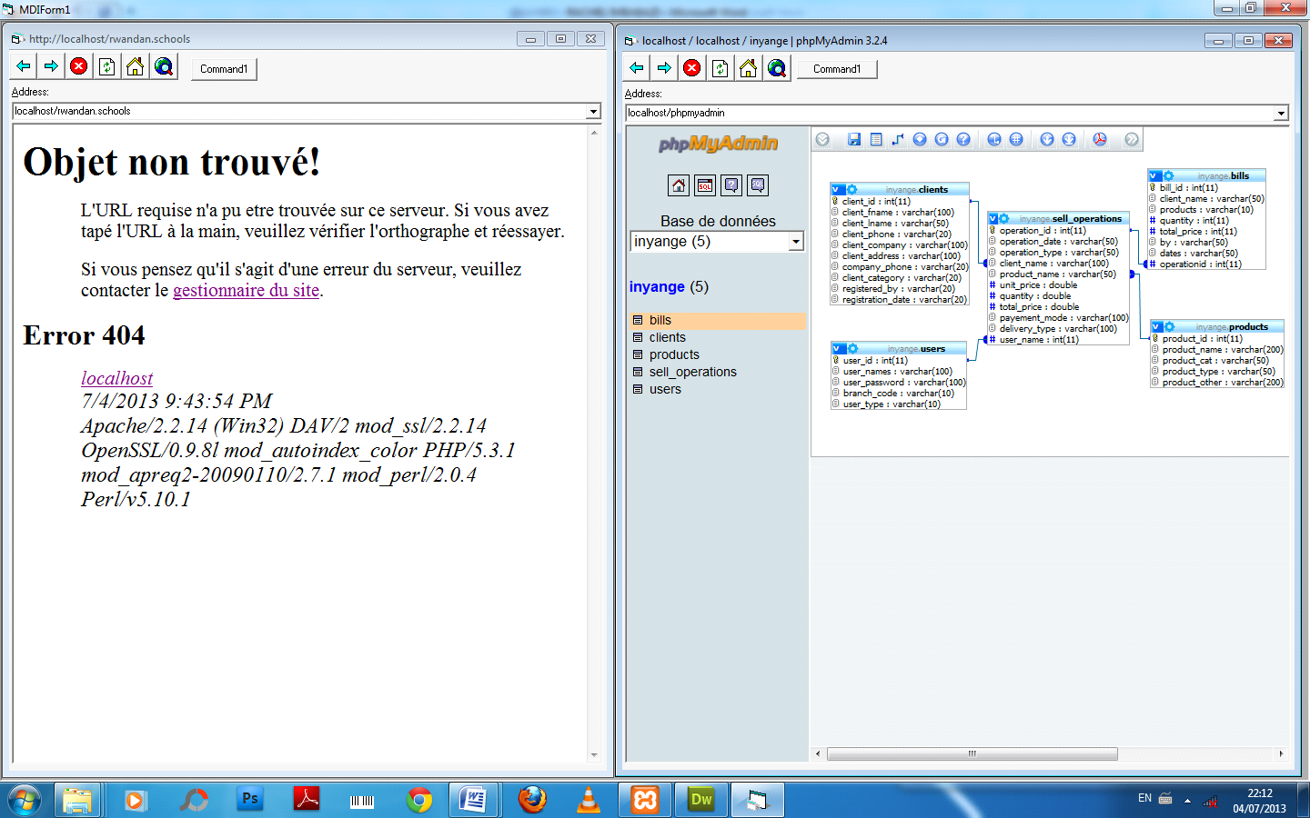**Database**

**Figure 1 ESTG DATABASE**

**Data dictionary**

**Contact table**

|  |  |  |
| --- | --- | --- |
| **Champ** | **Type** | **Description** |
| NAMES | varchar(30) | Username |
| ADDRESS | varchar(30) | Client names |
| MESSAGE | varchar(50) | Your comment |
| CONTACTDATE | timestamp | Date take place on |

**Table 2. table data dictionary**

**Message_table**

|  |  |  |
| --- | --- | --- |
| **Champ** | **Type** | **Description** |
| MSG_ID | int(11) | The unique ID of the message |
| MSGFROM | varchar(100) | Where message from |
| SUBJECT | varchar(50) | What you are gonna write on(topic) |
| BODY | varchar(20) | Message(text area) |
| MSGTO | varchar(100) | Username of where you are gonna send to |
| FLAG | varchar(100) | Flag |
| DOS | varchar(20) | Date of send |
| FILE | varchar(20) | Kind of what you do(upload) |
| FILENAME | varchar(20) | Name of a file you attach |
| SENDERFOLDER  RECEIVERFOLDER | varchar(20)  ENUM | Folder that will send a message  Folder that will receive a message |

**Table 3.signup table data dictionary**

**Signup table**

|  |  |  |
| --- | --- | --- |
| **Champ** | **Type** | **Description** |
| USER_ID | int(11) | Product id |
| FNAME | varchar(200) | Product name |
| LNAME | varchar(50) | Product category |
| ADDRESS | varchar(50) | Product type |
| BOD  SEX  PHONENUM  REGISTRYDATE | varchar(200)  varchar(30)  varchar(30)  varchar(30) | Other product description |

**Table 4. USERS table data dictionary**

**Users**

|  |  |  |
| --- | --- | --- |
| **Champ** | **Type** | **Description** |
| USER_ID | int(11) | User ID |
| USERNAME | varchar(35) | Username |
| PWD | varchar(50) | Password |
| STATUS | Bit(2) | Branch Code |

**Application User Interface**

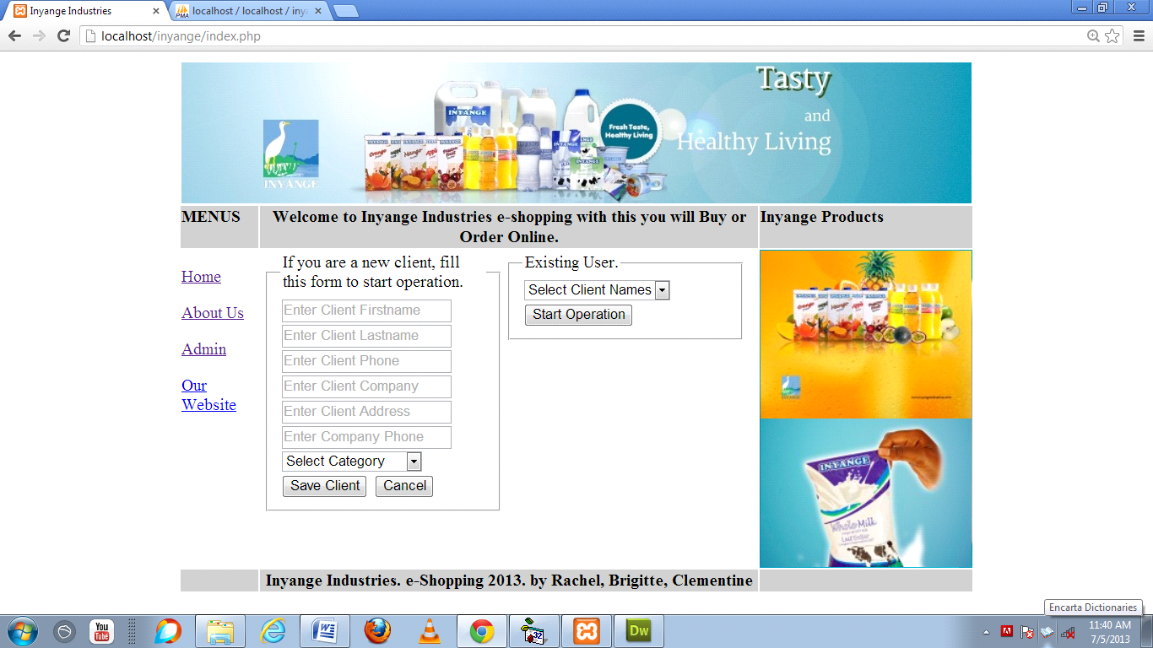

**Figure 2. Home Page**

**Home Page Description.**

First of all the User have to create an account in order to login in a system through sign up , after creating an account you will be login directly ,you will see a message that tells you that you are new user and do everything that allowed as user.

If you are an existing user, you do not have to create again you just login by entering username and password on screen in the field and you will see also a message that tells you that you are Existing User.then do whatever you want as user.

**Operation Form**

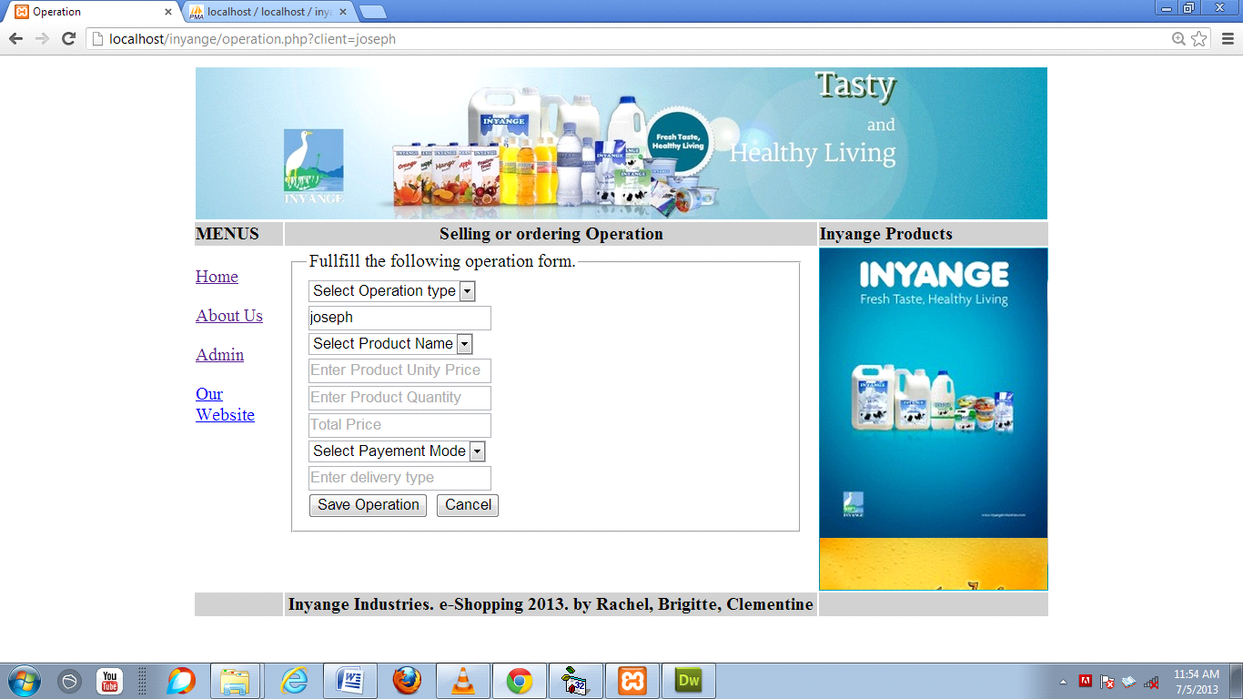

**Figure 3. signup Form**

**Login Form Description**

The registered user will click on signup and fill by entering first name then fill the last name , fulfill the address, select your date of birth, select sex and write your phone number,your phone number must be nine after +250 as code for Rwanda, fill your username that you will use to communicate with others, fill password you will use and your password must not be less than eight and confirm your password by reenter the password you have entered and then click on register.

**Bill**

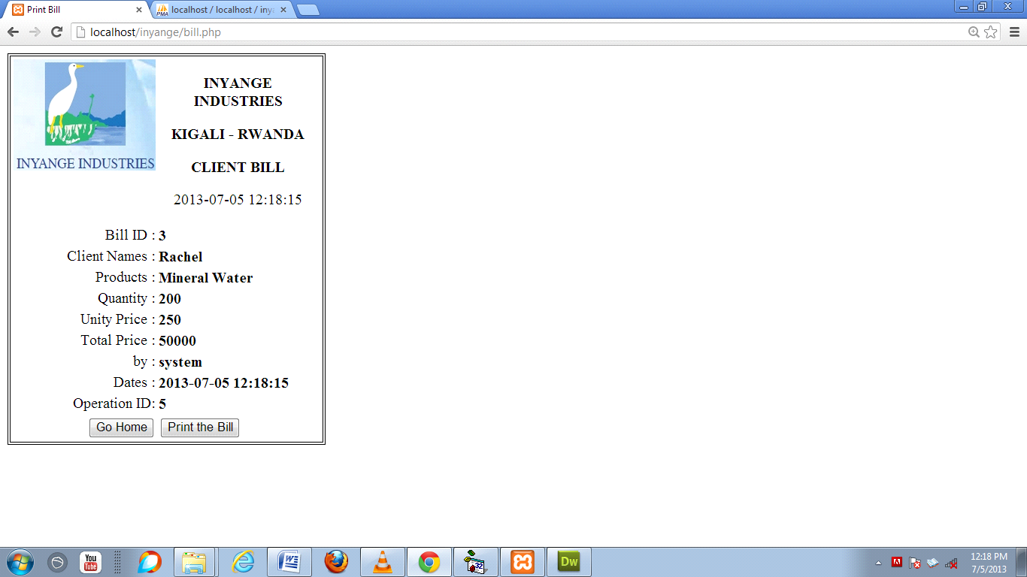This Bill is generated after each operation, Click on the Command Print the Bill to print it and Click on Go Home to return back to the home page of the system.

All list of bill are available on the administrator platform where it can be printed again.

**Figure 4. Bill Page**

Administration Platform

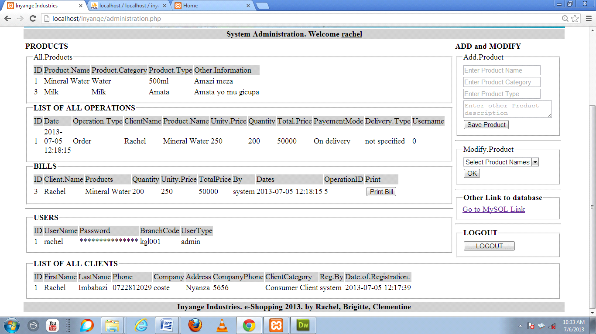

**Figure 5. Administration Platform**

To access to this page, you must login first with a registered username and password. Otherwise you will not be allowed to access to this page.

With this page the administrator will be able to Add Products and modify them. You will get access my MYSQL database for more administration, Logout and to view all products, list of operations, bills, users and list of all registered clients.

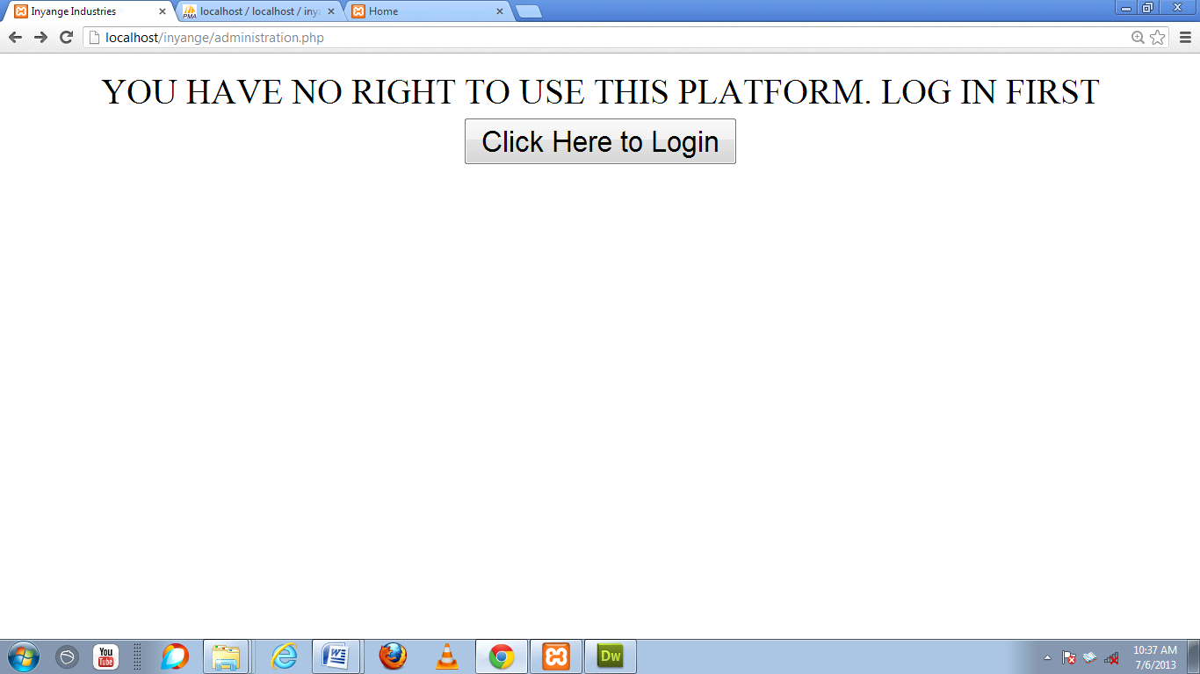

**Figure 6. Administration Security**

This message will be displayed if you enter administration.php in the address bar without login first.

**CHAPTER FIVE. CONCLUSION AND RECOMMANDATION.**

**Conclusion**

As conclusion, the use of Information Technology in different management and other operations is very important in the increment of the performance and usability.

ICT used as a tool of communication if all other companies have a private communication system which will be useful and very important to the society in general.

**Recommendation**

**To estg school**

* Through this idea of creating an intranet mail client system to make a paperless in this school to be used by estg members in general.
* To continue communication and chat of estg school in the country and aboard.
* To add a technology system in the estg school.

**To WDA**

* To provide a training to supervisors teachers so that they can help us in different project activities.
* To include a courses of Research and Projects management in the courses learn in senior six to allow students to be able to prepare projects themselves.

**To ESTG**

* To continue the training they provide to students in technical options
* To prepare students for the action of project implementation since the first term.

# ELECTRONIC REFERENCE

1. [www.wikepedia.vb_.vbnet](http://www.wikepedia.vb_.vbnet)
2. [www.commentcamarche.com](http://www.commentcamarche.com)
3. [www.commentcamarche.net](http://www.commentcamarche.net)
4. <http://en.wikipedia.org/wiki/Data_flow_diagram>
5. www. Kashipara.com