

REPUBLIC OF RWANDA

WESTERN PROVINCE

MINEDUC

RUBAVU DISTRICT

ECOLE SECONDAIRE TECHINIQUE DE GISENYI (ESTG)

OPTION: COMPUTER SCIENCE

LEVEL: A2

**STUNDENT INFORMATION SYSTEM**

**CASE STUDY: ECOLE SECONDAIRE TECHNIQUE GISENYI(ESTG)**

PRESENTED BY MUKOBWA Patience

TUYAMBAZE Jean Bosco

NIYITWIZERIMANA Jean Claude

Supervisor: NYERERE Justin

**Academic year: 2014**

**DECLARATION**

We, **MUKOBWA Patience,** TUYAMBAZE **Jean Bosco, TWIZERIMANA Jean Claude** to the best of our knowledge here by declare that, this project work entitled, “**student information system” case study ESTG (Ecole Secondaire Technique Gisenyi)** is original and has never been submitted to any high school or other institution, it is our own research where by other scholar’s writings were cited and references are provided.

**MUKOBWA Patience** Signature………………..

**TUYAMBAZE Jean Bosco** Signature………………..

**TWIZERIMANA Jean Claude** Signature………………..

**Supervisor: NYERERE Justin RUTIKANGA Butaref**

Signature………………..

Date………./………./2014

# 

# 

# 

# DEDICATION

We warmly dedicate my project marking the end of the secondary school to:

The Almighty God,

All members of our family,

All my friends and relatives,

My brothers and sisters,

My classmates,

Because without their help and prayers I don’t be able to accomplish my studies, finish this project and become the person I am today.

**ACKNOWLEDGEMENT**

We could not have completed this dissertation and realized our dreams without moral, material and financial support or otherwise, given by various people who deserve recognition and thanks. While those we are indebted to mention individually, some deserve special recognition.

We would like firstly to thank God and express our gratitude to him for his love, power, guidance and protection that has been with us up to this moment.

We extend our thanks and heartfelt gratitude to our teacher HODARI AUDACE, NYERERE JUSTIN, NZABIRINDA AIMABLE for the unreserved commitment, academic guidance, counseling and support they extended to us. Special thanks go to our lovely families whose financial support triggered our desire to start and complete this work.

We wish to, most sincerely, recognize our respondents like the Minister of Local Government of the Republic of Rwanda, WDA, and the Director of ESTG( Ecole Secondaire Technique de Gisenyi )who were not hesitant to provide to Rwandan students good knowledge.

We want to express our sincerest appreciation to all teachers of ESTG

, for the opportunities given to us in order to obtain innumerable computer skills and support during our studies. I am so grateful.

**LIST OF ABREVIATION AND ACRONYMS**

DB: Database

VB: Visual basic

WDA: Workforce Development Authorities

CDF: Common Development Fund

ESTG: Ecole Secondaire Technique Gisenyi

**Tel : 0725192920**

**CHAP I: INTRODUCTION AND BACKGROUND OF STUDYS**

**I.0.GENERAL INTRODUCTION**

Ecole Secondaire Technique Gisenyi (**ESTG**)is a school which located in Western province; Rubavu district .this school has two options Computer science and Electricity

**I.1.BACKGROUND OT STUDY**

## 1.1. ESTG Background

**Gisenyi Technical Secondary School (ESTG)** was independent secondary school that started in 2006,and started by Presbyterian church in Rwanda. the ESTG is located in kivumu cell, Gisenyi sector,Rubavu district in western Province.

ESTG started shortly after the Genocide as a vocational training center in plumber, welding and electricity. the idea behind was the creation of that vocational training center began with the Rwandan Presbyterian church members in Gisenyi parish as a way to tackle the issue of street children in Gisenyi,that increased considerably after the Genocide of Tutsi in 1994.so,it called Vocational Training center on February 5,1996 and was founded by KERK IN ACTIE.

When the center started, it carried out its daily activities in the locals serving as the guest house belonging to the Presbyterian in Gisenyi however four years after, the vocational training center got its own locals built with the aid of KERK IN ACTIE.

As aforementioned, the vocational training aimed at tackling the problems of street children by empowering them with skills that would help them to provide for their own needs, therefore reducing or eradicating the cases of street children. In addition, as the center was started by religious institution, there was a second purpose consisting of those children to spiritual grout. Since its beginning, 186 children graduated in different options.

Due to the fact that after the Genocide, so many vocational schools were created, the number of children adhering Secondary School was by a Ministerial Order as an independent technical secondary the secondary school education decreased and the founder of Gisenyi vocational training center decided to change it into a technical secondary school (ESTG).

In 2006, the Gisenyi technical school with a condition of building adequate buildings for a technical school.

Some of the objectives to create the ESTG can be summed up as following:

-Providing an opportunity to the children who couldn’t complete their studies to do so;

-To increase the number of children completing the second cycle of secondary studies then reducing the number of those who drops their studies after the ordinary level

-Providing skilled technicians to the Rwandan job market; - Increasing the number of Rwandan electricians.

Today, ESTG is one of the government supported technical school following the mutual agreement between the school and the ministry of education. The school has two options namely: Electricity and computer science. Since it is changed in to a technical secondary school, three classes had graduated and the fourth will graduate by the end of this year.

The School’s stakeholders are:

-ICCO&KERKINACTIE; -PARENTS; -EPR; -Ministry of Education

**I.2. PROBLEM STATEMENTS**

As solution, the new system which is computerized system will solve the problems list bellow, by using implemented of this software.

1. Services given slowly.
2. Difficulties of controlling the cash flow
3. Delay in services
4. Lack of control

**I.3. OBJECTIVES OF PROPOSED SYSTEM**

**I.3.1GENERAL OBJECTIVE**

The general objective is to design a new system which has the purpose of managing the student information, to develop the system that enables easy, convenience and effective way of managing the student information there are the following objectives:

* To make the application of Student Information System usable for the secondary schools.
* To access the student’s records and get the desired information which may require.
* To automate the existing system of manually maintain the records of the student records, Students Details, Attendance Details, Internal Marks etc.
* To increase data accuracy, make student information management more secure, effective, convenient and accessible. This application will provide the report which will help in the management of the company by providing overview of their daily work.
* Manual work has to be reduced.
* Get accuracy.
* Result to be received very quickly.
* It uses concept of user friendliness.
* It provides using of multiple applications at a time.
* Increase security, speed, storing and accuracy.
* Customer services can not only be satisfied but also enhanced to the extent that one can obtain or cancel a reservation from any branch for any route at any given time.
* To speed up the operation.
* Managing and maintaining data becomes easier.
* Provide convenience to travelers.
* It decreases manpower and high cost.

**1.2.2 Specific Objectives**

Our specific objectives are:

* To simplify and to improve the partnership both ESTG and its students
* To facilitate students to rich our services
* To enumerate the loss of hardcopies
* To provide high quality of services and being example of other secondary schools
* To provide safe and secured information in the whole way

**I.2.3. limitation of work**

This project is titled student information system it’s concerning with management of students registration , information about the internal marks and information about school fees .these contain the students information.

**I.3. RESEARCH METHODOLOGY**

**I.3.1TECHINIC OF DATA GATHERING**

During my final project research in order to be achieved I use many different methods to get information as well as possible.

**I.3.1.1 documentation method**

This method of documentation I tried to use [www.freestudentproject.com](http://www.freestudentproject.com) this is the website of free student project where I found many information about the student information system that helped me to get more details about the services that offer by the students and how the manually system is processed.

**I.1.3.1.2 interview method**

At the beginning of this project we really make an interview, we used this method in order to know deeply how the movement and activities of ESTG School so that to build this software/project become well designed and well understand/convenience to the users/ students.

we helped with one of the secretary of school (ESTG) and she explained to us all details were needed to finish our work.

I**II.1.3.1.3 observation**

During the period when we were gathering information we also used this method of observing with my eyes how customer/passenger and other activities were moving that gives us motivation of doing this project

**CHAPTERII: THEORETICAL CONCEPT AND** **LITTERATURE REVIEW**

**II.1 INTRODUCTION**

The manually system is the system which use ordinary materials in management for different work in different department. And also with this system in this school when the student present in the office to ask the information. They take a several time for finding the information needed by the student.

**II.1 DEFINITION OF KEY TERMS**

* **A database:** Database is a collection of [information](http://searchsqlserver.techtarget.com/definition/information) that is organized so that it can easily be accessed, managed, and updated.
* **System**: System can be defined as, a set of [detailed](http://www.businessdictionary.com/definition/detailed.html) [methods](http://www.businessdictionary.com/definition/method.html), [procedures](http://www.businessdictionary.com/definition/procedure.html), and [routines](http://www.businessdictionary.com/definition/routine.html) established or formulated to carry out a specific [activity](http://www.businessdictionary.com/definition/activity.html), perform a [duty](http://www.businessdictionary.com/definition/duty.html), or solve a [problem](http://www.businessdictionary.com/definition/problem.html).
* **Manual system**: Manual systemis a system which does not use any computer devices. All data would be kept in other ways, mainly on papers.
* **Visual Basic:** a visual basic is a programming language, in this project is used as an interface.
* **Relational Database Management System:** is a type of Database Management System that stores data in the form of related tables. Relational databases are powerful because they require few assumptions about how data is related or how it will be extracted from the database. An important feature of relational systems is that a single database can be spread across several tables.
* **Student Detail Edit:** Student details can be edited by searching for a particular student. Editing is allowed to administrative login.
* **Student Details**: Student details contain the personal details of any particular student which may contain student name, fathers name, DOB, address etc.
* **Option**: Course will consists of the different options which can be opted by the student s for example like BCA, BBM, B.Sc etc
* **Internal Marks Details**: Internal Marks gives the marks scored by the student in the internal examination held by the colleges or universities.

**II.2 SYSTEM**

O’Brien (1999) defines a “system” as a set of interested components with a clearly defined boundary; working together to achieve a common set of objectives by accepting inputs and producing outputs in organized transformation process basically there are three major components of system namely

Input, processing, output.

Input output

Processing

**II.2.6 ADVANTAGES OF STUDENT INFORMATION SYSTEM**

This project is aimed at how the institute can improve the efficiency of the services. Student Information System is one of the applications to improve the information of any particular student. This application involves almost all the features of the information system; the future implementation will be online help the users to obtain information.

.

**CHATERIII:** **ANALYSE OF THE EXISTING SYSTEM**

**III.0 INTRODUCTION**

This chapter discusses and shows the details used to achieve the objectives of this project.

It describes the area of study and gives also existing system and proposed system description. an overview of methodology is given in the enclosed work plan which includes the following main steps : iterative methodology to develop integrated bulletin boarder system called E-secretary system ,system requirements.

**III2 DESCRIPTION OF EXISTING SYSTEM**

Rwandair customers arrives at the airport she/he requests the information of available flight/airplane and the departure time and where receptionist requests to fill the papers contain the flight name, cost, identification (names,address,phone number).

The day-to-day entries are made manually into the book that has gotten all the relevant entries. This is a small aviation company. They have one booking office at the central location. All customers have to come here to book the flight. Presently they maintain all bookings manually. No customers can view the website of an airport and reserved the tickets online. If the customer wants to know about the airport and if they want to reserved or cancel the ticket, he/she has to walk to Aviation Company and have to wait in queue for long time.

**III.2.1 LIMITATION OF THE CURRENT SYSTEM**

The Existing system includes problems like lack of time consuming, accuracy, security problems, etc.

There are many problems in existing systems like

* Time and speed
* Man power
* Security
* Complexity
* Maintenance
* Accuracy
* Storing
* Records might get lost or be insufficient due to manual errors.
* Maintaining and managing data is very costly and time consuming, because there are many documents that have to be maintained by each branch and copies have to be transferred to relative branches.
* Transfer of information within the branches is costly and time consuming.

**III.3. TOOLS USED IN SOFTWARE MAKING**

**III.3.1 VISUAL BASIC 6.0**

**Visual Basic: is** a tool used to develop a window application by using Graphical User Interface (GUI)

**3.1.1Features of Visual Basic 6.0**

Visual Basic provides complete set of tools to simplify rapid application Development.

* It provides a vital link to graphical environment and allows you to develop applications based on standard windows features: Dialog boxes, Command buttons, pull down menus, Scroll Bars, Selection lists etc. It also allows creating robust applications that fully make use of the graphical user interface.
* ActiveX Data Objects (ADO) and OLE DB replace the Open database connectivity (ODBC) API as the preferred method for accessing shared file and client/server databases.
* Internet techniques such as Dynamic HTML (DHML), Extensible markup language (XML), Active server pages (ASP) and ActiveX documents offer browser-based alternatives for displaying and updating data.
* Extensions to Visual Basic class modules assist in writing middle-tier DLLs for Microsoft transaction server 2.0.
* A multitude of wizards and other graphical tools aid developers new to Visual Basic.
* Visual Basic is an event driven programming language.
* Visual Basic allows you to adopt more of parallel approach, with independent sections of code for each option that the user may select. This is known as Event driven programming language.
* Data Environment Designer (DED).
* Drag and drop form generation.
* Data view window.
* ADO Data Control (ADODC).
* ADO-compliant data-bound controls.
* Hierarchical record sets and the Flex Grid Control.
* Data report design.
* Data form wizards.
* Format objects.
* Data repeater control.
* Data source classes and data building.
* MTS transaction Mode property of Class modules.
* Visual data tools (VDTS).
* SQL editor.
* Component creation.
* Language.
* Packaging and Deployment wizard.
* Data object wizard.

The integrated development

**III.3.2 MICROSOFT OFFICE ACCESS (MS ACCESS)**

**Microsoft Access**, also known as **Microsoft Office Access**, is a [database management system](http://en.wikipedia.org/wiki/Database_management_system) from [Microsoft](http://en.wikipedia.org/wiki/Microsoft) that combines the [relational](http://en.wikipedia.org/wiki/Relational_database) [Microsoft Jet Database Engine](http://en.wikipedia.org/wiki/Microsoft_Jet_Database_Engine) with a [graphical user interface](http://en.wikipedia.org/wiki/Graphical_user_interface) and software-development tools. It is a member of the [Microsoft Office](http://en.wikipedia.org/wiki/Microsoft_Office) suite of applications, included in the Professional and higher editions or sold separately.

Microsoft Access stores data in its own format based on the Access Jet Database Engine. It can also import or link directly to [data](http://en.wikipedia.org/wiki/Data) stored in other applications and databases.

**III.3.3.3 ADOBE PHOTOSHOP**

**Adobe Photoshop** is a [raster graphics editor](http://en.wikipedia.org/wiki/Raster_graphics_editor) developed and published by [Adobe Systems](http://en.wikipedia.org/wiki/Adobe_Systems) for [Windows](http://en.wikipedia.org/wiki/Windows) and [OS X](http://en.wikipedia.org/wiki/OS_X).

Photoshop was created in 1988 by Thomas and John Knoll. Since then, it has become the *de facto* industry standard in raster graphics editing, such that the terms "photo shopping" and "Photoshop" were born.

It can edit and compose [raster images](http://en.wikipedia.org/wiki/Raster_image) in multiple layers and supports [masks](http://en.wikipedia.org/wiki/Mask_%28computing%29), [alpha compositing](http://en.wikipedia.org/wiki/Alpha_compositing) and several [color models](http://en.wikipedia.org/wiki/Color_model) including [RGB](http://en.wikipedia.org/wiki/RGB_color_model), [CMYK](http://en.wikipedia.org/wiki/CMYK_color_model), [Lab color space](http://en.wikipedia.org/wiki/Lab_color_space) (with capital L), [spot color](http://en.wikipedia.org/wiki/Spot_color) and [duotone](http://en.wikipedia.org/wiki/Duotone). Photoshop has vast support for [graphic file formats](http://en.wikipedia.org/wiki/Graphic_file_format) but also uses its own PSD and PSB file formats which support all the aforementioned features. In addition to raster graphics, it has limited abilities to edit or render text, [vector graphics](http://en.wikipedia.org/wiki/Vector_graphics) (especially through [clipping path](http://en.wikipedia.org/wiki/Clipping_path)), [3D graphics](http://en.wikipedia.org/wiki/3D_graphics) and [video](http://en.wikipedia.org/wiki/Video).

Photoshop's feature set can be expanded by [Photoshop plug-ins](http://en.wikipedia.org/wiki/Photoshop_plug-in), programs developed and distributed independently of Photoshop that can run inside it and offer new or enhanced features.

**III.4.1 DATA FROW DIAGRAM**

As information moves through software, it is modified by a series of transformations. A *Data Flow Diagram* (DFD) is a graphical technique that depicts information flow and the transformations that are applied as data move from input to output. The data flow diagram is know as a data flow graph or a bubble chart.

The *Data Flow Diagram* may be used to representation a system or software at any level of abstraction. In fact, DFDs may be used partitioned into levels that represent increasing information flow and functional detail. Therefore, the DFD provides a mechanism for functional modeling as information flow modeling.

**III.4.1.1 The Data Flow Diagram (DFD) serves two purposes:**

1) To provide an indication of how data are transformed as they move through

The system

2) To depict the functions those transform the data flow.

The DFD provides additional information that is used during the analysis of the information domain and serves as a basis for the modeling of function.

A Level 0 DFD also called as fundamental system model or a context model represents the entire software element as a single bubble with input and output data indicated by incoming and outgoing arrows respectively. Additional processes and information flow paths are represented as the level 0 is partitioned to reveal details. Each of the proves represents at level 1 is sub function of the overall system depicted in the context model. Each of the process may be refined are layered to depict more detail. Information continuity must be maintained in every layer, that is input and output to each refinement must remain the same.

**III.4.1 DATA FLOW DIAGRAM**

Figure2: data flow diagram

Admin

File

Enter Name to Edit

Confirm

Edit Form

Name not Found

Database

Runing

**III.4.2 USE CASE DIAGRAM**

**CHAPTERIV: DEVELOPMENT AND IMPLEMENTATION**

## IV.1 INTRODUCTION

The new system that I are going to implement in order to replace the manually will reduce effectively almost all of the problems enumerated above in sub section of introduction. Thus the software to implement in the system is analyzed in order to have the place of storage of the company’s data.

## IV.2 MODELS

### IV.2.1 PHYSICAL MODEL OF DATA

A physical model data (or database design) is a representation of data design which takes into account facilities and constraints of a given database management system. In the lifecycle of a project it typically derives from a logical data model, through it may be reverse-engineered from a given database implementation. A complete physical model data will include all the database artifacts required to create relationship between tables, partitioned tables or to achieve performance goals, such us indexes, constraint definition, linking tables, partitioned tables or clusters. Analyst can usually use a physical data model to calculate storage estimates; it may includes specific storage allocation details for a given database system.

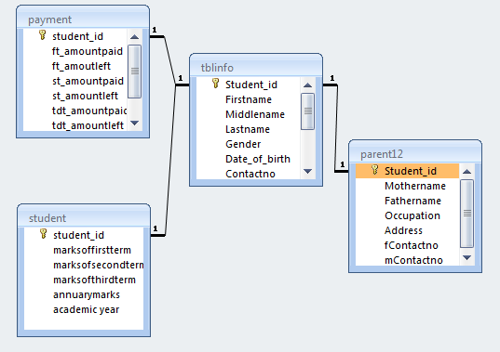

Figure 1: Relational Data Model

### IV.2.2 LOGICAL MODEL OF DATA (LMD)

The LMD represents the database architecture. In normal way of implementing a database, the LMD is obtained using the CMD and it is LMD which is implemented to have the database.

The LMD tries to describe in details the data of given by the CMD but it does not precise how the data will be physically implemented in the database.

Some concepts and rules followed when designing LMD:

In the LMD, the object of the CMD always becomes at a tables;

The relationship can also becomes a table certain cases;

The identifier of the CMD always becomes a primary key;

The foreign key is the parent table primary key inherited by the child table

**LMD**

STUDENT (student_id, marksoffirstterm, marksofsecondterm, marksofthirdterm, annuarymarks, academicyear)

PARENT (student_id#, motherame, fathername, occupation, Address, fcontactno, mcontactno)

PAYMENT (student_id#, ft_amountpaid, ft_amountleft, st_amountpaid, st_amountleft, tdt_amountpaid, tdt_amountleft, total credit, academic year)

USERTB (username, password user, function user, nameofuser)

TABLE_INFO(student_id ,Firstname, Middlename,Lastname ,Gender , Date_of_birth , Contact no , residence ,district ,province ,option ,class)

### 

### III.2.3 CONCEPTUAL MODEL DATA (CMD)

### III.2.3 .1 CMD

### It is a level of indicator between external and internal.

The MERISE method uses CMD model in order to obtain a diagram of a database. The CMD model helps to describe the information used by an organization.

In order words, the conceptual model data builds up a global description of data that are processed within the organization, all documents, and actors indeed.

Basic concepts of conceptual model data are:

**III.2.3.2** **Entity**

An entity is a person, thing, place or concept about which data can be collected. Examples include STUDENT, PARENT12, USERTB, PAYMENT, TABLE_BLINFO.

**III.2.3 .3** **Attribute**

Attributes represents information to describe entities. An attribute can be a property, a field or entity information .each entity should have at least one identifier that will be specific attribute and the value of that identifier corresponds only to one occurrence of the targeted entity. During the conception of database tables, the identifier stand for primary key and the primary key should be placed at the first place within the entity and underlined.

**III.2.3 .4** **Occurrences**

An occurrence is an individualized object of the specific object.

**III.2.3 .5Identifier**

it is a particular property of any given entity that identifies one and only one occurrence of that

===============================DRAW======================

**IV.2.3 DATA DICTIONARY**

|  |  |  |  |
| --- | --- | --- | --- |
| **FIELD NAME** | **DESCRIPTION** | **TYPE** | **CONSTRAINTS** |
| Student _id | Customer number | Number | Primary key |
| firstname | First name | Text | Not null |
| Middle name | Last name | Text | Not null |
| lastname | Province | Text | Not null |
| gender | Sex | Text | Not null |
| Date_of_birth | Dob | Date | Not null |
| contractno | Phone number | Number | Notnull |
| Present_address | Residence | Text | Not null |
| City_address | District | Text | Not null |
| Provincial_address | Province | Text | Not null |
| option | Option | Text | Not null |
| Class | Cantract duration | Text | notnull |
| Student_id | Student number | Number | Foreign key |
| mothername | Mother name | Text | notnull |
| fathername | Father name | Text | notnull |
| occupation | Position | Text | notnull |
| address | Location | Text | notnull |
| fcontactno | Father phone number | Number | notnull |
| mcontactno | Mother phone number | Number | notnull |
| Student_id | Student number | Number | Foreign key |
| Ft_amountpaid | First term amount paid | Number | notnull |
| Ft_amountleft | First term amount left | Number | notnull |
| St_amountpaid | Second term amount paid | Number | Notnull |
| St_amountleft | Second term amount left | Number | Notnull |
| Tdt_amountpaid | Third term amount paid | Number | Notnull |
| Tdt_amountleft | Third term amount left | Number | Notnull |
| totalcredit | Annual amount credoit | Number | Notnull |
| academicyear | Academic year | Number | Notnull |
| Student_id | Student number | Number | Foreign key |
| Marksoffirstterm | First term marks | Number | Notnull |
| Marksofsecondterm | Second term marks | Number | Notnull |
| Marksofthirdterm | Third term marks | Number | Notnull |
| annuarymarks | Annual marks | Number | Notnull |
| academicyear | Academic year | Number | Notnull |

Table 1: Data dictionary

# IV.3 PRESENTATION OF SOFTWARE INTERFACE

**3.1.LOGIN PAGE**

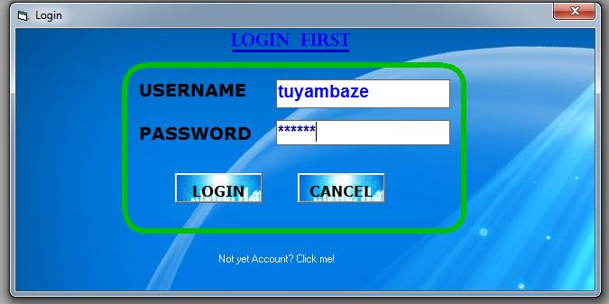

Figure 2: Login page

**2.Main Menu form**

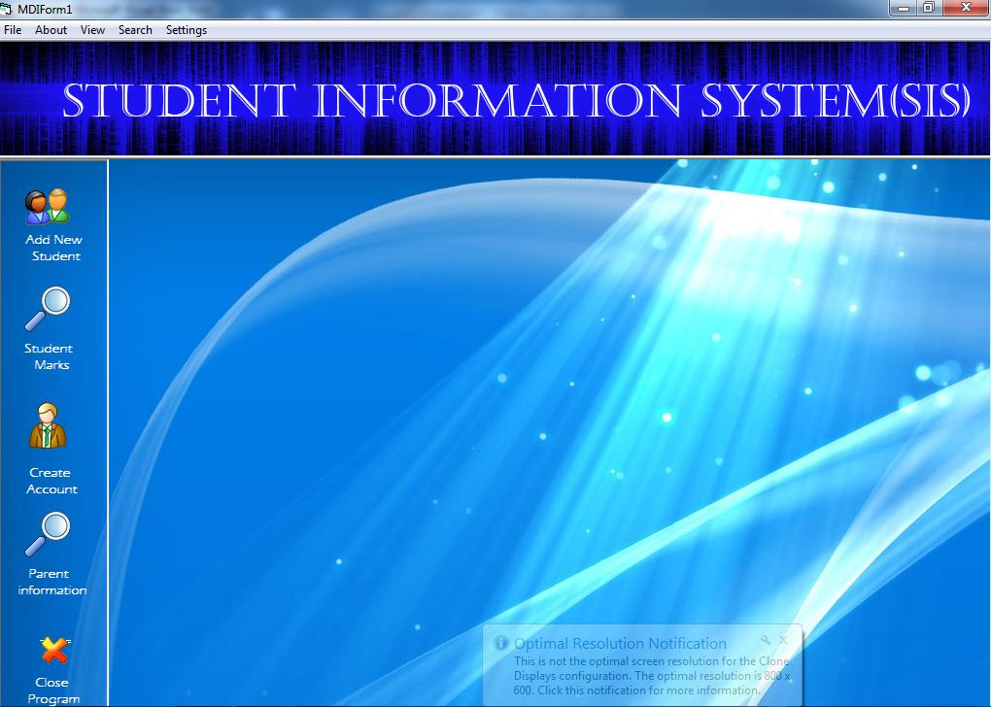

Figure 3: Main Menu Presentation form

**3.Student recording form**

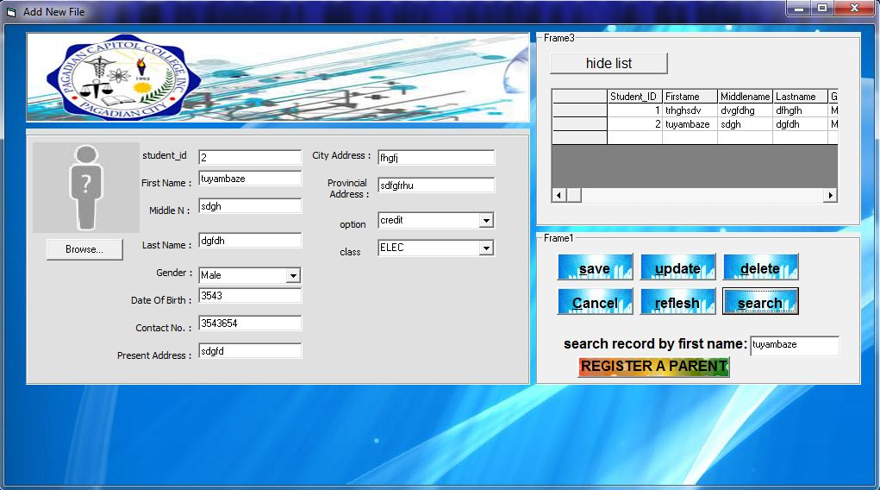

Figure 4**:Student Recording Presentation form**

**4.Parent recording form**

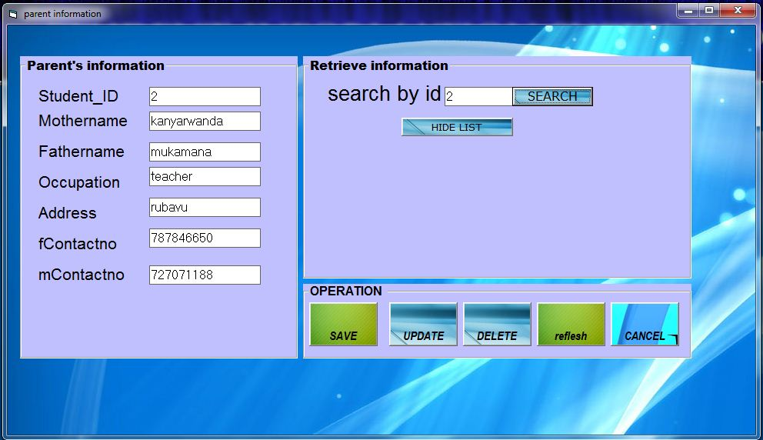

Figure 5: Parent Recording Presentation form

**5.Student marks form**

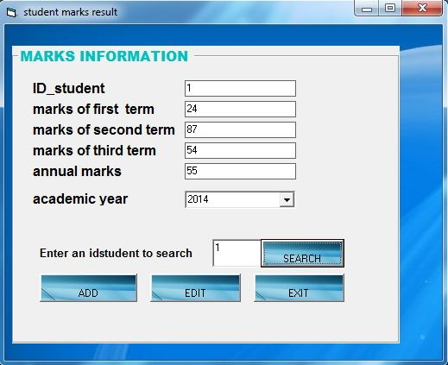

Figure 6: student marks view form

**Student payment form**

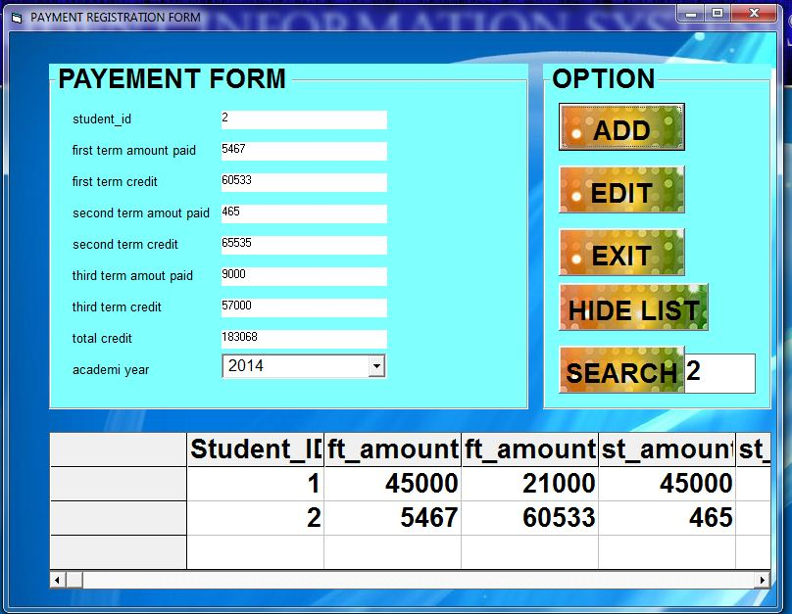

Figure 7: student payment form

**6.Create user form**

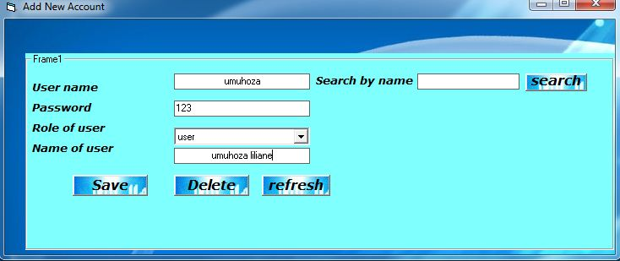

Figure 8: Create user account Presentation form

**7.Modify your account form**

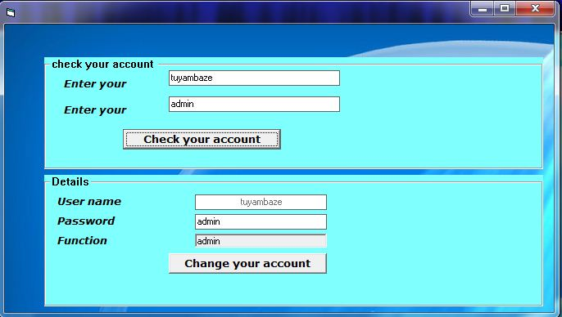

Figure 9: modify your account Presentation form

## 

## IV.4 REQUIREMENT OF SOFTWARE

To get the special software which will function and which will solve my problems at hundred percent I need tools which are very important:

1. Visual Basic as programming language
2. Microsoft office Access as Database.
3. Adobe Photoshop to design images used

CHAP.V: CONCLUSION AND RECOMMENDATION

## V.1: CONCLUSION

As conclusion, We wish to inform all the persons concerned to support this project in other to be implanted within the system for facilitating the controlling and to delivery the efficiency and effective service and to procure also other advantage that the manually system doesn’t have.

## 

## V.2: RECOMMENDATION

We are happy to recommend the administration of this school to follow up my project, and make the necessary adjustment in order to run it and to accomplish the task that is supposed to do and we recommend other young students to continuous to make further research about this subject for increasing the functionality.

We recommend that :

## To WDA

* To include a courses of Research and Projects management in the courses learnt in senior six to allow students to be able to prepare projects them self.
* To provide a training to supervisors teachers so that they can help us in different project activities.

## To ESTG

* To continue the training they provide to students in technical options
* To prepare students for the action of project implementation since the first term.
* To increase the knowledge for the supervisor

**REFERENCES AND BIBLIOGRAPHY**

# BIBLIOGRAPHY

# Christian GROSS, Beginning vb 2008

Steven HOLZNER, Visual Basic 6 programming

VB and DB’s class notes

# ELECTRONIC REFERENCE

1. [www.wikepedia.vb_.vbnet](http://www.wikepedia.vb_.vbnet)
2. [www.commentcamarche.com](http://www.commentcamarche.com)
3. <http://en.wikipedia.org/wiki/Data_flow_diagram>