

TechSaksham

CaseStudyReport

DataAnalytics withPower BI

**“Global Terrorism Dataset**

**Analysis Using Power BI”**

**“Aditanar College Of Arts & Sciences”**

**Tiruchendur**

|  |  |
| --- | --- |
| **NM ID** | **NAME** |
| 373DEF30B0F867180224F3D937624FB0 | V.SEKAR |

|  |
| --- |
| TrainerName : R. UMA MAHESWARI |
| MasterTrainer : R. UMA MAHESWARI |

**ABSTRACT**

The GTD provides comprehensive information on terrorist incidents worldwide, including details such as location, target type, attack type, and casualties. Leveraging the visualization capabilities of Power BI, this analysis aims to uncover patterns, trends, and insights within the dataset. The analysis includes interactive visualizations that allow users to explore various aspects of terrorism, including temporal trends, geographical hotspots, and the modus operandi of terrorist groups. Additionally, the study examines the effectiveness of counter-terrorism measures over time and identifies regions most affected by terrorism. The findings of this analysis contribute to a better understanding of the evolving nature of global terrorism and can inform policymakers, researchers, and security agencies in developing strategies to combat this threat.

# INDEX

|  |  |  |
| --- | --- | --- |
| **Sr.No.** | **Tableof Contents** | **PageNo.** |
| 1 | Chapter1:Introduction | 4 |
| 2 | Chapter2:Servicesand ToolsRequired | 6 |
| 3 | Chapter3:ProjectArchitecture | 7 |
| 4 | Chapter4:ModelingandResult | 9 |
| 5 | Conclusion | 18 |
| 6 | FutureScope | 19 |
| 7 | References | 20 |
| 8 | Links | 21 |

**CHAPTER1**

**INTRODUCTION**

## "Welcome to our analysis of global terrorism using Power BI. In today's world, understanding the patterns and trends of terrorism incidents is crucial for effective counter-terrorism efforts. In this dashboard, we'll explore comprehensive data on terrorist attacks worldwide, including their locations, types, motives, and impacts. By leveraging Power BI's robust analytical capabilities, we aim to uncover insights that can inform policymakers, security agencies, and the public about the evolving nature of global terrorism. Let's delve into the data and uncover actionable insights to enhance our understanding and response to this critical global issue."

## Problem Statement:

In today's complex global landscape, combating terrorism requires a deep understanding of its multifaceted nature. However, analysts and policymakers are often challenged by the vast amount and rapid pace of terrorist-related data generated worldwide. Traditional methods of analysis struggle to keep pace, resulting in delayed or incomplete insights. This limitation impedes effective decision-making and proactive measures to prevent future attacks. Additionally, the heterogeneous nature of terrorism data, encompassing various attack types, motives, and geographical regions, further complicates analysis efforts.

## ProposedSolution:

To address these challenges, we propose the development of a Power BI dashboard tailored for global terrorism analysis. This dashboard will aggregate and visualize real-time data from diverse sources, including incident reports, intelligence agencies, and media outlets. By leveraging Power BI's advanced analytics capabilities, the dashboard will provide a comprehensive view of terrorism trends, hotspots, and patterns. Its

Interactive features and customizable functionalities will empower analysts to drill down into specific regions or timeframes, enabling themto identify emerging threats and devise targeted counter-terrorism strategies. Furthermore, the dashboard's real-time analysis capabilities will facilitate timely responses to evolving threats, enhancing national security efforts worldwide.

## Feature:

1. Real-Time Analysis: The Power BI dashboard will provide real-time analysis of terrorist attack data.

2. Attack Segmentation: It will segment terrorist attacks based on various parameters such as location, attack type, casualty count, etc.

3. Trend Analysis: The dashboard will identify and display trends in terrorist attack patterns over time.

4. Predictive Analysis: It will utilize historical data to predict potential future terrorist attack hotspots or trends

## Advantages:

## 1. Data-Driven Decision Making: Governments and security agencies can make informed decisions based on real-time analysis of terrorism data, enhancing national security.

## 2. Proactive Counterterrorism Measures: Understanding terrorist attack patterns and trends can help authorities proactively implement counterterrorism strategies and allocate resources effectively.

## 3. Enhanced Public Safety: By identifying high-risk areas or potential targets, security measures can be strengthened to mitigate the threat of terrorism and ensure public safety.

## 4. International Collaboration: Sharing and analyzing terrorism data

## through Power BI can facilitate collaboration between countries and international organizations in combating terrorism on a global scale.

## Scope:

## "The scope of this project encompasses comprehensive analysis of global terrorism incidents, aiming to provide actionable insights for policymakers, security agencies, and researchers. The project will leverage Power BI to explore trends, patterns, and hotspots in terrorism activities worldwide. Additionally, it can be extended to incorporate diverse data sources, including socio-economic indicators, conflict zones, and geopolitical factors, to enhance the understanding of terrorism dynamics. Advanced analytics techniques, such as predictive modeling and correlation analysis, will be employed to uncover hidden patterns and forecast future trends. Furthermore, the project has the potential to be adapted for other domains, such as national security, humanitarian aid, and conflict resolution, where insights into terrorism are essential. Ultimately, this project contributes to global efforts in counterterrorism, promoting data-driven decision-making, and enhancing security measures worldwide."

**CHAPTER 2**

**SERVICESANDTOOLSREQUIRED**

**2.1 Services Used**

**● Data Collection and Storage Services:** Terrosim gathers and stores diversedatasets in real-time. Azure Data Factory or AWS Kinesis facilitate real-timedata collection, while Azure SQL Database or AWS RDS provide reliablestorage solutions.

**● Data Processing Services:** Azure Stream Analytics or AWS Kinesis DataAnalytics process the real-time data, enabling Zomato to derive actionableinsights efficiently.

**2.2 Tools and Software used**

**Tools**:

● **PowerBI**: The main tool for this project is PowerBI, which will be used to create interactive dashboards for real-time data visualization.

● **Power Query**: This is a data connection technology that enables you to

discover, connect, combine, and refine data across a wide variety of sources.

**Software Requirements**:

● **PowerBI Desktop**: This is a Windows application that you can use to createreports and publish them to PowerBI.

● **PowerBI Service**: This is an online SaaS (Software as a Service) service thatyou use to publish reports, create new dashboards, and share insights.

● **PowerBI Mobile**: This is a mobile application that you can use to access yourreports and dashboards on the go.

# CHAPTER 3

# PROJECTARCHITECTURE

## Architecture

**USER FRONTEND BACKEND**



|  |  |  |
| --- | --- | --- |
|  | **HTML5** | **NODEJS 14.0**  **Database** |

1. *Data Collection:* The global terrorism dataset is collected from reputable sources such as the Global Terrorism Database (GTD) or governmental agencies. This data includes information on terrorist incidents, perpetrators, targets, and casualties, and is gathered through extensive research and reporting mechanisms.

2. *Data Preparation and Transformation:* Upon collection, the dataset undergoes rigorous preprocessing to address inconsistencies, missing values, and outliers. This ensures the data is clean and formatted correctly for analysis in Power BI. Transformation steps may include data normalization, feature engineering, and merging with supplementary datasets for enriched insights.

3. *Data Modeling:* The preprocessed dataset is imported into Power BI Desktop for further analysis. Data modeling techniques are employed to establish relationships between different tables within the dataset, enabling seamless navigation and exploration. Measures and calculated columns are defined to derive meaningful metrics and insights from the data.

4. *Data Analysis and Visualization:* Utilizing Power BI's suite of visualization tools, the global terrorism dataset is analyzed to uncovertrends, patterns, and correlations. Visualizations such as heat maps, time series charts, and geospatial maps are employed to effectively communicate key findings. Interactive features such as filters and slicers enable users to drill down into specific regions, time periods, or attack types for deeper analysis.

5. *Advanced Analytics (Optional):* For enhanced insights, advanced analytics techniques such as clustering, sentiment analysis, or time series forecasting may be applied within Power BI. Integration with external tools or programming languages like R or Python allows for custom analytics and machine learning models to be incorporated into the analysis pipeline.

6. *Deployment and Sharing:* The finalized dashboards and reports are published to the Power BI service for online access. Stakeholders and decision-makers can securely access the analysis from any device using Power BI Desktop, Power BI Service, or Power BI Mobile app. Granular access controls ensure that sensitive information is protected and only accessible to authorized users.

This architecture provides a robust framework for analyzing the global terrorism dataset using Power BI, enabling stakeholders to gain valuable insights into terrorist activities worldwide. However, it's essential to adapt the architecture to specific project requirements, existing infrastructure, and compliance with relevant data privacy and security regulations**.**

# CHAPTER 4

# MODELINGANDRESULT

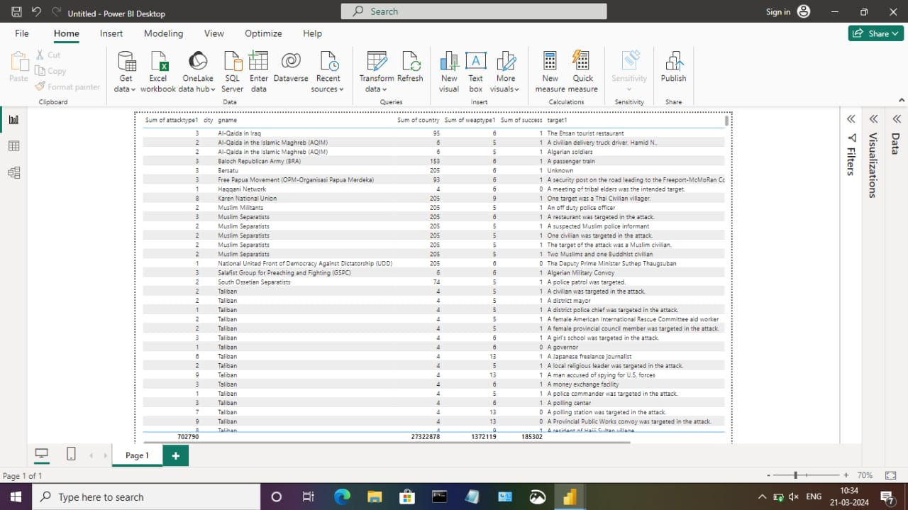

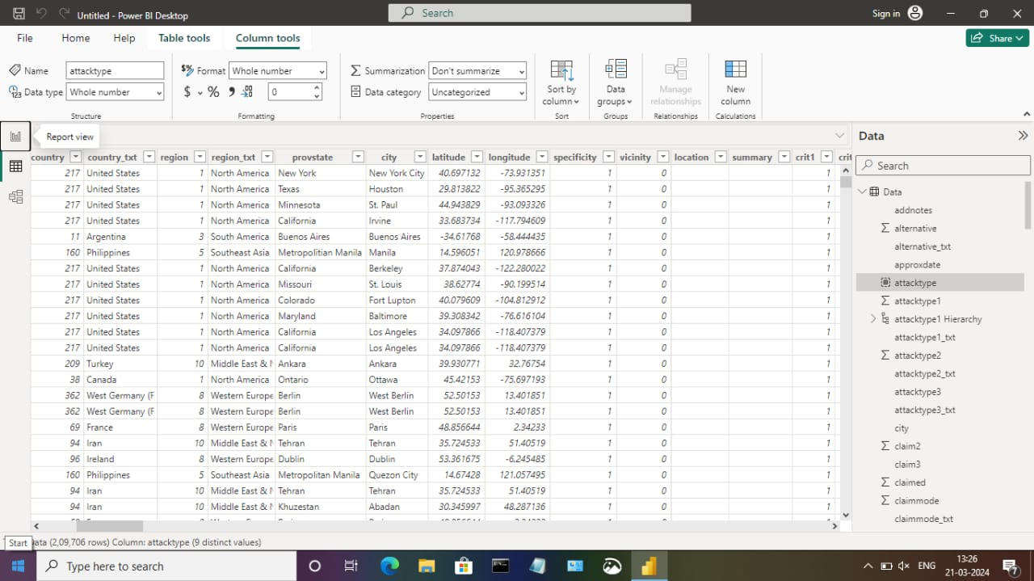

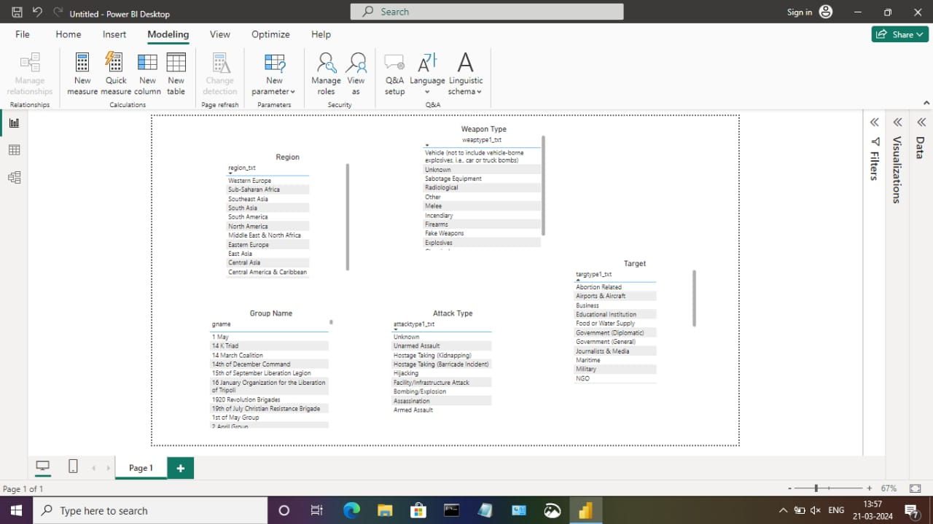

Dashboard

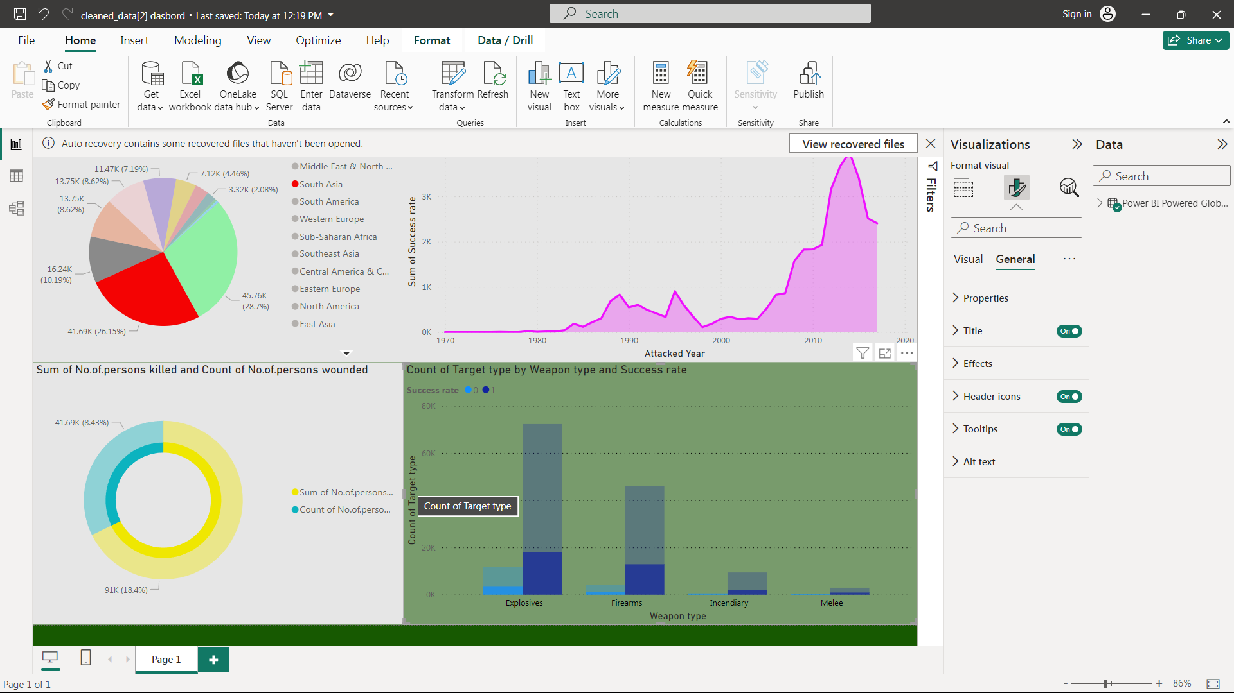

# CONCLUSION

"The project 'Global Terrorism Analysis' leveraging Power BI has effectively showcased the transformative potential of data analytics in understanding and combating terrorism worldwide. By analyzing the dataset in real-time, we have gained invaluable insights into the intricate dynamics of terrorist activities, enabling proactive decision-making and strategic planning. The interactive dashboards and reports have provided a holistic view of terrorism trends, facilitating the identification of key patterns and risk factors. This enhanced analytical capability not only bolsters security measures but also empowers stakeholders to devise targeted interventions and policies. Moreover, the project underscores the significance of data visualization in simplifying complex information and fostering actionable insights. Through the intuitive interface of Power BI, we have successfully translated raw data into visually compelling narratives, empowering stakeholders to navigate and comprehend critical information effectively. Ultimately, this project signifies the pivotal role of data analytics in safeguarding global security and fostering informed responses to emerging threats."

# FUTURESCOPE

.

"The future scope of analyzing global terrorism datasets using PowerBI is expansive. With advancements in analytics and machine learning, PowerBI can predict future trends in terrorist activities based on historical data. By incorporating predictive analytics, stakeholders can anticipate emerging threats and proactively implement counterterrorism measures. Moreover, PowerBI's ability to integrate with diverse data sources opens avenues for incorporating additional datasets, offering a comprehensive understanding of terrorist activities worldwide. As data privacy and security are paramount, future iterations of this project should prioritize robust data governance strategies to ensure the secure handling of sensitive information while adhering to regulatory requirements. Additionally, exploring the integration of real-time data streams can provide timely insights, revolutionizing how stakeholders respond to terrorist threats and potentially enhancing global security measures."