|  |  |  |  |  |  |  |
| --- | --- | --- | --- | --- | --- | --- |
|  |  |  |  |  |  |  |
|  |  |  |  |  |  |  |
|  |  |  |  |  |  |  |
|  |  |  |  | A |  |  |
|  |  |  |  |  |  |  |
|  |  | B |  |  |  |  |
|  |  |  |  |  |  |  |

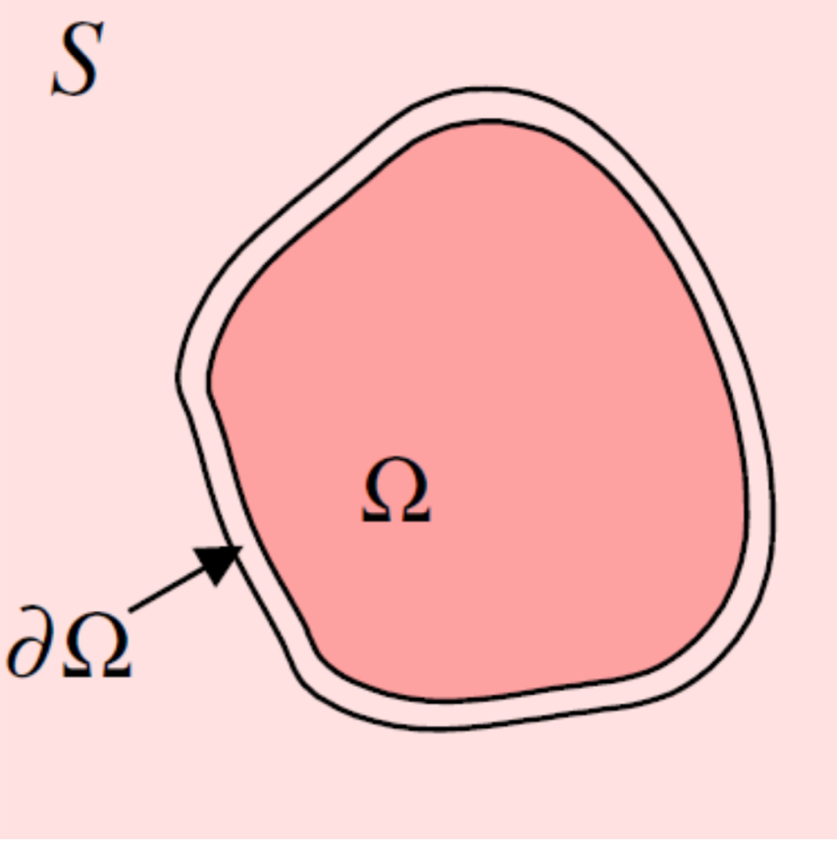

Source image *S(x,y)*

Target image *T(x,y)*

Target