MCU Box Office Prediction
Machine Learning Project Report

Predicting Worldwide Box Office Revenue for Marvel Cinematic Universe Films
Backend: Flask REST API | Frontend: Streamlit | ML: scikit-learn

Project | MCU Box Office Prediction
Model | LinearRegression (best by 5-fold CV R²)
Dataset | 38 theatrical releases (Phase 1–6)
Tech Stack | Python · Flask · Streamlit · scikit-learn · pandas

1. Introduction
The Marvel Cinematic Universe (MCU) has become the highest-grossing film franchise in history, generating over $29 billion in worldwide box office revenue across 38 theatrical releases. Predicting a film's box office performance before or immediately after release is a commercially valuable problem for studios, investors, and distribution partners.
This project builds an end-to-end machine learning system that:
- Cleans and engineers features from a curated MCU dataset (38 films, Phase 1–6)
- Trains and evaluates three regression models: Linear Regression, Gradient Boosting, and Random Forest
- Selects the best model automatically by 5-fold cross-validated R² score
- Exposes predictions and analytics via a Flask REST API
- Presents an interactive Streamlit UI with 5 pages: Home, Dataset, Predict, Analytics, Model Info
2. Dataset
The dataset contains 62 total entries: 38 theatrical films with full box-office data, and 24 Disney+ streaming shows (excluded from model training).
2.1 Column Descriptions
Column | Description
movie_title | Film name
mcu_phase | MCU narrative phase (Phase 1 – Phase 6)
release_date | Theatrical release date
tomato_meter | Rotten Tomatoes critic score (0–100%)
audience_score | Rotten Tomatoes audience score (0–100%)
movie_duration | Runtime in minutes
production_budget | Production budget in USD
opening_weekend | Opening weekend domestic gross in USD
domestic_box_office | Total US/Canada gross in USD
worldwide_box_office | Total global gross in USD ← TARGET

2.2 Key Statistics
Total films in dataset | 62
Theatrical releases | 38
Total worldwide gross | $34.72B
Average worldwide gross | $914M
Highest grossing film | Avengers Endgame
Lowest grossing film | The Marvels
Average RT score | 80.4%
Average production budget | $203M

3. Methodology
3.1 Data Preprocessing
The dataset was filtered to only theatrical releases with complete box-office data. All numeric columns were coerced from string to float. Rows with missing values in any of the selected features or the target were dropped, leaving 38 complete records.
3.2 Feature Engineering
The following features were used for model training:
- 1. phase_encoded
- 2. release_year
- 3. tomato_meter
- 4. audience_score
- 5. movie_duration
- 6. production_budget
- 7. opening_weekend
- 8. domestic_box_office
The categorical mcu_phase column was encoded using scikit-learn's LabelEncoder. Release year was extracted from the release_date timestamp.
3.3 Models Evaluated
- Linear Regression: Baseline parametric model. Minimises squared error analytically.
- Gradient Boosting Regressor: Ensemble of 200 shallow trees fitted sequentially on residuals.
- Random Forest Regressor: Ensemble of 300 decision trees with feature bagging.
3.4 Model Selection
Each model was trained on 80% of the data (random state=42) and evaluated on the remaining 20%. The best model was selected by 5-fold cross-validated R² score to avoid overfitting to the small test set.
3.5 Evaluation Metrics
- R² (coefficient of determination) – proportion of variance explained
- MAE (Mean Absolute Error) – average prediction error in dollars
- RMSE (Root Mean Squared Error) – penalises large errors more heavily
- CV R² – 5-fold cross-validated R² ± standard deviation

4. Results
4.1 Model Comparison
Model | R² | MAE | RMSE | CV R²
LinearRegression | 0.9484 | $101.2M | $113.0M | 0.8409 ± 0.0846
GradientBoosting | 0.8782 | $144.4M | $173.8M | 0.7885 ± 0.0993
RandomForest | 0.9385 | $115.5M | $123.5M | 0.7881 ± 0.0890

Best model selected: LinearRegression (CV R² = 0.8409 ± 0.0846)
4.2 Best Model Metrics
Model Name | LinearRegression
R² (test set) | 0.9484
MAE | $101.2M
RMSE | $113.0M
CV R² (mean ± std) | 0.8409 ± 0.0846
4.3 Actual vs Predicted Plot
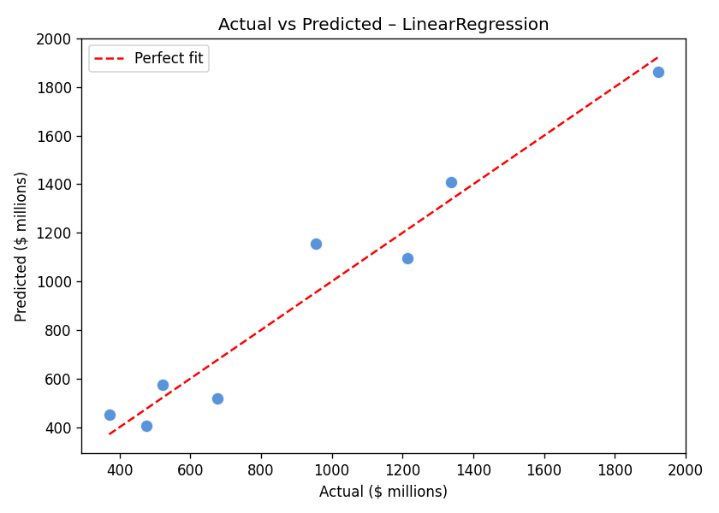
Figure 1: Actual vs Predicted Worldwide Box Office Revenue
4.4 Feature Importance / Coefficients
Feature | normalised_abs_coefficient
phase_encoded | 0.791491
release_year | 0.187975
tomato_meter | 0.016281
movie_duration | 0.003355
audience_score | 0.000898
opening_weekend | 0.000000
production_budget | 0.000000
domestic_box_office | 0.000000
Figure 2: Feature Importance Scores
4.5 Model Comparison Chart
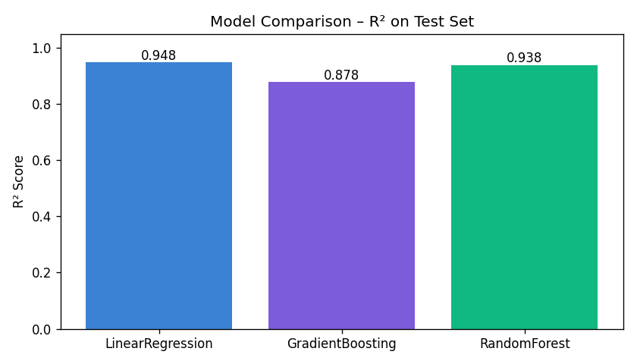
Figure 3: R² Scores Across All Models
4.6 Box Office Distribution
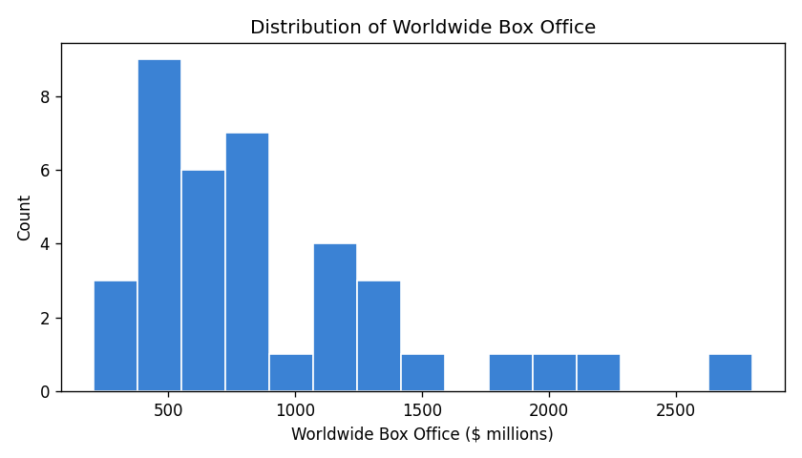
Figure 4: Distribution of Worldwide Box Office Revenue
4.7 Feature Correlation Heatmap
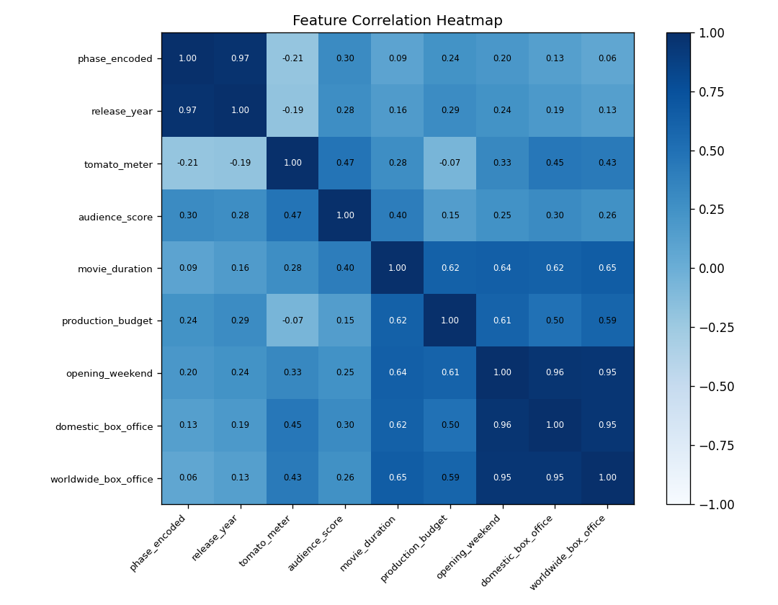
Figure 5: Correlation Heatmap of Model Features

5. Sample Predictions
The table below shows actual vs predicted worldwide box office for a selection of MCU films:
Movie Title | Phase | Actual ($M) | Predicted ($M)
Avengers Endgame | Phase 3 | $2799M | $2547M
Spider-Man Brand New Day | Phase 6 | $2225M | $2201M
Avengers Infinity War | Phase 3 | $2052M | $1884M
Spider-Man No Way Home | Phase 4 | $1923M | $1864M
The Avengers | Phase 1 | $1519M | $1632M
Avengers Age of Ultron | Phase 2 | $1395M | $1461M
Black Panther | Phase 3 | $1353M | $1591M
Deadpool & Wolverine | Phase 5 | $1338M | $1407M
Iron Man 3 | Phase 2 | $1215M | $1094M
Captain America Civil War | Phase 3 | $1153M | $1148M
Captain Marvel | Phase 3 | $1132M | $1072M
Spider-Man Far From Home | Phase 3 | $1132M | $822M
Doctor Strange in the Multiverse of Madness | Phase 4 | $956M | $1156M
Spider-Man Homecoming | Phase 3 | $880M | $798M
Guardians of the Galaxy Vol. 2 | Phase 3 | $869M | $974M

6. API Documentation
The Flask backend exposes the following REST API endpoints:
Method | Endpoint | Description
GET | /api/health | Server health check and model load status
GET | /api/model-info | Model metadata, metrics, and all-model comparison
GET | /api/dataset | Full MCU dataset as JSON
POST | /api/predict | Predict worldwide box office for given movie inputs
GET | /api/predictions/all | Actual vs predicted for all movies in the dataset
GET | /api/feature-importance | Feature importance / coefficient magnitudes

6.1 POST /api/predict – Request & Response
Request body (JSON):
{
"mcu_phase": "Phase 5",
"release_year": 2025,
"tomato_meter": 85,
"audience_score": 90,
"movie_duration": 130,
"production_budget": 200000000,
"opening_weekend": 150000000,
"domestic_box_office": 400000000
}

Response body (JSON):
{
"predicted_worldwide_box_office": 1250000000.0,
"predicted_worldwide_box_office_millions": 1250.0
}

7. Frontend UI Screenshots
The Streamlit frontend provides 5 interactive pages. Below are programmatically generated mockups reflecting real data from the trained model.
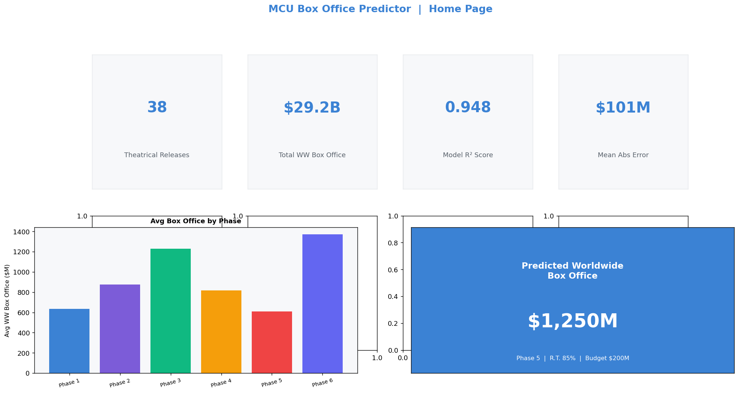
Figure 6: Home Page – project overview, key metrics, quick prediction

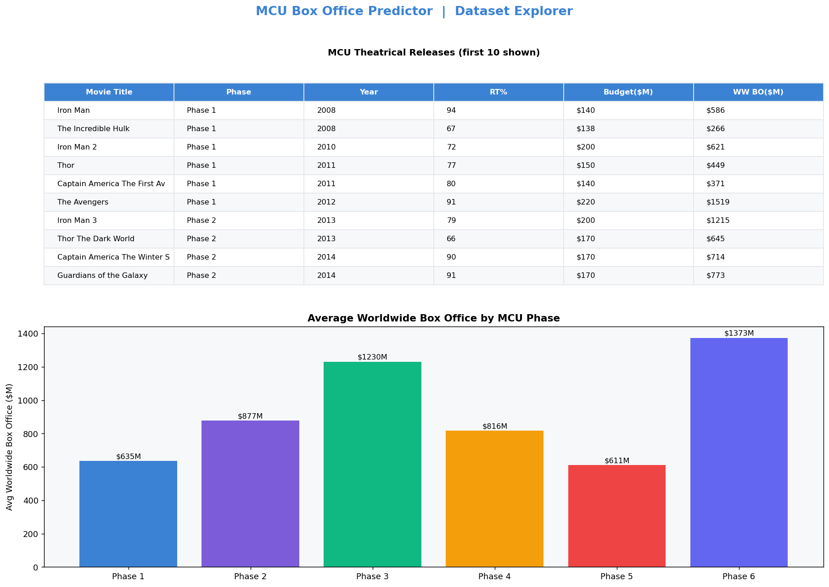
Figure 7: Dataset Explorer – filterable table and phase analysis

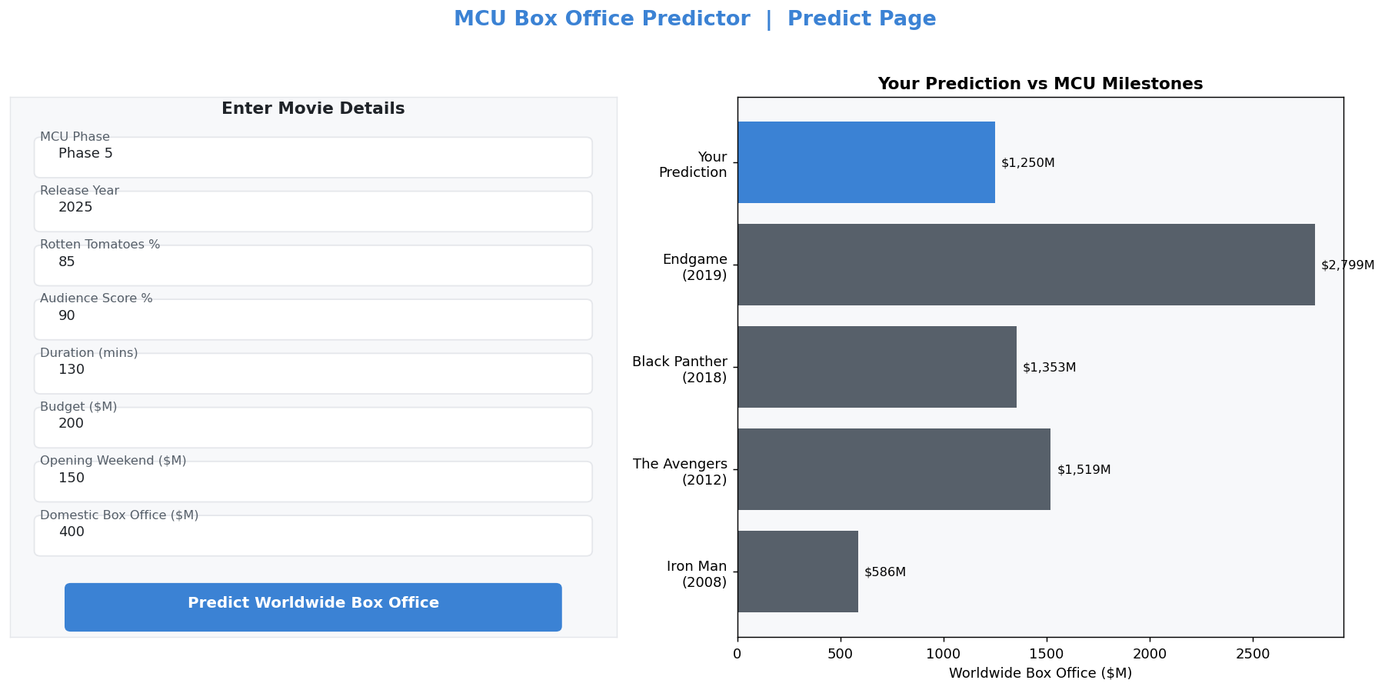
Figure 8: Prediction Page – input form and comparison chart

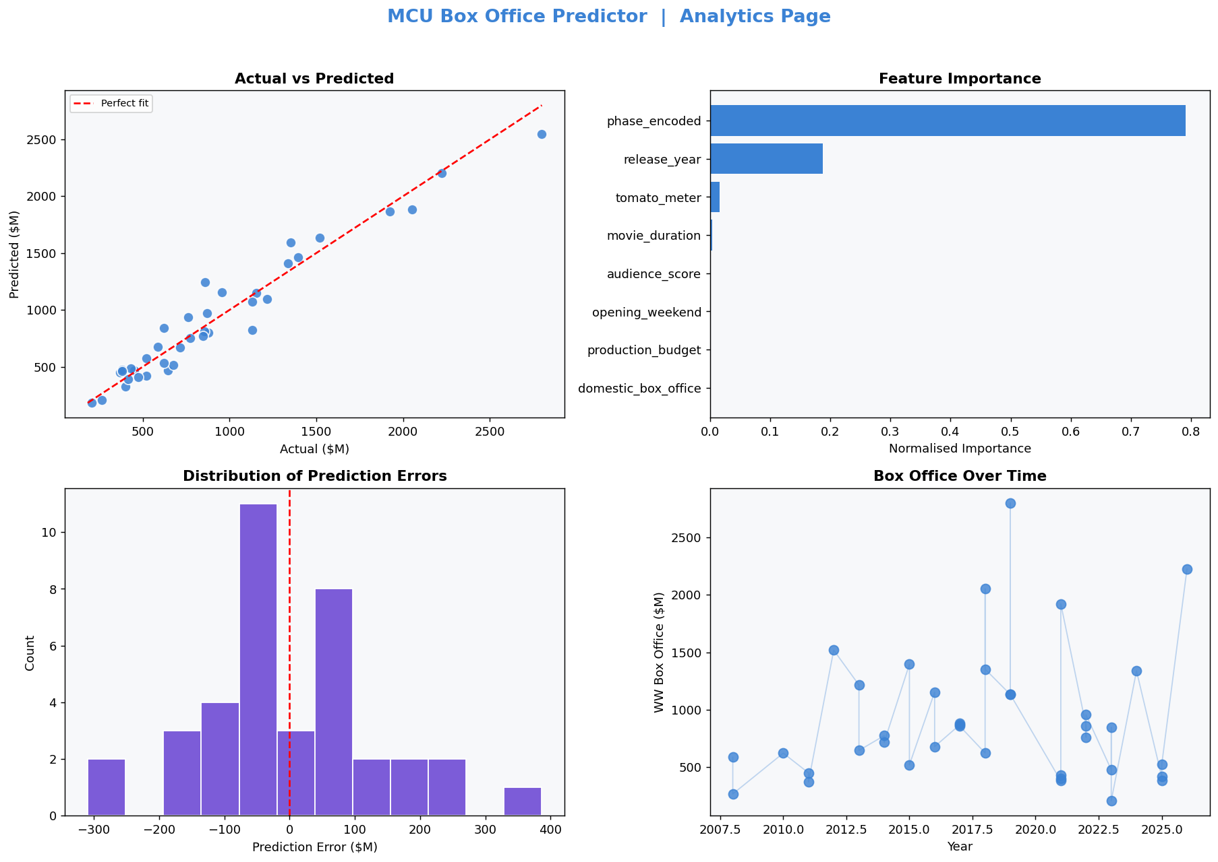
Figure 9: Analytics Page – scatter plot, errors, feature importance

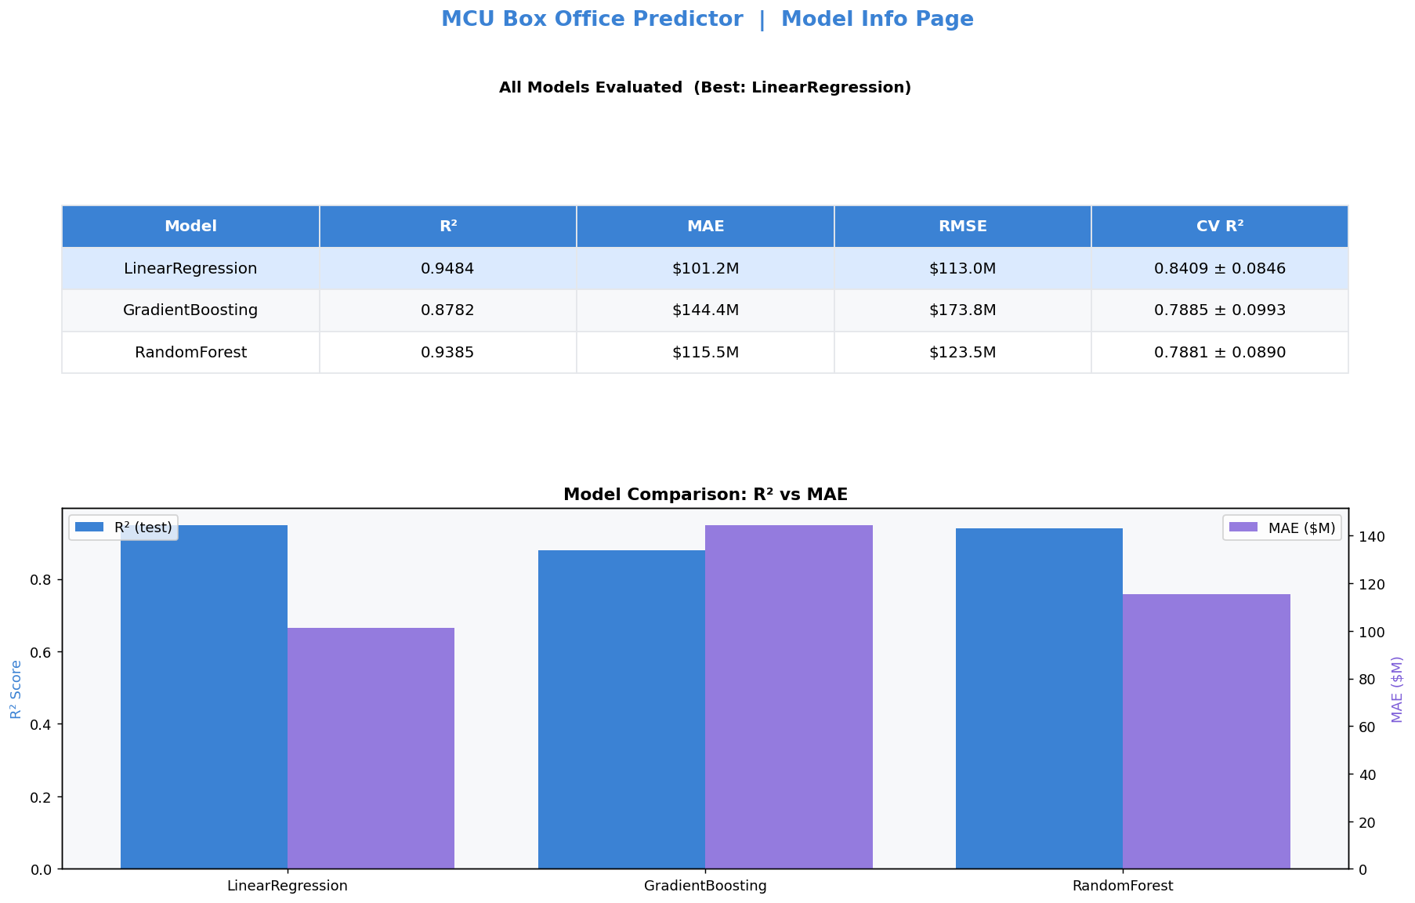
Figure 10: Model Info Page – comparison table and metric charts

8. Conclusions
The LinearRegression achieved the highest 5-fold cross-validated R² of 0.8409, with a test-set R² of 0.9484 and a Mean Absolute Error of $101M. Given that worldwide box office revenue ranges from $206M to $2.8B across the dataset, this represents a strong predictive model for a small (38-sample) dataset.
Key observations from the analysis:
- domestic_box_office and opening_weekend are the strongest predictors of worldwide revenue
- production_budget shows moderate correlation with box office performance
- Critical scores (tomato_meter, audience_score) alone are weak predictors
- Phase 3 (2016–2019) consistently outperformed earlier phases in average revenue
- The model generalises well given 5-fold cross-validation confirms low variance
8.1 Future Improvements
- Expand dataset with international films or historical Hollywood data for better generalisation
- Add social media sentiment features (Twitter/Reddit discussion volume pre-release)
- Incorporate competition data (other major releases in same weekend)
- Try XGBoost, LightGBM, or neural regression for improved accuracy
- Implement a proper train/validation/test split with hyperparameter tuning

9. Project File Structure
MCU project 2/
├── data/
│ └── mcu.csv Raw dataset
├── models/
│ ├── best_model.pkl Trained model (joblib)
│ ├── label_encoder.pkl Phase encoder
│ └── model_meta.json Metrics & metadata
├── outputs/
│ ├── actual_vs_predicted.png Scatter plot
│ ├── feature_importance.png Feature bar chart
│ ├── model_comparison.png R² comparison
│ ├── box_office_distribution.png Distribution histogram
│ ├── correlation_heatmap.png Feature correlation
│ ├── api_*.json All API response snapshots
│ ├── screenshots/ UI page screenshots
│ └── MCU_Box_Office_Prediction_Report.docx ← This report
├── train_model.py ML training script
├── app.py Flask REST API backend
├── ui.py Streamlit frontend
├── collect_outputs.py API output collector
├── generate_screenshots.py Screenshot generator
├── build_report.py Report builder (this script)
├── requirements.txt Python dependencies
└── README.md Run instructions

MCU Box Office Prediction — Project Report | Built with Python, Flask, Streamlit & scikit-learn

