**To get Server tab in Console:**

1.Goto Help -> Install new Software

2.Give address http://download.eclipse.org/releases/oxygen and name as your choice.

3.Search for Java EE and choose 1. Eclipse Java EE Developer Tools

4.Search for JST and choose 2.JST Server Adapters 3.JST Server Adapters Extensions

5.Click next and accept the license agreement.

Find the server option in the window-->preferences and add server as you need

How to configure tomcat server in Eclipse IDE

|  |
| --- |
| If you are using Eclipse IDE first time, you need to configure the tomcat server First. For configuring the tomcat server in eclipse IDE, click on servers tab at the bottom side of the IDE -> right click on blank area -> New -> Servers -> choose tomcat then its version -> next -> click on Browse button -> select the apache tomcat root folder previous to bin -> next -> addAll -> Finish. |

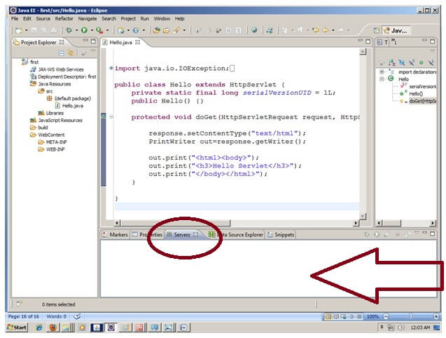

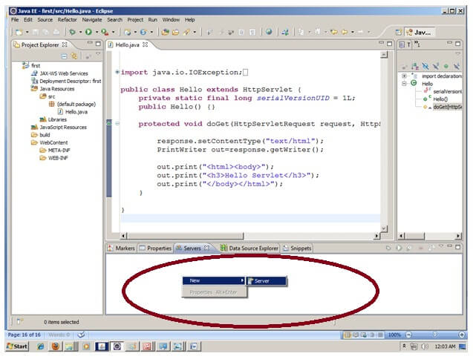

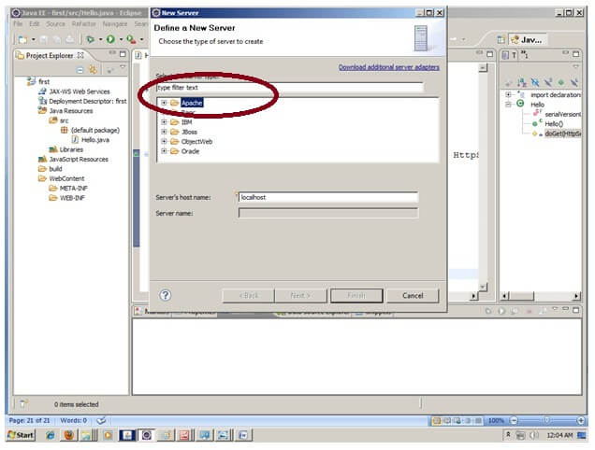

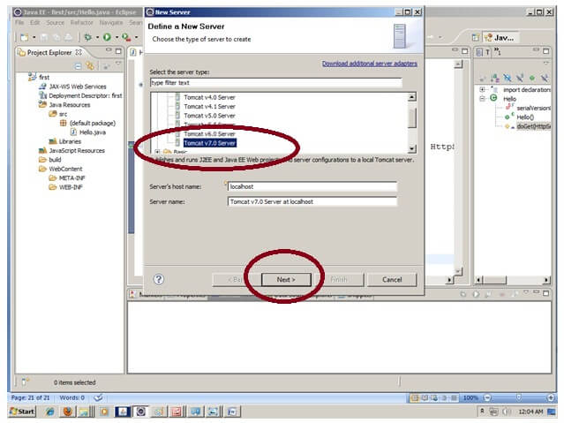

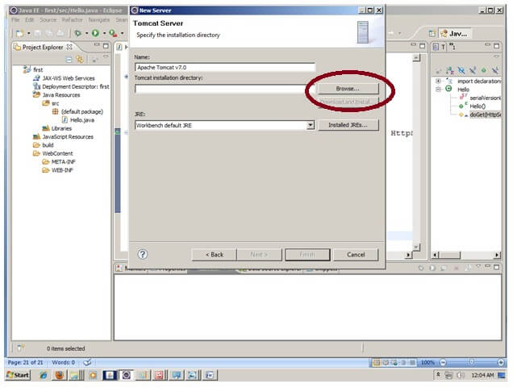

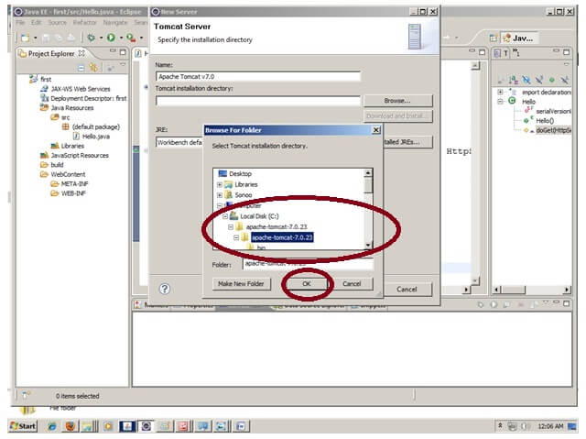

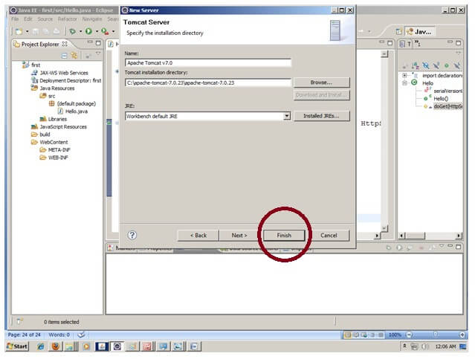

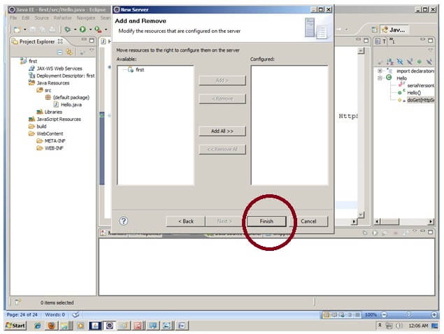

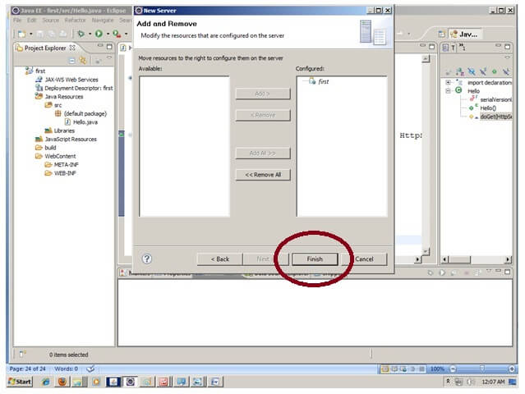

|  |
| --- |
| Now tomcat7 server has been configured in eclipse IDE. |

