**ID:2200030496**

**Name: V. Ganesh Balaji**

**Sec:21**

**Course: Cryptography and Security**

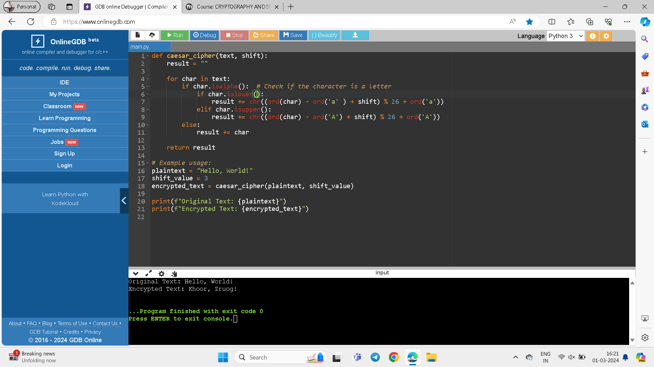

**Input:**

**plaintext = "Hello, World!"**

**shift_value = 3**

**output:**

**Original Text: Hello, World!**

**Encrypted Text: Khoor, Zruog!**