ASE - Lab Assignment2

Name : Adisekhar Raju Uppalapati

class Id : 55

mail Id : [auc2b@mail.umkc.edu](mailto:auc2b@mail.umkc.edu)

Partner Id : 54

Partner mail Id : [vtpr9@mail.umkc.edu](mailto:vtpr9@mail.umkc.edu)

Partner Name : venkata siva sai ram torlikonda

Part-1

Requirements: To create an android application which has following features

* Login and Registration activities using Realtime cloud storage services like firebase.
* Home activity should have Machine Learning api of our choice
* And should use any android built in features like camera etc.

Firebase authentication with android

* we have to create a project in console.google.firebase.com.
* we have to give android project package name to our firebase app and download google-services.json file and paste it in app level gradle file
* Add class path to project level gradle “classpath 'com.google.gms:google-services:4.0.1'”
* Add dependency and plugin “apply plugin: 'com.google.gms.google-services'”
* “implementation 'com.google.firebase:firebase-core:16.0.1'”

1.Login Activity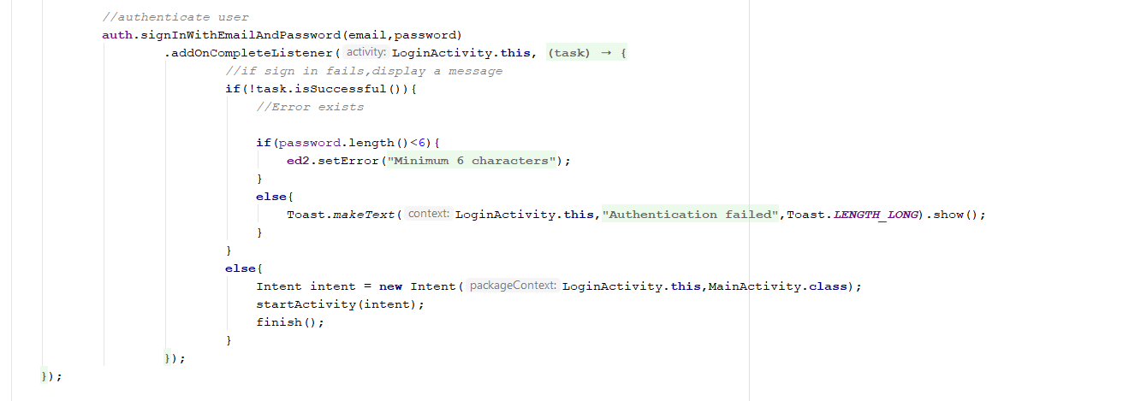

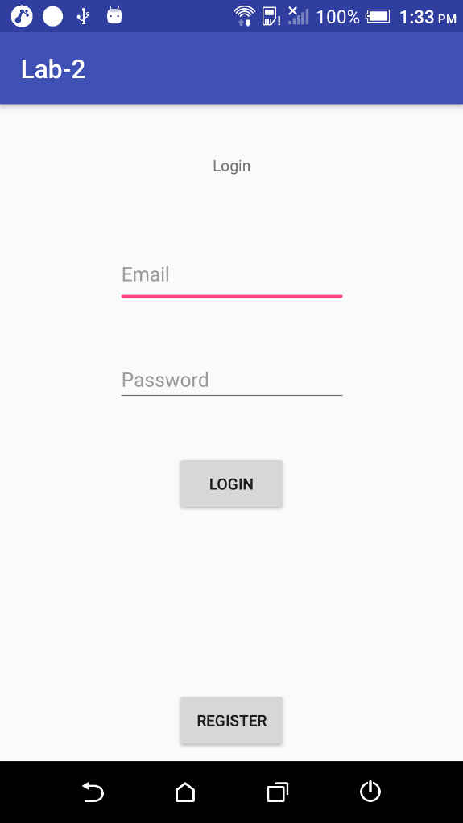

2.Registration Activity

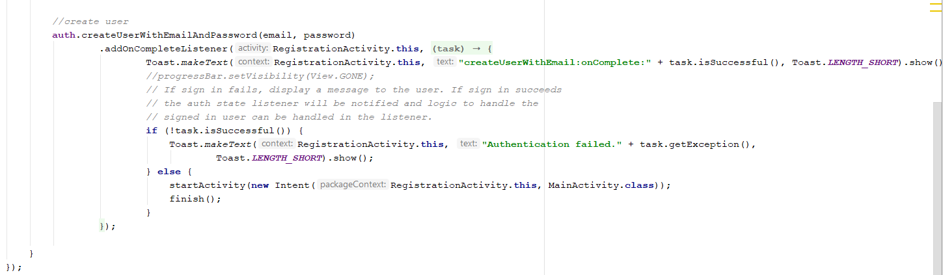

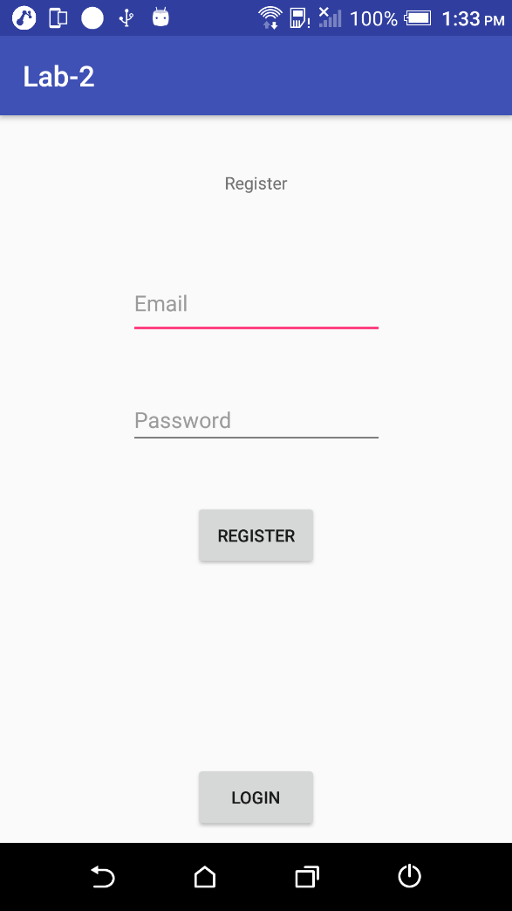

3.Home Activity

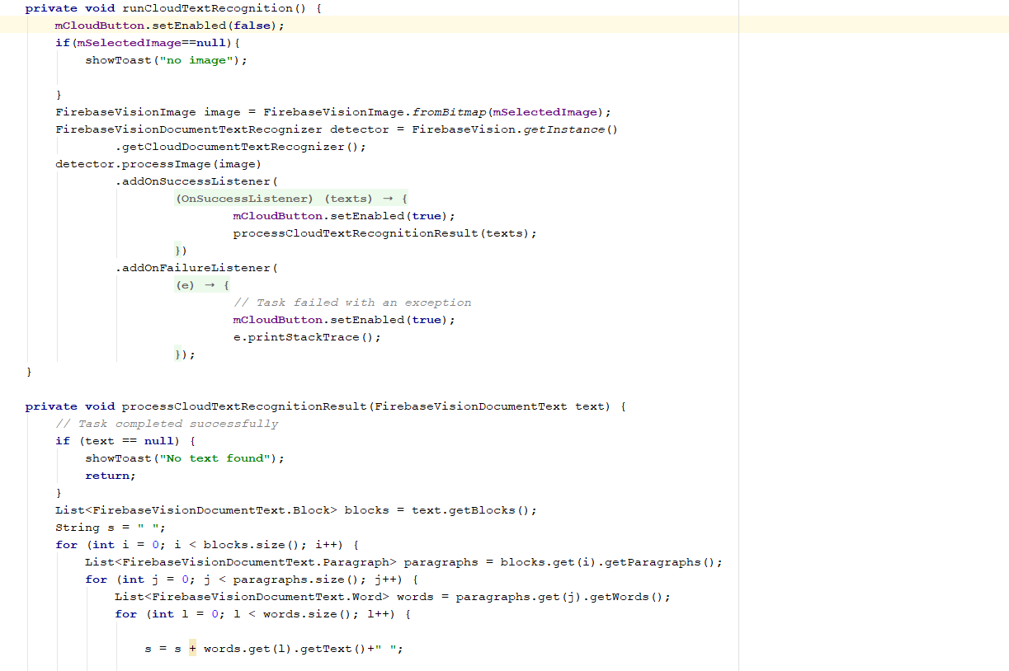

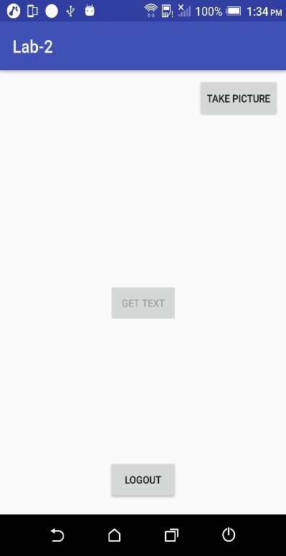

Here are some Result screen shots

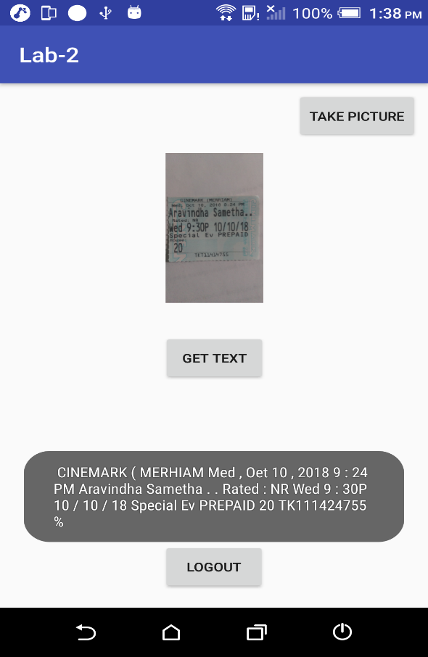

We used Firebase ML kit Text recognition api which uses cloud vision api

* Enable cloud api in firebase ml kit
* Add dependencies for ml vision

Part2

Requirements

* Create an ionic mashup application of atleast two web services
* Use atleast one cordova plugin

1. Login and register page

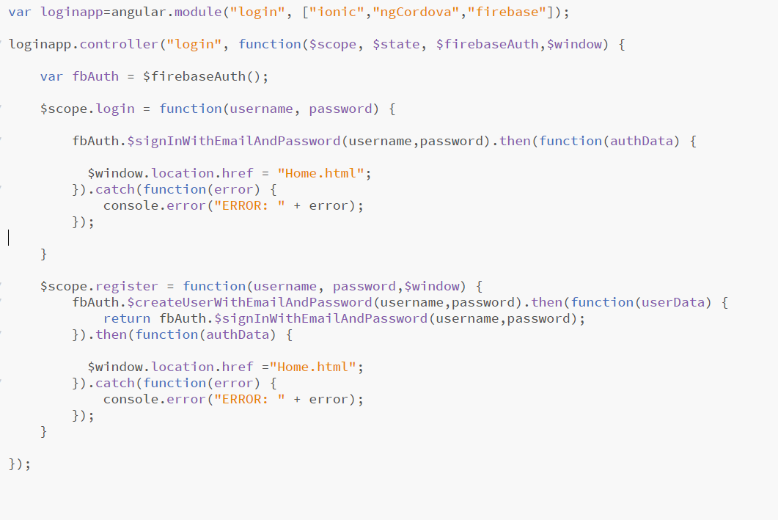

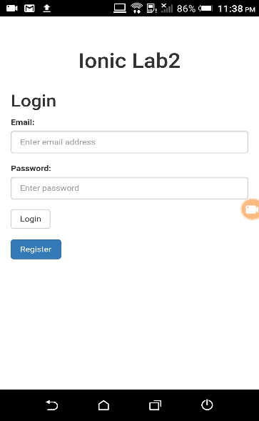

1. Home page

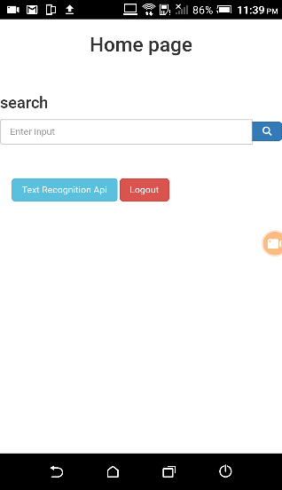

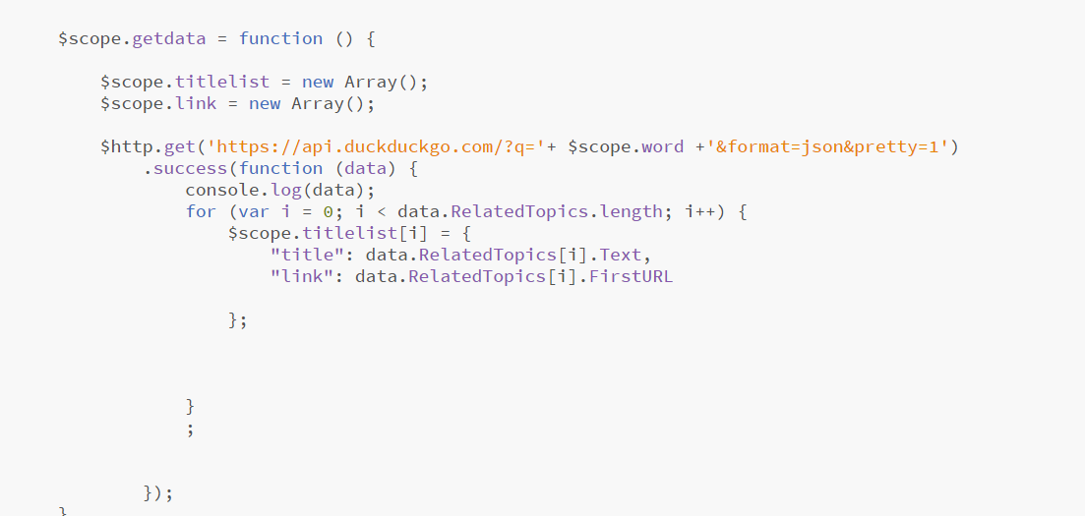

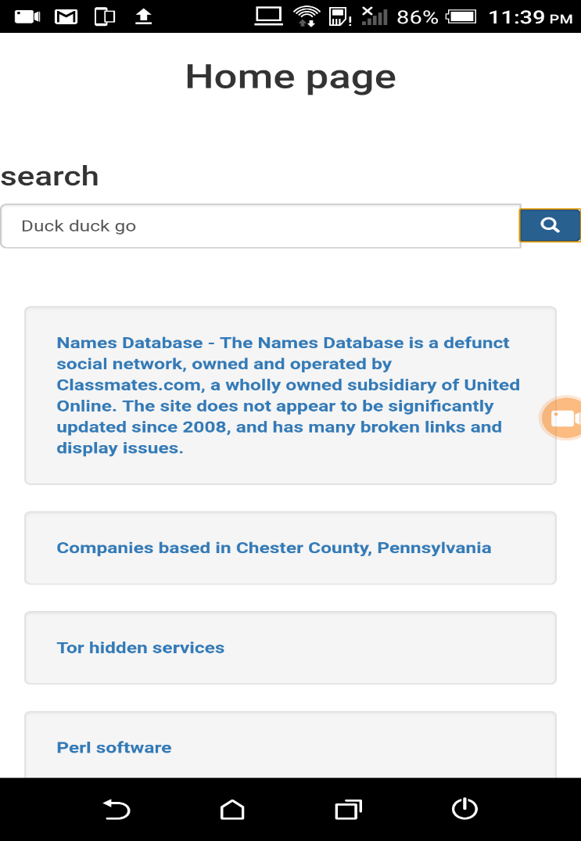

Text recognition

