**PROGRAMMING EXERCISE**

2.1)

#include<iostream> using namespace std; int main()

{

cout<<" Maths=90\n Physics=99\nChemistry=69"; return 1;

}

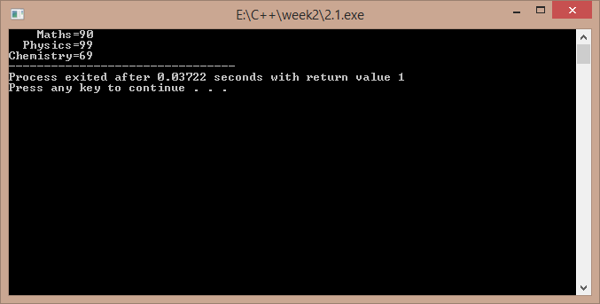

2.2)

#include<iostream> using namespace std; int main()

{

int a,b;

cout<<"enter two numbers : "; cin>>a>>b;

if(a>b)

cout<<"\nthe larger is "<<a; else

cout<<"\n the larger is "<<b; return 1;

}

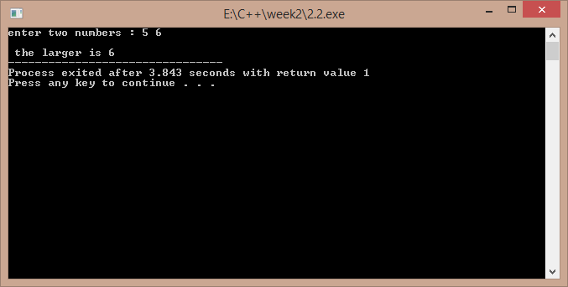

2.3)

#include<iostream> using namespace std; int main()

{

char ch;

cout<<"enter a character : "; cin>>ch;

cout<<"ASCII VALUE IS : "<<(int)ch;

return 1;

}

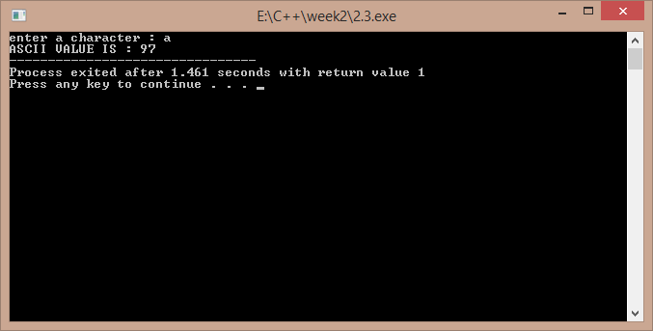

2.4)

#include<iostream> using namespace std; int main()

{

cout<<"enter a,b,c : "; int a,b,c,x; cin>>a>>b>>c;

x=a/b-c;

cout<<"\n the value of x is : "<<x; return 1;

}

a)

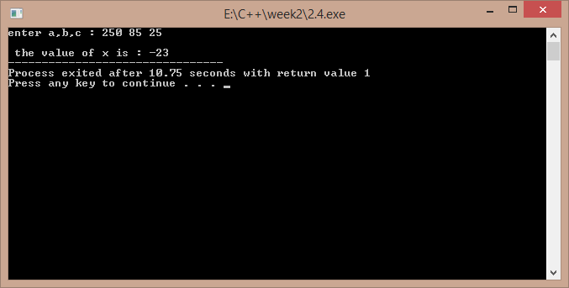

b)

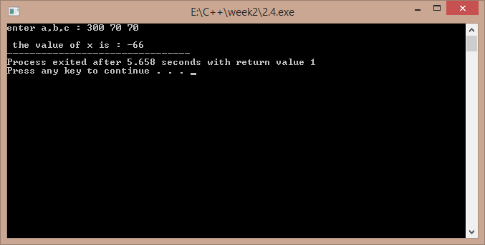

2.5)

#include<iostream>

using namespace std; int main()

{

float c,f;

cout<<"enter the temp in fahrenheit : "; cin>>f;

c=(5/9)*(f-32);

cout<<"temp in celsius is : "<<c; return 1;

}

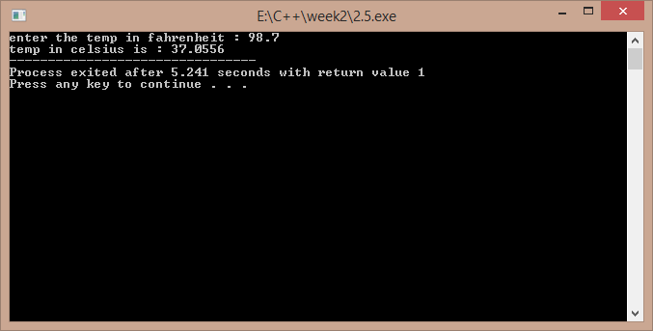

2.6)

#include<iostream> using namespace std; class temp

{

float f,c;

public:

void get(); void cel();

};

void temp::get()

{

cout<<"enter temp in fahrenheit : "; cin>>f;

}

void temp::cel()

{

c=5*(f-32)/9;

cout<<"temp in celcius is : "<<c;

}

int main()

{

temp t; t.get();

t.cel(); return 1;

}

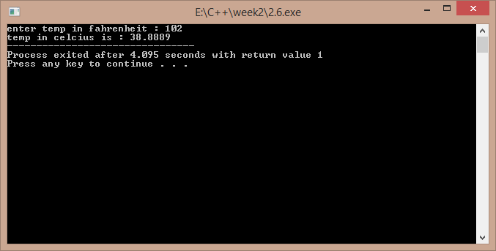

**DEBUGGING EXERCISE**

2.1)

#include<iostream> using namespace std; int main()

{

int i=0; i=i+1;

cout<<i<<͟ ͞;

/*comment\*/i=i+1; cout<<i;

}

‘ / ‘ should be removed from the 7th line

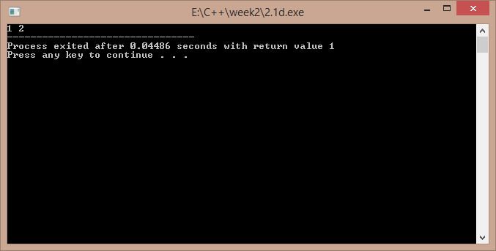

2.2)

#include<iostream> using namespace std; int main()

{

short i=2500,j=3000; cout<<"i+j="<<-(i+j);

return 1;

}

In 6th line insertion operator must be used , not the extraction operator ..

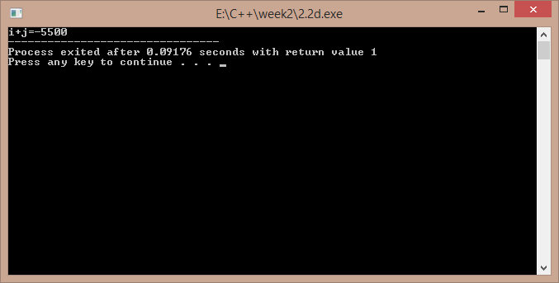

2.3)

#include<iostream> using namespace std; int main()

{

int i=10,j=5;

int modResult=0; int divResult=0; modResult=i%j;

cout<<modResult<<" "; divResult=i/modResult; cout<<divResult; return 1;

}

This code will generate a compiler error because in tenth line I is being divided by zero ..

# Programming Questions

1) #include<iostream> using namespace std; int main()

{

cout<<"enter the order of matrices : "; int m,n,i,j;

cin>>m>>n;

int p[10][10],q[10][10],r[10][10];

if(m>10||n>10) //an exception if the array size is huge

{

cout<<"size overload..."; return -1;

}

cout<<"\nenter the elements of the first matrix : "; for(i=0;i<m;i++)

for(j=0;j<n;j++) cin>>p[i][j];

cout<<"\nenter the elements of the second matrix : "; for(i=0;i<m;i++) //input of matrices for(j=0;j<n;j++)

cin>>q[i][j]; for(i=0;i<m;i++)

for(j=0;j<n;j++) //addition

r[i][j]=p[i][j]+q[i][j];

cout<<"\nthe addition matrix is : "; for(i=0;i<m;i++)

{

cout<<endl; for(j=0;j<n;j++)

cout<<r[i][j]<<" "; //display of the result matrix

}

return 1;

}

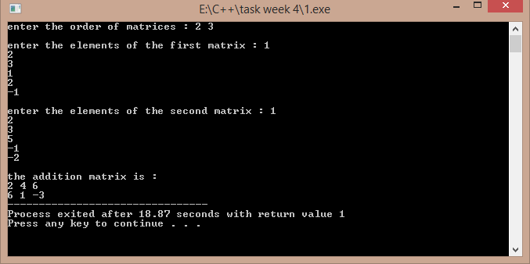

## 2)

#include<iostream> using namespace std;

void multi(int p[10][10],int q[10][10],int r[10][10],int m,int n,int q1)

{

int i,j,k; for(i=0;i<m;i++)

{

//a function to find out the product of matrices

for(j=0;j<q1;j++)

{

r[i][j]=0; for(k=0;k<n;k++) r[i][j]+=p[i][k]*q[k][j];

}

}

}

int main()

{

int p[10][10],q[10][10],r[10][10];int m,n,p1,q1,i,j; cout<<"enter the order of first and second matrix : "; cin>>m>>n>>p1>>q1; if(p1>10||q1>10||m>10||n>10)

{

cout<<"size exceeded ..."; return -1;

}

if(n!=p1)

{

//an exception if there is a wrong input of order

cout<<"wrong order input ..."; return -1;

}

cout<<"enter the elements of first matrix : \n"; for(i=0;i<m;i++)

{

for(j=0;j<n;j++) //input of matrix cin>>p[i][j];

}

cout<<"enter the elements of the second matrix : \n"; for(i=0;i<p1;i++)

{

for(j=0;j<q1;j++) cin>>q[i][j];

}

multi(p,q,r,m,n,q1);

cout<<"the output matrix is : \n"; for(i=0;i<m;i++)

{

cout<<endl; //output of the multiplication matrix for(j=0;j<q1;j++)

cout<<r[i][j]<<" ";

}

return 1;

}

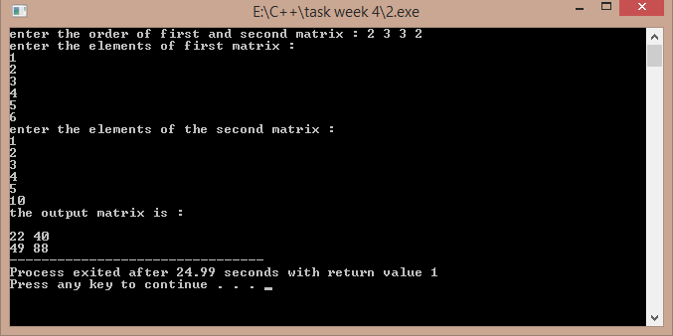

## 3)

#include<iostream> using namespace std;

void call_by_value(int a,int b)

{

int t; t=a; a=b; b=t;

}

void call_by_address(int *a,int *b)

{

int t; t=*a;

*a=*b;

*b=t;

}

void call_by_reference(int &x,int &y)

{

int t;

t=x; x=y; y=t;

}

int &return_by_reference(int a,int b)

{

if(a>b) return a; else return b;

}

int main()

{

cout<<"enter two numbers : "; int a,b,c;

cin>>a>>b;

cout<<"swap by call by value : \n"; //function calls to represent each mechanism call_by_value(a,b);

cout<<a<<" "<<b<<endl; cout<<"swap by call by address : \n"; call_by_address(&a,&b);

cout<<a<<" "<<b<<endl; cout<<"swap by call by refernce : \n"; call_by_reference(a,b);

cout<<a<<" "<<b<<endl;

return_by_reference(a,b)=-4; //the larger value is assigned the value of -4 if(a==-4) //by return by reference mechanism cout<<"first number is larger ..";

else

cout<<"second number is larger .."; return 1;

}

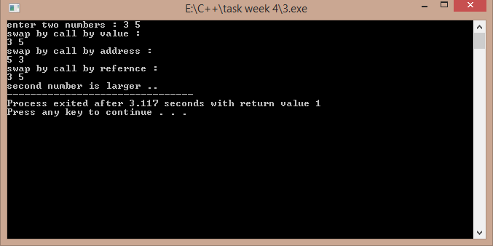

## 4)

#include<iostream> using namespace std; int main()

{

void area(float r,float pi=3.141592); //default value of pi is taken float a,pi; //if the pi value is not passed cout<<"enter the radius of the circle : ";

cin>>a;

cout<<"area by taking default value of pi : "; area(a);

cout<<"\nenter the value of pi : "; cin>>pi;

cout<<"area by taking your value of pi : "; area(a,pi);

return 1;

}

void area(float r,float pi)

{

cout<<(pi*r*r);

}

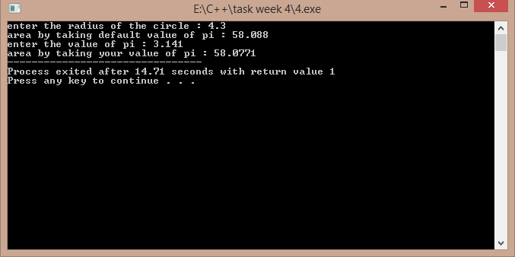

## 5)

#include<iostream>

#include<cmath> using namespace std; float area(float r)

{

return ((3.141592)*r*r);

}

int area(int s)

{

return s*s;

}

int area(int a,int b)

{

return a*b;

}

float area(float a,float b,float c)

{

float s,ar; s=(a+b+c)/2;

ar=sqrt(s*(s-a)*(s-b)*(s-c));

return ar;

}

int main()

{

int a,b,ar;float r,a1,b1,c1,ar1; cout<<"enter the sides of rectangle : "; cin>>a>>b;

ar=area(a,b);

cout<<"\nthe area of rectangle is : "<<ar<<endl; //calling different functions cout<<"enter the sides of the triangle : "; //with the same name cin>>a1>>b1>>c1;

ar1=area(a1,b1,c1);

cout<<"\nthe area of rectangle is : "<<ar1<<endl; cout<<"enter the radius of the circle : ";

cin>>r; ar1=area(r);

cout<<"the area of the circle is : "<<ar1<<endl; cout<<"enter the side of the square : ";

cin>>a; ar=area(a);

cout<<"\nthe area of the square is "<<ar; return 1;

}

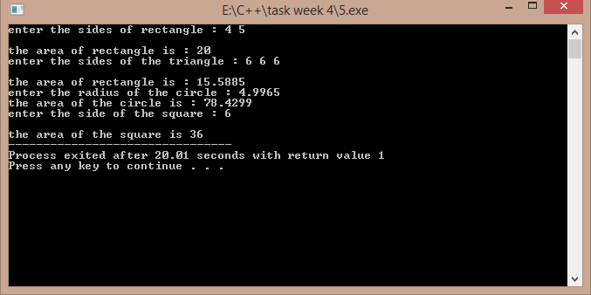

## 6)

#include<iostream> using namespace std;

template<class m> //template named m is used

void firsttwo(m *p,m &n) //a template pointer and the same data type reference is used

{

int i,m1=-1,m2=-1; for(i=0;i<n;i++)

{

if(m1<p[i])

{

m1=p[i];

}

}

for(i=0;i<n;i++)

{

if(m2<p[i]&&p[i]!=m1) //if the found number is not equal to

{ //the largest number .

m2=p[i];

}

}

cout<<"\nlargest and second largest numbers are : "<<m1<<" "<<m2;

}

int main()

{

int n,i;

cout<<"enter the size of the array : "; cin>>n;

int *p=new int[n];

cout<<"enter the elements : \n"; for(i=0;i<n;i++)

{

cin>>p[i]; //calling the template function

}

firsttwo(p,n); return 1;

}

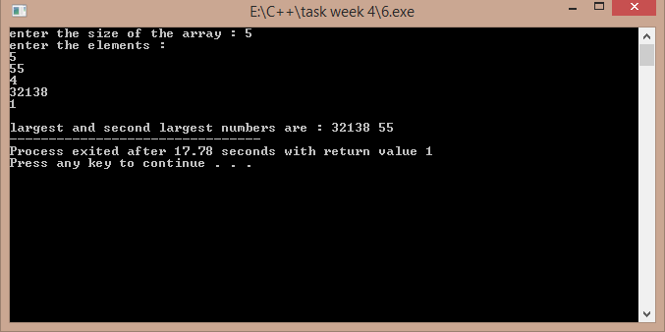

## 7)

#include<iostream> using namespace std;

template<class K> //template named K is used

void lsearch(K *p,K &x,K n) //searching array , search element , no of elements

{

int i,flag=0; for(i=0;i<n;i++)

{

if(p[i]==x)

{

cout<<"search found at "<<i+1<<" position."; flag=1;

break;

}

}

if(flag==0) //flag variable to check if search is successful or not cout<<"search not found ...";

}

int main()

{

int i,x;

cout<<"enter the search element : "; cin>>x;

int p[]={1,2,33,44,55,66,77,88,99,110};

lsearch(p,x,10); return 1;

}

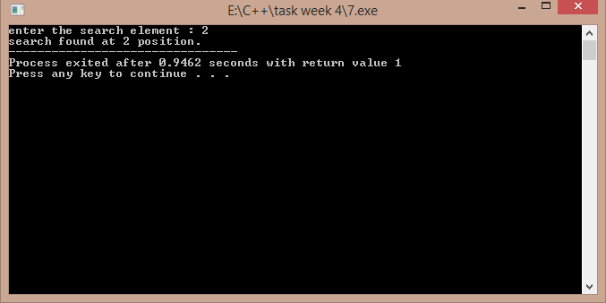

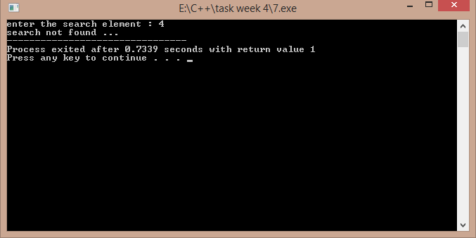

## 8)

#include<iostream> using namespace std;

int n; //number of elements declared as global template<class t>

void sort1(t *a) //a template function which may receive an array to be sorted of

{ //of unknown data type. int i,j;t k;

for(i=0;i<n;i++)

{

for(j=0;j<n-i-1;j++)

{

if(a[j]>a[j+1])

{

k=a[j]; a[j]=a[j+1]; a[j+1]=k;

}

}

}

}

int main()

{

cout<<"enter the data type : 1 for float , 2 for char , 3 for int : "; int ch,i;

cin>>ch;

cout<<"enter the number of elements : "; cin>>n;

switch(ch) //switch case used for multiple sorting entry

{

case 1:{

float *p=new float[n]; cout<<"enter the data : \n"; for(i=0;i<n;i++)

cin>>p[i]; sort1(p);

cout<<"sorted data is : \n"; for(i=0;i<n;i++)

{

cout<<p[i]<<" ";

}

case 2:

{

}break;

char *p=new char[n]; cout<<"enter the data : \n"; for(i=0;i<n;i++)

cin>>p[i]; sort1(p);

cout<<"sorted data is : \n"; for(i=0;i<n;i++)

{

case 3:

}

}break;

{

cout<<p[i]<<" ";

int *p=new int[n]; cout<<"enter the data : \n"; for(i=0;i<n;i++)

cin>>p[i]; sort1(p);

cout<<"sorted data is : \n"; for(i=0;i<n;i++)

{

}

}break;

cout<<p[i]<<" ";

default : cout<<"wrong option ....";

}

return 1;

}

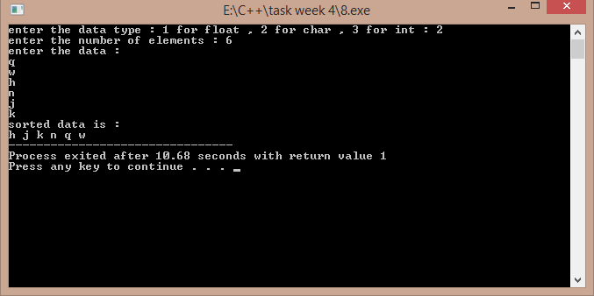

## 9)

#include<iostream> using namespace std;

void towers(int,char,char,char); int main()

{

int n; //Declare the variables to be used

//Get the input for number of disks cout<<"enter the no of disks : ";

cin>>n;

towers(n,'A','C','B'); //Call the function return 1;

}

void towers(int n,char from,char to,char aux)

{

if(n==1) // If there is only one disk

{

cout<<endl<<"move 1 from peg "<<from<<" to "<<to; return;

}

towers(n-1,from,aux,to); //Recursive Call cout<<endl<<"move "<<n<<" from peg "<<from<<" to "<<to; towers(n-1,aux,to,from);

}

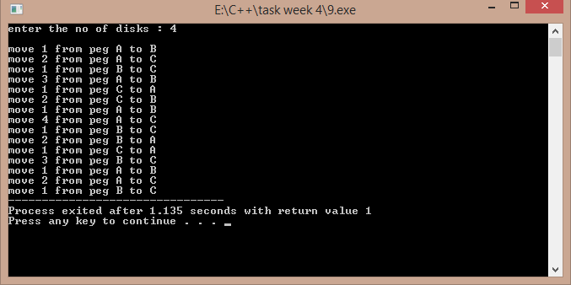

## 10)

#include<iostream>

#include<string.h> using namespace std;

void sort1(char a[100][100],int n)

{

int i,j;char temp[100]; //temporary variable to swap for(i=0;i<n;i++)

{

for(j=0;j<n-i-1;j++) //using bubble sort concept

{

if(strcmp(a[j],a[j+1])>0)

{

strcpy(temp,a[j]);

strcpy(a[j],a[j+1]); strcpy(a[j+1],temp);

}

}

}

}

int main()

{

char a[100][100];int n,i;

cout<<"enter the number of words : "; cin>>n;

if(n>100)

{

cout<<"too many words ..."; return -1;

}

cout<<endl<<"enter "<<n<<" words : "; for(i=0;i<n;i++)

{

cin>>a[i]; //displaying the words in sorted order

}

sort1(a,n);

cout<<"\nwords in sorted order are : \n"; for(i=0;i<n;i++)

cout<<endl<<a[i]; return 1;

}

//output is below ….

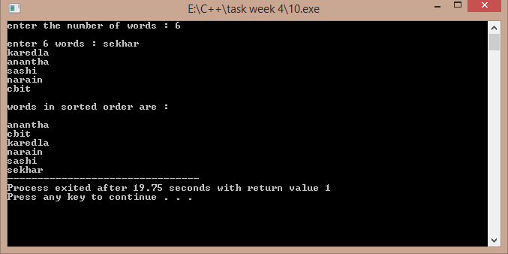

**3.1)**

ALGORITHM:-1)read two numbers

2)call the function swap 3)print the values after swap Function:-

void swap(int &x,int &y)

{

int t=x; x=y; y=t;

}

Return type is void.

Takes two parameters as reference variables.

/*Function program to swap the values of a pair of integers using reference variables. Developed by Sekhar Karedla of BE ¼ CSE-2, CBIT */

#include<iostream> using namespace std;

void swap(int &x,int &y) //function defination

{

int t=x;

x=y;

y=t;

}

int main()

{

cout<<"enter two numbers : "; //reading numbers

int a,b;

cin>>a>>b;

swap(a,b);

cout<<"after swapping : "<<a<<" "<<b; //displaying numbers

return 1;

}

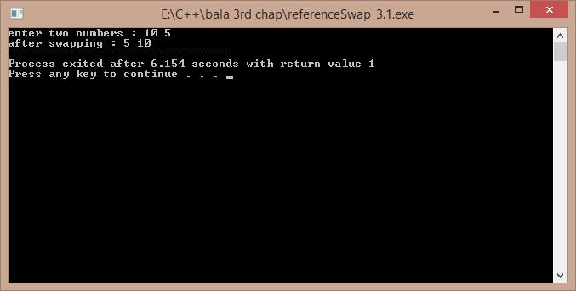

**3.2)**

ALGORITHM:-

1)read the size of vector from the user 2)create the vector using new operator

3)display the default values so as to show the created vector

/*A program to create a vector of size as demanded by the user , Developed by Sekhar Karedla BE ¼ CSE-2,CBIT*/

#include<iostream> using namespace std; int main()

{

int m,i;

cout<<"enter the size of vector : ";

cin>>m; //reading size

int *p=new int[m]; //creating the vector

cout<<"the garbage values are : \n";

for(i=0;i<m;i++) //displaying the garbage values

{

cout<<p[i]<<"\n";

}

return 1;

}

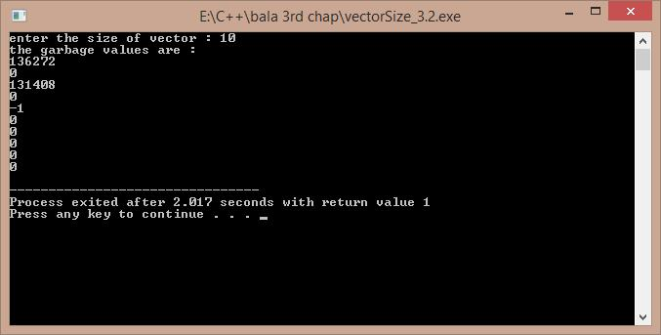

**3.3)**

ALGORITHM:-1)start

2)read the number of lines from user 3)use two for loops to get the pattern 4)end

/*A program to display the following pattern 1 22 333 4444

55555

……

, Developed by Sekhar Karedla BE ¼ CSE-2,CBIT*/ #include<iostream>

using namespace std; int main()

{

int i,j,m;

cout<<"enter the no of lines : "; cin>>m;

for(i=1;i<=m;i++)

{

for(j=1;j<=i;j++)

{

cout<<i;

}

cout<<"\n";

}

return 1;

}

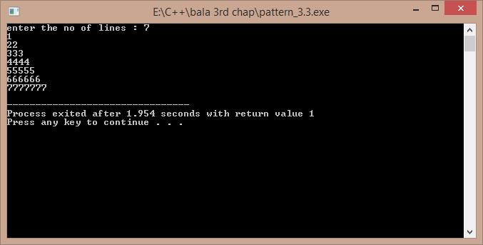

**3.4)**

ALGORITHM:-1)start

2)take all the values in float

3)create three loops , one for the increment of p , one for r , one for n (nested loops) 4) calculate the value of v in each case using pow function under cmath header file

5)store the obtained data in a file so as for the convenience of the user to display the output Mainly using fprintf() function.

6)end

/*A program to develop the results of the investment equation v=(1+p)^n. Developed by Sekhar Karedla BE ¼ CSE-2,CBIT*/

#include<iostream>

#include<cmath> using namespace std;

int main()

{

float p,v,n,r;FILE *fp;char ch;

fp=fopen("result3.4.txt","w"); //opening a file

fputs("3.4 PROBLEM REULTS \n ---------------------------------------------------------

------- \n",fp); //to initiate with the file some basic borders

fputs("P\t\tr\t\tn\t\t\tV\n",fp);

for(p=1000;p<=10000;p=p+1000)

{

for(r=0.10;r<=0.21;r=r+0.01)

{

for(n=1;n<=10;n++)

{

v=p*(pow((1+r),n)); //calculating v and storing in file the next line

fprintf(fp,"\n%f\t%f\t%f\t\t%f",p,r,n,v);

}

}

}

fclose(fp);

cout<<"the results have been stored int the text file result3.4.txt ."; return 1;

}

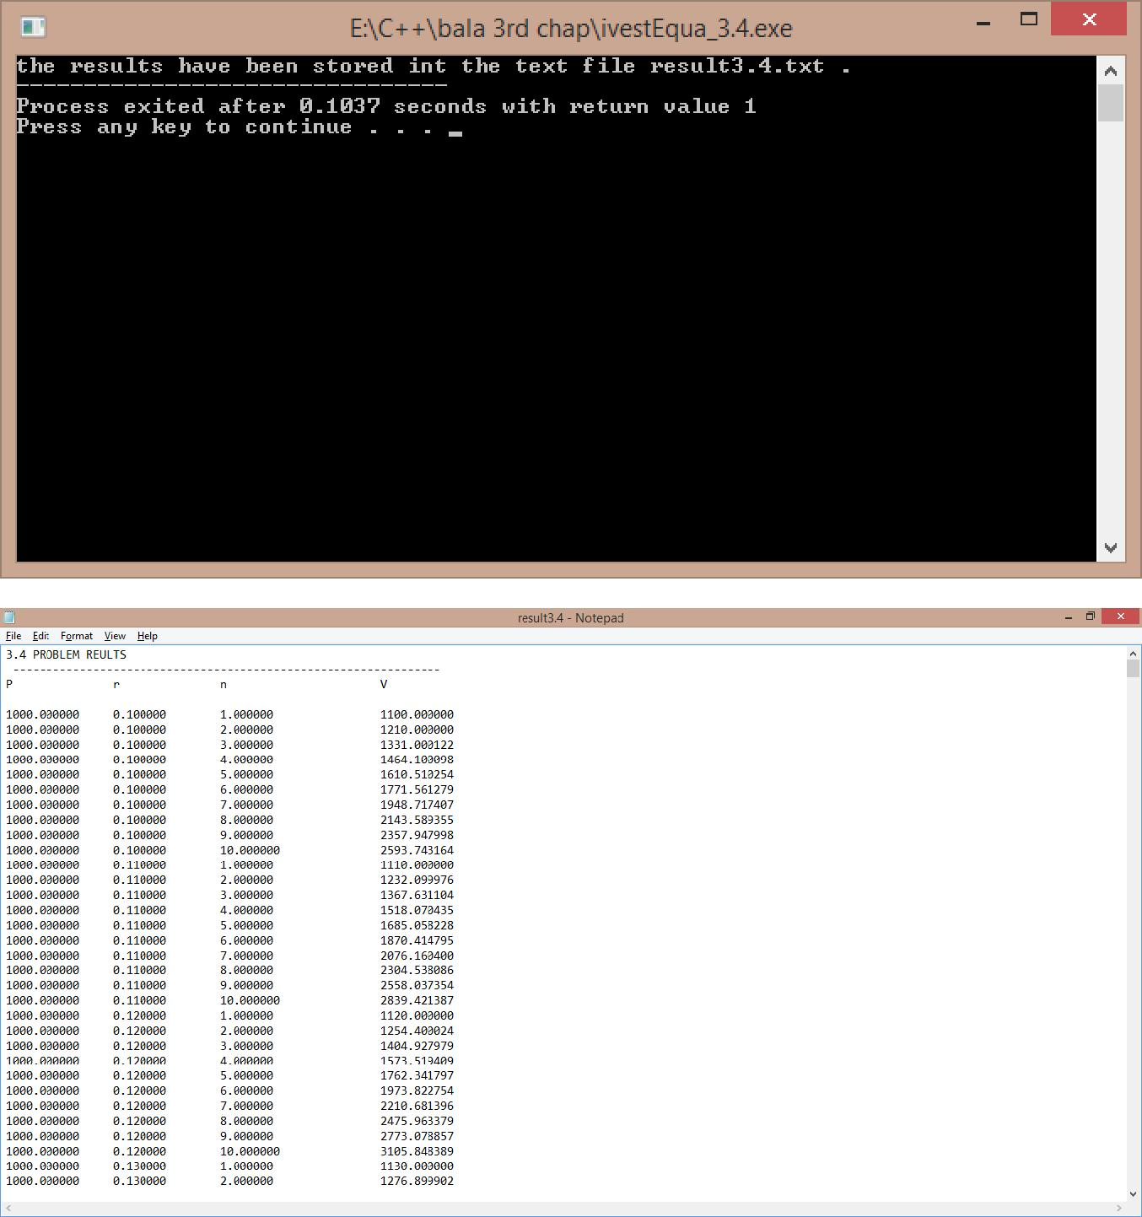

***THE CONTENTS OF THE FILE(RESULT3.4.txt) ARE:-***

|  |  |  |  |
| --- | --- | --- | --- |
| 3.4 PROBLEM REULTS | |  |  |
| ---------------------------------------------------------------- | | |  |
| P | r | n | V |

|  |  |  |  |
| --- | --- | --- | --- |
| 1000.000000 | 0.100000 | 1.000000 | 1100.000000 |
| 1000.000000 | 0.100000 | 2.000000 | 1210.000000 |
| 1000.000000 | 0.100000 | 3.000000 | 1331.000122 |

So on ……

**3.5)**

ALGORITHM:-1)start

2)read the number of ballots from the user 3)create an array on the ballots , using new operator 4)enter the result of each ballot using a for loop

5)calculate the result and spoilt ballots using again a for loop 6)display the results

7)end

/* A program to calculate the results of an election , . Developed by Sekhar Karedla BE ¼ CSE-2,CBIT*/

#include<iostream> using namespace std; int main()

{

cout<<"enter the no of ballots : "; //reading the number of ballots

static int n,i,r[6]; //static declaration so as get the results array to 0

cin>>n;

int *p=new int[n];

cout<<"enter the results of ballot : \n";

for(i=0;i<n;i++)

{

cin>>p[i];

if(p[i]>0&&p[i]<6) //reading the results of ballots as well as calculating the results

{

r[p[i]-1]++;

}

else

r[5]++;

}

for(i=0;i<5;i++)

{

cout<<"\n the no of votes for "<<i+1<<" party is "<<r[i];

}

cout<<"\n the spoiled ballots are "<<r[5];

return 1;

}

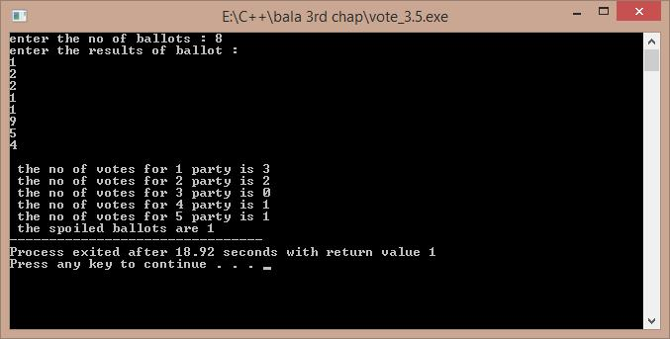

**3.6)**

ALGORITHM:-1)start

2)create a class which contains the data related to a player and functions

3)create a pointer in the main function to create a array of objects using new operator 4)input the values for each object and print them in a tabular form with the batting average 5)end

/*A program to tabulate the details of the cricket player with the batting average. Developed by Sekhar Karedla BE ¼ CSE-2,CBIT*/

#include<iostream> using namespace std; class player

{

char name[100]; int runs;

int inn; int t;

float avg;

public:

void getdata(); void display();

};

void player::getdata()

{

cout<<"enter name : "; cin>>name;

cout<<"enter runs , innings , times not out : "; cin>>runs>>inn>>t;

}

void player::display()

{

avg=float(1.0*runs/(inn-t)); cout<<name<<"\t\t"<<runs<<"\t"<<inn<<"\t"<<t<<"\t\t"<<avg<<"\n";

}

int main()

{

int n,i;

cout<<"\nenter the number of players : "; cin>>n;

player *p=new player[n];

cout<<"enter the details of "<<n<<" players : \n"; for(i=0;i<n;i++)

{

p[i].getdata();

}

cout<<"PLAYER NAME\t"<<"RUNS\t"<<"INNINGS\t"<<"TIMES NOT OUT\t"<<"AVERAGE\n"; for(i=0;i<n;i++)

{

p[i].display();

}

return 1;

}

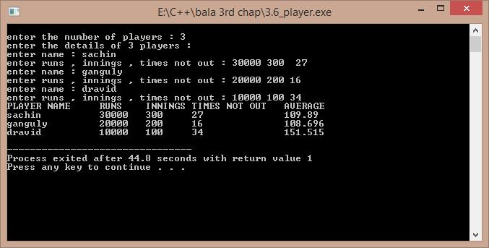

**3.7)a)**

ALGORITHM:-1)start

2)calculate the original value of sinx using cmath header file 3)calculate the sinx value obtained by eulers expansion 4)find the error and compare

5)end

/*A program to compare the original and obtained value of sinx , Developed by Sekhar Karedla CSE-2 BE ¼ ,CBIT*/

#include<iostream>

#include<math.h> using namespace std; int main()

{

long double s,t,x,i,j,n;

cout<<"enter x in degrees : "; //reading the degress cin>>x;

x=x*(3.141/180);

for(j=3;j<1000;j++)

{s=0;t=x;

for(i=2;i<=j;i++)

{

s=s+t;

t=t*-1*x*x/(2*(i-1)*(2*i-1)); //calculating sinx from euler formula

}

if(((s-sin(x))>-0.00000001)&&(s-sin(x))<0.00000001)

{

cout.precision(10);

cout<<"\nthe original value of sinx is : "<<sin(x); cout<<"\nthe obtained value of sinx is : "<<s; cout<<"\nthe order is : "<<j;

break;

}

}

return 1;

}

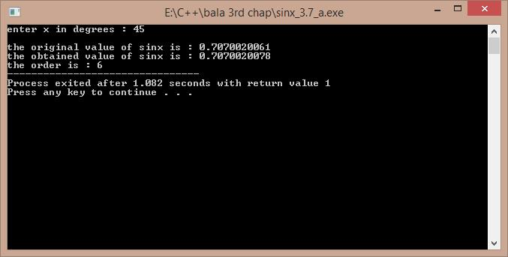

**3.7)b)**

ALGORITHM:-

1)reading the value of x from the user 2)calculating the sum using for loops 3)displaying the result

/*A program to calculate the sum of particular sequence , Developed by Sekhar Karedla CSE-2 BE ¼ ,CBIT*/

#include<iostream> using namespace std; int main()

{

float s,k,p,i,j,n,t;t=1; cout<<"enter N : "; cin>>n;p=1; for(i=1;i<=n;i++) {s=s+p;t=1;

for(j=0;j<i;j++)

{

t=t*(1/(i+1));

}

p=t;

}

cout.precision(10); cout<<"the sum is : "<<s;

return 1;

}

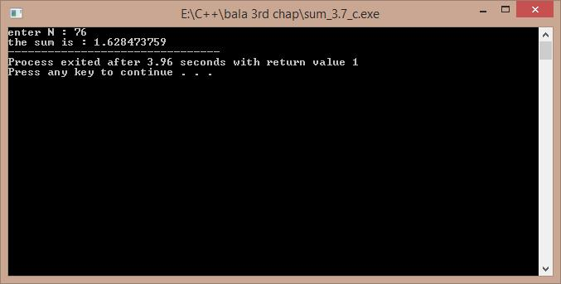

**3.7)c)**

ALGORITHM:-1)start

2)calculate the original value of cosx using cmath header file 3)calculate the cosx value obtained by eulers expansion 4)find the error and compare

5)end

/*A program to compare the original and obtained value of cosx , Developed by Sekhar Karedla CSE-2 BE ¼ ,CBIT*/

#include<iostream>

#include<math.h> using namespace std; int main()

{

float x,t,s,i,j;

cout<<"enter x in degrees : "; cin>>x;

x=x*(3.141/180);

for(j=0;j<1000;j++)

{

s=1;t=-(x*x)/2; for(i=0;i<=j;i=i+2)

{

s=s+t; t=t*-1*x*x/((i+3)*(i+4));

}

if(((s-cos(x))>-0.000001)&&((s-cos(x)<0.000001)))

{

cout.precision(10);

cout<<"\n the original value : "<<cos(x); cout<<"\n the obtained value : "<<s; cout<<"\n order : "<<j;

break;

}

}

return 1;

}

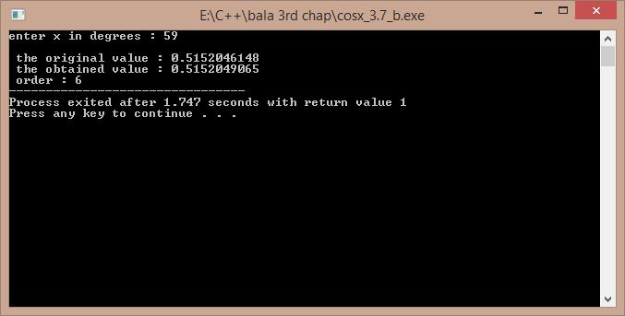

**3.8)**

ALGORITHM:-

1)start

2)we use two for loops for proper alignment

3)we store the results again in a file because viewing the results in the command prompt will cause the failure of alignment

4)we calculate the exp(-x) value for 0.1 increment

5)we store the values in a file

6)end

/*A program developed to show the results of exp(-x) in tabular form , Developed by Sekhar Karedla CSE-2 BE ¼ ,CBIT*/

#include<iostream>

#include<cmath>

using namespace std;

int main()

{

float i,j;float r;FILE *fp;int k;

fp=fopen("result3.8.txt","w"); //opening a file

fprintf(fp,"X"); fseek(fp,1,SEEK_SET);

for(i=0.1;i<=1.0;i=i+0.1) // setting the table headings fprintf(fp,"\t%f",i);

for(i=0.0;i<10.0;i=i+1.0)

{k=i;

fprintf(fp,"\n%d",k);

for(j=i+0.1;j<=i+0.9;j=j+0.1)

{

r=exp(-j);

fprintf(fp,"\t%f",r); // using fprintf to store the values in a file.

}

}

cout<<"\n the tabular form has been successfully stored in result3.8 ."; return 0;

}

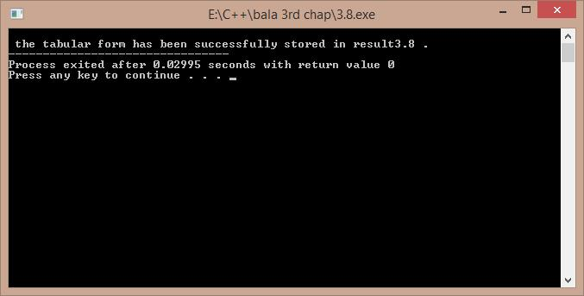

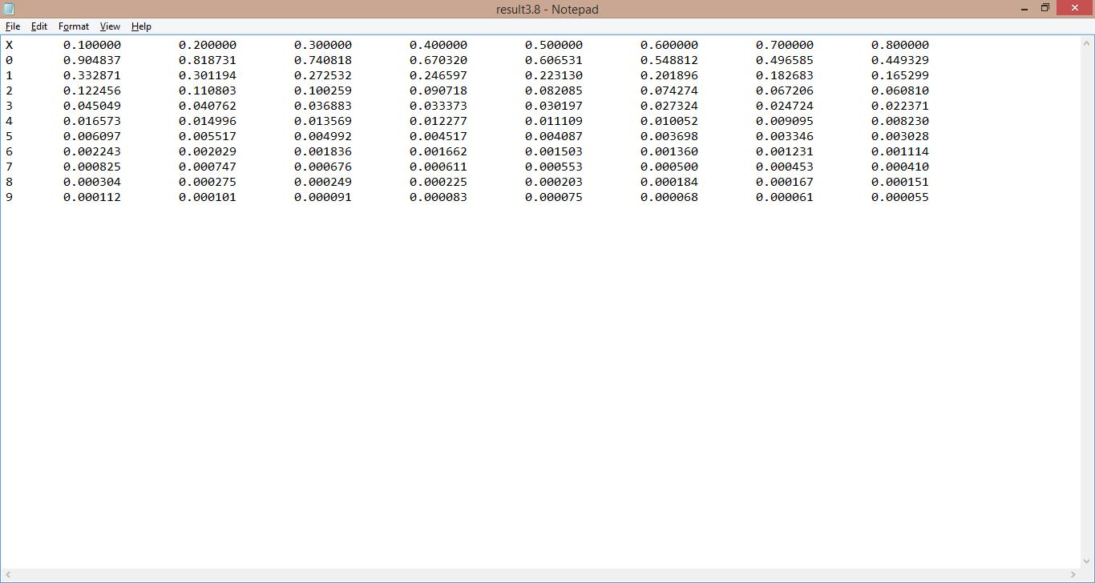

***THE CONTENTS OF THE RESULT3.8.txt:-***

|  |  |
| --- | --- |
| X | 0.100000 0.200000 0.300000 0.400000 0.500000 0.600000 0.700000 0.800000 |

1. 0.904837 0.818731 0.740818 0.670320 0.606531 0.548812 0.496585 0.449329
2. 0.332871 0.301194 0.272532 0.246597 0.223130 0.201896 0.182683 0.165299
3. 0.122456 0.110803 0.100259 0.090718 0.082085 0.074274 0.067206 0.060810
4. 0.045049 0.040762 0.036883 0.033373 0.030197 0.027324 0.024724 0.022371
5. 0.016573 0.014996 0.013569 0.012277 0.011109 0.010052 0.009095 0.008230
6. 0.006097 0.005517 0.004992 0.004517 0.004087 0.003698 0.003346 0.003028
7. 0.002243 0.002029 0.001836 0.001662 0.001503 0.001360 0.001231 0.001114
8. 0.000825 0.000747 0.000676 0.000611 0.000553 0.000500 0.000453 0.000410
9. 0.000304 0.000275 0.000249 0.000225 0.000203 0.000184 0.000167 0.000151
10. 0.000112 0.000101 0.000091 0.000083 0.000075 0.000068 0.000061 0.000055

**3.9)**

ALGORITHM:-

1)start

2)take the number of numbers input and create an array with new operator

3)input all number and take their sum , and hence calculate mean

4)use loops to calculate the variance by taking the difference from the mean 5)display the results

6)end

/* A program to calculate the standard deviation , variance , mean of the given numbers . Developed by Sekhar Karedla CSE-2 BE ¼ ,CBIT*/

#include<iostream>

#include<math.h> using namespace std; int main()

{

int n,s=0;

cout<<"enter the number of numbers : "; cin>>n;

int *p=new int[n]; int i;

cout<<"enter "<<n<<" numbers : "; for(i=0;i<n;i++)

{

cin>>p[i];

s=s+p[i];

}

float m,sd,v; m=(1.0/n)*s; float s1; for(i=0;i<n;i++)

{

s1=s1+((p[i]-m)*(p[i]-m));

}

sd=sqrt(s1);

v=sd*sd;

cout<<"\n\nvariance : "<<v<<"\nstandard deviation : "<<sd<<"\nmean : "<<m;

return 1;

}

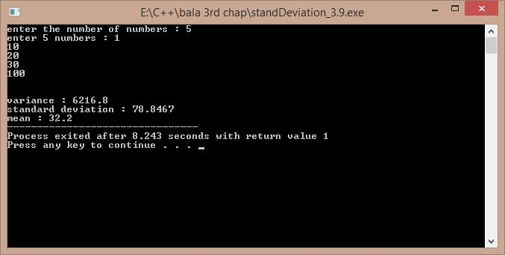

**3.10)**

ALGORITHM:-

1)start

2)input the number of units

3)use the given rates to compute the rate using if elseif statements

4)end

/* A program to calculate the current bill by the input of current units. Developed by Sekhar Karedla CSE-2 BE ¼ ,CBIT*/

#include<iostream>

using namespace std;

int main()

{

float u,sum;

cout<<"enter the units : "; //entering the units cin>>u;

if(u<100)

{

sum=u*60;

}

else if(u>100&&u<=300)

{

sum=(100*60)+(u-100)*80; //calculating the bill

}

else

{

sum=(100*60)+(200*80)+(u-300)*90;

}

sum=sum/100;

cout<<"the bill amount is : "<<sum<<" rupees"; return 1;

}

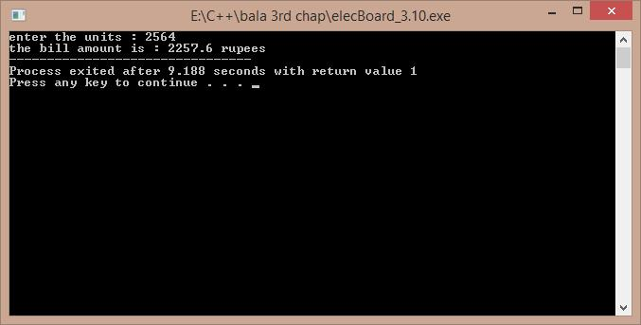

**Program 1:-**

//a program to implement the matrix operations.

/*Solution to this program is developed by BE ¼ CSE-2 Group-7(Sekhar, Dasaradh, Eshwar, Harsha and Harshavardhan)*/

#include<iostream>

#include<stdlib.h> using namespace std; class matrix

{

int m,n,p,q,**a,**b,m1,n1,**c; // using pointer to pointers for 2d array public:

void getdata(); void display(); void add(); void subtract(); void multiply();

};

void matrix::getdata()

{

cout<<"enter the order of the first matrix : "; cin>>m>>n;

cout<<"enter the order of the second matrix : "; cin>>p>>q;

a = new int *[m]; //allocating memory for 2-D array dynamically

for(int i = 0; i < m; ++i) a[i] = new int[n];

b = new int*[p]; for(int i = 0; i < p; ++i) b[i] = new int[q];

int i,j;

cout<<"enter the elements of the first matrix : \n"; for(i=0;i<m;i++)

for(j=0;j<n;j++) cin>>a[i][j];

cout<<"enter the values of the second matrix : \n"; for(i=0;i<p;i++)

for(j=0;j<q;j++) cin>>b[i][j];

}

void matrix::display()

{

int i,j;

cout<<"the matrix is \n"; for(i=0;i<m1;i++)

{

cout<<endl; for(j=0;j<n1;j++) cout<<c[i][j]<<" ";

}

}

void matrix::add()

{

if(m!=p||n!=q)

{

cout<<"wrong order : "; exit(-1);

}

int i,j; m1=m;n1=n;

c = new int*[m1];

for(int i = 0; i < m1; ++i) c[i] = new int[n1]; for(i=0;i<m1;i++) for(j=0;j<n1;j++) c[i][j]=a[i][j]+b[i][j];

}

void matrix::subtract()

{

if(m!=p||n!=q) //exceptions

{

cout<<"wrong order : "; exit(-1);

}

int i,j; m1=m;n1=n;

c = new int*[m1];

for(int i = 0; i < m1; ++i) c[i] = new int[n1]; for(i=0;i<m1;i++) for(j=0;j<n1;j++) c[i][j]=a[i][j]-b[i][j];

}

void matrix::multiply()

{

if(n!=p) //exception for multiplication

{

cout<<"wrong order : "; exit(-1);

}

int i,j,k; m1=m;n1=q;

c = new int*[m1];

for(int i = 0; i < m1; ++i) c[i] = new int[n1]; for(i=0;i<m1;i++)

{

for(j=0;j<n1;j++)

{

c[i][j]=0; for(k=0;k<n;k++) c[i][j]+=a[i][k]*b[k][j];

}

}

}

int main()

{

matrix s; s.getdata(); int ch;

cout<<"press 1 for addition , 2 for subtraction ,3 for multiplication , 4 for division ";

cin>>ch;

switch(ch) //using the switch case for menu purpose

{

}

return 1;

}

case 1: s.add();s.display();break;

case 2: s.subtract();s.display();break; case 3:s.multiply();s.display();break; default:cout<<"wrong choice ...";

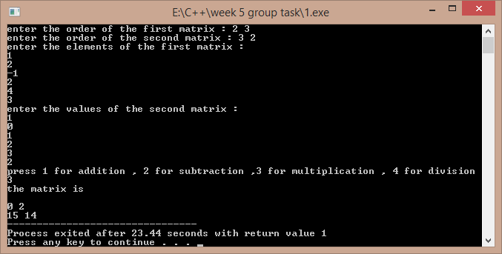

# Program 2:-

//a program to implement operations on complex numbers

/*Solution to this program is developed by BE ¼ CSE-2 Group-7(Sekhar, Dasaradh, Eshwar, Harsha and Harshavardhan)*/

#include<iostream> using namespace std; class complex

{

private:

float real; float imag;

public:

void add(complex,complex); void sub(complex,complex); void mul(complex,complex); void divide(complex,complex); void display();

void getdata(float,float);

};

void complex::add(complex x, complex y)

{

this->real=x.real+y.real; //using this pointer to point towards its own member this->imag=x.imag+y.imag;

}

void complex::sub(complex x, complex y)

{

this->real=x.real-y.real; this->imag=x.imag-y.imag;

}

void complex::mul(complex x, complex y)

{

this->real=(x.real*y.real)-(x.imag)*(y.imag); this->imag=(x.real*y.imag)+(y.real*x.imag);

}

void complex::divide(complex x, complex y)

{

this-

>real=((x.real*y.real)+(x.imag)*(y.imag))/((y.real*y.real)+(y.imag*y.imag)); this->imag=((y.real*x.imag)-

(x.real*y.imag))/((y.real*y.real)+(y.imag*y.imag));

}

void complex::display()

{

if(imag>0) cout<<real<<"+"<<imag<<"i\n"; else

cout<<real<<"-"<<imag<<"i\n";

}

void complex::getdata(float r,float i)

{

real=r; imag=i;

}

int main()

{

complex c1,c2,c3; //two complex numbers for storing the data float m,n; //c3 for storing the result

cout<<"\nenter the real and imaginery part of first complex no. : "; cin>>m>>n;

c1.getdata(m,n);

cout<<"\nenter the real and imaginery part of second complex no. : "; cin>>m>>n;

c2.getdata(m,n); int ch;

cout<<"\nenter 1 for addition\nenter 2 for subtraction\nenter 3 for

subtraction\nenter 4 division :\n"; cin>>ch;

switch(ch) //switch case for the menu

{

case 1:

{

c3.add(c1,c2);

}break; case 2:

{

c3.sub(c1,c2);

}break; case 3:

{

c3.mul(c1,c2);

}break; case 4:

{

c3.divide(c1,c2);

}break; default:cout<<"wrong choice ....";

}

cout<<"the output is : \n"; c3.display();

return 1;

}

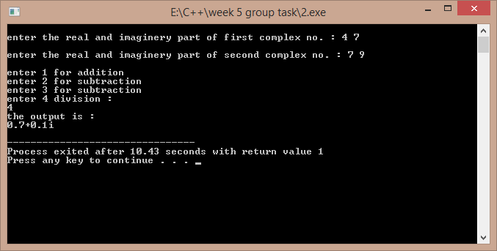

# Program 3:-

//a sample program to show the working of a bank program

/*Solution to this program is developed by BE ¼ CSE-2 Group-7(Sekhar, Dasaradh, Eshwar, Harsha and Harshavardhan)*/

#include<iostream>

#include<string.h>

#include<stdlib.h> using namespace std; class bank

{

long int ac; float bal;

char t,name[100],pass[100]; public:

void withdraw(float); void deposite(float); void display();

void create();

friend void assign(bank []); //two friend functions to access the friend int check(bank [],char [],long int); // private data of objects

};

void bank::display() // a function to display the record

{

cout<<"\n\n\nName : "<<name; cout<<"\nAccount no : "<<ac;

cout<<"\nAvailable Balance : "<<bal; cout<<"\nAccount Type : "<<t;

}

void bank::create() //a function to create a new account

{

cout<<"\nenter you name : "; cin>>name;

cout<<"\nenter your account number : "; cin>>ac;

cout<<"\nenter the balance : "; cin>>bal;

cout<<"\ncreate a new password : "; cin>>pass;

while(bal<1000)

{

amount ...";

}

cout<<"\nminimum amount should be 1000 , please re- enter cin>>bal;

cout<<"\nenter the type of account : "; cin>>t;

}

void bank::withdraw(float w)

{

if(w>bal)

{

cout<<"\nnot enough balance..."; //exception if there is not enough exit(-1); //balance

}

cout<<"\npresent balance is : "<<bal; cout<<"\nwithdrawal amount : "<<w; cout<<"\nnew balance is : "<<bal-w; bal=bal-w;

}

void bank::deposite(float w)

{

cout<<"\npresent balance : "<<bal; cout<<"\ndeposite amount : "<<w; cout<<"\nnew amount : "<<bal+w; bal=bal+w;

}

void assign(bank b[]) //a function to assign some existing accounts to objects

{

strcpy(b[0].name,"sekhar"); b[0].ac=23095; b[0].bal=9023099.4326; b[0].t='s';

strcpy(b[0].pass,"karedla1");

strcpy(b[1].name,"ram"); b[1].ac=23021; b[1].bal=90099.4326; b[1].t='s';

strcpy(b[1].pass,"shayam2");

strcpy(b[2].name,"shyam"); b[2].ac=23675; b[2].bal=10299.426; b[2].t='c';

strcpy(b[2].pass,"ram3");

}

int check(bank b[],char p[],long int z)

{ //a friend function to check acc no . and its corresponding password int i;

for(i=0;i<3;i++)

{

if(strcmp(b[i].pass,p)==0&&(b[i].ac==z)) return i;

}

return -1;

}

int main()

{

bank b[3]; assign(b); int ch;

cout<<"\nenter 1 to create an account\nenter 2 to deposite amount\nenter 3 to withdraw amount : ";

cin>>ch;

switch(ch) //a menu to create , with draw , create new account

{

case 1:

{

bank s; s.create();

}break; case 2:

{

char p[100];int k;long int z; cout<<"\nenter your account number : "; cin>>z;

cout<<"\nenter your pass-word : "; cin>>p;

k=check(b,p,z); if(k>=0)

{

}

else

{

b[k].display();

cout<<"no matching profile ..."; exit(-1);

}

cout<<"\nenter the amount to be deposited : "; float w;

cin>>w; b[k].deposite(w);

}break; case 3:

{

char p[100];int k;long int z; cout<<"\nenter your account number : "; cin>>z;

cout<<"\nenter your pass-word : "; cin>>p;

k=check(b,p,z); if(k>=0)

{

}

else

{

b[k].display();

cout<<"no matching profile ..."; exit(-1);

}

cout<<"\nenter the amount to be withdrawn : "; float w;

cin>>w; b[k].withdraw(w);

}break;

default : cout<<"wrong option entry ....";

}

return 1;

}

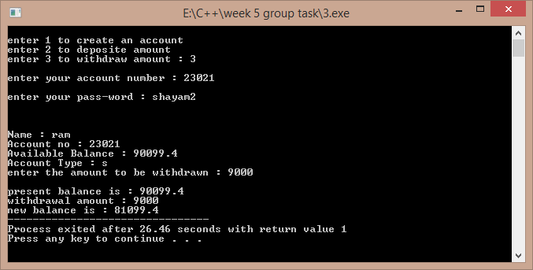

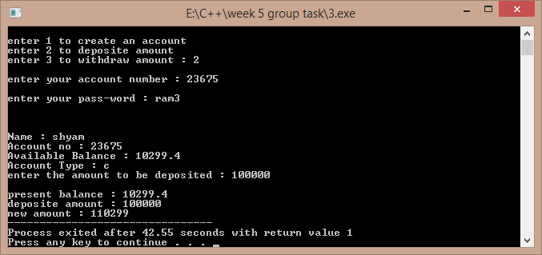

Another sample:-

# Program 4:-

//a sample program to demonstrate operations on vectors

/*Solution to this program is developed by BE ¼ CSE-2 Group-7(Sekhar, Dasaradh, Eshwar, Harsha and Harshavardhan)*/

#include<iostream> using namespace std;

class vector1

{

int *v,n; public:

void create(); void modify(); void multiply(); void display();

};

void vector1::create() //creating a vector of required size

{

int i;

cout<<"enter the size of the vector : "; cin>>n;

v=new int[n];

cout<<"\nenter the elements of the vector : \n"; for(i=0;i<n;i++)

cin>>v[i];

}

void vector1::modify() // modifying its elements

{

int p,ch;

cout<<"\nenter the element to be modified : "; cin>>p;

if(p>n) //the program terminates if this exception occurs

{

cout<<"element number out of bounds ..."; exit(-1);

}

cout<<"\nenter the modification : "; cin>>ch;

v[p-1]=ch;

}

void vector1::multiply() // multiplying its elements with a scalar

{

int s,i;

cout<<"\nenter the scalar to multiplied to the whole vector : "; cin>>s;

for(i=0;i<n;i++) v[i]=v[i]*s;

}

void vector1::display() // display the vector

{

int i;

cout<<"\n the vector is : \n"; for(i=0;i<n;i++)

cout<<" "<<v[i];

}

int main()

{

vector1 m; m.create(); int flag=0; do

{

cout<<"\nenter 1 so as to modify an element \nenter 2 so as to multiply the vector by a scalar\nenter 3 so as to display the vector\nenter 4 to quit\n";

int ch; cin>>ch; switch(ch)

{

case 1:m.modify();m.display();break; case 2:m.multiply();m.display();break; case 3:m.display();break;

default : flag=1;

}

}while(flag==0); return 1;

}

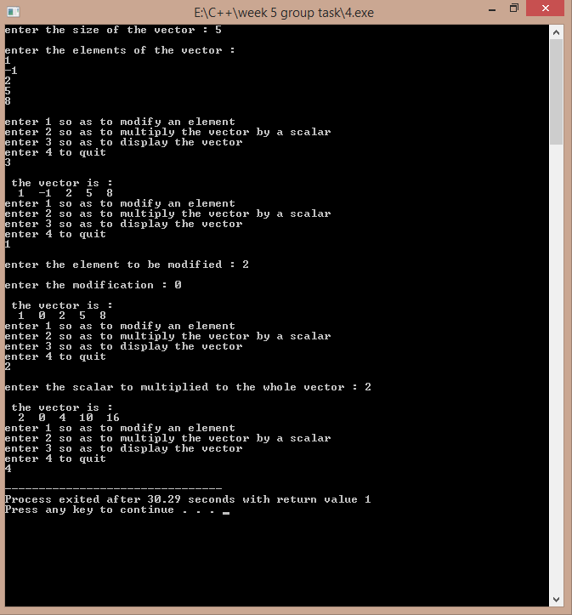

# Program 6:-

//a program to implement the displaying the marks of the students

/*Solution to this program is developed by BE ¼ CSE-2 Group-7(Sekhar, Dasaradh, Eshwar, Harsha and Harshavardhan)*/

#include<iostream> using namespace std; int m1,m2;

class student

{

char name[80],add[100]; int rno,t;

float avg;

int m[6]; public:

student()

{

avg=0;t=0;

}

void readata()

{

int i;

cout<<"\nenter name : "; cin>>name; cout<<"\nenter roll no : "; cin>>rno;

cout<<"\nenter the address : "; cin>>add;

cout<<"\nenter the marks of 6 subjects : "; for(i=0;i<6;i++)

cin>>m[i];

}

void percent()

{

int i; for(i=0;i<6;i++) t+=m[i]; avg=t/6.0;

}

void display()

{

int i;

cout<<"\n\n\nNAME : "<<name; cout<<"\nADDRESS : "<<add; cout<<"\nROLL NO : "<<rno; cout<<"\nTOTAL MARKS : "<<t;

cout<<"\nPERCENTAGE : "<<avg; cout<<"\n marks of individual subjects : \n"; for(i=0;i<6;i++)

{

cout<<"\nmarks subject "<<i+1<<" : "<<m[i];

}

}

friend void class_average(student s[],int n)

{m1=0;float cavg,t; // a friend function to to calculate class for(int i=0;i<n;i++) // highest and lowest

{

if(m1<s[i].avg)

m1=s[i].avg;

}

m2=m1;

for(int i=0;i<n;i++)

{

}t=0;

if(m2>s[i].avg)

m2=s[i].avg;

for(int i=0;i<n;i++) t+=s[i].avg; cavg=float(t/n);

cout<<"\nthe minimum is : "<<m2; cout<<"\nthe maximum is : "<<m1; cout<<"\nclass average is : "<<cavg;

}

friend void decending(student s[],int n)

{

float *avg1=new float[n];

for(int i=0;i<n;i++) //to display the student avg1[i]=s[i].avg; //record in descending order int i,j,k1=0,f=0;

for(j=0;j<n;j++)

{m1=0;

for(i=0;i<n;i++)

{

if(m1<s[i].avg)

{

k1=i; m1=s[i].avg;

}

}

s[k1].display(); s[k1].avg=0;

}

for(int i=0;i<n;i++) s[i].avg=avg1[i];

/* student temp; int i,j; for(i=0;i<n;i++)

{

for(j=0;j<n-1-i;j++)

{

if(s[j].avg<s[j+1].avg)

{

}

}*/

temp=s[j]; s[j]=s[j+1]; s[j+1]=temp;

}

}

friend void topn(student s[],int n,int p)

{

}

}

};

int main()

{

float *avg1=new float[n];

for(int i=0;i<n;i++) //a function to display the top n avg1[i]=s[i].avg; //students only

int i,j,k1=0,f=0; for(j=0;j<n;j++)

{m1=0;

for(i=0;i<n;i++)

{

if(m1<s[i].avg)

{

k1=i; m1=s[i].avg;

}

}

if(f<=p)

{

s[k1].display();

s[k1].avg=0;f++;

}

else break;

for(int i=0;i<n;i++) s[i].avg=avg1[i];

int n;

cout<<"\nenter the number of students : "; cin>>n;

student *s=new student[n];

cout<<"\nenter the data of "<<n<<" students : "; int i;

for(i=0;i<n;i++)

{

}

int ch;

s[i].readata();

s[i].percent();

cout<<"\nenter 1 display all student details \nenter 2 descending order view \nenter 3 to see top n students \nenter 4 to display class average , lowest

,highest : \n";

cin>>ch; switch(ch)

{

case 1:

{

for(i=0;i<n;i++) s[i].display();

}break; case 2:

{

decending(s,n);

}break; case 3:

{

int p;

cout<<"\nenter the value of n : "; cin>>p;

topn(s,n,p);

}break; case 4:

{

}

return 1;

}

class_average(s,n);

}break; default:cout<<"wrong choice .....";

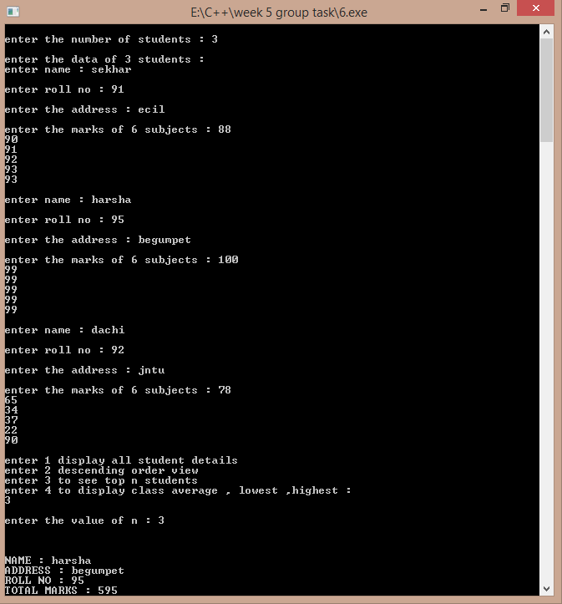

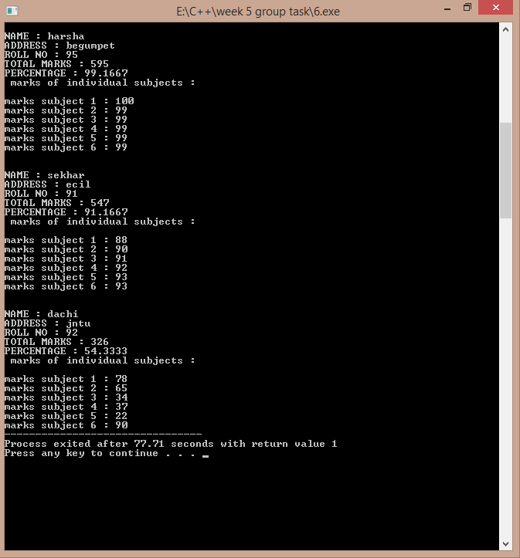

Another sample:-

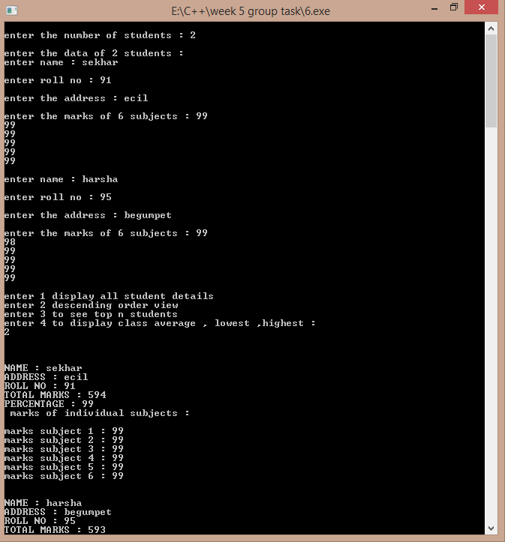

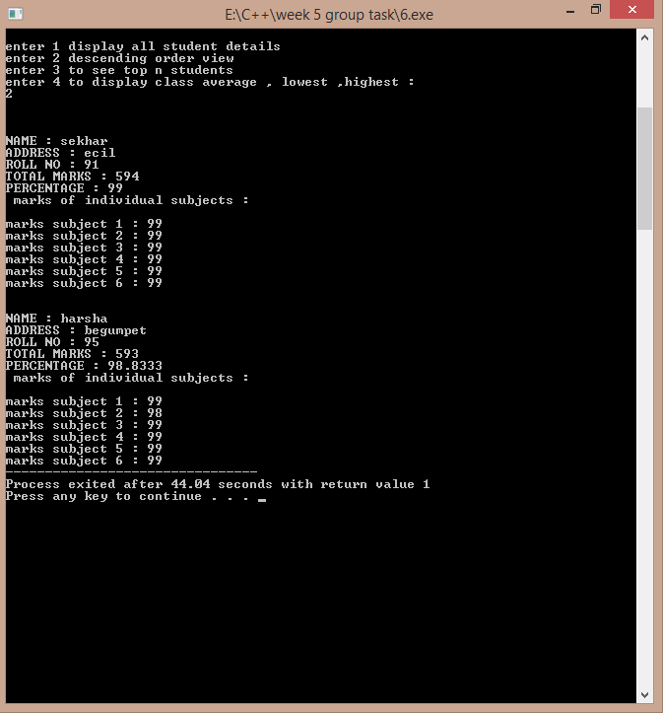

# Program 1

//a program to depict the function overloading concept

#include<iostream> using namespace std; float area(float r)

{

return (3.141)*r*r;

}

int area(int a,int b)

{

return a*b;

}

int area(int s)

{

return s*s;

}

int main()

{

float r,ac;

int a,b,s,ar,as;

cout<<"\nenter the radius of circle : ";

cin>>r; ac=area(r);

cout<<"\nenter the length and breadth of rectangle : "; cin>>a>>b;

ar=area(a,b);

cout<<"\nenter the side of the square : "; cin>>s;

as=area(s);

cout<<"\narea of the circle is : "<<ac; cout<<"\narea of the rectangle is : "<<ar; cout<<"\narea of the sqaure is : "<<as;

return 0;

}

Output:-

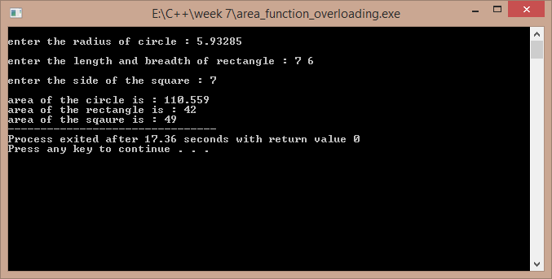

# Program 2

//a program to add complex numbers using operator overloading

#include<iostream> using namespace std; class complex1

{

float real,imag; public:

complex1()

{

real=imag=0;

}

complex1(float a,float b)

{

real=a; imag=b;

}

void display();

complex1 operator +(complex1 m);

};

void complex1::display()

{

cout<<"\n"<<real<<" + "<<imag<<"i"<<endl;

}

complex1 complex1::operator +(complex1 m)

{

complex1 temp; temp.real=this->real+m.real;

temp.imag=this->imag+m.imag; return temp;

}

int main()

{

complex1 a,b; float p,q,r,s;

cout<<"\nenter the real and imaginery part of first complex number : "; cin>>p>>q;

cout<<"\nenter the real and imaginery part of second complex number : ";

cin>>r>>s; a=complex1(p,q); b=complex1(r,s); complex1 c; c=a+b;

cout<<"\nthe addition complex number is : "; c.display();

return 0;

}

Output:-

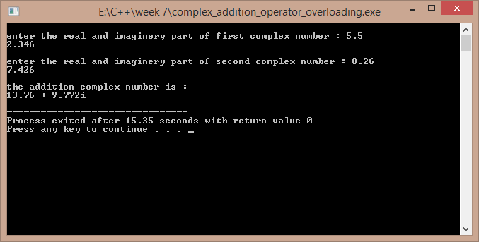

# Program 3

//a program to overload the operator regarding the strings

#include<iostream>

#include<cstring> using namespace std; class str

{

char *s; int l; public:

str()

{

l=0;

s=new char[l+1];

}

str(char *p)

{

l=strlen(p); s=new char[l+1]; strcpy(s,p);

}

str(int k)

{

l=k;

s=new char[l+1];

}

str operator +(str);

int operator <(str); int operator >(str); void operator =(str); int operator !=(str); void display()

{

// cout<<this->l; cout<<"\n"<<this->s;

}

};

str str::operator +(str a)

{

str t;

t=str(strlen(this->s)+strlen(a.s)); strcpy(t.s,this->s);

strcat(t.s,a.s); return t;

}

int str::operator >(str a)

{

if(strcmp(this->s,a.s)>0) return 1;

else return 0;

}

int str::operator <(str a)

{

if(strcmp(this->s,a.s)<0) return 1;

else return 0;

}

void str::operator =(str a)

{

strcpy(this->s,a.s);

}

int str::operator !=(str a)

{

if(strcmp(this->s,a.s)!=0) return 1;

else return 0;

}

int main()

{

str x,y;

char temp[100];

cout<<"\nenter the first word : "; cin>>temp;

x=str(temp);

cout<<"\nenter the second word : "; cin>>temp;

y=str(temp); str xy; xy=x+y;

cout<<"\nthe joint of the words is : "; xy.display();

cout<<"\nhere x is the first word and y is the second word ."; cout<<"\nthe result of x>y is : "<<(x>y);

cout<<"\nthe result of x<y is : "<<(x<y); cout<<"\nthe result of x!=y is : "<<(x!=y); return 1;

}

Output :-

